ISO New England, Inc.

Annual Markets Report

May 2001 – April 2002

Section 2

Technical Review

September 12, 2002

Table of Contents

1 Market Performance 1
1.1 Energy Clearing Prices 1
1.2 Ancillary Services Markets 2
1.3 Energy Price Volatility 4
1.4 Energy Uplift, Congestion, and NCPC Uplift 6
1.5 All-In Wholesale Price of Electricity 7
1.6 Comparison with Other Pools 9
1.7 Relative Size of ISO Residual Market for Energy 11
1.8 Bilateral Contract Prices 12
2 Load and Supply Conditions 14
2.1 Load 14
2.2 Net Energy for Load 15
2.3 Capacity Available 17
2.4 Imports From and Exports To New York 19
3 Bid and Offer Analysis 20
3.1 Energy Market System Supply Curves 20
3.2 Market Shares by Participant Bidding Authority 27
4. Marginal Price-Setting Analysis 30
4.1 Asset Types 30
4.2 Unit Types 33
4.3 Lead Participants 35
5. Transmission Congestion Activity and Mitigation 39
6. Administrative Price Corrections 44

List of Figures

Figure 1 - Monthly Average Reserve Markets Clearing Prices 3
Figure 2 - Total Reserve Costs 4
Figure 3 - Uplift Payments by Month, May 1999-April 2002 6
Figure 4 - Energy Price Duration Curves for ISO-NE, PJM, and NYISO 10
Figure 5 - Energy Price Duration Curves for ISO-NE, PJM, and NYISO 10
Figure 6 - Monthly Average Absolute ANI as a Percent of Load 11
Figure 7 - Average Month-Ahead Bilateral Trades in New England 12
Figure 8 – Day-Ahead Bilateral Trades in New England vs Average 13
Figure 9 - Daily Peak Load vs Temperature 15
Figure 10 - Monthly Actual Net Energy for Load 17
Figure 11 - Net Capacity, May 1999 - April 2002 18
Figure 12 - Difference of Installed Capacity and Monthly Peak Load 18
Figure 13 – Imports from and Exports to New York 19
Figure 14 - Internal Resource Supply Curves 20
Figure 15 - Internal Resource Cumulative Percent of Bids 21
Figure 16 - Supply Curves by Fuel Type – July 15 HE 14 22
Figure 17 - External Contract Supply Curves HE14 23
Figure 18 - Weighted Average Bid by Fuel Type - Hydros all Thursdays 24
Figure 19 - Weighted Average Bid by Fuel Type - Coal HE 14 25
Figure 20 - Daily Average ECP vs Variable Production Costs 26
Figure 21 - Market Shares by Participant Bidding Authority 27
Figure 22 – Normalized Bid Supply Curves for Several Lead Participants 28
Figure 23 – Normalized Bid Supply Curves for Several Lead Participants – HE14 29
Figure 24 - RTMP Setters by Asset Type 31
Figure 25 –RTMP Setters by Asset Type 31
Figure 26 - RTMP Setters by Asset Type 32
Figure 27 - RTMP Setters by Asset Type 32
Figure 28 - RTMP Setters by Asset Type 33
Figure 29 - RTMP Setters by Asset Type 33
Figure 30 - RTMP Setters by Unit Type 34
Figure 31 - RTMP Setters by Unit Type Frequency by Month 34
Figure 32 - RTMP Setters by Lead Participant 35
Figure 33 - RTMP Setters by Lead Participant 36
Figure 34 – Average Market Share and RTMP Setter Percentage 37
Figure 35 – Participant A Market Share and RTMP Setter Percentage 37
Figure 36 - Participant B Market Share and RTMP Percentage 38
Figure 37 - Monthly Congestion MWh for Total System 39
Figure 38 - Unmitigated v. Mitigated and NCPC 40
Figure 39 - Transmission Congestion MWh by Area 41
Figure 40 - Congestion by Cause 42
Figure 41 - Monthly Transmission Congestion MW by Major Congested Area 43
Figure 42 - Administrative Price Corrections by Month 45

List of Tables

Table 1 - ECP Frequency 1
Table 2 - ECP Frequency 1
Table 3 - ECP Frequency 2
Table 4 - Energy Clearing Price Statistics, $/MW 5
Table 5 – Uplift by Month 7
Table 6 - The Average Integrated Price of Wholesale Power Weighted by Load 8
Table 7 – Energy Market Clearing Price Statistics, ISO-NE, NYISO, and PJM 9
Table 8 - Monthly Peak and Minimum Loads, 14
Table 9 - New England Net Energy for Load 16
Table 10- Administrative Price Corrections 456

Market Performance

Energy Clearing Prices

Table 1 shows ECP frequencies and averages (unweighted) for the last 12 months and Tables 2 and 3 show values for the previous two years of market operation. Highlighted cells show the ranges with high frequencies of prices each month.

Table 1 - ECP Frequency
May 2001 – April 2002

ECP Range | May-01 | June-01 | July-01 | Aug-01 | Sep-01 | Oct-01 | Nov-01 | Dec-01 | Jan-02 | Feb-02 | Mar-02 | Apr-02 | 12 Months
<$10 | 7.66% | 5.83% | 0.94% | 0.40% | 1.25% | 0.67% | 7.50% | 0.67% | 3.36% | 0.45% | 1.08% | 3.06% | 2.74%
$10.01-$20.00 | 1.75% | 1.94% | 1.08% | 0.40% | 6.39% | 7.11% | 14.17% | 7.66% | 14.11% | 13.24% | 5.38% | 8.34% | 6.71%
$20.01-$30.00 | 6.85% | 18.61% | 39.25% | 22.45% | 44.31% | 41.21% | 49.44% | 67.74% | 61.56% | 73.21% | 41.53% | 35.61% | 41.05%
$30.01-$40.00 | 36.56% | 44.72% | 35.75% | 34.27% | 27.92% | 33.69% | 18.19% | 16.40% | 16.80% | 10.86% | 41.67% | 43.95% | 30.30%
$40.01-$50.00 | 25.27% | 16.53% | 10.89% | 25.81% | 14.03% | 15.44% | 9.58% | 5.91% | 2.96% | 1.79% | 7.80% | 6.26% | 12.28%
$50.01-$70.00 | 14.78% | 11.53% | 8.33% | 12.23% | 5.41% | 1.61% | 1.11% | 1.34% | 1.21% | 0.15% | 2.15% | 2.78% | 5.27%
$70.01-$100.00 | 5.78% | 11.53% | 1.08% | 2.96% | 0.56% | 0.13% | 0.00% | 0.27% | 0.00% | 0.15% | 0.00% | 0.00% | 1.06%
$100.01-$200.00 | 1.34% | 0.42% | 0.81% | 0.94% | 0.14% | 0.13% | 0.00% | 0.00% | 0.00% | 0.15% | 0.40% | 0.00% | 0.38%
$200.01+ | 0.00% | 0.42% | 1.88% | 0.54% | 0.00% | 0.00% | 0.00% | 0.00% | 0.00% | 0.00% | 0.00% | 0.00% | 0.21%
Average On Peak | $48.27 | $42.06 | $77.33 | $54.25 | $40.07 | $36.57 | $30.33 | $29.98 | $29.66 | $27.99 | $35.15 | $34.89 | $41.55
Average Off Peak | $26.50 | $21.78 | $26.84 | $31.25 | $21.80 | $22.51 | $18.71 | $21.99 | $20.05 | $21.60 | $25.35 | $21.90 | $23.36
Average | $41.01 | $35.41 | $52.24 | $43.34 | $33.45 | $30.95 | $25.61 | $27.18 | $25.49 | $25.10 | $30.84 | $30.07 | $38.48

Table 2 - ECP Frequency
May 2000 – April 2001

ECP Range | May-00 | Jun-00 | Jul-00 | Aug-00 | Sep-00 | Oct-00 | Nov-00 | Dec-00 | Jan-01 | Feb-01 | Mar-01 | Apr-01 | 12 Months
<$10 | 3.36% | 3.61% | 0.94% | 0.67% | 5.69% | 1.74% | 0.42% | 0.81% | 1.48% | 1.34% | 0.00% | 8.76% | 1.74%
$10.01-$20.00 | 9.68% | 11.39% | 11.02% | 4.30% | 7.64% | 1.48% | 1.67% | 1.08% | 2.02% | 3.42% | 0.27% | 4.31% | 4.61%
$20.01-$30.00 | 25.27% | 10.69% | 15.73% | 10.22% | 25.28% | 9.40% | 12.92% | 1.75% | 2.69% | 9.82% | 5.11% | 14.88% | 8.91%
$30.01-$40.00 | 28.90% | 31.94% | 27.15% | 34.95% | 40.97% | 38.39% | 39.31% | 6.45% | 3.49% | 23.17% | 14.25% | 19.61% | 19.66%
$40.01-$50.00 | 19.49% | 27.36% | 33.74% | 26.08% | 17.64% | 44.16% | 43.47% | 15.05% | 14.11% | 48.21% | 52.82% | 42.00% | 32.95%
$50.01-$70.00 | 8.60% | 13.33% | 11.02% | 19.22% | 2.50% | 4.56% | 1.94% | 43.28% | 52.15% | 13.24% | 20.43% | 9.18% | 24.79%
$70.01-$100.00 | 1.75% | 0.69% | 0.40% | 4.17% | 0.14% | 0.27% | 0.28% | 29.17% | 20.30% | 0.60% | 4.30% | 0.83% | 6.03%
$100.01-$200.00 | 2.15% | 0.56% | 0.00% | 0.40% | 0.14% | 0.00% | 0.00% | 2.28% | 3.09% | 0.74% | 2.28% | 0.42% | 1.06%
$200.01+ | 0.81% | 0.42% | 0.00% | 0.00% | 0.00% | 0.00% | 0.00% | 0.13% | 0.67% | 0.45% | 0.54% | 0.00% | 0.27%
Average On Peak | $123.63 | $47.46 | $44.34 | $49.86 | $49.11 | $56.49 | $52.97 | $70.78 | $70.76 | $48.77 | $57.25 | $44.98 | $59.70
Average Off Peak | $21.49 | $25.45 | $25.78 | $31.67 | $31.66 | $39.00 | $41.02 | $49.87 | $47.46 | $31.02 | $41.87 | $23.30 | $34.17
Average | $72.78 | $38.80 | $37.14 | $42.26 | $43.15 | $50.32 | $49.30 | $62.55 | $62.57 | $42.91 | $50.18 | $36.23 | $49.15

Table 3 - ECP Frequency
May 1999- April 2000

ECP Range | May-99 | Jun-99 | Jul-99 | Aug-99 | Sep-99 | Oct-99 | Nov-99 | Dec-99 | Jan-00 | Feb-00 | Mar-00 | Apr-00 | 12 Months
<$10 | 0.00% | 0.00% | 0.13% | 0.00% | 1.11% | 1.48% | 1.25% | 0.67% | 0.27% | 0.00% | 3.49% | 7.09% | 1.29%
$10.01-$20.00 | 3.76% | 7.64% | 9.81% | 10.89% | 20.00% | 26.34% | 33.33% | 29.84% | 7.26% | 4.74% | 31.05% | 21.14% | 17.19%
$20.01-$30.00 | 66.53% | 57.64% | 49.73% | 37.50% | 36.25% | 46.37% | 37.64% | 47.98% | 24.06% | 30.17% | 45.03% | 42.98% | 43.55%
$30.01-$40.00 | 27.82% | 16.53% | 26.34% | 47.45% | 34.72% | 25.00% | 24.31% | 19.89% | 38.44% | 37.21% | 18.68% | 21.14% | 28.15%
$40.01-$50.00 | 1.48% | 3.89% | 4.03% | 2.82% | 4.03% | 0.54% | 2.50% | 1.61% | 16.40% | 25.29% | 1.34% | 5.42% | 5.68%
$50.01-$70.00 | 0.27% | 6.39% | 2.02% | 1.21% | 3.61% | 0.13% | 0.83% | 0.00% | 9.68% | 1.87% | 0.13% | 1.11% | 2.25%
$70.01-$100.00 | 0.13% | 3.33% | 2.55% | 0.13% | 0.28% | 0.00% | 0.00% | 0.00% | 2.96% | 0.72% | 0.27% | 0.83% | 0.92%
$100.01-$200.00 | 0.00% | 1.25% | 3.23% | 0.00% | 0.00% | 0.13% | 0.14% | 0.00% | 0.67% | 0.00% | 0.00% | 0.28% | 0.49%
$200.01+ | 0.00% | 3.33% | 2.15% | 0.00% | 0.00% | 0.00% | 0.00% | 0.00% | 0.27% | 0.00% | 0.00% | 0.00% | 0.48%
Average On Peak | $31.72 | $73.36 | $46.84 | $32.90 | $33.89 | $30.36 | $31.34 | $26.76 | $43.78 | $38.86 | $28.52 | $32.86 | $37.60
Average Off Peak | $23.42 | $25.49 | $25.05 | $23.68 | $21.94 | $18.44 | $19.52 | $20.17 | $29.44 | $27.26 | $16.32 | $19.13 | $22.49
Average | $28.20 | $49.18 | $41.14 | $29.25 | $28.42 | $24.78 | $24.88 | $24.33 | $37.15 | $34.20 | $23.90 | $26.17 | $30.94

Ancillary Services Markets

The four ancillary services traded in the ISO-NE markets are: Automatic Generation Control (AGC), Ten-Minute Spinning Reserve (TMSR), Ten Minute Non-Spinning Reserve (TMNSR), and Thirty-Minute Operating Reserve (TMOR).

AGC is generation under ISO control that provides regulation, automatically tracking minute-to-minute changes in load. Approximately one-quarter of the generators in New England can provide AGC, and there are typically 12 or fewer generators actually providing AGC at any one time. Total AGC payments include opportunity costs, value of regulation, and service. The AGC clearing price is in $/Reg-Hour and cannot be strictly compared to the prices of the other ancillary services or energy, which are in $/MW. There is much less variation in AGC market-clearing prices than in the reserve or energy markets. Monthly average hourly AGC clearing prices in the third year of the markets ranged from $4.85 to $5.94. The highest hourly price was $138.35, and the lowest was $0.00.

ISO-NE designates ten-minute operating reserves equal to the MW amount of the control area's first contingency. Generally, 50% of the requirement is designated in the TMSR market and 50% in the TMNSR market. In addition, ISO-NE designates TMOR equal to one-half of the second contingency. Prices for the three ancillary services and energy are generally expected to observe the following relationship: ECP > TMSR > TMNSR > TMOR. This reflects the decreasing quality of the product from TMSR to TMNSR to TMOR. However, this price relationship does not always hold, and at times clearing prices in the non-spin markets exceed that of TMSR. Figure 1 shows monthly average hourly reserve market clearing prices since the beginning of the markets, and Figure 2 shows total reserve costs by month for the past year. The highest reserve costs in the third year of the market were in July 2001. These costs were driven by several hours in the month with $1000/MW clearing prices in the TMNSR and TMOR markets.

Figure 1 - Monthly Average Reserve Markets Clearing Prices
May 1999 – April 2002
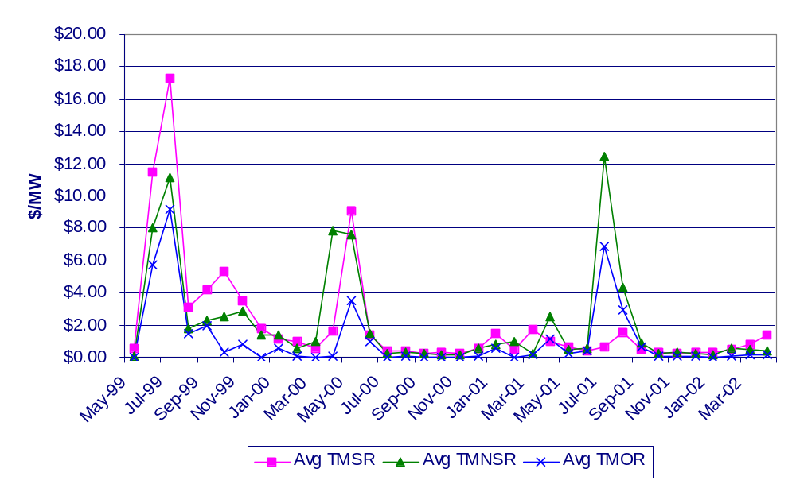

Figure 2 - Total Reserve Costs

May 2001 - April 2002

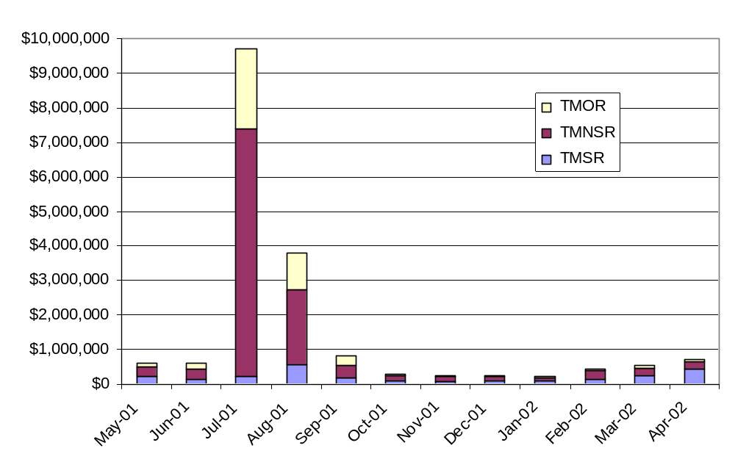

Energy Price Volatility

In assessing the hourly volatility of ECP data, a commonly used measure is the standard deviation. This measure of volatility is adequate for months without spikes. However, for months with spikes, this measure provides an inflated measure of volatility. Excluding these price spikes in computing the monthly volatility results in a reduced and inaccurate assessment of ECP volatility.

Two alternatives to the conventional standard deviation are the median absolute deviation and the modified interquartile range. These alternatives are less sensitive to the impact one or more spikes. In the case of the modified interquartile range, spikes merely add more points, but the overall computation is based on the most stable part of the data range. In the case of the median absolute deviation, the median taken is insensitive to the arithmetic impact of outlying points (although it includes them in the rank ordering of deviations).

Table 4 shows descriptive statistics by month for energy clearing prices (unweighted) during the first three years of market operation. Average prices ranged from a low of $23.90/MWh in March 2000 to a high of $72.78/MWh in May 2000. Also included are the standard deviation, interquartile range and median absolute deviation volatility measures.

Table 4 - Energy Clearing Price Statistics, $/MW

 | Average  (unweighted) | Median | Maximum | Minimum | Standard Deviation | Standard Deviation/Mean | Inter Quartile Range | Median Absolute Deviation
May-99 | $28.20 | $28.00 | $72.04 | $17.10 | $5.46 | 19.36% | $6.55 | $3.29
Jun-99 | $49.18 | $27.59 | $1,003.21 | $15.56 | $96.58 | 196.38% | $10.94 | $4.63
Jul-99 | $41.14 | $28.21 | $572.54 | $9.56 | $56.46 | 137.24% | $9.59 | $4.48
Aug-99 | $29.25 | $30.16 | $80.39 | $13.76 | $6.90 | 23.59% | $8.41 | $3.96
Sep-99 | $28.42 | $28.82 | $81.34 | $1.00 | $9.32 | 32.79% | $11.05 | $4.47
Oct-99 | $24.78 | $25.20 | $188.07 | -$2.75 | $9.17 | 37.01% | $10.93 | $5.22
Nov-99 | $24.90 | $23.82 | $109.04 | -$0.48 | $8.71 | 34.98% | $12.29 | $6.19
Dec-99 | $24.33 | $24.28 | $49.36 | -$2.64 | $6.40 | 26.30% | $10.27 | $5.16
Jan-00 | $37.15 | $34.71 | $233.40 | $3.57 | $18.77 | 50.52% | $15.07 | $7.43
Feb-00 | $34.17 | $35.00 | $79.32 | $14.39 | $9.10 | 26.63% | $13.16 | $6.65
Mar-00 | $23.90 | $22.95 | $74.67 | -$2.59 | $8.39 | 35.10% | $8.96 | $4.48
Apr-00 | $26.17 | $24.83 | $185.25 | -$0.42 | $12.59 | 48.11% | $11.82 | $5.84
May-00 | $72.78 | $34.74 | $6,000.00 | -$1.51 | $449.07 | 617.02% | $20.37 | $10.18
Jun-00 | $38.80 | $38.22 | $381.34 | $0.00 | $24.64 | 63.51% | $16.76 | $8.10
Jul-00 | $37.14 | $39.09 | $74.49 | $0.00 | $12.01 | 32.34% | $16.18 | $7.27
Aug-00 | $42.23 | $39.93 | $127.93 | $0.00 | $14.66 | 34.71% | $15.10 | $7.04
Sep-00 | $43.15 | $42.74 | $313.45 | $17.11 | $16.23 | 37.61% | $12.23 | $6.00
Oct-00 | $50.32 | $49.66 | $110.00 | $16.14 | $11.49 | 22.83% | $14.62 | $7.27
Nov-00 | $49.30 | $49.25 | $164.51 | $17.02 | $10.53 | 21.36% | $12.71 | $6.53
Dec-00 | $62.55 | $61.90 | $519.92 | $0.00 | $25.34 | 40.51% | $24.08 | $12.07
Jan-01 | $62.57 | $61.24 | $395.06 | $0.00 | $29.04 | 46.41% | $19.44 | $9.68
Feb-01 | $43.01 | $43.83 | $427.48 | $0.00 | $22.99 | 53.45% | $11.83 | $5.75
Mar-01 | $50.18 | $45.36 | $472.72 | $16.75 | $28.22 | 56.24% | $10.04 | $4.64
Apr-01 | $36.27 | $40.51 | $119.90 | -$6.45 | $16.03 | 44.20% | $16.94 | $6.74
May-01 | $41.01 | $38.71 | $180.76 | $0.00 | $20.56 | 50.13% | $15.69 | $7.88
Jun-01 | $35.41 | $33.53 | $130.38 | $0.00 | $14.62 | 41.29% | $13.50 | $4.80
Jul-01 | $52.24 | $31.42 | $1,000.00 | $0.00 | $127.44 | 243.95% | $12.04 | $4.92
Aug-01 | $43.34 | $37.03 | $1,000.00 | $0.00 | $53.01 | 122.31% | $15.82 | $7.66
Sep-01 | $33.45 | $32.43 | $117.25 | $0.00 | $13.59 | 40.63% | $16.77 | $8.55
Oct-01 | $30.95 | $30.37 | $105.08 | $0.00 | $9.58 | 30.95% | $13.61 | $7.10
Nov-01 | $25.61 | $24.27 | $68.03 | -$4.04 | $11.05 | 43.15% | $10.77 | $4.82
Dec-01 | $27.18 | $25.12 | $79.25 | $0.00 | $8.23 | 30.28% | $7.28 | $3.11
Jan-02 | $25.49 | $25.12 | $62.83 | -$2.32 | $8.16 | 32.01% | $7.92 | $3.91
Feb-02 | $25.10 | $24.03 | $197.78 | $0.00 | $9.06 | 36.10% | $5.89 | $2.89
Mar-02 | $30.84 | $30.23 | $141.29 | $0.00 | $10.12 | 32.81% | $8.71 | $4.49
Apr-02 | $30.07 | $30.43 | $67.79 | $0.00 | $9.30 | 30.93% | $7.47 | $3.69

Energy Uplift, Congestion, and NCPC Uplift

Energy uplift is the payment that a unit receives for generation in bid blocks that are priced higher than the energy market-clearing price. Several conditions can result in the ISO’s directing a unit to operate in blocks above the clearing price, including units fulfilling minimum run time requirements, or baseload units required to meet demand the following day. In these cases, the unit is paid for its generation, up to the price bid in the last dispatched bid block.

Energy Uplift became part of the NCPC calculation on July 1, 2001. Figure 3 and Table 5 shows Energy Uplift, Congestion Uplift, and NCPC Uplift payments, since the beginning of the markets. Further discussion of transmission congestion uplift and NCPC uplift is provided in section 5.

Figure 3 - Uplift Payments by Month, May 1999-April 2002
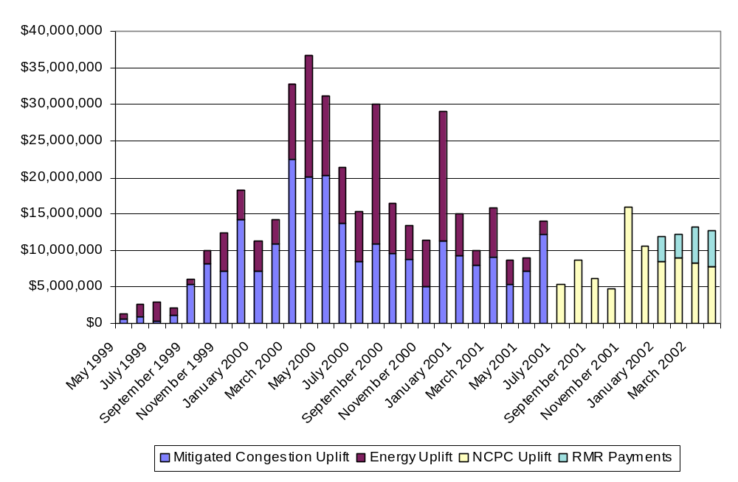
Table 5 – Uplift by Month

 |  | 1999-2000 |  |  | 2000-2001 |  |  | 2001-2002
 | Congestion | Energy | NCPC | Congestion | Energy | NCPC | Congestion | Energy | NCPC
May | $591,921 | $723,209 | N/A | $20,288,657 | $10,972,538 | N/A | $7,136,197 | $1,907,756 | N/A
June | $949,917 | $1,610,575 | N/A | $13,746,135 | $7,579,113 | N/A | $12,190,626 | $1,918,413 | N/A
July | $360,195 | $2,523,035 | N/A | $8,495,705 | $6,826,052 | N/A | N/A | N/A | $5,364,499
August | $1,074,022 | $1,081,276 | N/A | $11,009,426 | $18,973,757 | N/A | N/A | N/A | $8,723,113
September | $5,341,772 | $697,552 | N/A | $9,577,755 | $6,840,406 | N/A | N/A | N/A | $6,230,711
October | $8,209,934 | $1,794,578 | N/A | $8,885,391 | $4,477,782 | N/A | N/A | N/A | $4,758,316
November | $7,145,172 | $5,285,830 | N/A | $5,013,856 | $6,410,999 | N/A | N/A | N/A | $15,964,755
December | $14,281,049 | $4,077,678 | N/A | $11,241,196 | $17,868,975 | N/A | N/A | N/A | $10,687,232
January | $7,232,323 | $4,075,677 | N/A | $9,270,981 | $5,688,030 | N/A | N/A | N/A | $8,545,528
February | $10,964,144 | $3,270,142 | N/A | $7,999,653 | $2,012,473 | N/A | N/A | N/A | $8,977,978
March | $22,470,031 | $10,338,310 | N/A | $9,084,649 | $6,819,501 | N/A | N/A | N/A | $8,300,358
April | $20,118,384 | $16,673,347 | N/A | $5,445,918 | $3,235,963 | N/A | N/A | N/A | $7,871,168

All-In Wholesale Price of Electricity

Table 6 shows the average all-in price for wholesale power, weighted by load, for FY 1999, FY 2000 and FY 2001. The spot energy market price accounted for nearly 87% of the total $38.40/MWh price in FY 1999. This compares with energy’s being over 90% of the $57.27/MWh price in FY 2000, and over 90% of the $39.90/MWh price in FY 2002.

Table 6 - The Average Integrated Price of Wholesale Power Weighted by Load
May 1999-April 2002

Energy | May 1999-April 2000 |  | May 2000 - April 2001 |  | May 2001-April 2002
 |  | % of total |  | % of total |  | % of total
Total $ (Total ECP X Load) | 4,206,971,765 |  | 6,776,331,875 |  | 4,669,625,992
Total System Load - MWh | 126,483,287 |  | 130,665,258 |  | 129,581,333
Average ECP - $/MWh | 33.26 |  | 51.86 |  | 36.04
Sub Total Energy $ | 4,206,971,765 | 86.6% | 6,776,331,875 | 90.5% | 4,669,625,992 | 90.6%
Ancillary
TMSR
Total $ (Total CP X Requirement) | 27,707,914 |  | 8,905,514 |  | 3,508,558
TMNSR
Total $ (Total CP X Requirement) | 25,099,140 |  | 8,086,582 |  | 11,061,021
TMOR
Total $ (Total CP X Requirement) | 7,178,347 |  | 2,050,327 |  | 4,227,798
AGC
Total $ (Total CP X Requirement) | 17,102,052 |  | 21,622,357 |  | 24,365,357
Sub-Total Ancillary $ | 77,087,453 | 1.6% | 40,664,780 | 0.5% | 43,162,734 | 0.8%
Sub Total Energy & Ancillary $ | 4,284,059,218 | 88.2% | 6,816,996,655 | 91.1% | 4,712,788,726 | 91.4%
Sub Total $/MWh | 33.87 |  | 52.17 |  | 36.37
ICAP | 421,721,900 | 8.7% | 449,041,196 | 6.0% | 332,754,690 | 6.5%
Sub Total $/MWh | 3.33 |  | 3.44 |  | 2.57
Uplift
Energy Uplift | 52,151,210 |  | 97,705,589 |  | 3,826,169
Mitigated Congestion Uplift | 98,738,864 |  | 120,059,321 |  | 19,326,823
NCPC Uplift (Economic Yes and No) | - |  | - |  | 85,423,657
RMR Agreements |  |  |  |  | 16,473,269
Sub-Total Uplift $ | 150,890,074 | 3.1% | 217,764,910 | 2.9% | 125,049,919 | 2.1%
Sub Total $/MWh | 1.19 |  | 1.67 |  | 0.97
Total All Markets $ | 4,856,671,191 | 100.0% | 7,483,802,761 | 100.0% | 5,170,593,335 | 100.0%
Total $/MWh | $ 38.40 |  | $ 57.27 |  | $ 39.90

Comparison with Other Pools

Table 7, Figure 4 and Figure 5 compare energy clearing prices for ISO-NE with those in PJM and NYISO. Prices in the pools are not strictly comparable: PJM and NYISO are multi-settlement market systems with zonal or nodal pricing, while ISO-NE has a single-settlement system with one clearing price for the entire control area. The prices shown are as follows:

- ISO-NE: Hourly Clearing prices.

- PJM: Hourly Real-time unconstrained System Locational Marginal Price (LMP).

- NYISO: Hourly Integrated Real-time Locational Bus Marginal Price. Values are the average of 11 zonal prices weighted by forecasted load for each zone.

Table 7 – Energy Market Clearing Price Statistics, ISO-NE, NYISO, and PJM

 | ISO-NE |  | PJM |  | NYISO
 | Average ECP | Standard Deviation | Average ECP | Standard Deviation | Average ECP | Standard Deviation
May-01 | $41.01 | $20.56 | $30.24 | $18.23 | $47.70 | $50.90
Jun-01 | $35.41 | $14.62 | $31.71 | $23.52 | $39.10 | $38.70
Jul-01 | $52.24 | $127.44 | $35.54 | $50.96 | $41.32 | $33.55
Aug-01 | $43.34 | $53.01 | $62.67 | $124.81 | $60.46 | $67.74
Sep-01 | $33.45 | $13.59 | $25.98 | $14.41 | $34.16 | $21.38
Oct-01 | $30.95 | $9.58 | $23.90 | $9.54 | $30.03 | $9.48
Nov-01 | $25.61 | $11.05 | $20.34 | $8.58 | $26.99 | $12.43
Dec-01 | $27.18 | $8.23 | $19.96 | $8.46 | $26.83 | $10.29
Jan-02 | $25.49 | $8.16 | $20.99 | $8.26 | $25.57 | $7.93
Feb-02 | $25.10 | $9.06 | $20.19 | $8.68 | $23.69 | $7.15
Mar-02 | $30.84 | $10.12 | $24.42 | $11.36 | $31.17 | $17.51
Apr-02 | $30.07 | $9.30 | $26.69 | $16.12 | $34.60 | $22.40

Figure 4 - Energy Price Duration Curves for ISO-NE, PJM, and NYISO
Prices below $100, May 2001 – April 2002
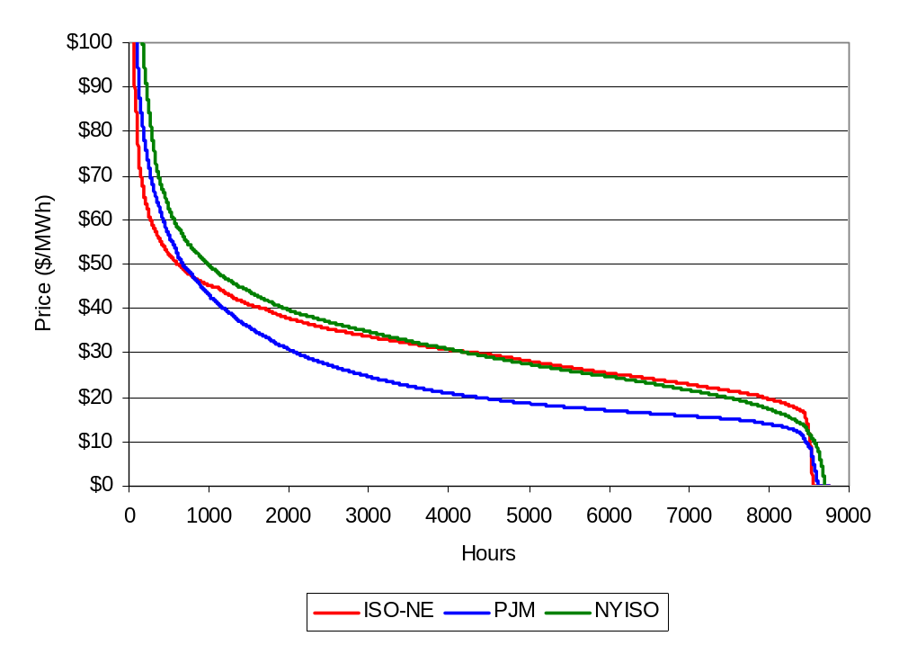

Figure 5 - Energy Price Duration Curves for ISO-NE, PJM, and NYISO
Prices above $100, May 2001 – April 2002
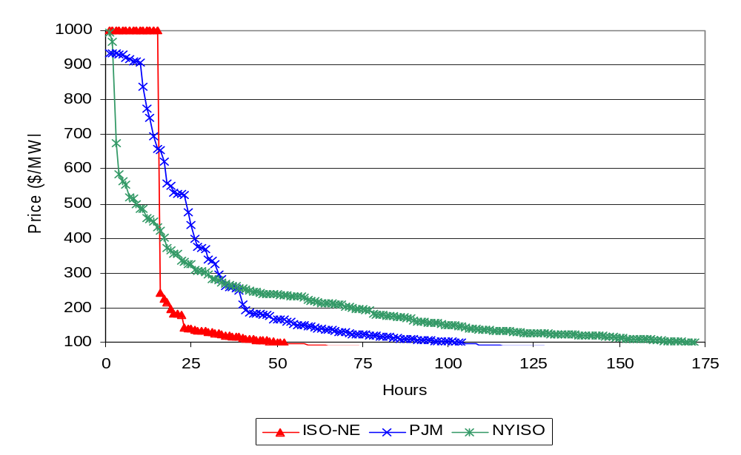

Relative Size of ISO Residual Market for Energy

This section discusses the amount of energy traded in the ISO-NE market. The size of the residual market is a measure of the market's liquidity. A small market has fewer sellers and is more susceptible to price volatility or market manipulation.

Participants in the New England markets have entitlements, comprised of the total of entitlements to NEPOOL generation, system contract purchases, and external unit contract purchases. They also have obligations, comprised of the total of electrical loads and internal system contract sales. The majority of load obligations in New England are met, and the majority of generation entitlements sold, through contract sales and purchases. A participant's entitlement total minus its obligation total is its Adjusted Net Interchange (ANI), which can be positive or negative. For example, a participant with entitlements of 400 MW in an hour, and obligations of 500 MW in the same hour, would have an ANI of -100 MW in that hour. ANI is settled at the energy-clearing price, while contracts are settled at prices agreed upon by the contract parties.

The residual market is measured here as the hourly maximum of either total negative ANI or total positive ANI. The difference between positive and negative ANI is typically less than 1%. Figure 6 shows monthly average ANI since the start of the markets. There has been two significant increases in ANI as a percent of load: one in January 2000 and one in January 2002. In both cases, the increases were due primarily to changes in activity by single participants, rather than a broad change in market activity.

Figure 6 - Monthly Average Absolute ANI as a Percent of Load

May 1999 - April 2002
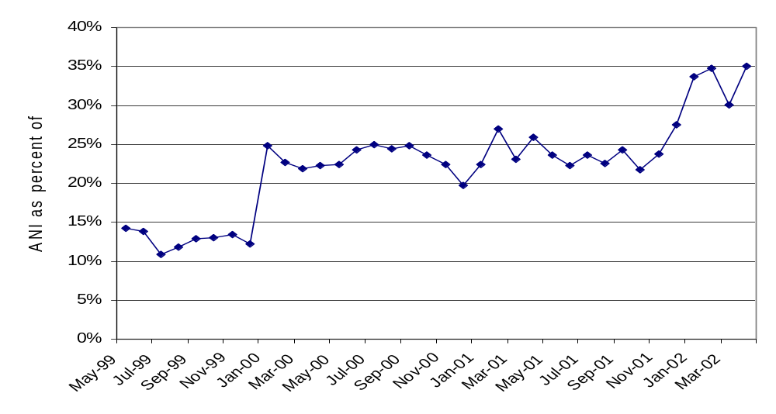

Bilateral Contract Prices

Figure 7 shows average month-ahead bilateral trade prices for on-peak power in New England. Analysis of bilateral energy trade data is useful because it shows market expectations for month-ahead (prompt month) prices. Actual weather and market conditions will cause spot prices to vary from forward market expectations. In Figure 7, trades shown labeled "May 2001," for example, are for deliveries in June 2001.

Figure 7 - Average Month-Ahead Bilateral Trades in New England

May 2001 - April 2002

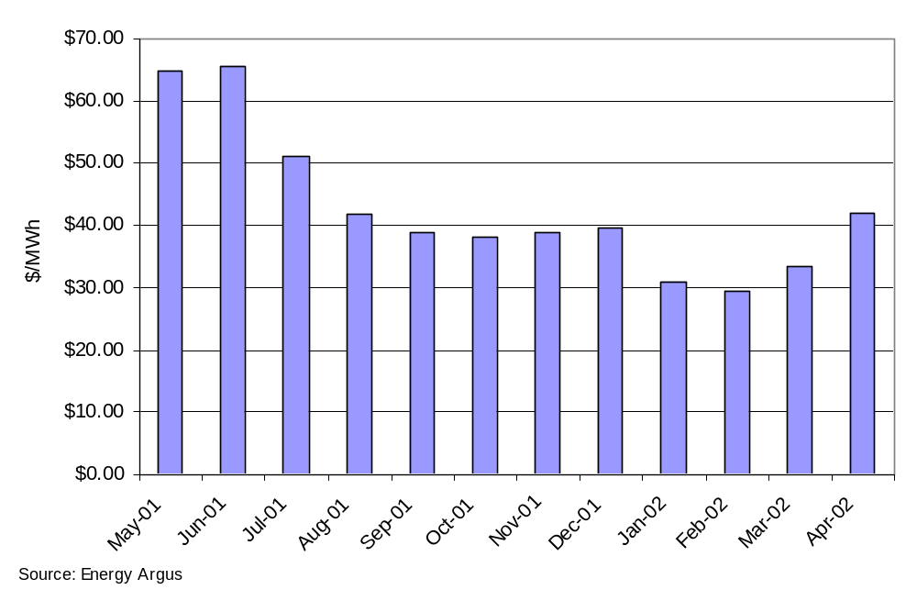

Figure 8 compares day-ahead trades for on-peak energy, averaged by month, with the average on-peak ECP; average values are unweighted. In the last eight months, bilateral prices varied little from the corresponding ECP.

Figure 8 – Day-Ahead Bilateral Trades in New England vs Average
ECP by Month

May 2001 - April 2002

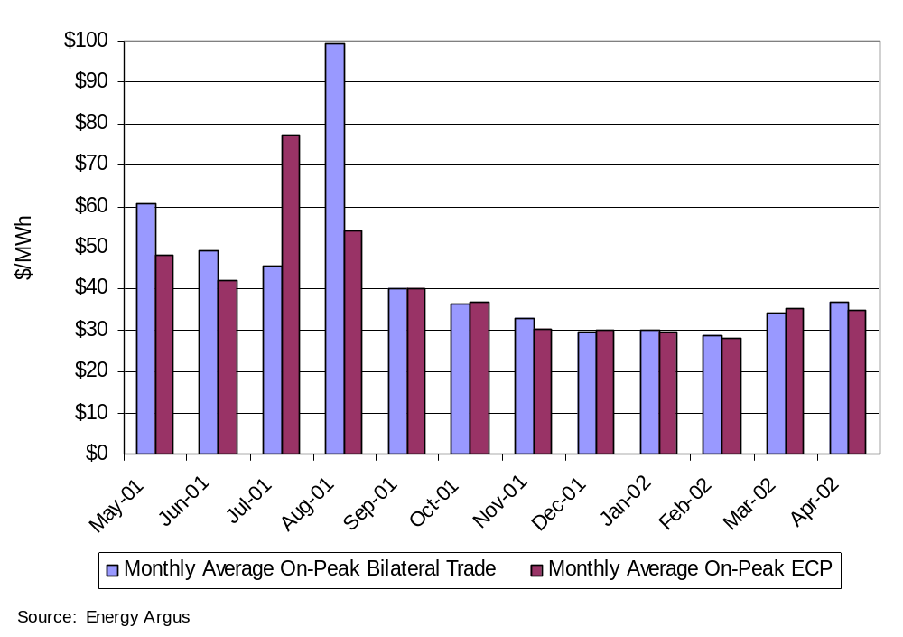

Load and Supply Conditions

Load

The third year of the markets saw record-breaking demand during heat waves in July and August 2001, and relatively low demand during the warmest winter on record in New England. Table 8 shows monthly peak loads, the date and hour of the peak, and dry bulb temperature at the time of the peak. This table also shows the minimum load (excluding operation of pumped storage units) for the month. A new record NEPOOL peak load of 24,967 MW was established on August 9, 2001.

Table 8 - Monthly Peak and Minimum Loads,

May 2001 - April 2002
 | Peak Load (MW) | Day | Hour Ending | Temperature  (ºF) | Minimum Load  (MW)
May-01 | 18,904 | May 4 | 15 | 86.0 | 8,808
Jun-01 | 22,358 | June 27 | 17 | 87.7 | 8,900
Jul-01 | 23,952 | July 25 | 15 | 91.0 | 9,261
Aug-01 | 24,967 | August 9 | 15 | 95.2 | 9,659
Sep-01 | 20,594 | September 10 | 15 | 83.0 | 8,910
Oct-01 | 17,246 | October 29 | 18 | 53.1 | 8,964
Nov-01 | 18,116 | November 29 | 18 | 41.3 | 9,028
Dec-01 | 19,872 | December 17 | 18 | 33.0 | 9,093
Jan-02 | 19,241 | January 2 | 18 | 31.6 | 10,212
Feb-02 | 19,260 | February 11 | 19 | 21.3 | 9,995
Mar-02 | 18,327 | March 5 | 19 | 28.7 | 9,076
Apr-02 | 18,450 | April 17 | 15 | 87.7 | 8,790

Figure 9 shows the relationship of daily peak load and temperature at the time of the peak for each day, excluding weekends and holidays. A strong relationship between load and temperature is evident.

Figure 9 - Daily Peak Load vs Temperature

May 1999 - April 2002
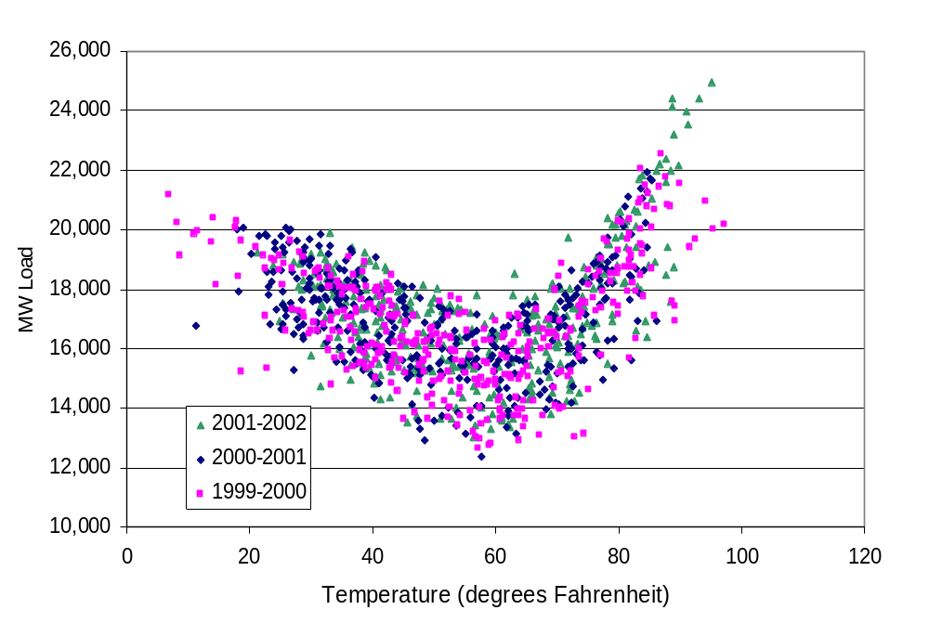

Net Energy for Load

Table 9 shows actual and weather-normalized monthly total net energy for load (NEL) in MWh. Actual net energy for load (NEL) is the total net energy used to serve load for the month in the New England control area, calculated as: Load = Generation - Pumping + Net Interchange. The weather normalized NEL is calculated by the ISO-NE planning department for use in long-term forecasting. It provides an estimate of what the NEPOOL monthly NEL would have been had weather conditions been normal. Figure 10 shows actual NEL by month for the three years of market operation. The high-energy use in August 2001 and relatively low use in winter 2001-2002 are evident.

Table 9 - New England Net Energy for Load

May 2001 - April 2002

Month | Current NEL (GWH) | Prior Year NEL (GWH) | %Change | Current Weather Normalized NEL (GWH) | Prior Year Weather- Normalized NEL (GWH) | %Change
May-01 | 9,818 | 9,686 | 1.4% | 9,762 | 9,562 | 2.1%
Jun-01 | 10,873 | 10,409 | 4.5% | 10,401 | 10,151 | 2.5%
Jul-01 | 10,936 | 10,675 | 2.4% | 11,595 | 11,533 | 0.5%
Aug-01 | 12,246 | 11,173 | 9.6% | 11,334 | 11,395 | -0.5%
Sep-01 | 10,017 | 10,068 | -0.5% | 10,030 | 9,952 | 0.8%
Oct-01 | 9,978 | 9,989 | -0.1% | 10,027 | 10,010 | 0.2%
Nov-01 | 9,751 | 10,051 | -3.0% | 9,839 | 9,928 | -0.9%
Dec-01 | 10,689 | 11,572 | -7.6% | 10,996 | 11,445 | -3.9%
Jan-02 | 11,009 | 11,466 | -4.0% | 11,260 | 11,448 | -1.6%
Feb-02 | 9,785 | 10,058 | -2.7% | 9,950 | 10,053 | -1.0%
Mar-02 | 10,331 | 10,719 | -3.6% | 10,442 | 10,588 | -1.4%
Apr-02 | 9,557 | 9,425 | 1.4% | 9,549 | 9,492 | 0.6%

Figure 10 - Monthly Actual Net Energy for Load

1999-2000, 2000-2001 and 2001-2002

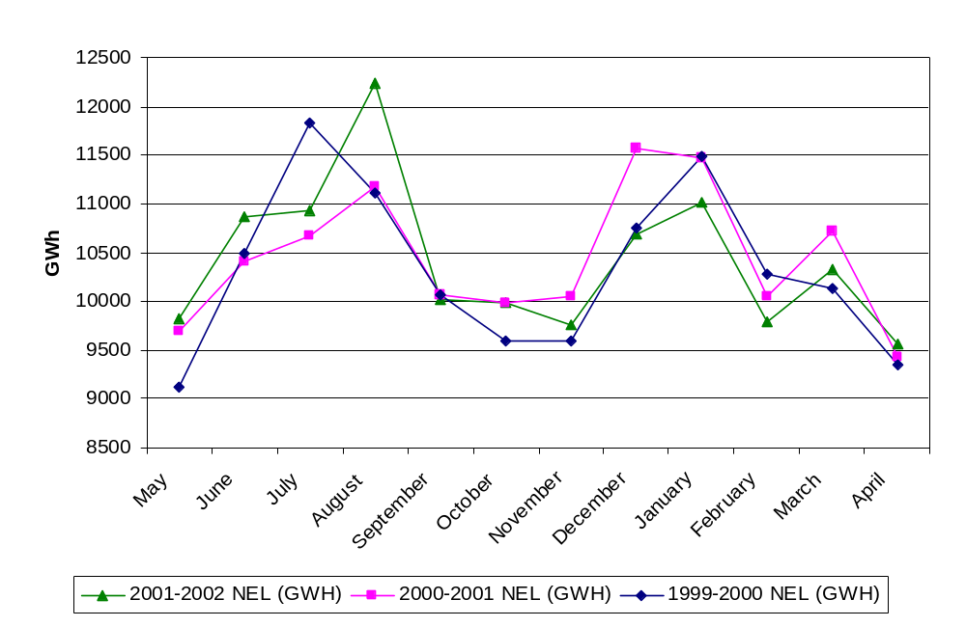

Capacity Available

The total capacity made available for a given hour is the sum of all New England generators’ High Operating Limits (HOLs), plus available capacity from firm external contracts (E2 Capacity), minus exports. Many of the available external contracts do not flow regularly because their prices are higher than those of available internal resources. External contract capacity included here is limited to the amount for which there is transmission import capacity. Total capacity does not include possible emergency purchases, but does include generators that may be unavailable in the hour due to start time or transmission constraints. Unit outages are included. In Figure 11, load and reserves are subtracted from total capacity and the net, or excess, capacity is reported Net capacity exceeded 2,000 MW in 98.5% of hours in the third year of market operation. The difference in total installed capacity and peak load by month, since the beginning of the markets is shown in Figure 12.
Figure 11 - Net Capacity, May 1999 – April 2002

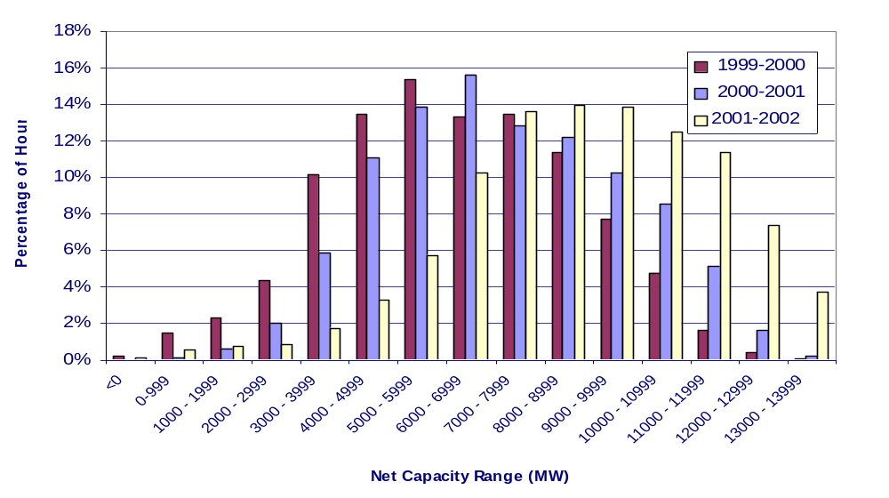

Figure 12 - Difference of Installed Capacity and Monthly Peak Load
1999-2000-2001-2002
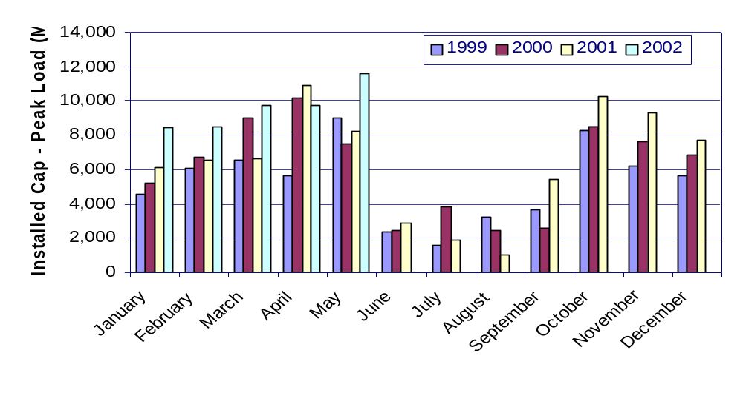

Imports From and Exports To New York

Figure 13 shows hourly MW imports from and exports to New York for January, 2001 through April, 2002. Imports, shown on the negative axis, decreased over the course of FY 2001. Export quantities varied, with larger amounts exported in the spring and summer months. Also shown in Figure 13 is the rolling 30-day average of the net interchange with New York. For the purposes of this figure, net interchange is defined as exports minus imports. Significantly, New England became a net exporter at the end of the fiscal year.

Figure 13 – Imports from and Exports to New York
January 2001 – April 2002
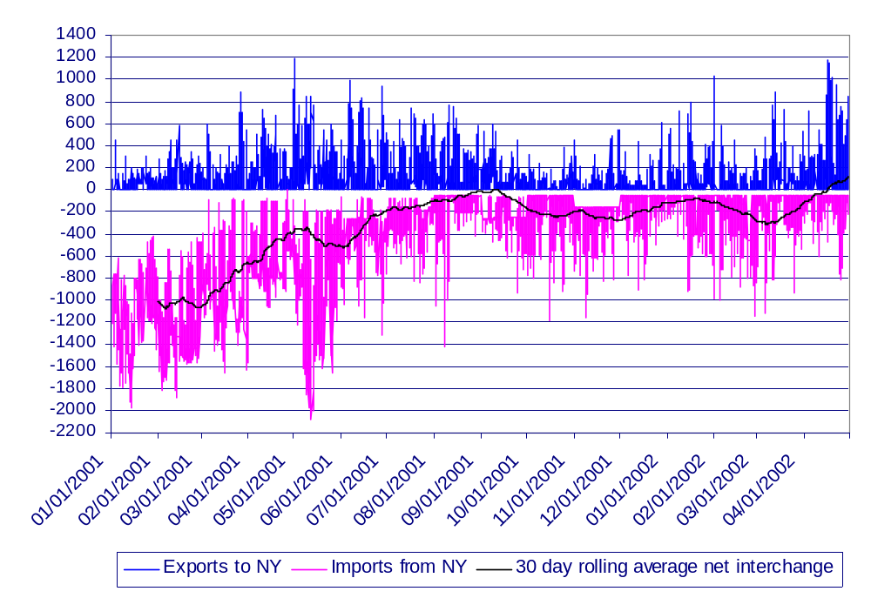

Bid and Offer Analysis

Energy Market System Supply Curves

Figure 14 shows the energy market supply curves for internal New England resources that bid in (with bid HOL > 0) to the market for four selected days for hour 1400 during FY 2001. These days were selected to cover the highest load during summer, winter, and shoulder months. The highest priced bid blocks occurred in July with a peak price of $2,500 followed by October at $1,249.

Figure 14 - Internal Resource Supply Curves

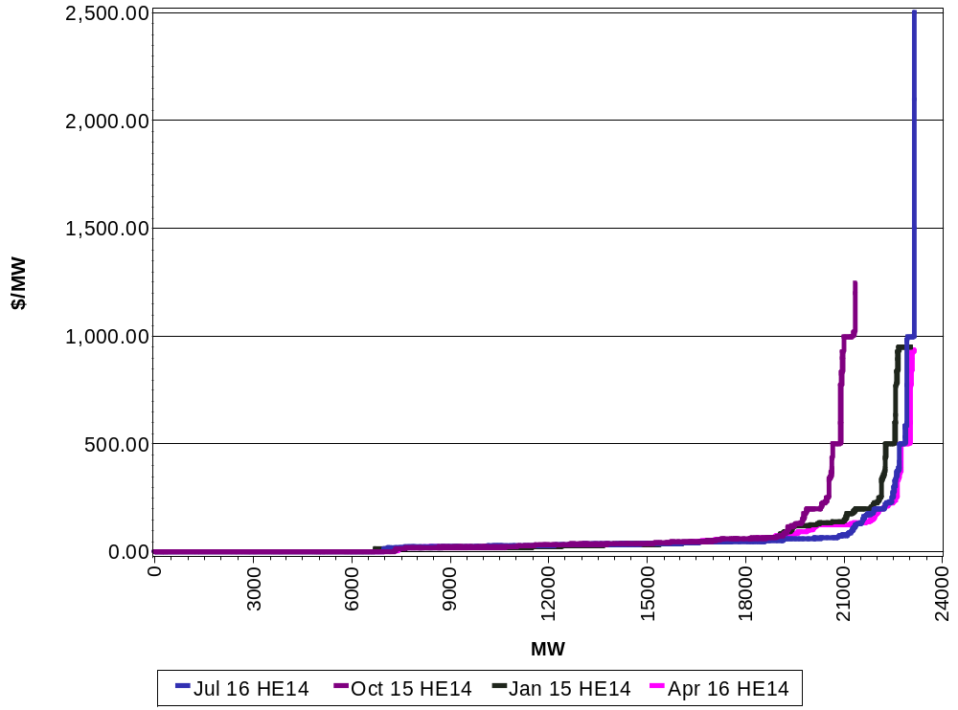

Figure 15 - Internal Resource Cumulative Percent of Bids
4 Business Days FY 2001

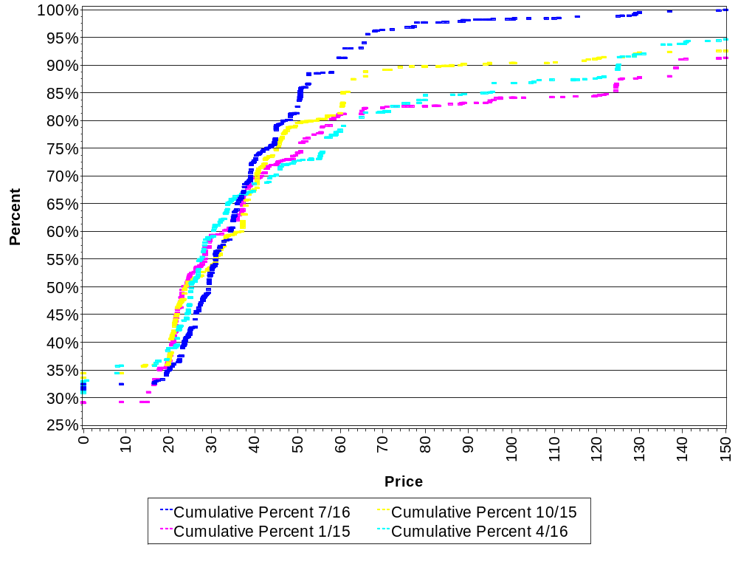

The cumulative internal resources bid distributions for the four selected business days are shown in Figure 15. Approximately 80% of the bids on the January, April and October days were priced at under $60.00 while 90% of the July day bids were priced under $60.00.

.

Figure 16 - Supply Curves by Fuel Type – July 15 HE 14

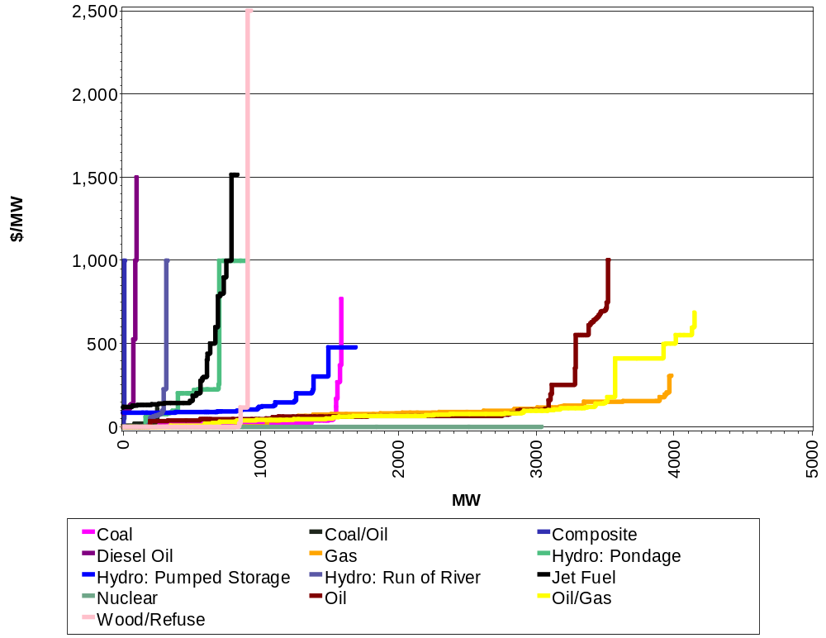

Internal resource supply curves by fuel type for a business day in July, FY 2001 is shown in Figure 16. As was the case in FY 2000, the sum of Oil/Gas, Nuclear and Oil represents the largest percentage of the total internal resources bid; this year at 57%. Bid prices for oil reached $999.67 while gas reached $222.12.

Figure 17 - External Contract Supply Curves HE14

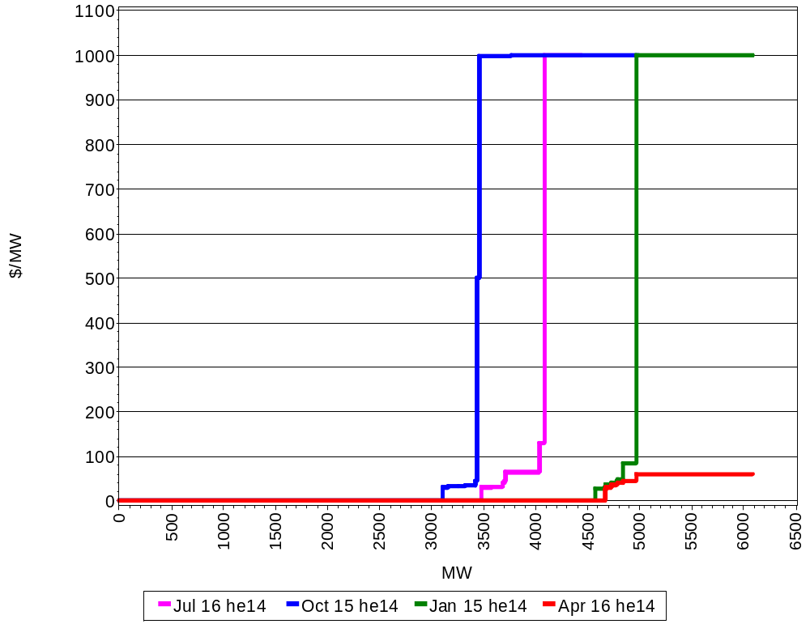

Shown in Figure 17 are the energy supply curves for external resources that bid into the market for the four-selected business days at hour 14 in FY 2001. The quantities offered represent 19.5% of the total resources bid into the energy market. This is an increase of approximately 5% over FY 2000’s percentage of 14.2%.

Figure 18 - Weighted Average Bid by Fuel Type - Hydros all Thursdays
5/1/01-4/30/02, HE14

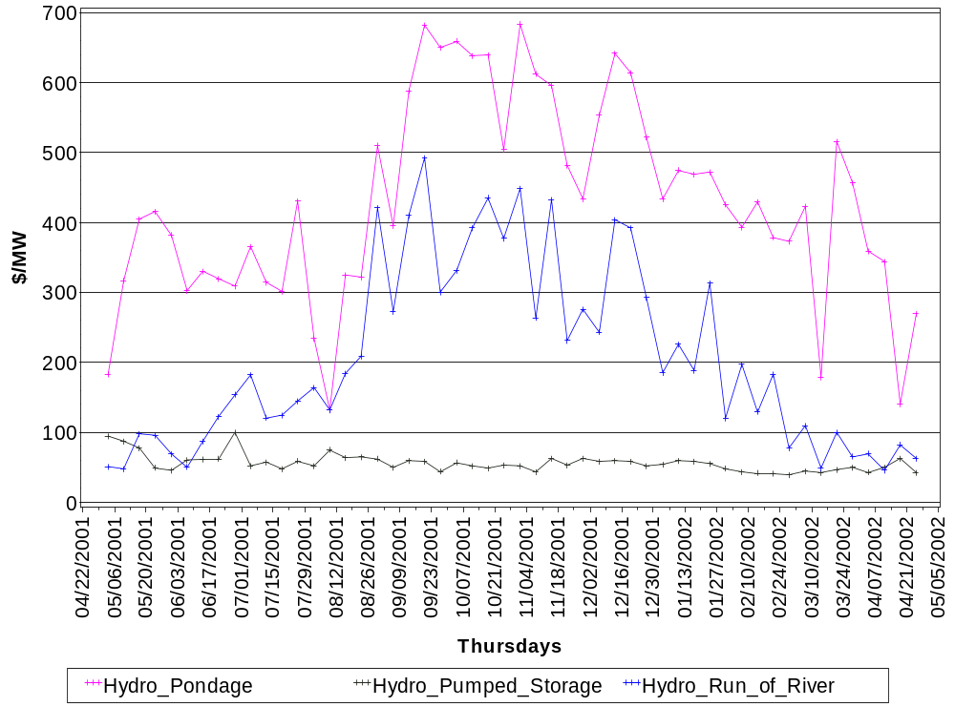

Figure 18 and Figure 19 show the bid patterns for units that use hydro or coal respectively for their primary fuel source. Figure 18 shows that hydro bids are quite variable, particularly in the summer and fall months, reflecting higher demand and lower water levels.

Hydro pondage had the most fluctuation of the three, reflecting the scarcity of water in the drier months. Run-of-river paralleled the pondage but at less fluctuation and prices.

Figure 19 - Weighted Average Bid by Fuel Type - Coal HE 14
all Thursdays 5/1/2001-4/30/2002

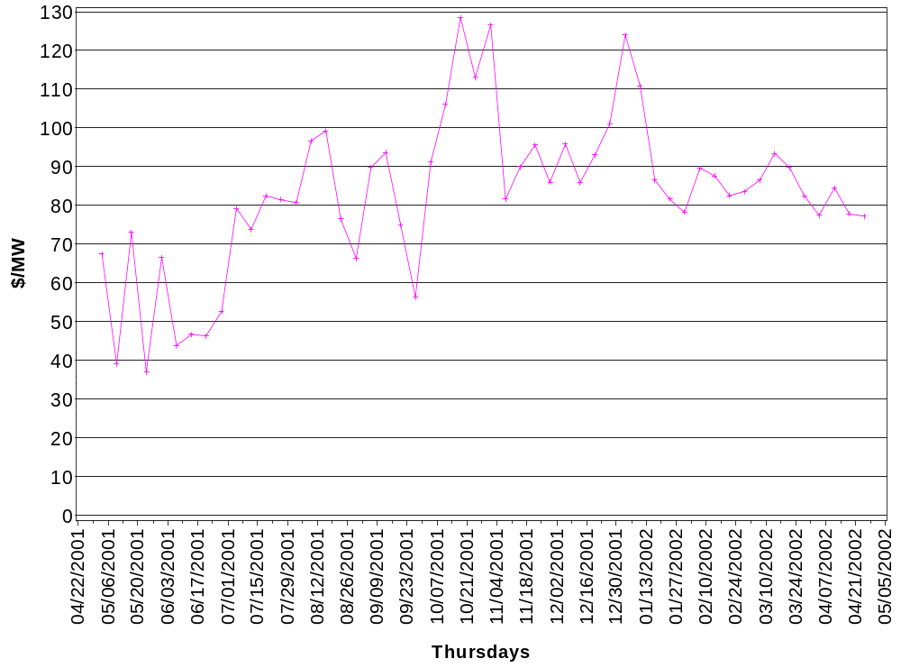

Figure 19 shows the average bid weighted dollars per mw for units whose primary fuel is coal. This value reflects both the use of Low and High Sulfur Coal. The average price for low sulfur hour 14 for all Thursdays was $82.

Figure 20 compares average daily ECP (unweighted) with average variable costs at two hypothetical plants, one natural gas fired and one fuel oil fired.

Figure 20 - Daily Average ECP vs Variable Production Costs
May 2001 – April 2002**
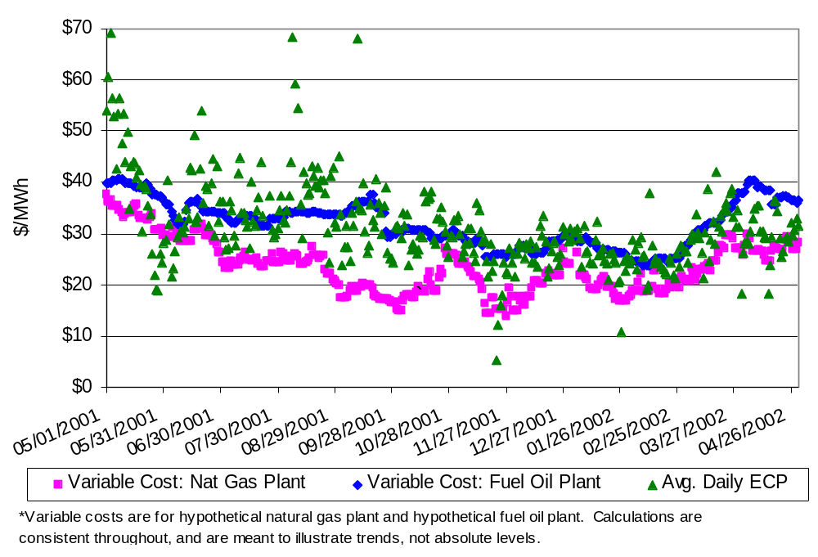
** Does not include observations greater than $70.00

Market Shares by Participant Bidding Authority

Figure 21 shows the distribution of generating capability market share in New England by Participants with bidding authority for the portfolio for selected months during the past years. Letters have been substituted for Participant names.

Figure 21 - Market Shares by Participant Bidding Authority

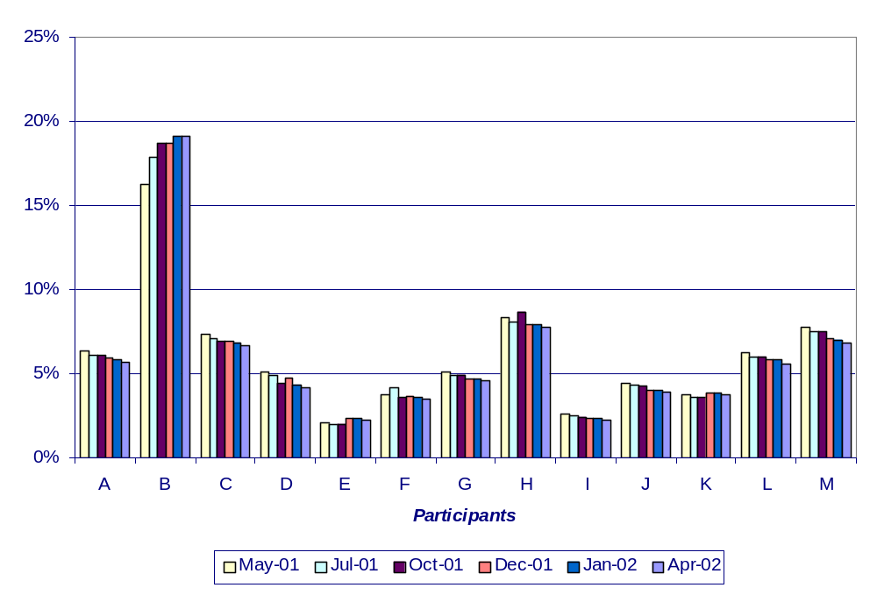

Figure 22 – Normalized Bid Supply Curves for Several Lead Participants
July16, 2001 at HE14

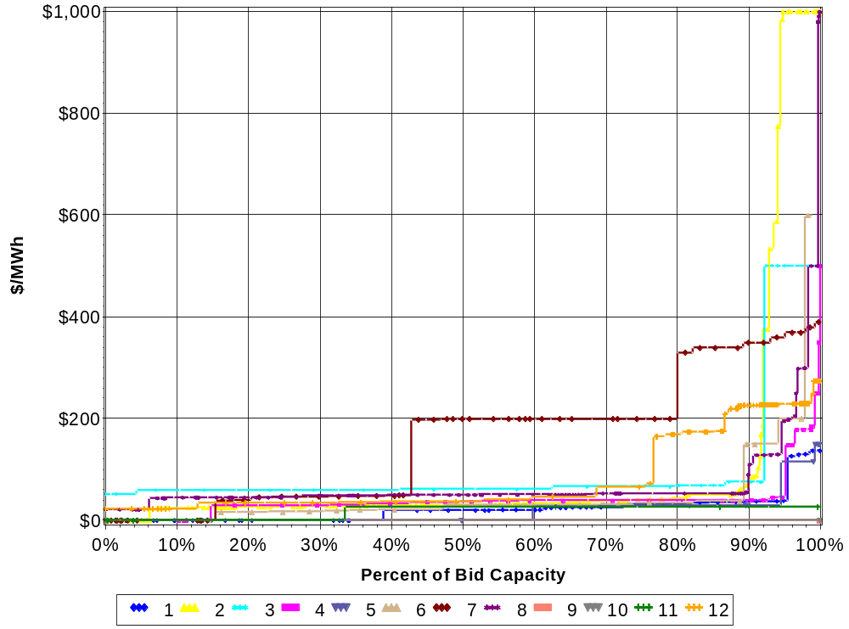
Participants

Figure 22 shows the energy market bid supply curves of several Participants for a selected business day during July 2001. The curves reflect the bids submitted by the participants for their portfolio. With the exception of Participants 7 and 12, bids for the first 90% of portfolios were priced at or below $34.68/MW.

The labeling of Participants in this figure does not necessarily correspond to the labels used to denote Participants in other figures.

Figure 23 – Normalized Bid Supply Curves for Several Lead Participants – HE14
Jan 15, 2002

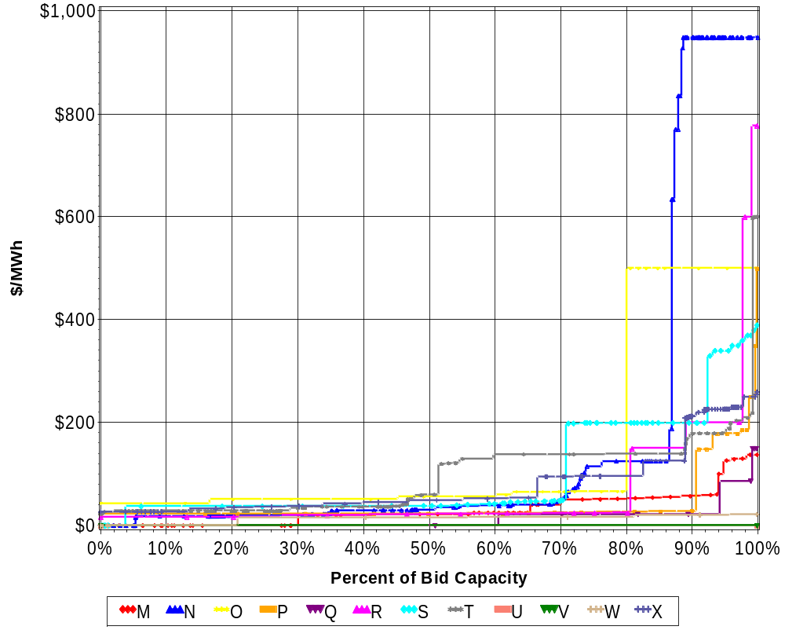
Participants

Figure 23 shows the participant portfolio bid supply curves for a selected business day during January 2002. With the exception of Participants S and X, bids for the first 90% of portfolios were at or below $50.36/MW.

The labeling of Participants in this figure does not necessarily correspond to the labels used to denote Participants in other figures.

Marginal Price-Setting Analysis

Asset Types

Periodically, but no less frequently than once every 5-minutes, the ISO’s EMS software determines a Desired Dispatch Point for each resource. This optimization takes into account each generator’s penalty factor, Operational Flag(s), Response Rates, and limit constraints required to maintain desired levels of TMSR, AGC capability, or generation for a transmission-constrained zone. Under normal system conditions, the Real-Time Market Price (RTMP) is the price of the next least expensive MW that may be dispatched above the Desired Dispatch Points while taking into account each Generator’s penalty factor, Operational Flag(s) and other limit constraints. For each hour, the ECP is the time-weighted average of the RTMP calculations made during the hour.

Associated with the RTMP is the unit that sets the marginal price. Accordingly, the unit that is associated with the marginal price is the RTMP price setter.

If external bilateral contracts have been committed, and the internal five-minute real-time marginal price based on internal resources is less than the hourly price of any external bilateral purchase, the final real-time marginal price is set to the maximum of (1) the internal price or (2) external bilateral price. In these cases, the real-time marginal price setter is the NEPOOL unit that would have set the price in the absence of the external contract.

Many factors influence which fuels or units set the 5-minute RTMP. ISO dispatch software seeks to dispatch the cheapest available bid MW. However, the cheapest MW available depends on which units are on-line, which are designated for ancillary services, and the ability of units to respond quickly to changes in desired generation. For example, during a period of rapid load increase, a flexible, quick-response hydro unit may be more likely to set the RTMP than a cheaper, but relatively inflexible coal unit.

The following figures present analyses of RTMP setting by fuel type, by unit type (generating technology) and by lead participant.

Figures 24 through 29 show the monthly and yearly frequencies of five-minute Real-Time Marginal Price (RTMP) setters by fuel type for:

- All hours;
- Weekday on-peak, and;
- Weekday off-peak and Weekends all hours.

For all hours significant changes from the previous year include:

- Wood/Refuse rose from 9.4% to 10.6%.

- Hydro: Run of River declined from 11.8% to 9.4%

Figure 24 - RTMP Setters by Asset Type
May 1, 2001 – April 30, 2002

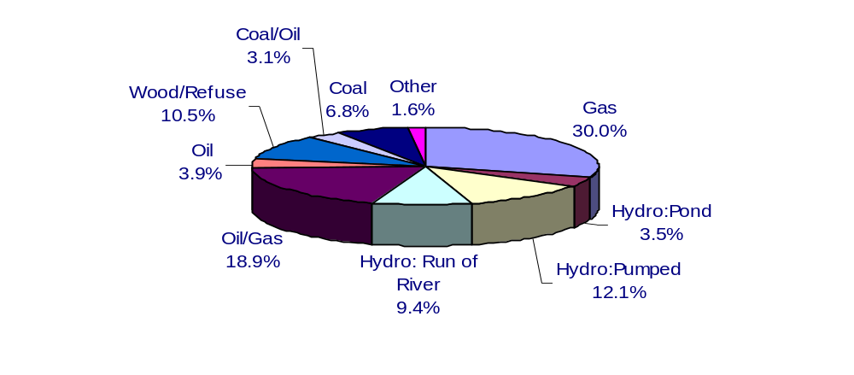

Figure 25 –RTMP Setters by Asset Type
Frequency by Month, May 2001 – April 2002

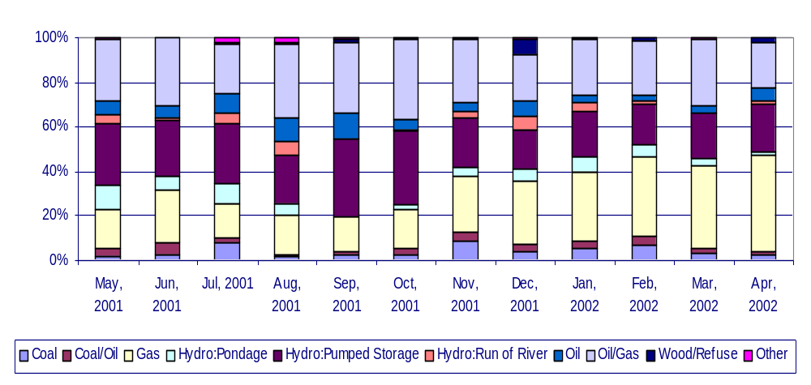

Figure 26 - RTMP Setters by Asset Type
On-Peak Weekday, May 2001 – April 2002
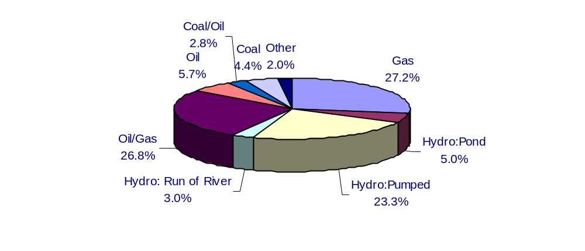

Figure 27 - RTMP Setters by Asset Type
Frequency by Month Weekday On-Peak
May 2001 – April 2002
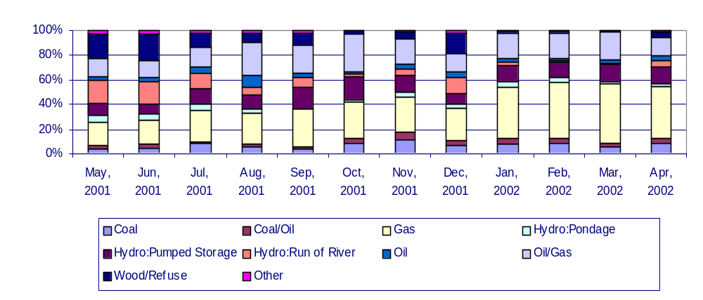

Figure 28 - RTMP Setters by Asset Type
Weekday Off-Peak, Weekend All Hours, May 2001 – April 2002
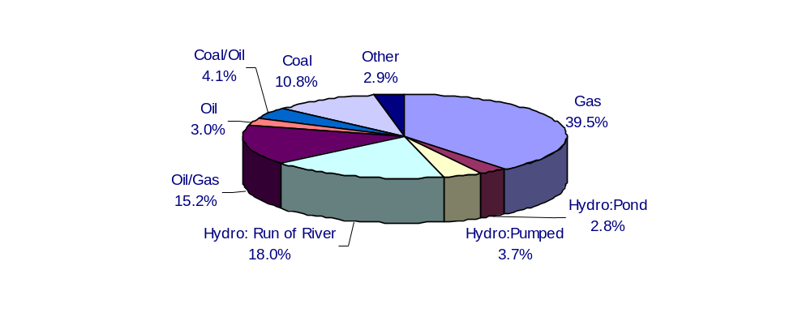

Figure 29 - RTMP Setters by Asset Type
Frequency by Month Weekday Off-Peak, Weekend All Hours
May 2001 – April 2002

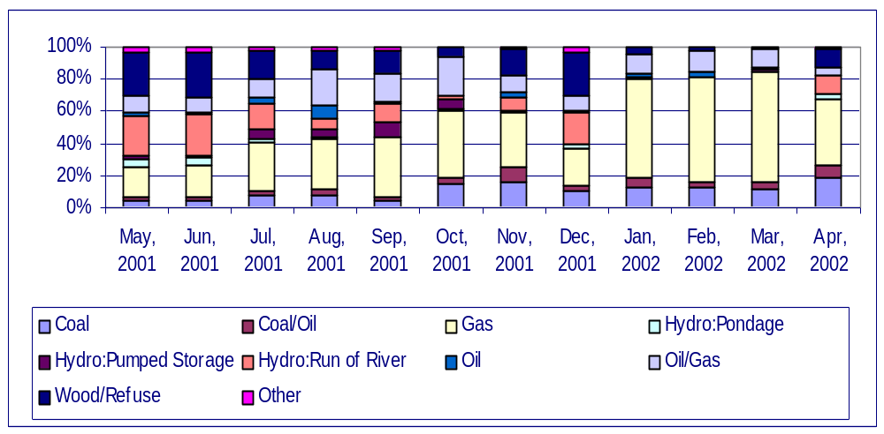

Unit Types

Figure 30 and Figure 31 present the yearly and monthly frequency of RTMP setters by unit type.

Figure 30 - RTMP Setters by Unit Type
May 1, 2001 – April 30, 2002
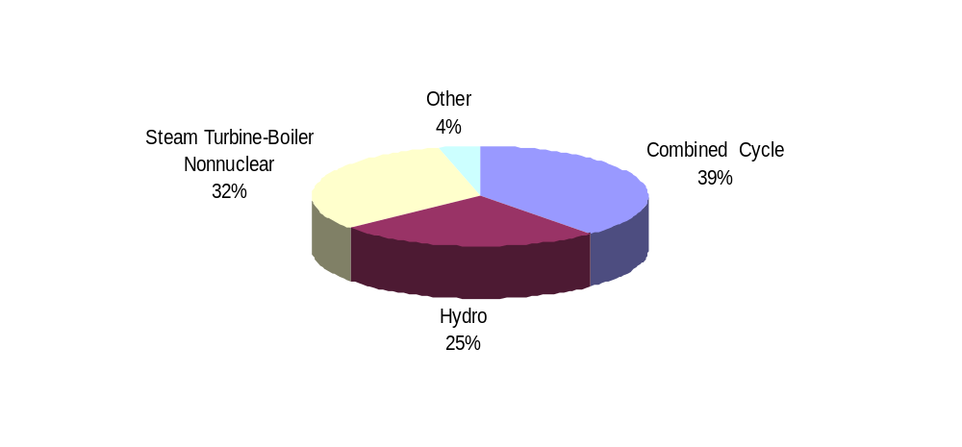

Figure 31 - RTMP Setters by Unit Type Frequency by Month
May 1, 2001 – April 30, 2002

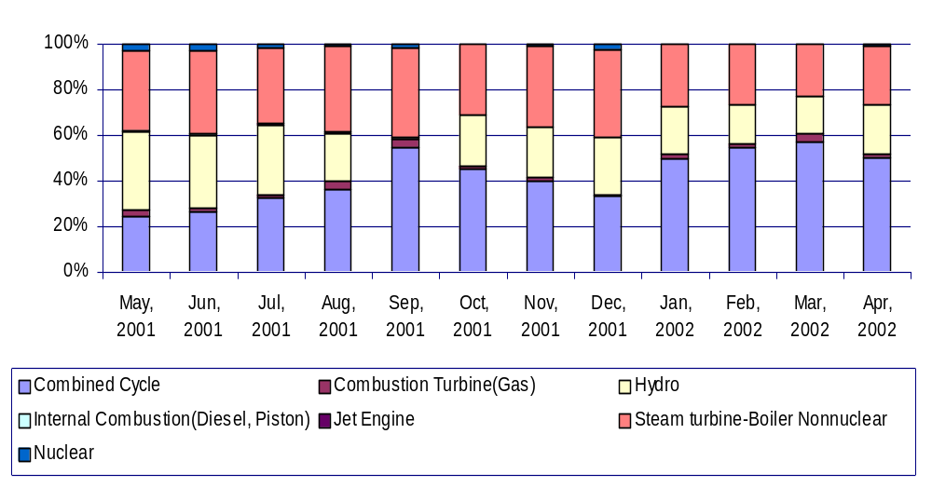

Significant changes from the previous year include:

- RTMP setting by Combined Cycle units increased from 34.4% to 38.6%
- RTMP setting by Steam Turbine units decreased from 35.8% to 32.3%

Monthly patterns showed an increase in combined cycle RTMP setting percentages in the months of January through April 2002 compared with 2001 as the percentages rose from 27% to 49.7% in January, 28% to 55% in February, 40% to 57% in March, and 26% to 50.9% in April.

Lead Participants

Figure 32 and Figure 33 show the frequencies of five-minute RTMP setters by Participant, with letters substituted for names for all of FY 2001 and by month.

The letters assigned to Participants remained the same from the previous year. Accordingly, RTMP setting by Participant A dropped from 12% to 8.2%, Participant B dropped from 23% to 18%, whereas Participant L rose from under 3% to 11.9%.

Figure 32 - RTMP Setters by Lead Participant
May 2001 – April 2002
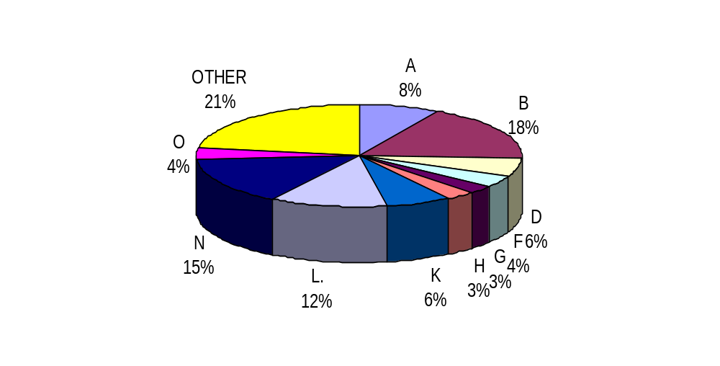

Figure 33 - RTMP Setters by Lead Participant
Frequency by Participant, May 2001 – April 2002
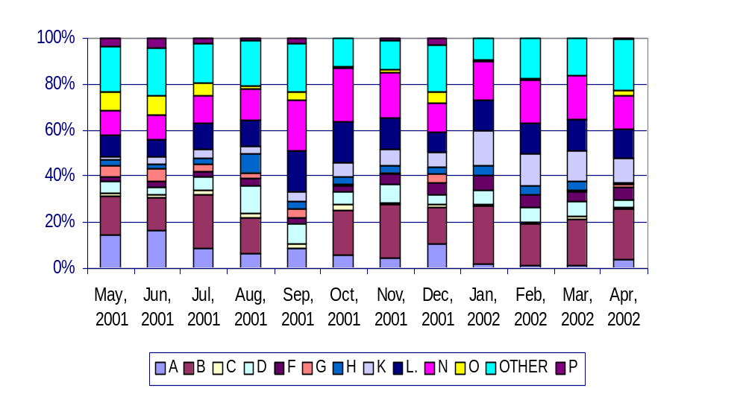

Figure 34 presents the market shares (of generating capability) and Real-Time Marginal Price setting frequencies for each of the largest Participant portfolios in FY 2001. Figure 35 and Figure 36 show the shares and frequencies by month for two of the larger Participants.

Significant changes from FY 2000 to FY 2001 include:

- Participant A dropped significantly in both market share and RTMP setting percentage; the decrease was approximately uniform on a month-to-month basis.

- Participant L rose in market share and more substantially in RTMP percentage.

- Participant B, the largest Participant at 18% market share, also set RTMPs approximately 18% of the time in FY 2001. This compares with a market share of 17% and RTMP of 23% for FY 2000.

Figure 34 – Average Market Share and RTMP Setter Percentage
May 2001 – April 2002

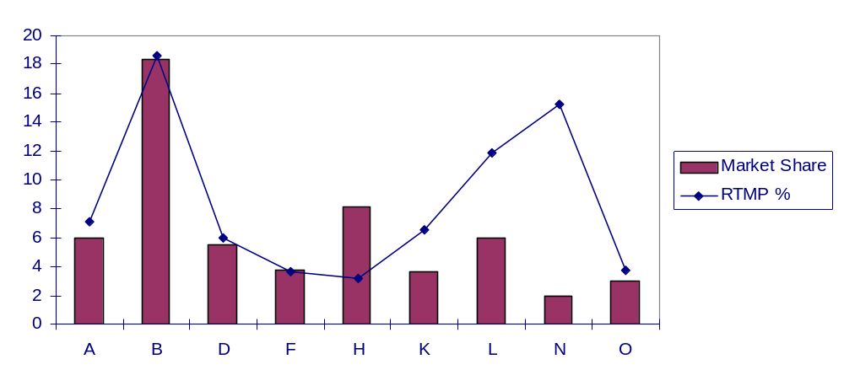
Figure 35 – Participant A Market Share and RTMP Setter Percentage
May 2001 – April 2002

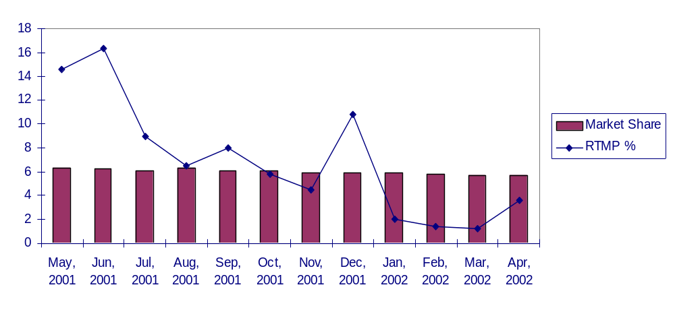

Figure 36 - Participant B Market Share and RTMP Percentage
May 2001 – April 2002
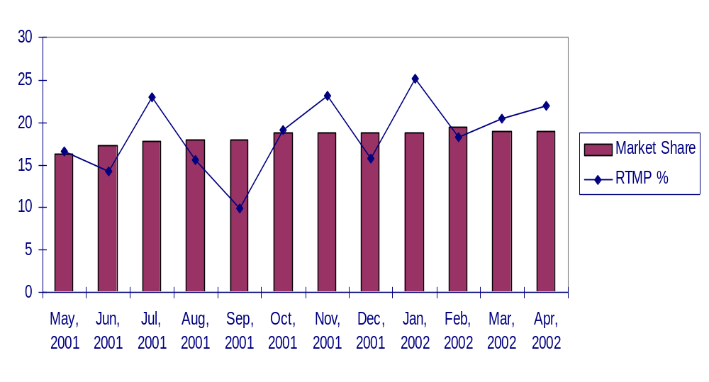

Transmission Congestion Activity and Mitigation

At times, resources must be dispatched out of economic merit order due to transmission congestion. In such cases, the resource is not eligible to set the clearing price and is eligible to receive uplift payments for generation in bid blocks that are higher than the energy-clearing price. Each block of generation that is used to alleviate a transmission constraint is subject to market power screens as specified in NEPOOL Market Rules and Procedures 17 “Market Monitoring, Reporting And Market Power Mitigation” (MRP 17 – see Section 17.3). If the price of the constrained up/on generation is mitigated, the Participant with bid submission authority for the resource can enter into negotiations with the ISO to determine an appropriate uplift compensation.

Figure 37 shows the number of Out of Merit Order MWh that were flagged for congestion from January 2000-April 2002, as well as the MWh that were mitigated.

Figure 37 - Monthly Congestion MWh for Total System
January 2000-April 2002
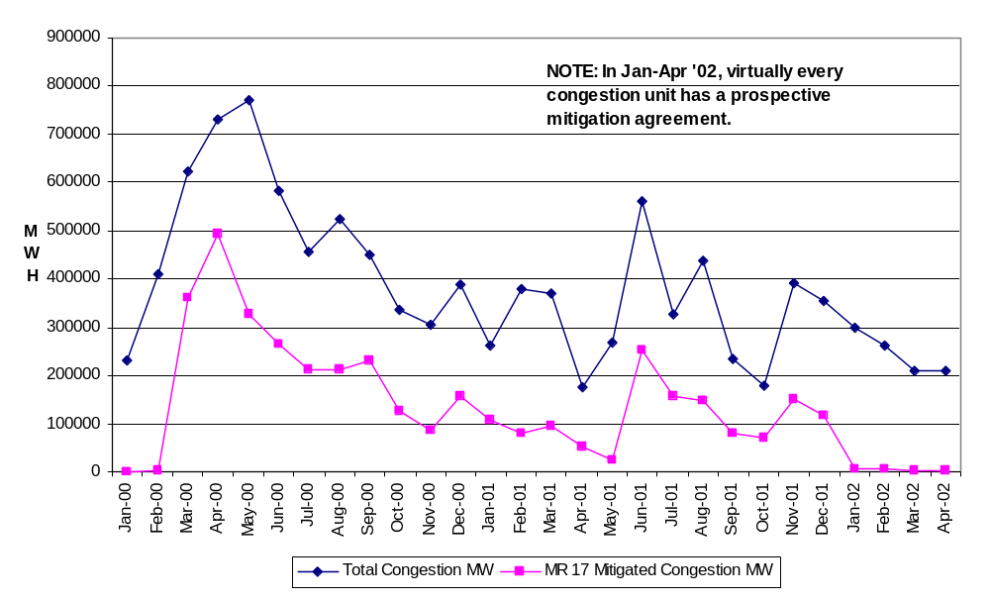
Figure 38 shows the unmitigated congestion uplift costs and the mitigated uplift costs determined after application of the MRP 17 price screens and negotiations with Participants for January 2000 – April 2002. Prior to July 1, 2001, the mitigated amount was the uplift total used for settlement. After July 1, the NCPC uplift during congestion hours was used for settlement; the values are also shown in the figure.

The principles used in the ISO negotiations with Participants adhere to the spirit of the transmission-congestion mitigation elements of MRP 17. Negotiated transmission uplift compensation for those generating units that normally run in merit order is limited to their short run variable costs (i.e., fuel costs and other related costs that are incurred due to ISO dispatch for transmission congestion). For units that normally run out of merit for transmission reliability purposes, both variable and other costs necessary to maintain the availability of the units for system reliability are considered. Variations from this categorical approach to congestion-uplift compensation have also been identified. A prime example is generating units that face daily or annual environmental emission limitations. To maximize revenue from limited hours of generation, bidders submit offers higher than costs to reflect the units’ opportunity costs (i.e., forgone future energy market revenues). Such factors are also considered in the transmission-congestion negotiations.

Figure 38 - Unmitigated v. Mitigated and NCPC
Uplift for Congestion Hours
January 2000 – April 2002
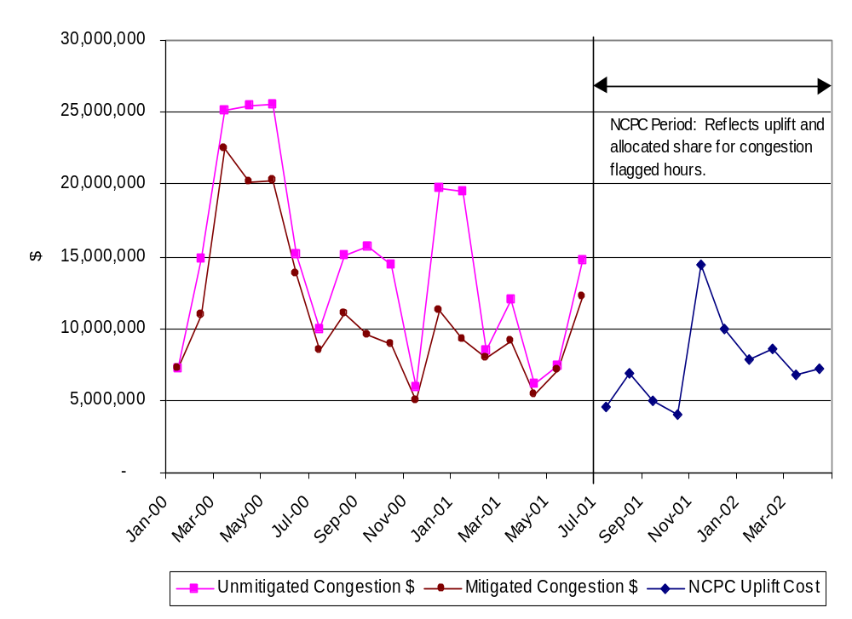
Figure 39 shows transmission congestion uplift MWh by transmission area as a percent of total system transmission uplift MWh for FY 2001. Over the course of the 12 months, 75% of congestion occurred in the Northeast Massachusetts/Boston area, 8% occurred in the Southwest Connecticut area, and 15% occurred when Connecticut import capacity was binding. Figure 40 shows congestion by cause for selected areas since September 1999, and Figure 41 shows congestion MWh by area for January 2000 – April 2002.

Figure 39 - Transmission Congestion MWh by Area

May 2001-April 2002
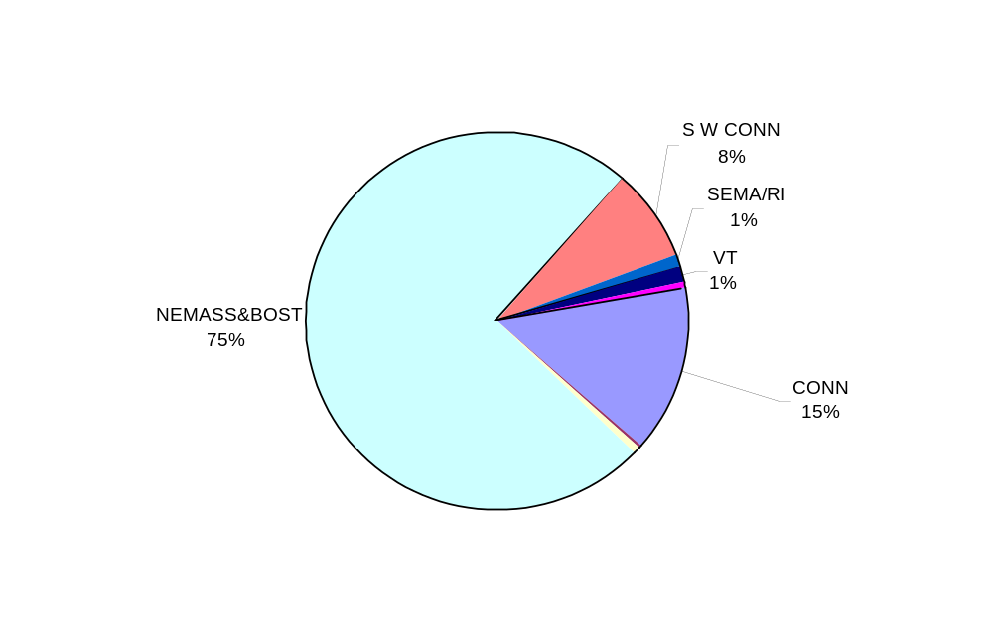

Figure 40 - Congestion by Cause

September 1999- April 2002 All Congestion MW Hours

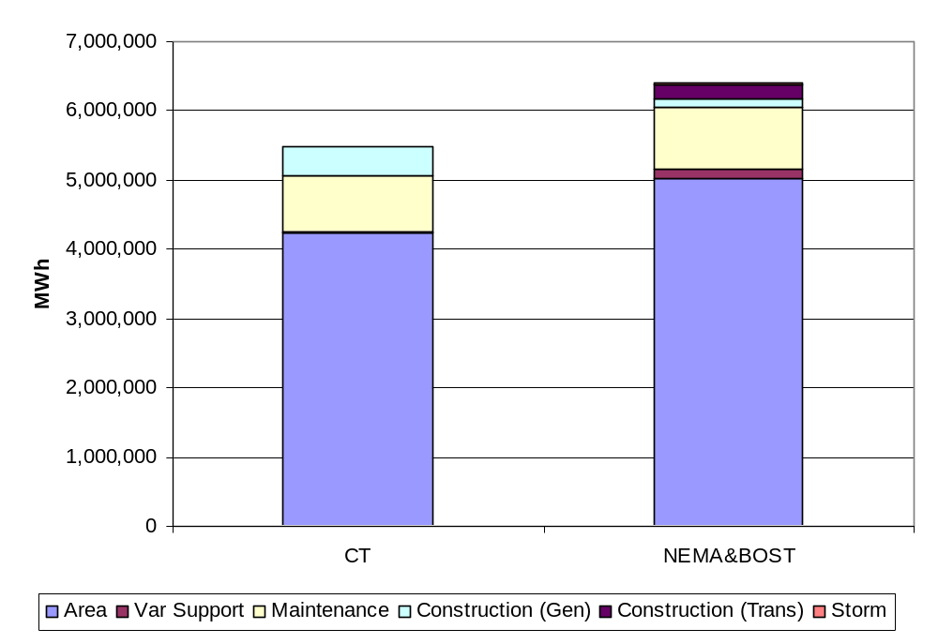

Figure 41 - Monthly Transmission Congestion MW by Major Congested Area
January 2000-April 2002
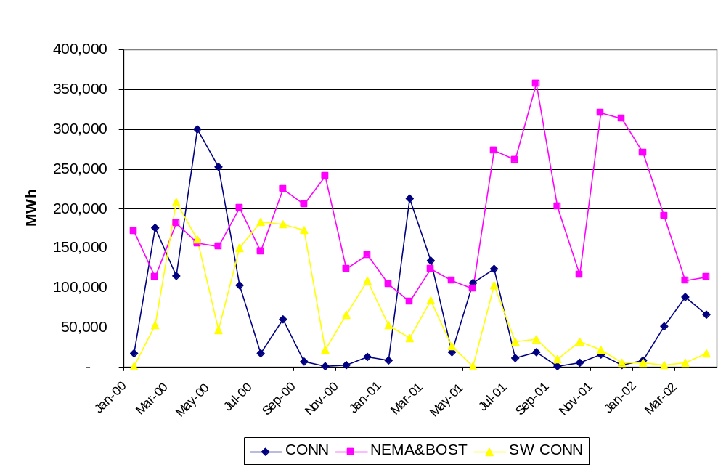

Administrative Price Corrections

Under the ISO Agreement approved by the FERC, ISO-NE is responsible for ensuring the competitiveness and efficiency of the markets. Specific market rules, in addition to the filed rate doctrine, obligate ISO-NE to correct prices when it determines that incorrect prices exist.

Figure 42 shows the total number of price corrections by month since the beginning of market operations. ISO-NE administered a total of 1,039 hourly prices in the third year of market operations. Table 10 summarizes price changes by cause and by month for FY 2001. Corrections have been grouped into categories for analysis.

The largest single category for price administration during the third year of market operation was a set of revisions to energy clearing prices due to confusion over a FERC order on the ability of external bilateral dispatchable contracts to set a floor price in the energy market. Prices of external bilateral contracts were first removed from and then reinstated in the calculation of hourly ECPs. Initially, ECPs from September 1-14 were revised to remove the external bilateral prices, reflecting ISO-NE's interpretation that the FERC's order directed this action. ECPs for 83 hours in this period were changed. After the FERC's October 24 order directing that external contract prices be allowed to set the energy price, the changes to the 83 hours were reversed and an additional 305 ECPs in the second half of September and October were revised to include the contract prices.

Two-hundred-sixty-nine (269) reserve prices were revised under the Special Interim Market Rule, which limits reserve prices to the energy price. There were two different versions of the Special Interim Rule in effect during the third year of market operation. Reserve bids were capped at the energy-clearing price during periods of capacity shortage from April 1, 2001 through October 31, 2001. Because this version of the rule specified that reserve bids were capped at the ECP, rather than reserve hourly clearing prices, reserve caps were administered at the five-minute level.

A new version of the Amended Special Interim Rule went into effect November 1, 2001. Under this version of the rule, reserve hourly clearing prices were capped at ECP during all hours, rather than just during periods of deficiency. The reserve caps are administered at the hourly level, not the five-minute level. Although ISO-NE implemented a software feature to automatically limit the hourly reserve-clearing prices to the ECP, eliminating the need for ISO staff to manually flag, review, and revise each hour when reserve clearing prices exceed the ECP, there were still conditions when the caps had to be manually applied.

During periods of excess generation, a flaw in the Scheduling, Pricing, and Dispatch software prevented the ECP from being correctly set to $0/MWh as the market rules require, and ISO staff manually flagged and revised the ECP to $0/MWh when excess generation conditions occurred. The excess generation software flaw was largely fixed in February 2002. During November 1, 2001 through February 2002, staff manually flagged and revised reserve hourly clearing prices to $0/MWh during excess generation periods so that the clearing prices would not exceed the ECP. The majority of reserve prices capped under the November 1, 2001 version of the Special Interim Rule were in hours with excess generation conditions. Two-hundred-four energy clearing prices were revised due to inaccurate pricing during periods of excess generation over the course of the year.

Figure 42 - Administrative Price Corrections by Month
May 1999 - April 2002

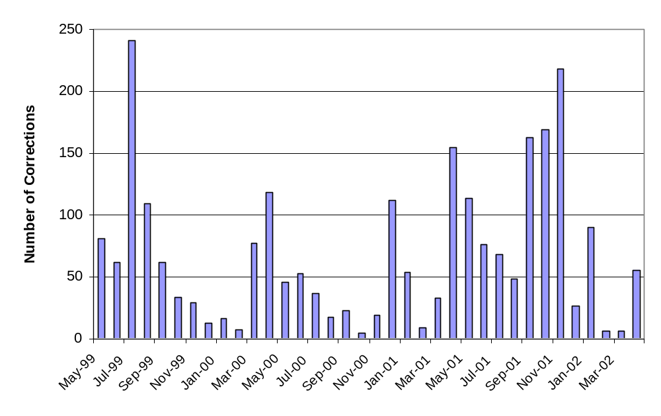

Table 10- Administrative Price Corrections

Reason for Price Correction | May-01 | Jun-01 | Jul-01 | Aug-01 | Sep-01 | Oct-01 | Nov-01 | Dec-01 | Jan-02 | Feb-02 | Mar-02 | Apr-02 | Total
Revised per FERC order eliminating /reinstating External Floor Price | 0 | 0 | 0 | 0 | 147 | 158 | 0 | 0 | 0 | 0 | 0 | 0 | 305
Interim MRPs for Reserve Capping (6,8,9 or Interim rule) | 3 | 7 | 24 | 37 | 6 | 0 | 149 | 0 | 40 | 0 | 0 | 3 | 269
Software Error: Excess Generation | 47 | 40 | 4 | 3 | 9 | 6 | 55 | 5 | 29 | 0 | 0 | 6 | 204
Software Error: Electronic Dispatch | 30 | 25 | 34 | 0 | 0 | 0 | 0 | 0 | 0 | 0 | 0 | 0 | 89
Misc. Software Error (not including ED or Excess Gen) | 10 | 0 | 2 | 4 | 0 | 0 | 0 | 15 | 19 | 1 | 5 | 22 | 78
Hardware/Software failures | 14 | 3 | 1 | 4 | 1 | 4 | 12 | 5 | 1 | 3 | 0 | 20 | 68
Data Entry Error | 7 | 1 | 3 | 0 | 0 | 1 | 2 | 1 | 1 | 2 | 1 | 4 | 23
Emergency Sales | 3 | 0 | 0 | 0 | 0 | 0 | 0 | 0 | 0 | 0 | 0 | 0 | 3
Total for Month | 114 | 76 | 68 | 48 | 163 | 169 | 218 | 26 | 90 | 6 | 6 | 55 | 1039

One reg is equivalent to approximately 0.42 megawatts.

