Draft Transmission Planning Process Guide

© ISO New England Inc.
System Planning
February 5, 2013

Contents
Section 1 Purpose 4
Section 2 Process for Addressing Reliability Needs 5
2.1 Overview of Process 5
2.2 Process Steps Overview 7
2.3 Stakeholder Involvement 7
2.4 Needs Assessment 7
2.4.1 Process Overview 7
2.4.2 Needs Assessment Process and Triggers 9
2.4.3 Initiation of a Needs Assessment 10
2.4.4 Needs Assessment Study Group 10
2.4.5 Determine Study Area 10
2.4.6 Study Scope Development and Review (PAC) 11
2.4.7 Types of Analysis 11
2.4.8 Inclusion of Market Solutions in Needs Assessment 11
2.4.9 Conduct Needs Assessment 12
2.4.10 Collect and Analyze Results 12
2.4.11 Develop Problem Statement 12
2.4.12 Publish Needs Assessment Report 12
2.4.13 Proponents May Suggest “Concept” Solutions 13
2.5 Development of a Regulated Transmission Solutions Study 13
2.5.1 Process Overview 13
2.5.2 Solutions Study Process 15
2.5.3 Study Initiation Notification and Scope Review (PAC) 15
2.5.4 Development of Regulated Transmission Solution Alternatives 16
2.5.5 Discussion Regarding Transmission Alternatives Being Considered (PAC) 17
2.5.6 Interregional Coordination Study 17
2.5.7 Review of Preferred Transmission Solutions (PAC) 17
2.5.8 Publish Solutions Study Report 18
2.5.9 Determination of the Regionally-Preferred Transmission Solution 18
2.5.10 Transmission Cost Allocation 18
2.6 Changes in Study Assumptions 19
Section 3 Regional System Plan 20
3.1 Description of the Regional System Plan 20
3.2 RSP Project Listing 20
3.3 Inclusion and Update of Projects in the Regional System Project List 21
Section 4 Planning Advisory Committee Process 22
4.1 Role of the PAC 22
4.2 Membership 22
4.3 Meeting Notification, Frequency and Materials 22
4.3.1 CEII Information and Materials 23
4.4 TOPAC/Local System Planning 23

Purpose
ISO New England (the “ISO”), Northeast Power Coordinating Council (“NPCC”) and North American Electric Reliability Corporation (“NERC”) criteria and reliability standards provide the minimum transmission system performance standards, which serve as the foundation for the ISO’s regional transmission planning. All proposed system modifications, including transmission and generation additions or significant load reductions or additions, must be analyzed and designed to ensure system wide coordination and continued system reliability in compliance with these standards.
The purpose of this planning document is to provide additional detail on the existing regional system planning process as described in Attachment K of Section II of the ISO New England Transmission, Markets and Services Tariff (the “Tariff”).
This document is not intended to address every activity that may be associated with the regional system transmission planning process. There are a number of activities that are not the subject of this document but may be briefly touched upon in this document for context and to help provide a thorough explanation of the regional system planning process. These include activities such as the “Local System Planning Process” as described in Section 2.5 of Attachment K which is the responsibility of each Participating Transmission Owner (“PTO”), the Proposed Plan Application (“PPA”) process, and the Transmission Cost Allocation (“TCA”) procedures.
The provisions in this document are intended to be consistent with ISO New England’s Tariff. If, however, the provisions in this planning document conflict with the Tariff in any way, the Tariff takes precedence as the ISO is bound to operate in accordance with the ISO Tariff.

Process for Addressing Reliability Needs

Overview of Process
Through an open stakeholder process, the ISO develops long range plans for the region’s networked transmission facilities to address future system needs over the ten year planning horizon. Subject to Information Policy including Critical Energy Infrastructure Information (“CEII”) requirements approved by FERC, all planning study efforts are discussed with the Planning Advisory Committee (“PAC”), and opportunities are provided for comments ranging from the draft scope of work through the posting of final reports. Study base cases and contingencies, which are used to simulate the system performance, are available, upon request, to stakeholders subject to CEII requirements.
The transmission planning study process begins by developing a study scope and identifying all key inputs for conducting a Needs Assessment to determine the adequacy of the power system, as a whole or in part, to maintain the reliability of the facilities while promoting the operation of efficient wholesale electric markets in New England. After the results of a Needs Assessment are made available for stakeholder input, the potential transmission system solutions are evaluated thoroughly to determine the most cost-effective and reliable solution(s) for the region. These study efforts and the proposed transmission solutions are documented in a Solutions Study, which also is subject to stakeholder review and input. These studies, in aggregate, provide the basis to update the ISO’s Regional System Plans and ensure an ongoing 10-year plan for the region consistent and in compliance with the standards and criteria of the ISO, NPCC and NERC.
The following flowchart depicts this process. Not shown in the flowchart, but important to the process, is the iterative nature of the planning process and, in some cases, a Project may need to be re-evaluated to make sure the proposed solution remains necessary and still continues to be the preferred solution for the need.

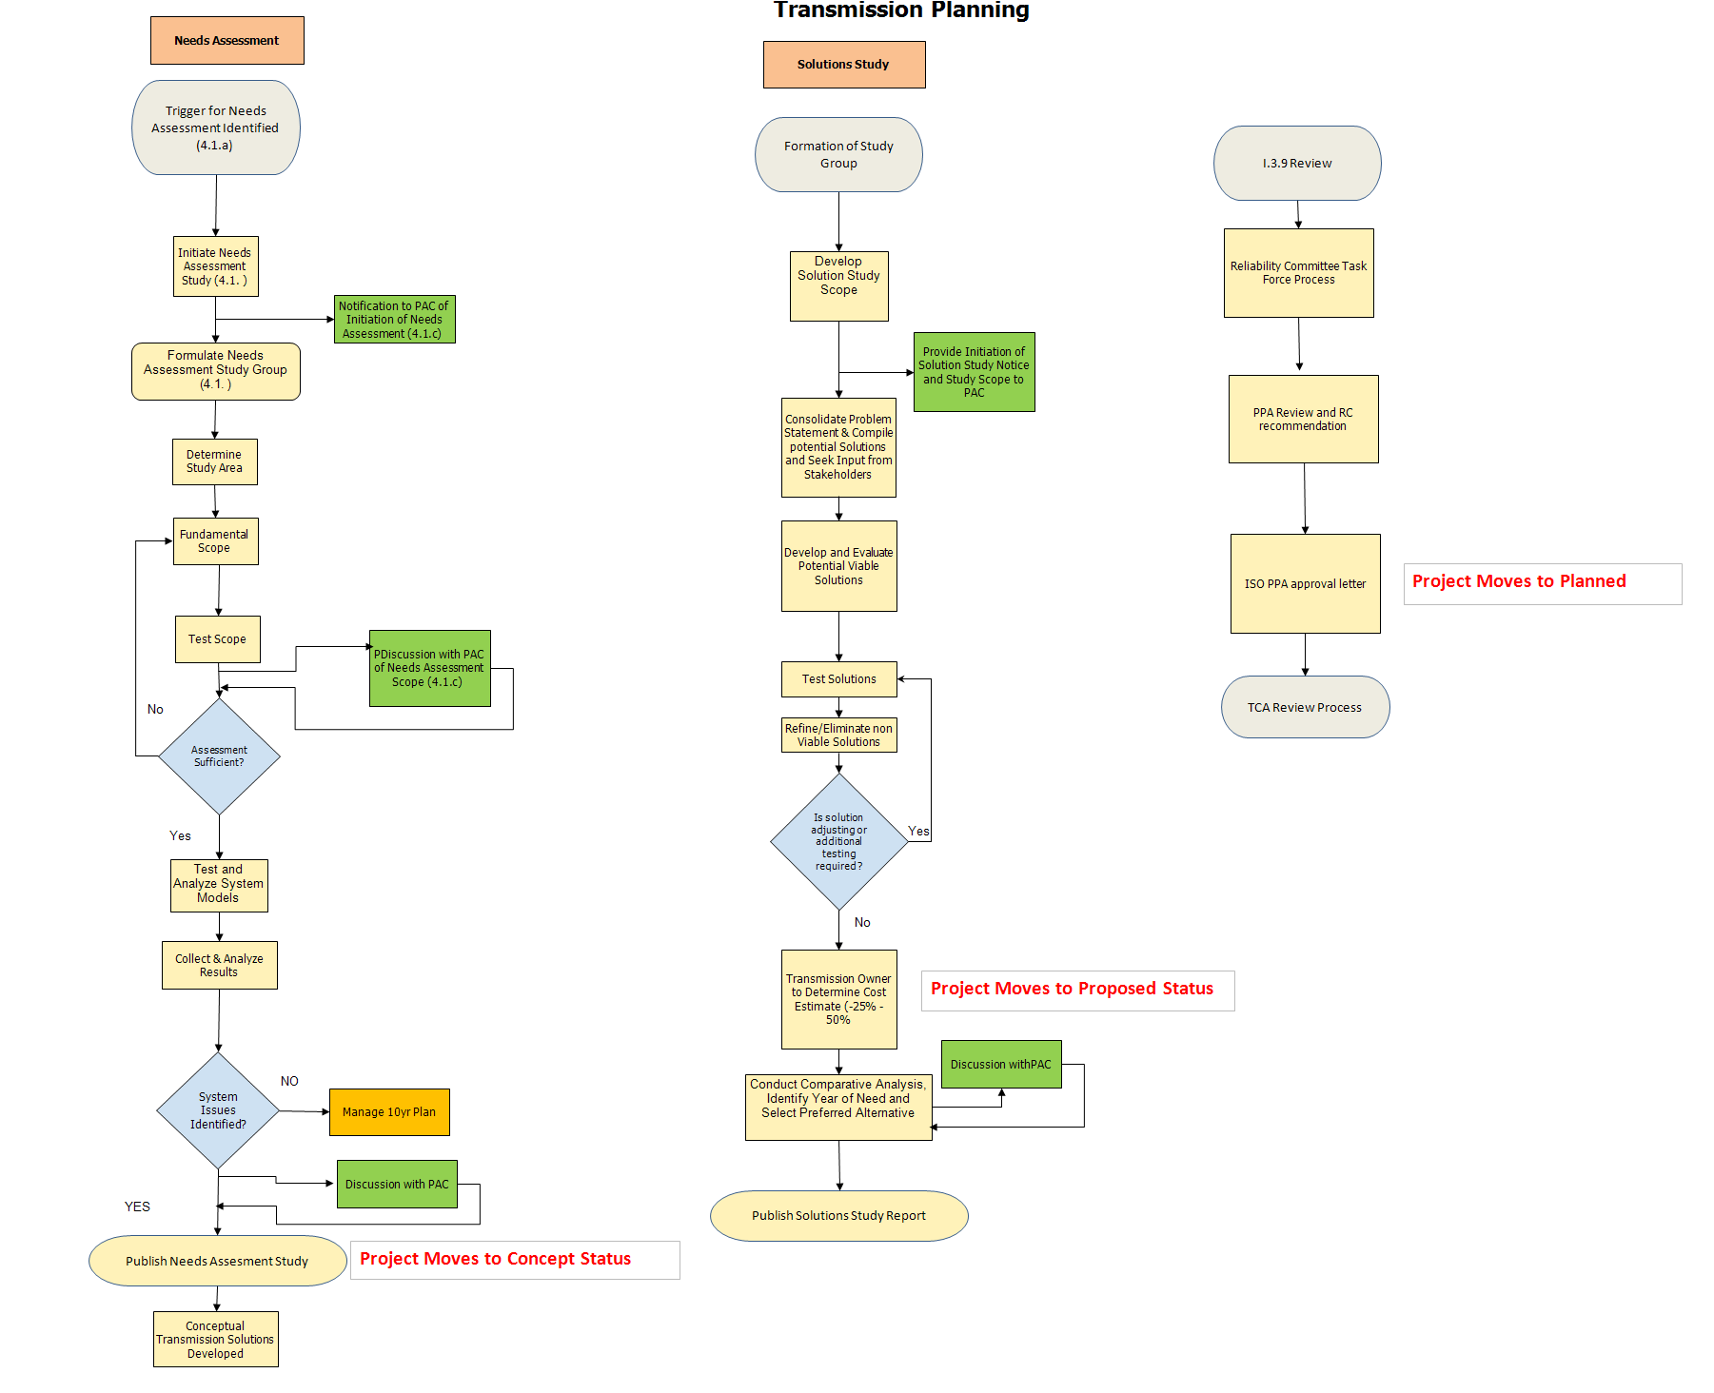

Process Steps Overview
A Needs Assessment must be developed to assess the reliability performance of the Pool Transmission Facility (“PTF”) system. This assessment may determine that the current system will not meet reliability criteria during the study period. Where that occurs, the ISO leads a Solutions Study to identify possible transmission system upgrades that will address the identified needs and to identify the year of need if it was not already identified in the Needs Assessment. Once a Solutions Study has identified the most cost effective solution to address identified reliability needs identified in the Needs Assessment, additional activities under the proposed-plan process are necessary to ensure that proposed solutions are acceptable. This procedure describes the process for performance of a Needs Assessment in Section 2.4, performance of a Solutions Study in Section 2.5, and the steps necessary to complete the review and approval process for proposed projects or plans. Activities such as treatment of Market Solutions and incorporation of changes in Needs Assessment or Solutions Study assumptions are also discussed.

Stakeholder Involvement
Stakeholders are expected to actively participate in the Planning Advisory Committee (“PAC”) process by attending meetings, commenting on posted study scopes and reports and otherwise providing useful comments on the process. ISO will consider all comments received from stakeholders during the PAC process and will describe the reason for not incorporating certain comments. Membership requirements for the PAC are described in Section 4.2 of this document. Consistent with the intention of Attachment K, and for the efficiency of the planning process, members of the Reliability Committee (“RC”) are expected to participate in the PAC process to provide comments and input on study scopes, Needs Assessments and the selection of a preferred solution at that time, rather than waiting for the PPA or TCA review.
Stakeholders may provide comments at the Planning Advisory Committee meetings or they may also submit comments in writing at PACMatters@iso-ne.com.
Stakeholders whose facilities may be electrically impacted based on the scope of a project may be asked by the ISO to participate in a Needs Assessment study group. As described further in Section 2.4.4 this is not open to all stakeholders, but only those whose system may be the subject of a Needs Assessment or whose equipment may be directly impacted by a potential solution. Access to information may be limited because of the ISO’s Information Policy and FERC Standards of Conduct.

Needs Assessment

Process Overview
The Needs Assessment process is depicted by the following flowchart.
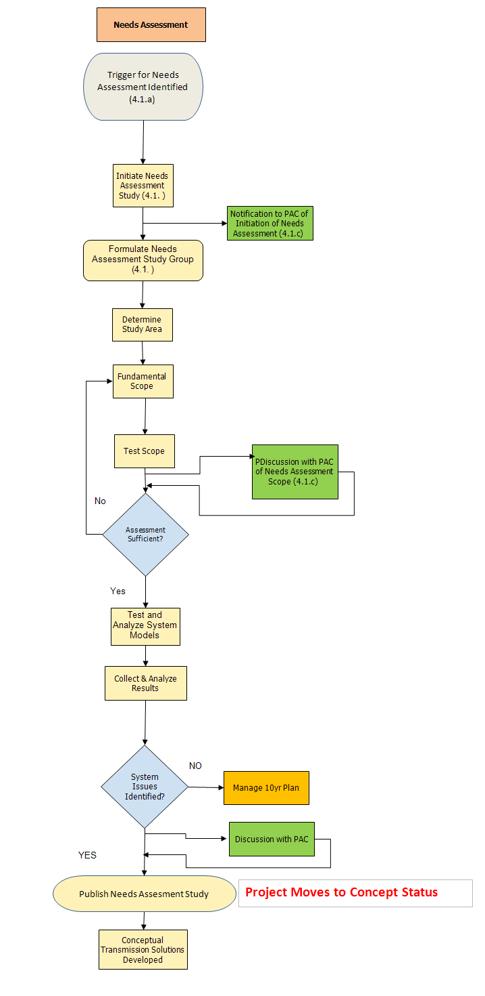

Needs Assessment Process and Triggers
As described in Section 4.1 of Attachment K, the ISO, in coordination with the PTOs and the PAC, shall conduct Needs Assessments of the adequacy of the PTF system, as a whole or in part, to maintain the reliability of such facilities while promoting the operation of efficient wholesale electric markets in New England. The triggers for a Needs Assessment are in Sections 4.1(a) and 4.1(b) of Attachment K. Needs Assessments that may be conducted to determine the status of the transmission system include, but are not limited to the following:
- Conduct analysis to assess compliance with reliability standards, criteria, or guides (including those established by the ISO, NERC, NPCC and the Transmission Owner) consistent with the long term needs of the system

- Assess the adequacy of the transmission system capability, such as transfer capability, to support local, regional and interregional reliability

- Assess the efficient operation of the wholesale electric market. (See Attachment N regarding the identification of market efficiency upgrades)

- Assess sufficiency of the system to integrate new resources and loads on an aggregate or regional basis as needed for the reliable and efficient operation of the system

- Examine the need to replace a significant amount of system equipment due to age or condition (see ISO Planning Procedure No. 4 for determination of what would be considered significant)

- Analyze various aspects of system performance. (Including but not limited to, transient network analysis, small signal analysis, electromagnetic transients program (“EMTP”) analysis, or delta P analysis)

- Examine short circuit performance of the system. (e.g. circuit breakers, bus systems, ground grids, and circuit switchers)

- Assess the ability to efficiently operate and maintain the transmission system

- Assess the capability of the transmission system to support the transmission services including generator interconnection, that have been or are expected to be provided

- Address requests for an economic study consistent with section 4.1.b of Attachment K

The following sections of the document provide an overview of the process for conducting a Needs Assessment. Studies may address one or more of the types of assessments listed. In general the process described is applicable to all of the study types listed. Where it is necessary, procedures that are specific to particular types of analyses will be noted in the descriptions.
The process for completing a Needs Assessment includes a review of the study scope, a review of initial results, presentation of final results, and documentation of the study using the ISO standard report format.

Initiation of a Needs Assessment
Following a determination that a Needs Assessment is to be conducted, the first step is to develop and issue a notice that a Needs Assessment will be initiated. This notice should identify the type of study to be performed and include general information about what the study will encompass. When initiating a Needs Assessment, the following procedures should be followed:
- For a Needs Assessment on the PTF system the ISO will be the initiator and for a Needs Assessment for the Non-PTF System the initiator will be the PTO. The PTO may also be the initiator for certain engineering and asset condition assessments.

- The ISO coordinates and directs the performance of all Needs Assessments.

- The ISO notifies PAC (in the form of a presentation or email notification) of the initiation of a Needs Assessment. The notice includes a general description of the objectives of the study and the portion of the system to be studied. Stakeholders whose systems or equipment may be affected within the study area that are interested in participating in the study should provide notice to the ISO.

Needs Assessment Study Group
As described in Section 4.1(e) of Attachment K, the ISO will determine whether an ISO-led targeted study group of representatives of the affected stakeholders (“Needs Assessment study group”) is needed for performing the study analysis. Based on the anticipated scope of the study effort, the ISO may conclude that a study group is not needed. Studies of a smaller scale or those that are driven by a non-PTF need that may have a limited impact on the PTF, may be conducted by single entities and may abbreviate or consolidate the procedures described below.
If deemed appropriate, the ISO forms a study group following the determination that a Needs Assessment will be conducted. The Needs Assessment study group is a technical engineering working group convened to perform the study work under ISO direction, which is composed of transmission owners whose systems or equipment may be directly affected within the study area. Needs Assessment study groups consult with additional potentially affected equipment owners on an as-needed basis during the Needs Assessment. It is not the purpose of the Needs Assessment study groups to include stakeholders or interested parties with a general business interest. Participation in the PAC is the means by which these entities have opportunity to review and comment on the study process (assumptions, scope, results, etc) and to receive feedback from the ISO on their input.
The ISO, in consultation with Needs Assessment study group participants, determines the resources needed to conduct the study. The Needs Assessment study group may be expanded as necessary as the study scope is developed and refined, and also throughout the course of the study. Needs Assessment Study group participation is limited due to the purpose of the group and, because of ISO New England Information Policy and FERC Code of Conduct constraints.

Determine Study Area
The ISO is responsible for studying the entire New England PTF system. For practical work management and to focus on particular technical issues, the system is typically subdivided into separate study areas. Study areas may be distinct, may overlap, or may be wholly contained within other study areas. The ISO in conjunction with the study group will determine, and coordinate with other study groups, the appropriate boundaries of the area to be studied. The study area should be large enough to ensure that the study captures potentially related performance impacts.

Study Scope Development and Review (PAC)
In the case of PTF-related studies, after the study area is established, the Needs Assessment study group, in conjunction with the ISO develops a detailed study scope and a study schedule/timeline. The ISO determines when the study scope is ready for review by the PAC. As deemed necessary by the ISO, the ISO may also provide the scope and subsequent Needs Assessment and Solutions Study reports to the Market Advisor to the ISO Board of Directors and the ISO Board of Directors. Upon receiving input from the PAC, the ISO will determine the final study scope and respond to the input from the PAC. The final version of the study scope will be posted on the ISO website under Planning Advisory Committee Reports. During the course of the study, the findings may reveal that a scope change is needed. PAC will be notified of the revised scope.
The study scope should as a minimum include:
- Study objective

- Portion of the New England transmission system that will be included in the study

- Years to be studied

- Load levels to be studied

- Description of the type of analysis and testing that will be included in the study

- Assumptions to be included in the modeling and testing

- Any sensitivity considered such as potential retirements, demand-response performance characteristics, load forecast changes, topology changes included or excluded, etc.

- A study schedule and timeline

Types of Analysis
The ISO along with the Needs Assessment study group will determine what types of analysis are required for the study. While these typically include steady-state, stability and short circuit studies, EMTP analysis and other types of analysis are sometimes required.

Inclusion of Market Solutions in Needs Assessment
The Needs Assessment shall reflect proposed market solutions. Market solutions including resources (such as demand-side projects or distributed generation projects) and merchant transmission facilities are included in the assessment if they meet the requirements as described in Section 4.2(a) of Attachment K of the Tariff. For a resource to be included in a Needs Assessment, that resource needs to be cleared in the Forward Capacity Auction (as described in Market Rule 1 Section 12.6), needs to have a financially binding obligation, or needs to be contractually bound by a state-sponsored request for proposal.

Conduct Needs Assessment
The Needs Assessment study is conducted as described within the study scope. The ISO will report to the PAC on the progress of the study and will provide updates to the PAC about studies expected to deviate substantially in terms of scope or schedule from what had been previously presented to the PAC. It may be necessary to update the Need Assessment study analysis based on changes in assumptions.

Collect and Analyze Results
The results of the Needs Assessment are compiled, analyzed and documented for review by the ISO and the Needs Assessment study group. The information is compiled in a manner that allows for a detailed review of results on the basis of established criteria through concise presentation of the data. Each instance of system performance issues identified as part of the study should be documented and summarized.
The results of the analysis are reviewed in detail by the Needs Assessment study group to confirm the validity of the information and to ensure that all contributing factors have been taken into account. For example, if an overload was reported and a known operator action that was not explicitly modeled could mitigate that overload, then an assessment should be performed to confirm that such actions would remove the overload. All such cases are included in the results documentation.

Develop Problem Statement
A problem statement is developed that is based on analysis of the study results. The problem statement, included in the Needs Assessment Report, summarizes the system performance issues found in the study and identifies the magnitude of the performance issues as well as the conditions and time frame of their occurrence. The problem statement also identifies the high-level functional requirements and basic characteristics that either regulated transmission solutions or market responses will need to satisfy in order to meet the needs described in the Needs Assessment Report. This is not meant to be a detailed analysis, but to convey sufficient information to indicate whether such solutions are potentially viable to meet the identified needs. This may include identification of the critical load levels at which problems become evident.
The problem statement and study results are actively discussed with the PAC. This includes a review of the study that was conducted including all assumptions and testing performed, a summary of the conditions modeled and a summary of the problems and concerns identified in the study. A review of system performance relative to the standards or criteria used in the assessment is also provided. This is the opportunity for PAC to understand the nature of the problems and their causes identified in the Needs Assessment. Some studies are more complex and may require additional PAC meeting discussions in order to respond to all stakeholder concerns or questions.

Publish Needs Assessment Report
Upon completion of the PAC reviews, a final Needs Assessment Report is published using the ISO Standard Needs Assessment Report format describing the study that was performed and the results of the analysis. The report should conform to the standard report structure to allow for a consistent review by all stakeholders and to allow a consistent method of identifying reliability needs for the PTF system. This standardization also supports compliance audits performed by NPCC and NERC. The ISO will publish the final Needs Assessment Report on its website in accordance with CEII publishing protocol. The ISO will also present the report in appropriate market forums in order to facilitate market responses, if formally requested to do so. The PAC is generally considered the proper market forum.
The objective of the Needs Assessment Report is to document the results of studies that evaluate system performance against criteria and standards and the report is not intended to document likely or proposed solutions to any of the problems identified. Mitigation of identified performance issues to criteria is determined through performance of a Solutions Study and Section 2.5 below describes the process for conducting and documenting such a study.
Where problems identified through a Needs Assessment appear to be independent and likely solutions are expected to be independent then more than one Solutions Study may be conducted to address the identified needs. Also, where common or overlapping problems or their causes are identified through more than one Needs Assessment, a single Solutions Study should be pursued to produce one, well coordinated preferred solution. Various combinations of these are likely to be common. The ISO, in consultation with the study groups, determines when a single Solutions Study will be utilized to address the problems described in multiple Needs Assessments.
The Needs Assessment Report will be posted on the PAC web site for a 30 day stakeholder review period and shall be updated as appropriate based on comments received from stakeholders. Written comments must be submitted to PACmatters@iso-ne.com. The final report will serve as the basis for conducting a Solutions Study if one is determined to be needed.

Proponents May Suggest “Concept” Solutions
In response to the results of the Needs Assessment, proponents may suggest regulated transmission solutions that address the identified system needs. The suggested regulated transmission solutions may be considered for inclusion as part of the analysis conducted within a Solutions Study.
Market Responses that meet the criteria specified by Section 4.2(a) of Attachment K of the Tariff and which in the judgment of ISO New England planning staff are material enough to possibly impact the study results, will trigger a re-study of the Needs Assessment. When such study is deemed necessary, the PAC will be notified of the reasons for the re-study and apprised of the study results as described above in the Needs Assessment process section.

Development of a Regulated Transmission Solutions Study

Process Overview
The Solutions Study process is depicted by the following flowchart:
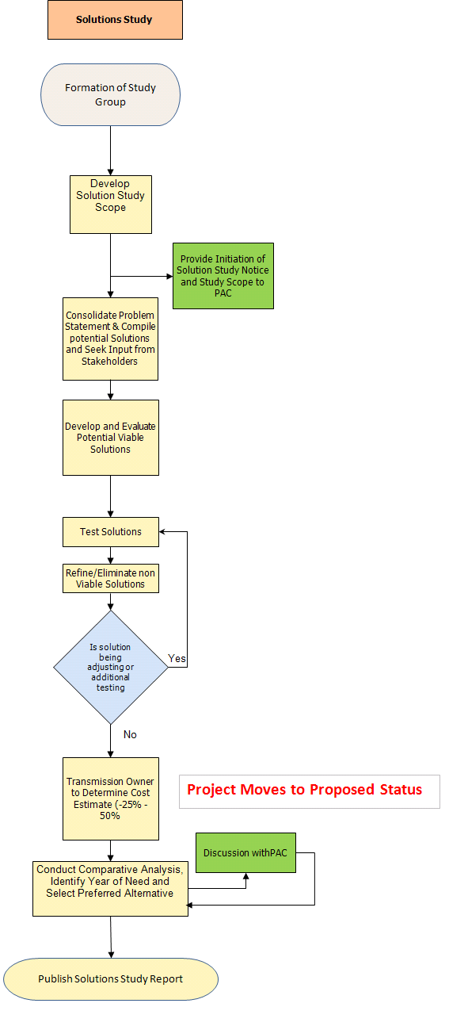

Solutions Study Process
If a Needs Assessment identifies system performance issues, the ISO will lead a solutions development process that will conduct studies to identify the most cost-effective and reliable transmission solution that meets the needs identified in the Needs Assessment. The process for performing a Solutions Study includes a review of the study scope, a review of initial results, presentation of final results, and documentation of the study using the ISO standard report format.
The ISO may form an ISO-led study groups to conduct Solutions Studies. Those stakeholders whose systems may be the subject of a Solutions Study or whose equipment may be affected within the study may provide a request to the ISO to participate in the study group. The Solutions Study group is responsible for conducting the solution development and assessment. The results of the ISO-led Solutions Studies will be discussed with the PAC and be reflected in the RSP and /or its Project List.
Market solutions are not assessed in a Solutions Study and instead become an integral assumption in the Needs Assessment. See Section 2.4.8 for an explanation of how and when Market Solutions are considered.

Study Initiation Notification and Scope Review (PAC)
After a Needs Assessment is completed and it is determined that a Solutions Study will be required, the ISO will provide notice of the initiation and the scope of the Solutions Study to the PAC. The ISO shall provide notice in the form of a presentation or e-mail notification to the PAC. The notice may include study objective, analysis period, study schedule, conceptual solutions and other relevant information to the study.
The ISO-led Solution Study group will determine a study scope consistent with the Needs Assessment study scopes, considering the results of both the needs analyses and all stakeholder comments received through the PAC review process. Those entities working with the ISO in the solutions development process may have access to some information restricted due to ISO confidentiality policy or CEII requirements. The process for development of a study scope and explanation of the information to be included in the study scope will be provided.
The study scope should as a minimum include:
- Study objective

- Portion of the New England transmission system that will be included in the study

- Years to be studied

- Load levels to be studied

- Description of the type of analysis and testing that will be included in the study

- Assumptions to be included in the modeling and testing

- Any sensitivity considered such as potential retirements, demand-response performance characteristics, load forecast changes, topology changes included or excluded, etc.

- A study schedule and timeline

If the scope of the proposed Solutions Study differs significantly from that of the scope of the Needs Assessment it will be posted for the PAC review. In most cases, the scope is the same as the Needs Assessment and has already been vetted through the PAC process and therefore will not be brought back for further review.

Development of Regulated Transmission Solution Alternatives
The process for development of regulated solutions to identified problems and system performance relative to standards and criteria of the existing or projected transmission system should follow a set of basic development and evaluation procedures. This process is generally as follows:
- Evaluation of possible transmission system improvements that have the potential of mitigating the concerns

- Selection of viable alternatives through more detailed assessments

- Testing of viable alternatives to ensure they are complete and they fully address the identified concerns, and are consistent with the long-term needs of the system

- Testing system performance for issues such as short circuit margins, stability performance, thermal loading, voltage control, EMTP analyses, and extreme contingency performance of the alternative solutions should be considered

- Examining operational and maintenance related issues on a high level basis to ensure that solution alternatives do not introduce operational or maintenance related concerns

- Evaluating the overall cost (possibly including a net present value analysis) and performance of the proposed set of viable alternatives to determine which among them is the most appropriate and cost-effective solution

Each of these steps is performed in a consistent and structured manner.
After a full set of possible system improvements has been developed, the possible solutions are assessed to determine the viability of their implementation. A set of factors (such as performance, high-level costs and land-acquisition requirements) should be developed that allow for a consistent process for determining which upgrades are viable and which are to be eliminated from further consideration. Attachment D to ISO Planning Procedure No. 4 outlines accuracy ranges for estimates and also provides guidance on contingency and escalation values. To allow all possible solutions to be compared equally estimates should be done in accordance with Attachment D to ISO Planning Procedure No. 4.
Upon completion of the review of alternatives with respect to feasibility, a set of viable alternatives should be established. These alternatives should then be tested against the set of performance measures that the Needs Assessment process used. This may result in an iterative process during which an alternative may be rejected or modified to account for any failure to address the full set of problems identified in the Needs Assessment study. Each of the final viable alternatives should fully address the set of problems identified in the Needs Assessment.
To comprehensively compare each of the alternatives, the set of complete and viable alternatives is evaluated by the study proponent at a more detailed level for cost, consistent with Attachment D to ISO Planning Procedure No. 4, and other development factors. In some cases, it may be necessary to also conduct a performance comparison of the alternatives. To fully differentiate alternatives that have similar cost and siting characteristics, the long term system improvements, as well as other factors (such as - loss savings, operability, asset condition, etc.) afforded by each alternative should be considered in the evaluation. This information provides the basis for selection of a proposed solution.

Discussion Regarding Transmission Alternatives Being Considered (PAC)
As the Solutions Study progresses, transmission alternatives will be discussed with the PAC as they are being developed. The PAC will have the opportunity to comment on the alternatives and/or suggest different transmission alternatives to be studied and ISO will respond to PAC input. The ISO and the proponent(s) will return to PAC, as needed, to provide updates on the study and to provide information as transmission alternatives are narrowed down.

Interregional Coordination Study
In developing the Regional System Plans, the ISO coordinates study efforts with surrounding RTOs and balancing authority areas and analyzes information and data presented in neighboring plans. This is achieved through a number of interregional agreements and joint studies with neighboring regions and across the entire Eastern Interconnection. The ISO is a participating member of the Northeastern ISO/RTO Planning Coordination Protocol which describes the interregional planning process that the ISO engages with NYISO and PJM. Pursuant to the Protocol, the ISO participates in the Joint ISO/RTO Planning Committee. The Inter-Area Planning Stakeholder Advisory Committee (“IPSAC”) is the multi-regional stakeholder body that covers the areas of the ISO, NYISO and PJM. Members of the ISO PAC are automatically members of the IPSAC and are sent notices of IPSAC meetings and materials. The ISO also actively participates in NPCC interregional planning activities.
The ISO will consult with the PAC concerning inter-area needs assessments and the potential responses to any identified inter-area needs. When a Solutions Study is being performed in an area that may impact another region, the ISO-led Study Group will review the plans of that region to determine if there will be an impact to the proposed study area.

Review of Preferred Transmission Solutions (PAC)
Based on the analyses performed in the Solutions Study, the ISO will determine which regulated transmission solution represents the most cost-effective and reliable solution. This most cost-effective solution is the “preferred solution”. The project that is ultimately constructed will be compared to the preferred solution during the TCA process in order to identify localized costs. The results of the Solutions Study are reviewed and discussed with the PAC and will, as appropriate, be reflected in the RSP and/or its RSP Project List as it is updated from time to time pursuant to Attachment K and in accordance with Section 3.3 of this document. The PAC and other interested Stakeholders are given the opportunity to comment on the preferred transmission solution before the Solutions Study Report is published.

Publish Solutions Study Report
Upon completion of review and discussion with the PAC, a study report shall be published using the ISO Standard Solutions Study Report format describing the study that was performed and the results of the analysis. The report should conform to the standard report structure to allow for a consistent review by all stakeholders. This allows for a consistent method for identifying reliability solutions for the PTF system. The Solutions Study report will be posted on the ISO website under PAC materials for a 30 day stakeholder review period and shall be updated as appropriate based on comments received from stakeholders. Comments should be submitted to PACmatters@iso-ne.com.

Determination of the Regionally-Preferred Transmission Solution
After the preferred solution has been reviewed by the PAC, the proponent of that solution will need to comply with Proposed Plan Application process set out in Section I.3.9 of the ISO Tariff to ensure that there is no material adverse impact to the system as a result of the transmission plan. This review process is accomplished through the use of engineering task forces. These task forces include the Transmission Task Force (“TTF”) and the Stability Task Force (“STF”). Members of the TTF and STF are required to have CEII clearance to participate on a Task Force. Once the generator or transmission proponent(s) completes the Task Force technical review process the proponent submits their PPA to the ISO which places it on the Reliability Committee agenda for an advisory vote. The Tariff Section I.3.9 process (also called the PPA process) applies only for the evaluation of significant adverse impacts on reliability and operating characteristics, and is not used for determining cost allocation of preferred alternatives.

Transmission Cost Allocation
The transmission cost allocation process is outlined in Schedule 12 of the ISO Tariff with additional implementing detail set out in ISO Planning Procedure 4. That process can be summarized as follows: PTOs that are intending to build non-Participant funded Pool Transmission Facilities may file a Transmission Cost Allocation (“TCA”) application. The TCA application can be filed before the ISO approves the I.3.9, but the ISO will not be able to make a final determination on the TCA until it approves the PPA.
The TCA application is submitted to the ISO and the RC. The ISO reviews the application for completeness and may request additional data to supplement the information provided. The ISO engages in a review of the project set out in the application as compared to the preferred solution. The RC also reviews the TCA application for any localized costs and makes a recommendation to the ISO on the application. Criteria employed in this review are set out in Schedule 12c to Part II of the ISO Tariff and Planning Procedure No. 4. The ISO makes the final determination on localized costs and submits a TCA determination letter to the applicant and the RC. Additional information requests can be found on the ISO website along with copies of the TCA determination letters. For large or complicated applications, the ISO may hold a public meeting to receive additional stakeholder input on the project, and may also post a draft determination and request feedback prior to a final determination being made.

Changes in Study Assumptions
If the assumptions change during a study, but adequate progress has been made, the study will continue with the original assumptions unless the change in assumptions is expected to affect the year of need by more than 5 years or result in a significant change in the design of the solution. If the new study assumptions must be adopted, it is preferred to restart the assessment with updated assumptions. If restarting the study is not practical because the study is almost complete or because of the urgency of the need for upgrades, the updated assumptions will be addressed in the next study of the affected area. The ISO, as the NERC-registered Planning Authority, will make the final decision on whether a study will continue or will be re-started.

Regional System Plan

Description of the Regional System Plan
The ISO publishes the Regional System Plan (“RSP”) on a yearly basis. This document is vetted with the PAC and is based on periodic comprehensive assessments of the PTF system-wide needs to maintain the reliability of the New England Transmission System while accounting for market efficiencies, economic, environmental and other considerations. The ISO updates the RSP with the results of ongoing Needs Assessments and Solutions Studies. In addition, the RSP accounts for projected improvements to the PTF that are needed to maintain system reliability and the operation of efficient markets. Further, the RSP must specify the physical characteristics of the physical solutions that can meet the needs defined in the Needs Assessments and include information on market responses that can address them. The RSP also provides sufficient information to allow Market Participants to assess the quantity, general location, operating characteristics and required availability criteria of the type of incremental supply or demand-side resource, or merchant transmission project that would satisfy the identified needs or that may serve to modify, offset or defer proposed regulated transmission projects. The provision of this type of information is evolving and has included approaches such as providing critical load levels at which problems arise and providing preliminary identification of conceptual locations for market resources which can solve problems and serve as potential market inputs.

RSP Project Listing
The following are the classification of projects that are listed in the RSP. Further detail on estimate ranges can be found in Attachment D to ISO Planning Procedure No. 4:

- A “Concept” project is placed on the Project List if a Needs Assessment has been completed. A Concept project does not require a cost estimate to be included as part of the list but any other project classification must have a cost estimate consistent with what is shown below.

- A “Proposed” project is placed on the Project List after the Solution Study and the preferred transmission solution have been discussed with PAC and ISO has received that committee’s advisory input. A “Proposed” project has a cost estimate that is -25% to +50%.

- A “Planned” project will only be placed on the Project List if a Needs Assessment & Solutions Study have been completed as described above and the Tariff section I.3.9 approval has been received. The cost estimate for a “Planned” project will increase in accuracy to +/-25% as detailed engineering progresses. A “Planned” project is still subject to a Schedule 12C review for Transmission Cost Allocation.

- An “Under Construction” project is a Transmission Upgrade that has received the approvals required under the Tariff and engineering and construction is underway.

- An “In Service” project is one that has been placed into operation.

- An Elective Transmission Upgrade (ETU) that has a PTF component can be included on the Project List without a Needs Assessment. If an ETU does not have a PTF component then it will not be included on the Project List.

Note: A Project may be cancelled if they are deemed no longer needed.

Inclusion and Update of Projects in the Regional System Project List
The RSP Project List is updated periodically, typically three times per calendar year. Updates are given to the PAC in February/March, May/June and October. The Project List and updates are posted on the ISO website. ISO asks the Participating Transmission Owners for updated information on the RSP Project List approximately two months before the posting date. The PTOs are expected to provide the updated information back to the ISO approximately one month prior to the posting date. New projects are added during the periodic updates.

Planning Advisory Committee Process

Role of the PAC
The regional system planning process in New England is open and transparent and reflects advisory input from regional stakeholders, particularly members of the Planning Advisory Committee (PAC), according to the requirements specified in the Tariff and the planning principles described in FERC Order 890. The PAC is open to all parties interested in regional system planning activities in New England.

The Planning Advisory Committee may provide input and feedback to the ISO concerning the regional system planning process, development of the RSP, and updates to the RSP Project list. Specifically, the Planning Advisory Committee serves to review and comment on:

- Development of the RSP

- Assumptions for Studies

- Results of Needs Assessments and Solutions Studies

- Potential market responses to the needs identified by the ISO in a Needs Assessment or the RSP

The PAC, with assistance of and in coordination with the ISO, serves also to identify and prioritize requests for Economic Studies to be performed by the ISO, and provides input and feedback to the ISO concerning the conduct of Economic Studies, including criteria and assumptions for such studies.

Based on input and feedback from PAC to the ISO, the ISO refers to the appropriate NEPOOL technical committees, including but not limited to, the Markets, Reliability and Transmission Committees, issues and concerns identified by the PAC for further investigation and consideration.

Membership
The PAC is open to any entity, including state regulators or agencies. A regional state committee or similarly situated entity, as specified in Attachment N of the ISO Tariff, may designate a member to the Planning Advisory Committee. NESCOE currently fills this role in New England.

Meeting Notification, Frequency and Materials
Prior to the beginning of the calendar year, the ISO lists on its calendar the proposed meeting dates of the Planning Advisory Committee for each month of the year. Before each meeting the ISO will provide notification of the meeting agenda, location, format and time to the PAC members via e-mail. Meetings are scheduled at a frequency needed to serve the intent of the Attachment K. The ISO posts materials for Planning Advisory Committee meetings on the Planning Advisory Committee section on the ISO’s website prior to meetings. The materials for the Planning Advisory Committee meetings are made available to the PAC members subject to protections required by confidentiality requirements of the ISO New England Information Policy set forth in Attachment D of the ISO Tariff and CEII policy as further described in Section 2.4(d) of Attachment K.

CEII Information and Materials
Planning materials determined to be CEII will be posted on the ISO’s website. However access to this material requires stakeholders to possess an ISO-issued digital security certificate. To obtain access to planning-related materials determined to be CEII, the entity seeking to obtain such access must contact the ISO’s Market Support Services department at 413-540-4220 or by e-mail, custserv@iso-ne.com. Authorized Market Participants or their representatives, such as consultants, are bound by the ISO New England Information Policy and will be able to access CEII materials through the ISO’s website. State and federal governmental agency employees and their consultants will be able to access such materials through the ISO’s website upon submittal of a signed non-disclosure agreement, which is available on the ISO’s website. Personnel of the Electric Reliability Organization, NPCC, other regional transmission organizations or independent system operators, and transmission owners from neighboring regions will be able to access CEII materials pursuant to governing agreements, rules and protocols. All external requests by other persons for planning-related materials determined to be CEII shall be recorded and tracked by ISO’s Market Support Services staff. Such requestors will be able to obtain access to CEII documents filed with the Commission pursuant to the Commission’s regulations governing access to CEII. To the extent a request seeks access to planning-related material that is not filed with the Commission, such requestor shall comply with the requirements provided in the CEII procedures of the ISO, available on the ISO’s website, prior to receiving access to CEII information. Upon compliance with the ISO’s CEII procedures, the ISO shall grant the request or access to the planning-related CEII document through direct distribution or access to the ISO website. The ISO issues a draft version of the RSP each year that is listed as CEII because there may be CEII material in the document. The final version of the RSP that is released has been reviewed thoroughly and does not contain any CEII material and therefore does not need to be considered CEII.

TOPAC/Local System Planning
As described in Section 6 and Appendix 1 to attachment K, the PAC periodically provides input and feedback to PTO’s concerning the development of their Local System Plans (“LSP”). It has been common practice to extend the PAC meeting to allow the PTO’s the time to present their LSP’s to any interested member of the PAC. Each PTO will present its respective LSP to the interested members of the PAC for advisory stakeholder input not less than one time per year. Each PTO’s LSP will include transmission system plans for Non-Pool Transmission Facilities (“Non-PTF”) that are not incorporated into the RSP planning process.

http://www.ferc.gov/whats-new/comm-meet/2008/101608/M-1.pdf
http://www.iso-ne.com/committees/comm_wkgrps/prtcpnts_comm/pac/reports/2012/index.html
http://www.iso-ne.com/rules_proceds/isone_plan/othr_docs/sample_needs_assessment_rev1.doc
http://www.iso-ne.com/rules_proceds/isone_plan/pp4_0_attachment_d.pdf
http://www.iso-ne.com/rules_proceds/isone_plan/pp4_0_r5.pdf
A balancing authority area is a group of generation, transmission, and loads within the metered boundaries of the entity (balancing authority) that maintains the load-resource balance within the area. Balancing authority areas were formerly referred to as control areas. Further information is available in the NERC glossary at http://www.nerc.com/docs/standards/rs/Glossary_12Feb08.pdf.
The Eastern Interconnection consists of the interconnected transmission and distribution infrastructure that synchronously operates east of the Rocky Mountains, excluding the portion of the system located in the Electric Reliability Council of Texas (ERCOT) and Québec.
http://www.interiso.com/public/document/Northeastern%20ISO-RTO%20Planning%20Protocol.pdf
http://www.iso-ne.com/rules_proceds/isone_plan/othr_docs/sample_standard_solution_study_report_72910.doc
http://www.iso-ne.com/committees/comm_wkgrps/prtcpnts_comm/pac/reports/index.html
http://www.iso-ne.com/trans/pp_tca/isone_app_approvals/tca/index.html
http://www.iso-ne.com/committees/comm_wkgrps/prtcpnts_comm/pac/projects/index.html
Direct link to ISO monthly calendar http://www.iso-ne.com/calendar/month.action?date=20111228&cats=&type=&link=yes&filter=off
Direct link to PAC Materials: http://www.iso-ne.com/committees/comm_wkgrps/prtcpnts_comm/pac/mtrls/index.html

