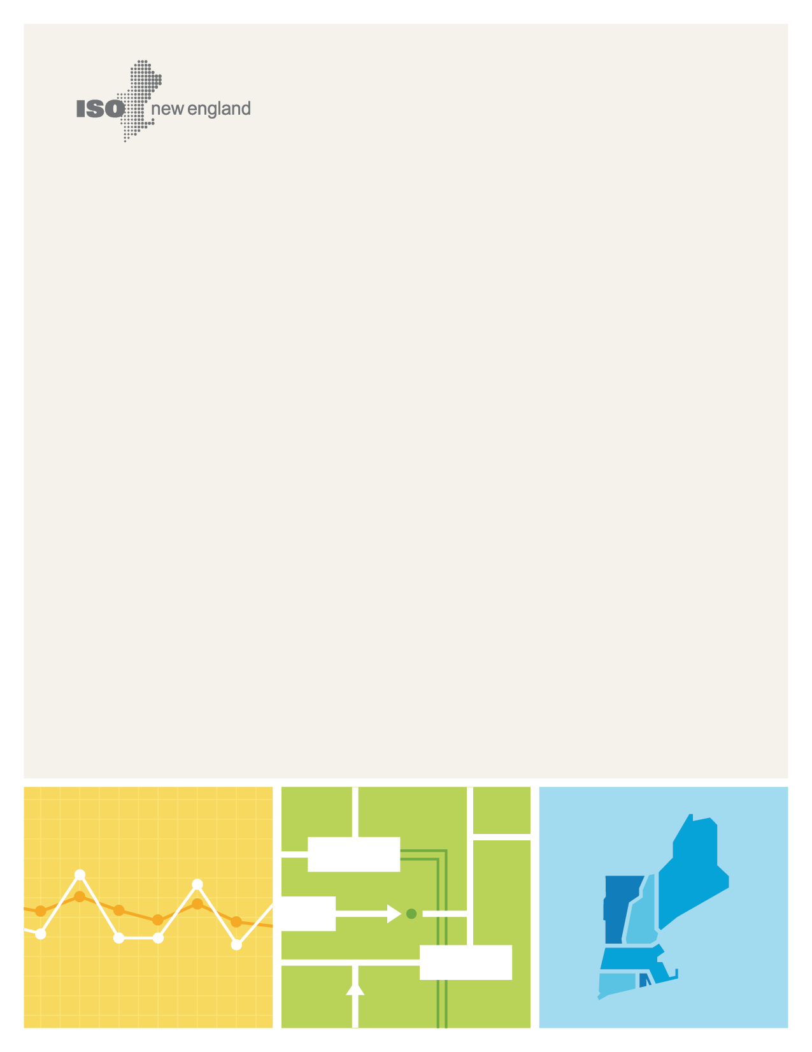
DRAFT
2050 Transmission Study
© ISO New England Inc.
Transmission Planning
November 1, 2023

ISO-NE PUBLIC

Project Team
Peter Bernard
Reid Collins
Liam Durkin
Annie Kleeman
Andrew Kniska
Brent Oberlin
Dan Schwarting
Kannan Sreenivasachar
Marvin Valencia Perez
Pradip Vijayan

Supporting Departments:
Corporate Communications
External Affairs
Economic Studies & Environmental Outlook

Contents
Contents iv
Figures vi
Tables vii
Section 1 : Study Overview 8
1.1 Study Background and Objectives 8
1.1.1 Development of Study Objectives and Study-Specific Terms 9
1.1.2 Source of Study Inputs for the Future Scenarios Examined 9
1.1.3 Summary of Input Assumptions for the Future Scenarios Examined 10
1.1.4 Practical Considerations and Limitations 13
1.2 Overview of the New England Transmission System 14
1.2.1 General Configuration of the New England Transmission System 14
1.2.2 Geographic Location and Types of Transmission Lines in New England 15
Section 2 : Key Takeaways 16
2.1 Reducing Peak Load Significantly Reduces Transmission Cost 16
2.2 Targeting and Prioritizing High Likelihood Concerns is Highly Effective 17
2.3 Incremental Upgrades Can Be Made as Opportunities Arise 18
2.4 Generator Locations Matter 19
2.5 Transformer Capacity Is Crucial 19
Section 3 : High-Likelihood Concerns 21
3.1 High-Likelihood Concerns: North-South 22
3.2 High-Likelihood Concerns: Boston Import 23
3.3 High-Likelihood Concerns: Northwestern Vermont Import 25
3.4 High-Likelihood Concerns: Southwest Connecticut Import 26
Section 4 : Roadmaps and Representative Transmission Solutions 27
4.1 North-South/Boston Import Roadmaps 27
4.1.1 North-South/Boston Import Roadmap #1: AC Roadmap 27
4.1.2 North-South/Boston Import Roadmap #2: Minimization of New Lines Roadmap 28
4.1.3 North-South/Boston Import Roadmap #3: Point-to-point HVDC Roadmap 29
4.1.4 North-South/Boston Import Roadmap #4: Offshore Grid Roadmap 30
4.1.5 Other Projects to Resolve Concerns in Boston 32
4.2 Northwestern Vermont Import Roadmaps 33
4.2.1 Northwestern Vermont Import Roadmap #1: PV-20 Upgrade and Doubling of K-43 Roadmap 33
4.2.2 Northwestern Vermont Import Roadmap #2: Coolidge-Essex Roadmap 34
4.2.3 Northwestern Vermont Import Roadmap #3: New Haven-Essex and Granite-Essex Roadmap 35
4.2.4 Northwestern Vermont Import Roadmap #4: Minimization of New Lines Roadmap 36
4.3 Southwest Connecticut Import 37
4.4 Transformer Additions 38
4.5 Other High-Likelihood Concerns 39
4.6 Non-High-Likelihood Concerns 40
4.7 Map of All Transmission Upgrades and Additions 41
Section 5 : Cost of Transmission System Upgrades 43
5.1 Estimated Costs by Roadmap and Year 45
Section 6 : Future Work 54
Section 7 : Conclusion 55

Figures
Figure 1-1: Load Levels Analyzed by Study Year 11
Figure 1-2: Renewable Generation and Energy Storage Input Assumptions 12
Figure 2-1: Costs by Year Studied 16
Figure 3-2: Line Mileage Overloaded in Boston with Generator Interconnection Locations Optimized 25
Figure 4-1: North-South/Boston Import AC Roadmap 28
Figure 4-2: North-South/Boston Import Minimization of New Lines Roadmap 29
Figure 4-3: North-South/Boston Import Point-to-Point HVDC Roadmap 30
Figure 4-4: Boston Import Offshore Grid Roadmap 32
Figure 4-5: Northwestern Vermont Import PV-20 Upgrade and Doubling of K-43 Roadmap 34
Figure 4-6: Northwestern Vermont Import Coolidge-Essex Roadmap 35
Figure 4-7: Northwestern Vermont Import New Haven-Essex and Granite-Essex Roadmap 36
Figure 4-8: Northwestern Vermont Import Minimization of New Lines Roadmap 37
Figure 4-9: Southwest Connecticut Import Transmission Additions 38
Figure 4-10: All Transmission Upgrades and Additions 42
Figure 5-1: Estimated Cumulative Costs for North-South/Boston Import Roadmaps 46
Figure 5-2: Cost Categories for North-South/Boston Import Roadmaps: 51 GW Winter Peak 47
Figure 5-3: Cost Categories for North-South/Boston Import Roadmaps: 57 GW Winter Peak 47
Figure 5-4: Estimated Cumulative Costs for Northwestern Vermont Import Roadmaps 48
Figure 5-5: Cost Categories for NWVT Import Roadmaps: 51 GW Winter Peak 49
Figure 5-6: Cost Categories for NWVT Import Roadmaps: 57 GW Winter Peak 49
Figure 5-7: Total Costs by Year Studied 53

Tables
Table 3-1: Miles of Transmission Lines Overloaded in the Boston Subregion by Snapshot Year/Load 24
Table 4-1: Transformer Overloads by Snapshot Year, Pre- and Post-Optimization 39
Table 5-1: Cost Assumptions for 2050 Transmission Study Upgrades 44
Table 5-2: Cost Assumptions for Offshore Grid Components 45
Table 5-3: Estimated Cumulative Costs for North-South/Boston Import Roadmaps 46
Table 5-4: Estimated Cumulative Costs for Northwestern Vermont Import Roadmaps 48
Table 5-5: Estimated Cumulative Costs for Southwest Connecticut Import 50
Table 5-6: Estimated Cumulative Costs for Southwest Connecticut Import 50
Table 5-7: Estimated Cumulative Costs for Non-High-Likelihood Concerns 51
Table 5-8: Estimated Cumulative Costs by Year Studied 52

: Study Overview
The New England power system is in the midst of an unprecedented shift in the ways in which electricity is produced and consumed. Five of the six New England states have committed to reducing their carbon dioxide emissions by at least 80% by 2050, prompting ongoing changes in the grid’s resource mix and the increased electrification of the heating and transportation sectors. Driven largely by these statewide commitments, the grid continues its shift toward renewable resources like wind and solar photovoltaic (PV) generation. Over the next several decades, these renewable resources are expected to substantially displace natural gas-fired generation as the region’s primary resource type. At the same time, increased electrification is expected to significantly increase overall consumer demand for electricity and drive changes in usage patterns that include seasonal and daily shifts in peak demand.
Among ISO New England’s responsibilities as a Federal Energy Regulatory Commission (FERC)-authorized Regional Transmission Organization is ensuring the regional power system continues to operate reliably as system conditions change. Transmission planning helps to maintain system reliability and enhance the region’s ability to support a robust, competitive wholesale power market by moving power from various internal and external sources to the region’s load centers. This 2050 Transmission Study is a pioneering look at the ways in which the transmission system in New England may be affected by changes to the power grid, and includes roadmaps designed to assist stakeholders in their efforts to facilitate a smooth, reliable clean energy transition.
Who is NESCOE? NESCOE is a not-for-profit entity that represents the collective perspective of the six New England Governors in regional electricity matters and advances the New England states’ common interest in the provision of electricity to consumers at the lowest possible prices over the long-term, consistent with maintaining reliable service and environmental quality.

Study Background and Objectives
In October 2020, the New England States Committee on Electricity (NESCOE) released the New England States’ Vision for a Clean, Affordable, and Reliable 21st Century Regional Electric Grid. This vision statement recommended that the ISO work with stakeholders to conduct a comprehensive long-term regional transmission study. This study, eventually titled the 2050 Transmission Study, would help inform stakeholders of the amount and type of transmission infrastructure necessary to provide reliable, cost-effective energy to the region throughout the clean energy transition.
In response to NESCOE’s vision statement, the ISO revised Attachment K to the ISO New England Open Access Transmission Tariff to incorporate a new transmission planning process designed to look beyond the current 10-year planning horizon. The first phase of the effort established the rules that will allow New England states, through NESCOE, to request that the ISO perform longer-term scenario-based transmission planning studies, such as this one, on a routine basis. Changes to the ISO Tariff were approved by FERC in early 2022. The 2050 Transmission Study is the first example of its kind within New England.
The longer-term transmission study process is currently informational. The process does not include a formal mechanism for triggering the construction of a new transmission project. However, the ISO is currently discussing the second phase of the longer-term transmission study Tariff changes that will establish a process to enable the states, through NESCOE, to move policy-related transmission projects forward, with an associated cost allocation. This effort began at stakeholder meetings in October 2023, and will continue through early 2024.

Development of Study Objectives and Study-Specific Terms
In 2021, the ISO began coordination with NESCOE to develop objectives and assumptions for this study.
The 2050 Transmission Study has two main objectives:
- Determine the region’s transmission needs in order to serve load while satisfying North American Electric Reliability Corporation (NERC), Northeast Power Coordinating Council (NPCC), and ISO reliability criteria.
- Develop roadmaps for transmission upgrades designed to satisfy those needs while considering both the feasibility of construction and cost.
In this study, the term roadmap is intended as a high-level plan designed to show generally how transmission-related objectives can be accomplished. The roadmaps provided in this study are not intended as comprehensive or detailed plans for construction. They include:
- Conceptual projects specific to the input assumptions of the study.
- Concerns defined as high-likelihood; projects that address these concerns are considered useful to the region because they are less dependent on the specific locations of generation and supply to load.
- Lessons learned that can be applied to future long-term transmission studies.

Source of Study Inputs for the Future Scenarios Examined
The future scenarios envisioned by NESCOE included load forecasts and potential resource mixes for the years 2035, 2040, and 2050 that were based on the All Options Pathway in Massachusetts’ Deep Decarbonization Roadmap report, published in December 2020. This Pathway was also used in the ISO’s recent Future Grid Reliability Study Phase 1 (FGRS), referred to in FGRS as Scenario 3. This future scenario will be referred to in this report as the All Options Pathway.
The All Options Pathway provided two types of data input for the 2050 Transmission Study: 1) New England’s expected hourly loads for all hours in a year for 2035, 2040, and 2050 and 2) renewable and conventional energy capacity for the same years. This data was combined with hourly wind and solar production data developed by an advisory firm, DNV, for various locations in New England to create year-round hourly profiles of renewable generation output. Using this data, the ISO developed “snapshots” for the years studied, which combined load and resource profiles for contingency analysis. Contingencies are unexpected events that affect the flow of power on the transmission system, such as the loss of a transmission line, a transformer, or certain types of substation equipment. This contingency analysis was designed to test peak load boundary conditions, which represent the most extreme or severe cases of combined load and renewable resource output that could realistically be expected to occur. An example of a boundary condition would be a particularly cold winter peak hour, corresponding with high loads, in which weather conditions resulted in low renewable resource production. Essentially, boundary conditions in this study were designed to represent the realistic “worst case scenario” for future transmission planning needs related to serving peak loads.
It is important to note that all conceptual projects in this 2050 Transmission Study are formulated from one particular pathway among the eight mentioned in the MA Deep Decarbonization Roadmap. Changing inputs to the No Thermal Pathway, or the 100% Renewable Pathway, for example, would impact the conceptual projects list. It is likely that the future power system will differ from the assumptions found in the All Options Pathway. As an example, the expected nameplate capacity of battery energy storage for 2030 has already exceeded the All Options Pathway’s assumptions for 2035. As the system evolves, the quantity and location of generating resources and load will likely lead to differences between reality and this study’s results. However, this study’s key takeaways and high-likelihood concerns still represent crucial high-level directional results that can be used by stakeholders to plan for a smooth clean energy transition.

Summary of Input Assumptions for the Future Scenarios Examined
The first input taken from the All Options Pathway was the hourly load for each snapshot year, which was then recast from a 2012 weather year to a 2019 weather year. The next inputs were the highest-load hours from the winter and summer periods. For winter periods, each state in New England was at or near its own peak load while New England as a whole was at its overall peak load, so a single snapshot in time captured worst-case or near-worst-case conditions in all six states. For summer periods, three varieties of peak loads were chosen in order to ensure the study captured the most severe conditions for each part of New England. The first was a summer daytime peak condition, intended to represent a period when total power consumption is highest. This condition is likely to be most pronounced in areas with little behind-the-meter solar penetration, such that solar power production cannot offset the hottest mid-day temperatures. The two remaining conditions used as summer period inputs were evening peak conditions, where the total load served by the transmission system (end-user load less any reductions for behind-the-meter solar) was greatest. During summer evenings, load decreases due to slightly lower consumption, but behind-the-meter solar production is low or zero. Hence, net load is greatest during this time. The All Options Pathway data showed that the three northern New England states (Maine, New Hampshire, and Vermont) tended not to peak at the same time as the region as a whole. To ensure that the worst-case conditions for the northern states were captured, a second summer evening peak snapshot was created, reflecting the hour in which load served from the transmission system was highest in the three northern states.
The resulting loads in each snapshot were significantly higher than any loads seen to-date in New England, and rose significantly from 2035 to 2040 and from 2040 to 2050. The highest load modeled was the 2050 winter evening peak snapshot, at approximately 57 gigawatts (GW). For comparison, the highest load observed to date on the New England system was the 2006 summer peak of just over 28 GW, and the highest winter load observed to date was the January 2004 peak of just below 23 GW. The loads analyzed in each year studied are shown in Figure 1-1.

Figure 1-1: Load Levels Analyzed by Study Year
These loads were assumed to be served by a generation fleet that differs significantly from today’s resource mix. All coal, oil, diesel, and municipal solid waste-fueled generation, as well as a portion of today’s natural-gas-fueled generation, was assumed retired by 2035, the earliest year studied. The remainder of today’s natural-gas-fueled generation, as well as biomass, nuclear, hydroelectric, and renewable generators, were assumed to remain operational through 2050. The retired generation, as well as the increases in load, were assumed to be offset by a significant increase in wind and solar generation, as well as battery energy storage and increased imports from neighboring power systems in New York and Québec. Much of this increased wind capacity is located offshore, either off the coast of southeastern Massachusetts and Rhode Island, or in the Gulf of Maine. Figure 1-2 shows the growth in renewable generation and energy storage assumed as inputs for this study.

Figure 1-2: Renewable Generation and Energy Storage Input Assumptions
While the All Options Pathway specified a total amount of each generation type by state, transmission planning studies like the 2050 Transmission Study require location data on a more granular level. Exact generator location is needed to develop useful results. In this study, new offshore wind generation was initially assumed to interconnect at major 345 kilovolt (kV) substations near the coast of New England, in order to minimize the length of cables between the interconnection points and offshore wind locations. As the study progressed, some of these interconnection points were relocated in order to eliminate transmission system concerns to the extent possible without changing the total amount of generation in each state (see section 2.4 for further details on generator relocation decisions). Similarly, energy storage facilities were initially assumed to interconnect at major 345 kV stations, but were later relocated within the same state to reduce transmission concerns where possible. Many of these relocations were from 345 kV stations to 115 kV stations. Finally, solar generation was distributed evenly across each 115 kV substation in each state, with certain substations in densely populated areas excluded due to the lack of available land.
In addition to generation located within New England, the All Options Pathway assumed that New England would import power to serve some of its peak load needs from neighboring areas. The following inter-area imports were part of the All Options Pathway and were used in all snapshots examined in this study:
- 1,000 MW imported from New Brunswick over existing 345 kV AC ties.
- 1,850 MW imported from New York over the existing 345 kV, 230 kV, 115 kV, and 69 kV AC ties.
- 1,400 MW imported from Quebec over the existing Phase II HVDC tie (interconnected at Sandy Pond substation in Ayer, Massachusetts).
- 225 MW imported from Quebec over the existing Highgate HVDC back-to-back converter (interconnected in Highgate, Vermont).
- 1,200 MW imported from Quebec over the under-construction New England Clean Energy Connect HVDC tie (interconnecting at Larrabee Road substation in Lewiston, Maine).
- 1,000 MW imported from Quebec over a hypothetical new HVDC tie between Quebec and Vermont (assumed to interconnect at the Coolidge substation in Cavendish, Vermont).

Practical Considerations and Limitations
Three major practical considerations were applied to this study and are important to note when interpreting study results. First, analysis is restricted to thermal steady-state analysis, which identifies thermal overloads that could only be solved by major transmission additions or upgrades. Thermal overloads occur when transmission lines, transformers, or certain substation equipment carries more than its rated amount of current or power flow. This condition can lead to overheating, equipment disconnection, or, in some cases, permanent damage. Analysis of voltage, short circuit or transient stability performance was omitted, and will need to be explored in future studies. This simplification allowed the study team to quickly identify major transmission line and transformer additions, which are usually more expensive and harder to site than the substation upgrades typically required for voltage, short circuit, or transient stability needs.
Second, analysis in this study is limited to transmission needs and conceptual transmission projects. Significant upgrades to the distribution systems will be necessary to accommodate a 2050 peak load that will be roughly double what New England has historically experienced. This anticipated expansion of the distribution system or the sub-transmission infrastructure is beyond the scope of this study, and will likely add significant costs to the evolution of the power system. This consideration required a simplification by modeling all loads at substations operated at 69 kV and above rather than at the lower voltage substations at which they actually connect.
The third and final practical consideration involves resource adequacy. This study found that the resource quantities assumed by the All Options Pathway, when combined with the resource availability assumptions made by the ISO, were insufficient to meet the snapshot loads for the Summer Evening and Winter Evening Peaks of 2035, 2040 and 2050. The largest observed shortfall was roughly 12,000 MW in the 2050 57 GW Winter Peak snapshot. In order to conduct analysis of the transmission system during these snapshots and ensure the model could run, shortfall MWs were added as needed in order to meet load. These shortfall MWs were added at offshore wind points of interconnection (POIs). Future work will be needed to determine more specifically how shortfalls will be resolved. For the purposes of this study, the added shortfall MWs can be thought of as more offshore wind (either higher output or higher installed capacity), battery storage that charges from excess wind during times of high production and discharges when wind production is lower, or additional imports from regions outside of New England through a hypothetical inter-area offshore grid.

Overview of the New England Transmission System
This section is designed as a primer for those unfamiliar with the New England transmission system. Those readers who are more familiar with transmission planning are invited to skip ahead to Section 2.

General Configuration of the New England Transmission System
ISO New England is responsible for the long-term planning of the networked portions of the high-voltage transmission system (known in New England as the Pool Transmission Facilities, or PTF), and this study was performed in support of this objective. The role of the electric transmission system is to efficiently deliver electricity over long distances, from generation within New England or imports from adjacent areas, to connections to local distribution systems. The transmission system is a networked grid of high-voltage transmission lines and transformers, with electric power naturally distributing itself among many parallel paths according to the locations of supply (generation/imports), demand (load), and electrical characteristics of the high-voltage transmission lines and transformers. Substations, found at the intersection of transmission lines, handle switching, protection, and transformation from one voltage level to another. At many of these substations, transformers step power down from higher transmission voltages, typically 69 kV and above, to distribution voltages below 69 kV. Local transmission owners and distribution companies, rather than the ISO, are responsible for the planning of any radial portions of the transmission system (which have only a single connection to the rest of the transmission system), the transmission-distribution interface, and the distribution systems.
The future evolution of the power system toward renewable and variable or intermittent resources increases the importance of a robust transmission system. Many of the best locations for renewable resources like large-scale wind and solar farms are not near major load centers (i.e., the urban areas of New England) and the transmission system will be relied on to deliver the power from these renewable resources to electricity consumers. While distributed resources, such as rooftop solar, can be located in more populated areas, the transmission system still helps bring power into these areas during nighttime periods or other times when intermittent renewable resources’ output is not sufficient to meet the local load. Transmission can also help to provide geographic diversity in renewable resources, smoothing out variations in wind and solar production in different parts of the power system. Finally, with the expected future increase in the electrification of the heating and transportation sectors, summer and winter peak loads are expected to increase dramatically. Additionally, New England’s current summer peaking system is forecasted to become winter peaking by the mid 2030s. A robust transmission system will ensure that loads under these future conditions can be served reliably.
New England’s power system provides electricity to diverse geographic areas, ranging from rural communities to densely populated cities. The majority of consumer demand, roughly 77%, is located in the southern states of Massachusetts, Connecticut, and Rhode Island. Although the land area in the northern states is larger, the greater urban development in southern New England creates greater demand and corresponding transmission density. However, it is the larger areas of land in northern New England that offer greater potential for renewable power generation. Today, flows on the transmission system are primarily from west to east and from north to south. However, flows change throughout each day, and the predominant flows will change significantly by 2050 due to additional new renewable generation and significant load growth. Because the demands on the New England transmission system can vary widely, the system must at all times be able to reliably move power from various internal and external sources to the region’s load centers under a wide-ranging set of conditions. Included in these conditions are contingencies. The exact lists of contingencies that must be analyzed are set by reliability standards created by the North American Electric Reliability Corporation (NERC), the Northeast Power Coordinating Council (NPCC), and the ISO. In accordance with these standards, the 2050 Transmission Study examines “N-0” conditions (all facilities in-service), “N-1” conditions (single contingency), and “N-1-1” conditions (two consecutive contingencies, with time for manual system readjustments between contingencies).

Geographic Location and Types of Transmission Lines in New England
The New England transmission system consists of mostly 115, 230, and 345 kilovolt (kV) transmission lines, which are generally longer and fewer in number in northern New England than in the southern states. The region has 13 interconnections with neighboring power systems in the United States and eastern Canada. Nine interconnections are with New York (NYISO)—two 345 kV ties; one 230 kV tie; one 138 kV tie; three 115 kV ties; one 69 kV tie; and one 330-megawatt (MW), ±150 kV high-voltage direct-current (HVDC) tie, the Cross-Sound Cable interconnection. New England and the Maritimes (New Brunswick Power Corporation) are connected through two 345 kV alternating current (AC) ties. New England also has two HVDC interconnections with Québec (Hydro-Québec, or HQ). One is a 120 kV AC interconnection with a 225 MW back-to-back converter station (Highgate in northern Vermont), which converts AC to direct current (DC) and then back to AC. The second is a ±450 kV HVDC line with terminal configurations allowing up to 2,000 MW to be delivered at Sandy Pond in Massachusetts (Phase II).

: Key Takeaways
The 2050 Transmission Study resulted in several high-level observations related to transmission-related challenges the future grid may face as a result of the clean energy transition. These key takeaways are detailed in the following subsections. They are:
- Reducing peak load significantly reduces transmission cost.
- Targeting and prioritizing high likelihood concerns is highly effective.
- Incremental upgrades can be made as opportunities arise.
- Generator locations matter.
- Transformer capacity is crucial.

Reducing Peak Load Significantly Reduces Transmission Cost
Increases in load become significantly more expensive (with regard to transmission costs) as peak load levels increase. This is especially true at levels above ~51 GW of load. Increases in load at peak load levels below 51 GW do increase costs (roughly $0.75 billion per GW of load added from 28 GW to 51 GW), but these increases are small when compared to the increase in costs above 51 GW of load (roughly $1.5 billion per GW of load added from 51 GW to 57 GW). Figure 2-1 shows the approximate cost required for transmission expansion to serve load reliably in each year studied.

Figure 2-1: Costs by Year Studied
Limiting load growth to no more than a 51 GW peak load level could be achieved in several different ways. A 2050 New England grid with 100% heating and transportation electrification is expected to result in a ~57 GW peak load. However, a 51 GW peak could be achieved under a scenario in which New England retains some stored fuels like natural gas, oil, propane, hydrogen, etc. for heating and transportation. Since loads above 51 GW would only occur during extremely cold winter days, peak load could be limited to 51 GW in a scenario in which the grid is 100% electrified for most of the year, with only the coldest days using some stored fuels for heating. If the full 6 GW of load reduction came out of heating, this could still represent approximately 80% heating electrification while still maintaining 100% transportation electrification.
Alternately, more aggressive demand response (when customers reduce their electrical consumption for compensation) and peak shaving programs (e.g., smart thermostats that reduce the set temperature during a winter peak time) that could shift load to times of lower demand may also help maintain a 51 GW peak load level, thereby reducing transmission costs. Work from other studies, however, including Economic Planning for the Clean Energy Transition (EPCET), have shown a potential overall energy deficit in the winter months whether these strategies are deployed or not. Since shifting MWs to other hours of the day would still lead to an overall energy shortfall, the total MWhs consumed in the winter months may still need to be reduced. Reducing load by shifting energy from peak hours to off-peak hours on the same day would help address transmission costs but would not address energy adequacy concerns over longer periods of days or weeks. More aggressive energy efficiency programs (such as incentivizing customers to install better insulation in their homes/businesses, and/or upgrade appliances and heat pumps, etc.) are among the options that could be considered in order to maintain a 51 GW peak load while still achieving electrification goals.
Public education and involvement may be an important factor in modifying consumer behavior to reduce electricity demand at key times. Consumer awareness of the nature and timing of peak load may help consumers participate in the reduction of peak loads to more manageable levels, which could save billions of dollars in transmission system upgrade costs.

Targeting and Prioritizing High Likelihood Concerns is Highly Effective
One major outcome of the 2050 Transmission Study was the identification of system concerns that could be resolved through transmission system expansion and could appear under a wide variety of possible future conditions. This wide variety of conditions, detailed in Section 3, include different load levels, different generator locations, and differing rates of load growth at particular substations. This report describes a number of high-likelihood concerns that appear to meet these conditions. While this study examined just one of many possible futures for the New England power system, and of that possible future examined only certain hours of the year when electricity consumption is expected to be at its highest, these results can still be used to infer which areas of the transmission system are likely to be most limiting as the system evolves.
Projects that address these high-likelihood concerns are likely to bring the greatest benefit for a wide range of possible future conditions as the clean energy transition accelerates. The assumptions used for future load and generation patterns include a fair amount of uncertainty, but these high-likelihood concerns are likely to appear even under somewhat different future conditions. Targeting these concerns should be considered higher-priority than other potential challenges identified in the 2050 Transmission Study, which would likely occur only if generators interconnect at specific locations or if load grows in specific patterns.
In an effort to identify high-likelihood concerns and other transmission overloads, the locations of new generator interconnections were optimized, within reason. By locating these interconnections so as to minimize transmission overloads observed under peak load conditions, any remaining overloads would likely only be solved through transmission expansion. Concerns that could be alleviated by new generation interconnections (within the bounds of the total amounts of generation in each New England state assumed for this study) are therefore not included in the results because they were resolved by the change of generation interconnection location.

Incremental Upgrades Can Be Made as Opportunities Arise
Many of the transmission system concerns identified in the 2050 Transmission Study could be addressed by rebuilding existing transmission lines with larger conductors, rather than expanding the transmission system into new locations. In many cases, replacing transmission lines with larger conductors and increasing their power transfer capability would allow the system to serve significantly higher peak loads. This type of conductor replacement, or reconductoring, may also require replacing some or all of a transmission line’s structures in order to accommodate heavier, larger conductors. Other incremental upgrades could also be beneficial; examples include bundling multiple conductors per phase on 115 kV lines (already a common practice on 345 kV lines in New England) or rebuilding transmission lines to allow for a higher operating voltage.
Limiting brand new line construction by taking advantage of line rebuilds could minimize costs, especially in densely populated areas in southern New England. In many areas, expanding existing rights-of-way or constructing new rights-of-way could be difficult, expensive, and environmentally disruptive, and thus maximizing the use of existing rights-of-way is critical to the success of the region’s transmission system reliability through the clean energy transition.
While these incremental upgrades should be considered crucial to the improvement of New England’s transmission system, it is not necessarily prudent for the region to pursue large numbers of line rebuilds immediately. Many of these line rebuilds are highly dependent on the locations of generator interconnections, the geographic distribution of end-user load, and the locations of new load-serving substations. Since these incremental upgrades can generally be built in a shorter timeframe than new transmission on new rights-of-way, it may be more practical to address these incremental needs via the traditional ten-year reliability planning process rather than the longer-term planning process that prompted this study. This strategy would allow the region to hold off on committing to further transmission system investment until new information is available, and also provide opportunities for more cost-effective “right-sizing” transmission projects.
“Right-sizing” is a term used to describe combining line rebuilds necessitated by increased loads with replacements designed to meet asset condition needs. In New England, asset condition projects are identified by transmission owners when equipment exceeds its useful life. Since a significant portion of New England’s transmission system was developed in the mid-20th century, many transmission lines are beginning to reach the end of their life and must be replaced. During such an asset condition replacement project, the incremental cost of upgrading a transmission line to a larger conductor size and stronger structures is relatively low. Many expenses inherent in transmission line rebuilds are unrelated to the line’s capacity; costs related to building access roads along a right-of-way, labor for building structures, and financing an ongoing project are not significantly affected by the size of the conductor chosen. Therefore, upgrading the capacity of lines as the opportunity arises, or “right-sizing” asset condition projects when they occur, could be a financially prudent way for New England to reliably serve increased peak loads. Further discussions between the ISO, the Transmission Owners, and NESCOE on “right-sizing” asset condition projects will continue at the Planning Advisory Committee in 2024 in order to inform the region of the possible economic advantages of these opportunities more fully.

Generator Locations Matter
The 2050 Transmission Study also found that the specific location of generators can have a significant impact on the transmission upgrades required for reliability. The study attempted to optimize, within reason, new generator locations for offshore wind, solar photovoltaics (PV), and batteries in import-constrained regions to reduce the number and severity of overloads experienced while serving peak loads. As a result, the overloads observed were those that persisted in spite of these optimized generation locations. Locating generators in suboptimal areas would likely significantly worsen the overloads, particularly in import-constrained regions like Boston. Optimizing generation locations is also crucial for determining which lines must be upgraded, since a generator could either push back on heavy flows toward load centers or contribute to even higher loading on transmission lines, depending on the location of its interconnection. Essentially, locating generators closer to large population hubs will help reduce the strain on the transmission system, since the cumulative distance power must flow to reach electricity consumers will be greatly reduced.
Generator location is less important for some of the larger-scale upgrades like new major lines leading from northern New England to southern New England. Whether a generator is placed at one substation in Maine or at a different station 10 miles away matters very little, since the majority of the power from that generator will ultimately flow from Maine into southern New England regardless of the generator’s exact location. As long as generators in northern New England are located in the general vicinity of the terminal of a large-scale upgrade, the exact substation where they interconnect is not as critical.

Transformer Capacity Is Crucial
Increasing electrification results in load growth, which then requires more renewable resources to be added to the New England power system. This increase in load and generation can strain the existing transformer capacity within New England, particularly the 345/115 kV transformers. Transformers must reliably “step down” power from higher to lower transmission voltages, and the 2050 Transmission Study revealed that existing transformers across the system were frequently unable to do so without thermal overloads. Between 2035 and 2050, the assumed load increased significantly across the region, in tandem with the increase in generation located farther from load centers. This trend increases the importance of higher voltage lines such as the 345 kV system to transfer power over long distances. Throughout all snapshot years, transformers created choke points, since the system’s existing transformers were not originally designed to handle the large loads assumed in this study.
As described in the previous key takeaway, generator locations matter. When generation location was optimized in order to locate more generation on the 115 kV system closer to the load, rather than on the 345 kV system, transformer overloads were reduced.
Results from the 2050 Transmission Study reveal that the power system is only as reliable as its ability to deliver power through transformers without experiencing overloads. One benefit of higher voltage transmission (in New England, primarily 345 kV) is its increased capacity to transfer more power across long distances while minimizing losses of power along the way. However, this additional power transferred along higher voltage lines must eventually “step down” to 115 kV via transformers on its way to distribution substations fed by 115 kV lines, and these transformers must be able to support the increase in load and power injection. Results from the studied snapshots show that the existing transformer fleet will not be able to adequately support future power flows from the 345 kV to the 115 kV system. This is not an issue with the transformers themselves, but rather is a predictable consequence of increases in load and the fact that this increased load is originating predominantly from locations far away from the generation.
One of the simplifying assumptions of this study was to model load on the 115 kV system, rather than on the distribution system. As a result, this takeaway applies to transformers with windings at or above 115 kV. Presumably, a large number of additional distribution transformers will be required to step down from 115 kV to individual customers. This distribution infrastructure is beyond the scope of this study, and the related planning responsibility lies with the distribution utilities and their state regulators rather than with the ISO. However, this infrastructure will be necessary to support increasing electrification of transportation and heating.
These results indicate that transformers are a key component in the reliable delivery of bulk power as loads increase. Major challenges in addressing these concerns include the time and expense required to build new, large transformers. Lead times for new transformers are often one to two years, and adding a large number in a short period of time will be difficult. Nonetheless, adding transformers throughout the system could likely relieve thermal overloads and support reliability. Ideally, New England transmission owners would wait to order new transformers until it is determined that they are definitely needed, and the location where they are needed is known; however, due to the long lead times and the large number of transformers needed, it may be prudent to start ordering transformers ahead of time and determining their exact locations later on.

: High-Likelihood Concerns
In response to stakeholder interest and feedback, the 2050 Transmission Study identified what the ISO has termed high-likelihood concerns, as discussed in Section 2.2. It is helpful to identify the transmission concerns that have a high likelihood of occurring even if the assumptions used in the study do not unfold exactly as predicted. This allows the New England region to prioritize concerns based on their likelihood. The ISO has defined a “high-likelihood concern” as one that satisfies the following three criteria:
- The thermal concern must appear at two or more load levels. This could mean that the concern occurs in the same year, but during both summer and winter peaks, or it could mean that it only appears during the winter peak in two separate years, e.g., 2040 and 2050. Requiring the concern to appear at two or more load levels in study simulations significantly increases the probability that the concern will be realized. For example, if a concern appears at the 2040 43 GW winter peak and also at the 2050 51 GW winter peak, there is a much higher likelihood that the concern will occur whether loads reach the highest studied levels (57 GW) or not. As a counterexample, if a concern only occurs once, at 57 GW of load in the winter, then the likelihood of this concern existing in reality will be much lower. If load growth falls slightly short of the study’s highest prediction, then the concern is highly unlikely to occur.
- The thermal concern must not rely heavily on specific substation-level generator locations. Many of the generator locations in this study are hypothetical— particularly for offshore wind, solar PV, and batteries, since many of these generators do not yet exist. In reality, these generators will likely be located in somewhat different locations. It is therefore important to prioritize concerns that are not directly triggered by specific generator locations. If observed overloads are caused by a generator interconnected at a certain substation, and this overload would not be observed if the generator was connected to a substation several miles away, this is not considered a high-likelihood concern. However, if a generator could be located anywhere within a range of substations and still cause a thermal overload, this would be considered a high-likelihood concern, provided that it also meets the other two criteria described in this section.
- The thermal concern must not rely heavily on load growth at a particular substation. The study assumed that load will grow proportionally across all of New England; in reality, load will likely grow faster at some substations than it will at others. It is therefore important to prioritize thermal concerns that are not heavily dependent on the exact location of load. For example, if a substation is fed from a single transmission line, the flow on that line is entirely dependent on the load located at that particular substation, and future loads that fall slightly short of forecasts used in this study would not precipitate a thermal concern. This type of concern is not considered high-likelihood. However, thermal concerns observed on transmission lines that transfer power between New England’s subregions are much less dependent on specific load locations, and are therefore considered high-likelihood provided they meet the other two criteria described in this section. If load grows slightly more at one station than another in the same area, or if a new station is added to that area, roughly the same amount of power will still flow over the major transmission line between areas.
Roadmaps that could address each of these high-likelihood concerns are included in Section 4, along with graphic representations of each roadmap.

High-Likelihood Concerns: North-South
The Maine-New Hampshire and North-South transmission interfaces connect Maine and New Hampshire to northeastern Massachusetts. The 2050 Transmission Study found that these interfaces are high-likelihood concerns due to a variety of thermal overloads that met the criteria described in the previous section. These concerns were observed primarily during winter peak snapshots and were precipitated by the large volume of offshore wind production flowing from relatively generation-heavy and light-load areas in Maine and New Hampshire into the dense, high-load areas in southern New England. Although less severe than the winter observations, concerns were also observed during the summer daytime peak snapshots, precipitated by large excesses in solar production in northern New England. Transporting this excess power between subregions overloaded a significant number of 345 kV and 115 kV transmission lines connecting northern and southern New England. These overloads increased in severity between the 51 GW and 57 GW load levels during the 2050 winter peak snapshot.
The overloads experienced on the Maine-New Hampshire and North-South interfaces were observed in a number of studied years. Some overloads began in 2035 and extended all the way through 2050. Some overloads were observed in both the winter peak and the summer daytime peak snapshots. Additionally, these observed overloads were not highly dependent on generator location. While the total generation in northern New England is a factor in these overloads, the precise locations of particular generator interconnections in Maine do not affect the probability that the overloads will occur; most of the power generated in this subregion still ultimately flows down through the major lines leading into Massachusetts. The exact load distribution within a subregion also does not heavily influence these major transmission lines since they transfer power between subregions rather than serving one particular substation. Even if the precise load location varies within those subregions, the resulting flow on the major lines would remain relatively similar.
Other ISO studies such as FGRS and EPCET’s Market Efficiency Needs Scenario (MENS) have also identified bottlenecks on the interfaces between Maine and southern New England. These studies examined the hourly dispatch of the transmission system on a year-round basis, rather than the peak load snapshots used in this study. While the methodology of these studies differs from a full transmission system study (e.g., FGRS used a “pipe-and-bubble” approach to transmission limits and the EPCET MENS used a nodal model with N-1 contingencies rather than N-1-1 contingency analysis), their results support this study’s findings, and transfers across the Maine-New Hampshire and North-South interfaces will increase beyond today’s limits over a wide range of future conditions.
Analyzing different state-by-state totals of renewable generation, other than those in the All Options Pathway, was beyond the scope of this transmission study. However, it is possible that offshore wind that the study assumed would interconnect in Maine or New Hampshire could be routed south into Massachusetts instead, alleviating some of the stress on the North-South interface. The precise interconnection locations for offshore wind in the Gulf of Maine will depend on many factors, including the exact location of wind lease areas that have not yet been finalized.

High-Likelihood Concerns: Boston Import
Since most of the load increases examined in the 2050 Transmission Study were the result of increased electrification in the same locations where load is observed today, this heavily impacted already load-dense areas of the New England region, and the Boston subregion in particular. The Boston subregion is the area bound by the Boston Import interface, and it extends from downtown Boston south to Hyde Park, west to Framingham, and north to Amesbury. The 2050 Transmission Study determined that the Boston Import interface is a high-likelihood concern. There were a variety of thermal overloads observed along this interface that met all three criteria. Across most snapshots studied, current import paths into the Boston area are unable to support increasing load due to high load density and low assumed availability of wind generation in the area under summer peak load conditions. The balance of load and generation within the Boston Import interface affects the degree of overloads in this area, and additional generation within the Boston Import subregion could help to reduce overloads on the import paths.
It should also be noted that a significant number of overloads occurred on underground cables that would be expensive to fix through upgrades. In most situations, increasing the rating of underground cables requires a complete replacement of all underground equipment, resulting in costs that are six to eight times higher than rebuilding existing overhead transmission lines. Table 3-1 displays the overloaded mileage on all lines in the Boston area. There are two categories for each set of results: All Lines (Overhead and Underground Lines) and Underground Lines. The results labeled “pre-optimization” show study results from July 2022, before any work to optimize generator interconnection locations (see Section 2.4). Results marked “post-optimization” show the effects of generator interconnection location optimization on reducing transmission overloads. All results are presented without any representative transmission upgrades included; potential upgrades for this area are described in Section 4, and eliminate all of the transmission overloads shown here.

Table 3-1: Miles of Transmission Lines Overloaded in the Boston Subregion by Snapshot Year/Load
Year Studied | Miles of Transmission Lines Overloaded in the Boston Subregion
 | Pre-Optimization: All Lines | Post-Optimization: All Lines | Pre-Optimization: Underground Lines | Post-Optimization: Underground Lines
2035 | 77.6 | 98.3 | 54.8 | 62.0
2040 | 169.4 | 184.5 | 103.2 | 97.1
2050 (51 GW winter peak) | 398.8 | 313.5 | 202.0 | 165.4
2050 (57 GW winter peak) | 477.3 | 344.6 | 205.5 | 169.6

Results indicated that underground cables were the source of a significant percentage of observed overloads in Boston (see Figure 3-2). These results also illustrate that generation location matters, as described in the key takeaway Section 2.4. When generator relocations were optimized to best suit the 2050 snapshots, the number of miles overloaded were reduced. However, optimizing the generation relocation for 2050 produced more overloaded miles in the 2035 and 2040 snapshots than in the original pre-optimization results. Although the best optimization for 2050 was not optimal for 2035 and 2040 results, the results from all later snapshots showed a decrease in overloaded miles between pre- and post-optimization. This example illustrates potential trade-offs between optimization of the transmission system for the long-term and addressing near-term problems that must be considered as the region tackles the clean energy transition. Boston likely requires more import capability and transmission system improvements to address these high-likelihood concerns, and the roadmaps detailed in Section 4 solve for all concerns observed in all years studied while considering generator point-of-interconnection optimization for 2050.

Figure 3-2: Line Mileage Overloaded in Boston with Generator Interconnection Locations Optimized
Alternative approaches that might address these issues yield trade-offs between cost and effectiveness. Moving generator interconnection locations will address some of the identified concerns during peak load conditions, but may be less optimal under off-peak or high-wind-output conditions. Optimizing generator interconnection locations may be more cost-effective than building new transmission, since some interconnection equipment will be needed regardless of the substation where a generator interconnects. However, relocating generator interconnections is not completely cost-free, especially when moving offshore wind interconnections farther from shore, since extra costs associated with cables between offshore and onshore locations may arise. The costs of generator interconnection equipment are also allocated differently than transmission upgrades, potentially complicating the optimization of generator interconnection locations. If there were more generation in load-dense areas, the need to import power into Boston would be less. Bulk power must travel through multiple stations to satisfy load in Boston, and lines may overload along the way due to the large volume of power flow. Locating more generation within the Boston subregion would therefore reduce overloads along this interface under heavy load conditions.

High-Likelihood Concerns: Northwestern Vermont Import
The 2050 Transmission Study found that importing power into northwestern Vermont is a high-likelihood concern, specifically with regard to the area around Burlington. The study’s observed overloads stemmed from the significant amount of forecasted load in the general area without a corresponding amount of local generation, combined with the lack of significant 345 kV transmission lines transferring power into the area. These overloads were observed exclusively in the winter, when load is expected to be highest, as heating in the region becomes significantly more electrified. Overloads were observed primarily on 115 kV lines around the Burlington area, along with a 115 kV inter-area tie line between Plattsburgh, New York and the Sandbar substation in Milton, Vermont.
While the overloads did not appear in both summer and winter, many of them did appear in 2035, 2040, and 2050, indicating a high probability that they will occur even if load in 2050 is lower than assumed. These overloads were not heavily dependent on generation location, as there is no significant generation located in northwestern Vermont. Some new solar was assumed; however, since the overloads occurred after sunset during the winter peak, solar units were unable to provide power. This region is also not ideal for connecting with larger generators or with significant imports like the HVDC connection with Canada assumed in southern Vermont, because northwestern Vermont does not have a strong connection to the 345 kV transmission system. While more generation could help mitigate some of the concerns in the region, it would not be well-connected to other subregions and thus not particularly useful for exporting to those subregions when load is low in Vermont. With few transmission paths in this part of the state, any new, large generation or HVDC import into the area could require significant transmission upgrades.
The high-likelihood concerns observed in northwestern Vermont are dependent on the overall load growth in the area; however, they are not highly dependent on where that load growth is located station-by-station. As long as the load growth occurs somewhere in the general region, many of these overloads are expected to persist.

High-Likelihood Concerns: Southwest Connecticut Import
Southwest Connecticut arose as a high-likelihood concern due to its positioning in the power system combined with high load density. Since the area is located in a corner of the New England power system, increases in assumed load there surpassed line ratings and precipitated thermal overloads. There are only two 345 kV paths connecting Southwest Connecticut to the rest of the New England system, which limits the amount of power that can flow over the higher voltage transmission lines. The loss of one or both of these 345 kV paths can lead to high flows on the underlying 115 kV system, and transformers in this area suffered thermal overloads as the load increased on the system across all snapshots studied.
Thermal concerns appeared across all studied load levels due to the total load increase across the substations, but were most severe in the 57 GW snapshot. The location of generator interconnections was optimized to address as many overloads as possible, but this had only a limited effect due to the relatively small amount of generation in the area as compared to peak load. The overall subregion was not very sensitive to changes in load since these concerns persisted across 2035, 2040, and 2050. As long as the load was located within Southwest Connecticut, it generally did not matter on a substation-to-substation level exactly where the load was located.

: Roadmaps and Representative Transmission Solutions
The term roadmap is intended in this study as a high-level plan designed to show generally how transmission-related objectives can be accomplished. The roadmaps provided in this study are not intended as comprehensive or detailed plans for construction. They include conceptual projects specific to the study’s input assumptions—projects that could be useful in addressing high-likelihood concerns, including line rebuilds, and lessons learned that could be applied to future long-term transmission studies. Roadmaps were developed for groupings of high-likelihood concerns for North-South, Boston Import, and Northwestern Vermont Import. Roadmaps were not developed for Southwest Connecticut or other high-likelihood concerns, since these concerns had a relatively clear single solution, and any alternatives were much costlier. The North-South and Boston Import roadmaps were combined, since these areas were heavily dependent on each other. The cost assumptions for the representative transmission solutions are described in Section 5.
To develop each roadmap, the ISO first focused on designing solutions to meet the 2050 Summer Peak snapshots along with the 2050 51 GW Winter Peak snapshot. Once those solutions were developed, a subset of those solutions were determined to meet the 2035 and 2040 snapshots such that a smooth path could be developed to move from 2035 to 2040 to 2050 without having to build a solution and then rebuild it in the future. Finally, the study identified additional upgrades on top of the 2050 51 GW Winter Peak snapshot that were required to reach the 2050 57 GW Winter Peak snapshot.

North-South/Boston Import Roadmaps
Four main roadmaps were developed for solving the high-likelihood concerns observed on the North-South and Boston Import interfaces. These roadmaps were developed to provide the region’s stakeholders a variety of examples of how these concerns might be mitigated. The ISO does not recommend any particular roadmap over another; each includes advantages and disadvantages. Collaboration between stakeholders and the region as a whole will help determine the best path forward.

North-South/Boston Import Roadmap #1: AC Roadmap
The first roadmap centers around an AC 345 kV framework. This roadmap consists of a 345 kV line from the Surowiec substation in Pownal, Maine to the Timber Swamp substation in Hampton, New Hampshire, and another 345 kV line from Timber Swamp to the Ward Hill substation in Haverhill, Massachusetts. These two 345 kV lines would primarily be constructed overhead, with short underground sections as needed to address segments where overhead construction is difficult or impossible. An additional 345 kV partially overhead/partially underground line would also be required from Ward Hill to the Wakefield Junction substation in Wakefield, Massachusetts, continuing to the Mystic substation in Everett, Massachusetts. Finally, a third AC cable (in addition to two existing AC cables) from the Stoughton 345 kV substation in Stoughton, Massachusetts to the K Street substation in Boston, Massachusetts would be required to help resolve import issues in the southern and western portions of the Boston sub-region. These upgrades, along with ancillary rebuilds of existing transmission lines, would be sufficient to meet the 51 GW winter peak load. A 57 GW winter peak would require a second 345 kV Timber Swamp-Ward Hill line in addition to the above-mentioned new lines. In addition to the major upgrades described above, this roadmap would require approximately 666 miles of overhead line rebuilds to reliably serve a 51 GW load and 1,058 miles of overhead line rebuilds to reliably serve a 57 GW load.
This option is somewhat limited in its flexibility due to constrained rights-of-way along much of the path, since lines connecting Maine to Massachusetts should be overhead in order to have enough capacity. While it may be possible to add new 345 kV transmission to existing rights-of-way, there will be expenses associated with reconfiguring existing lines. Additionally, the risk that all lines in a right-of-way may be lost (e.g., due to brush fires) would need to be evaluated further outside of this study. Figure 4-1 represents the general direction of power flow and location of major new transmission lines in this roadmap.
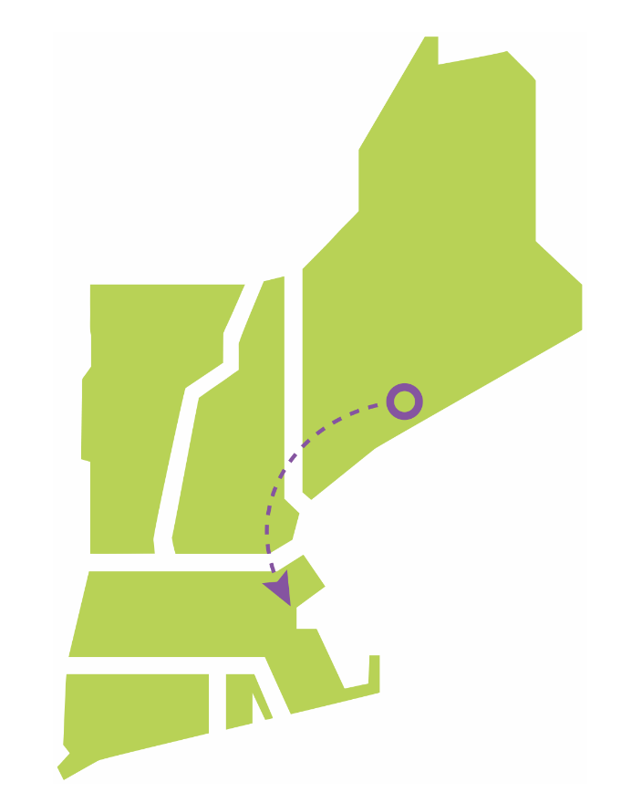
Figure 4-1: North-South/Boston Import AC Roadmap

North-South/Boston Import Roadmap #2: Minimization of New Lines Roadmap
The second roadmap attempts to minimize the number of newly constructed lines, and instead prioritizes rebuilding existing lines with larger conductors. This roadmap would still require the new 345 kV partially overhead/partially underground Ward Hill-Wakefield Junction-Mystic line and the third Stoughton to K St AC cable mentioned in roadmap #1, but it would not require any of the new lines in Maine or New Hampshire. The omission of new ME-NH lines would, however, necessitate approximately 252 miles of additional rebuilds, for a total of 918 miles of rebuilt overhead lines to support a 51 GW winter peak load.
It is important to note that this roadmap is not sufficient to support a 57 GW winter peak load. Additional new lines will be required to support a 57 GW winter peak, and line rebuilds alone cannot address the concerns observed in this study. The study did not determine exactly which new lines would be necessary to serve a 57 GW peak reliably, since this roadmap began to converge on the same solutions as other roadmaps as more lines were added. If this roadmap is followed, the region could potentially use demand response, energy efficiency, and other measures to achieve 6 GW of load reduction and avoid a 57 GW winter peak. However, these solutions also have associated costs. This roadmap would be easier to site than roadmaps #1 and #3, although building fewer new lines would likely come with disadvantages related to stability and voltage performance that cannot be accurately quantified in this study. The concerns regarding loss of right-of-way described at the end of section 4.1.1 with regard to roadmap #1 would apply to this roadmap as well. Figure 4-2 represents the approximate locations of rebuilds described in this roadmap.

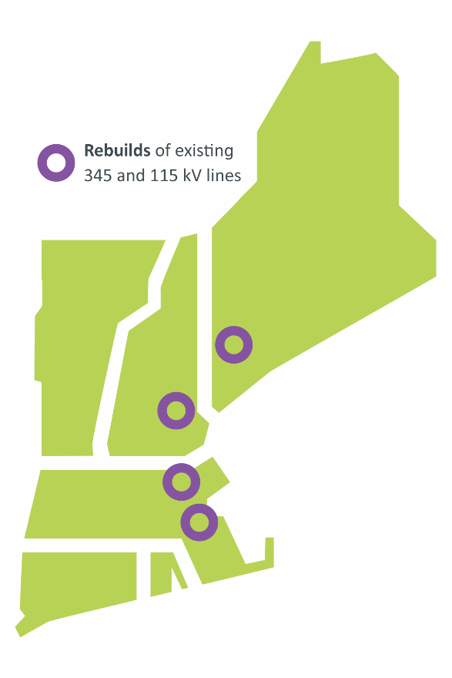
Figure 4-2: North-South/Boston Import Minimization of New Lines Roadmap

North-South/Boston Import Roadmap #3: Point-to-point HVDC Roadmap
The third roadmap centers around a potential point-to-point HVDC framework. It consists of a single 1,200 MW HVDC line from the Surowiec substation in Pownal, Maine to the Mystic substation in Everett, Massachusetts. Additionally, the new AC cable from Stoughton to K Street described in Roadmap #1 would be required to help resolve import issues in the southern and western portions of the Boston sub-region. This roadmap is useful for addressing high-likelihood concerns for all snapshots through 51 GW of load. In order to reliably serve the 57 GW load level in the 2050 winter peak snapshot, an additional 1,200 MW HVDC line would need to be constructed between 2040 and 2050 from the South Gorham substation in Gorham, Maine to the Tewksbury substation in Tewksbury, Massachusetts. The HVDC lines in this roadmap could be constructed overhead, underground, or underwater, offering flexibility for siting. The DC/AC converters at each terminal of the HVDC lines may also have short-circuit and stability benefits that were not quantified by this study. The main disadvantage to this roadmap will likely be related to land availability in Boston for siting the large DC/AC converter stations needed to terminate these new HVDC lines; although the Tewksbury area likely has enough land availability for this converter station, and Mystic may have enough availability once the existing generation at that location has been retired. In addition to the major upgrades described above, this roadmap would require approximately 624 miles of overhead line rebuilds to reliably serve a 51 GW load and 1,027 miles of overhead line rebuilds to reliably serve a 57 GW load. Figure 4-3 represents the general direction of power flow and location of major new transmission lines in this roadmap.
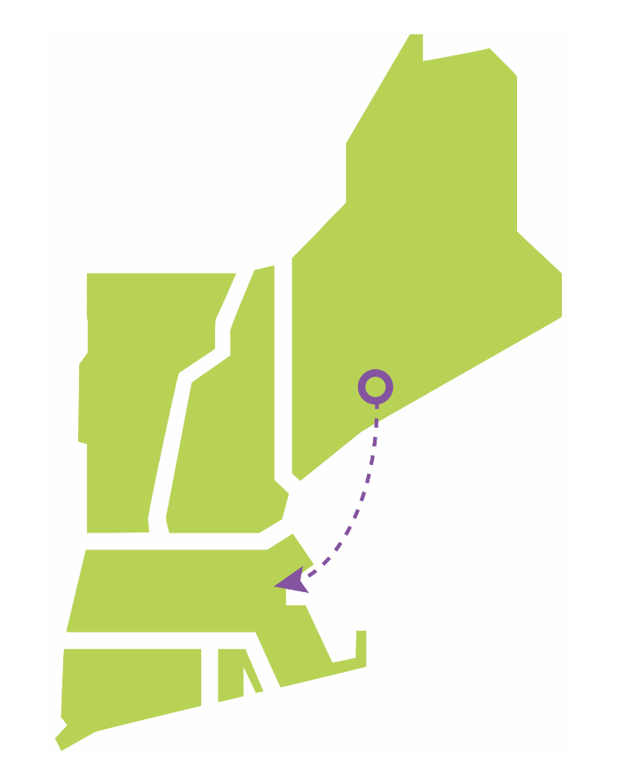
Figure 4-3: North-South/Boston Import Point-to-Point HVDC Roadmap

North-South/Boston Import Roadmap #4: Offshore Grid Roadmap
The final roadmap would make use of an offshore grid framework by connecting up to three offshore wind plants. These would be connected with offshore HVDC cables to form new paths between wind farms. In combination with the cables already built to connect these wind farms to on-shore substations, these offshore connections will enable the transfer of power between various sub-regions in New England. Several different configurations were examined. Initially, the study investigated a grid connecting offshore wind that interconnected in Maine, New Hampshire, and Boston. This solution was not efficient, since offshore grids are most effective when there is excess capacity on the offshore cables, i.e., when wind output is relatively low and more spare capacity is available to transfer power through the cables. The North-South interface was most highly overloaded during the winter peak snapshots, when wind output was at its highest, meaning that each 1,200 MW offshore connection had just ~200 MW of excess capacity available. This made only a minor difference in resolving overloads. Overloads on lines crossing the North-South interface were so high that roughly 10 connections between northern New England and Boston would be required (under the offshore grid framework) to solve the concerns, and there were not enough offshore wind interconnection points to make this feasible. Additionally, such a high number of offshore connections would lead to significantly higher costs than other roadmaps for North-South transfers.
The offshore grid was much more effective in the summer peak snapshots, when the wind production was low and there was more spare capacity available on the cables. Many of the Boston Import overloads were worse in the summer, when wind injections into Boston dropped. When overloads were observed in winter, they were relatively small. The offshore grid is therefore a good candidate for solving these particular concerns.
Various configurations were examined before this roadmap was finalized. To address concerns related to high Boston Import flows, the roadmap centers on a three-terminal offshore grid between Brayton Point in Somerset, Massachusetts; K Street in Boston, Massachusetts; and Mystic in Everett, Massachusetts by building offshore connections between Brayton Point Wind, K Street Wind, and Mystic Wind. This framework was sufficient for the 2035 and 2040 snapshots. For the 2050 snapshots, two separate connections between pairs of offshore wind farms were required in addition to the three-terminal grid; one between West Farnum Wind (interconnecting in North Smithfield, Rhode Island) and Brighton Wind (interconnecting in Boston, Massachusetts), and another between Montville Wind (interconnecting in Uncasville, Connecticut) and Woburn Wind (interconnecting in Woburn, Massachusetts). These offshore upgrades were sufficient to solve the Boston Import concerns. The study assumed that all interconnected wind plants would be located in the wind lease area off of the southern coast of New England, and thus would be connected together with relatively short underwater cables.
The incremental cost of this offshore grid roadmap is simply the total cost of these offshore-offshore connections, since the study inherently assumed offshore wind generation and thus associated cables to the shore were covered by generation interconnections which were beyond the scope of the 2050 Transmission Study. These offshore – onshore cables would be required to bring wind energy onshore whether the individual wind plants are each connected directly to the shore or as part of a networked offshore system. Any interconnected offshore wind plants would need to be built such that they are compatible with other offshore wind plants in the area, facilitating their connection to a network. For example, any HVDC technology used on the cables would need to be inter-operable between any other wind farms that would eventually be connected together. Solving the remaining North-South interface concerns under this roadmap would require the AC roadmap’s North-South upgrades: a new 345 kV line from Surowiec, Maine to Timber Swamp, New Hampshire, and a new 345 kV line from Timber Swamp to Ward Hill in Massachusetts, with this line doubled for the 57 GW winter peak snapshot. The continuation of this line to Wakefield Junction and Mystic would not be necessary, since the Boston Import issues addressed by this continuation in the second roadmap were resolved by the offshore grid in this roadmap. The offshore grid also removes the need for a third 345 kV Stoughton – K Street underground cable. In addition to the major upgrades described above, this roadmap would require approximately 606 miles of overhead line rebuilds to reliably serve a 51 GW load and 1,023 miles of overhead line rebuilds to reliably serve a 57 GW load. Figure 4-4 represents the general location of conceptual wind projects and interconnections in this roadmap.

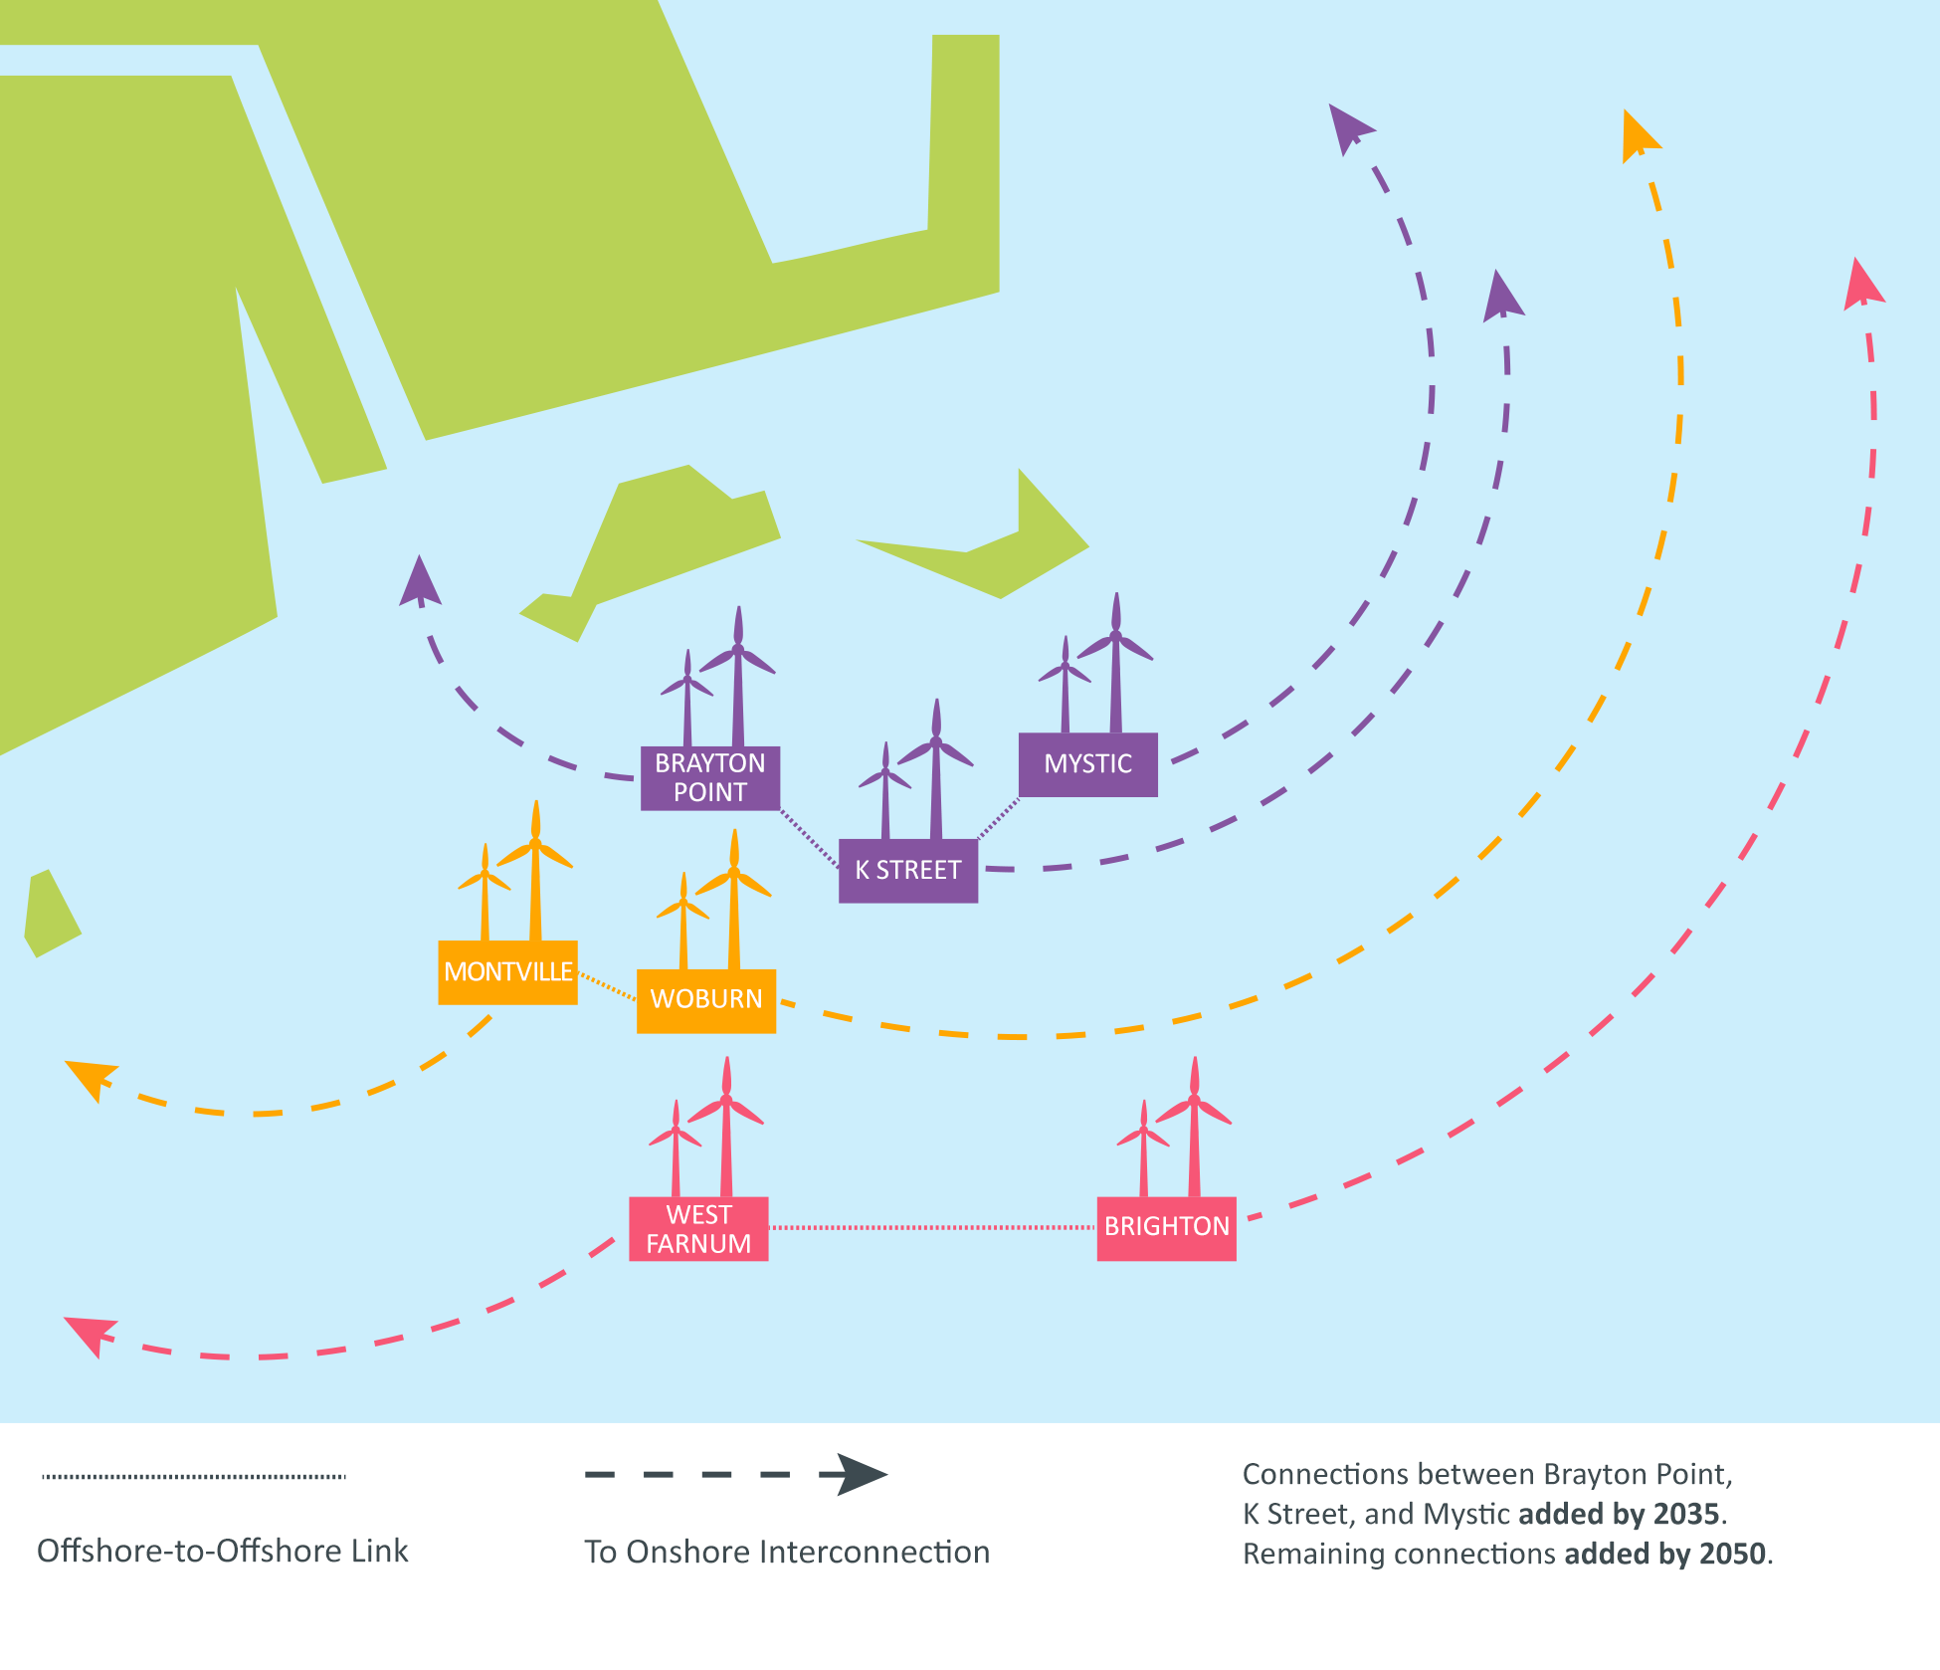
Figure 4-4: Boston Import Offshore Grid Roadmap

Other Projects to Resolve Concerns in Boston
The roadmaps described in previous sections resolve many concerns related to bringing power into the Boston sub-region from elsewhere in New England. However, these roadmaps do not resolve a number of concerns related to moving power around the Boston sub-region. These concerns were caused primarily by the need to bring power from the major 345 kV hubs in Boston to each individual 115 kV substation where power is delivered to the local distribution network. As described previously, relocation of offshore wind interconnections addresses some of these concerns. The remaining concerns, shown in Figure 3-2, are addressed with a combination of the Boston-related portions of the other roadmaps and the following projects.
The first project includes the conversion of three existing 230 kV lines in the western portion of the greater Boston region to 345 kV standards. These lines would bring power from the West Medway substation, in Medway, Massachusetts, to the Waltham, Sudbury, and Framingham substations, and help bring power to other 115 kV substations nearby. Upgrading these lines to 345 kV would allow them to bring more power into these areas from the southwest, reducing the stress on underground cables west of Boston. The mileage of these rebuilt lines is included in the total overhead line mileage listed for each roadmap above.
The second project includes a new substation in Cambridge, Massachusetts designed to tie together lines serving the Kendall Square area of Cambridge with lines leading towards Brighton and other neighborhoods in the western portion of Boston. This new substation is included in all Boston Import roadmaps in this study in order to eliminate overloads on the cables connecting the 345 kV network at the North Cambridge substation to the Brighton substation.

Northwestern Vermont Import Roadmaps
Four roadmaps were developed for solving the high-likelihood concerns observed in northwestern Vermont around the city of Burlington. These roadmaps were developed to provide the region’s stakeholders with a variety of examples of how these concerns might be mitigated. As with the previous roadmaps, the ISO does not recommend any particular roadmap over another; each includes advantages and disadvantages. Collaboration between stakeholders and the region as a whole will help determine the best path forward.

Northwestern Vermont Import Roadmap #1: PV-20 Upgrade and Doubling of K-43 Roadmap
The first roadmap centers on upgrading the PV-20 line from New York into Vermont from 115 kV to 230 kV, and constructing a new 115 kV overhead line in parallel to the existing K-43 line that runs from the New Haven substation in New Haven, Vermont to the Williston substation just south of the city of Burlington in northern Vermont. The 230 kV conversion of the existing PV-20 line would only require work on the overhead portion of the line, since the underwater portion that runs under Lake Champlain is already capable of operating at 230 kV. The portion of the line that would need to be upgraded to 230 kV is approximately 9.3 miles long. An additional 7.55 miles of overhead line would need to be converted to 230 kV between Vermont and New York, but the cost estimates in this study only cover the portion of the line that is within New England, ending at the overhead-to-submarine transition structure on the eastern shore of Lake Champlain. A new 230/115 kV transformer would also be required at the Sandbar substation north of the city of Burlington. The build of the new 115 kV line in parallel to the existing K-43 line will be similar to the existing 20.8-mile-long line, with the assumption that the existing K-43 line is also rebuilt with larger conductors. This roadmap would also require approximately 120 miles of 115 kV overhead line rebuilds to reliably serve a 51 GW load and 151 miles of 115 kV overhead line rebuilds to reliably serve a 57 GW load. Both of these numbers include the 20.8 mile rebuild of the existing K-43 line mentioned above. In addition to transmission line additions and upgrades, three new 345/115 kV transformers need to be added at existing 345 kV stations in Vermont to reach a 51 GW load, and an additional two new 345/115 kV transformers need to be added at existing 345 kV stations in Vermont to reach a 57 GW load. Figure 4-5 represents the general direction of power flows and location of the new transmission line and the 115-to-230-kV conversion in this roadmap.

Figure 4-5: Northwestern Vermont Import PV-20 Upgrade and Doubling of K-43 Roadmap

Northwestern Vermont Import Roadmap #2: Coolidge-Essex Roadmap
The second roadmap would require the construction of a new 345 kV line from the Coolidge substation north of Ludlow, Vermont, to the Essex substation just outside of the city of Burlington, Vermont. This line would be approximately 90 miles long and would likely require the expansion of existing transmission rights-of-way for the majority of its length. New 345 kV substation equipment, including a 345/115 kV transformer, would be required at the Essex substation, as this station is currently only capable of 115 kV operation. This option would require approximately 105 miles of 115 kV overhead line rebuilds to reliably serve a 51 GW load and approximately 189 miles of 115 kV overhead line rebuilds to reliably serve a 57 GW load. In addition to the new transformer at Essex, one new 345/115 kV transformer would need to be installed at an existing 345 kV substation to reach 51 GW and an additional one 345/115 kV transformer would be needed at an existing 345 kV substation to reach 57 GW. Figure 4-6 represents the general direction of power flow and location of new transmission lines in this roadmap.
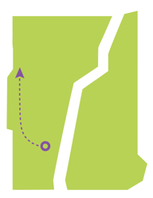
Figure 4-6: Northwestern Vermont Import Coolidge-Essex Roadmap

Northwestern Vermont Import Roadmap #3: New Haven-Essex and Granite-Essex Roadmap
The third roadmap would require construction of a new 345 kV line from the New Haven substation in New Haven, Vermont, to the Essex substation just outside of the city of Burlington, in addition to a new 230 kV overhead line from the Granite substation east of Williamstown, Vermont, to the Essex substation. Both of these new lines would require their own new substation equipment at the Essex substation to operate at 345 kV and 230 kV, since the Essex substation is currently only capable of 115 kV operation. This new equipment would include a new 345/115 kV transformer and a new 230/115 kV transformer. The length of the line from New Haven to Essex would be approximately 25 miles and the length of the line from Granite to Essex would be approximately 45 miles. This option would require approximately 79 miles of 115 kV overhead line rebuilds to reliably serve a 51 GW load and approximately 121 miles of 115 kV overhead line rebuilds to reliably serve a 57 GW load. In addition to new transformers at Essex, two new 345/115 kV transformers would need to be installed at existing 345 kV substations to reach a 51 GW load and an additional one 345/115 kV transformer would be needed at an existing 345 kV substation to reach 57 GW. Figure 4-7 represents the general direction of power flows and location of new transmission lines in this roadmap.
Figure 4-7: Northwestern Vermont Import New Haven-Essex and Granite-Essex Roadmap

Northwestern Vermont Import Roadmap #4: Minimization of New Lines Roadmap
A variation on the first roadmap was also examined to determine if the Vermont high-likelihood concerns could be resolved without constructing entirely new overhead lines. Results showed that the new line in parallel to the K-43 line could be eliminated if the 0.4 mile underground section of the K-65 line between the North Ferrisburg substation and Charlotte substation, along with the 1.7 mile underground section of the K-65 line between the Shelburne substation and the Queen City substation in southern Burlington, had an additional parallel cable added to each section. The PV-20 upgrade from 115 kV to 230 kV (in both New York and in Vermont), along with the new 230/115 kV transformer, would still be required. This option would require approximately 142 miles of 115 kV overhead line rebuilds to reliably serve a 51 GW load and approximately 192 miles of overhead line rebuilds to reliably serve a 57 GW load. Three new 345/115 kV transformers would need to be installed to reach 51 GW of load, and an additional two 345/115 kV transformers would be needed to reach 57 GW. The choice between the first roadmap and this variation is therefore a choice between building a 20.8 mile overhead line versus doubling up 2.1 miles of underground cables plus rebuilding approximately 41 miles of overhead lines to reliably serve a 57 GW load. However, this approach of minimizing new overhead construction is generally less robust than roadmaps involving additional overhead transmission lines. In addition to the voltage and stability benefits of new transmission lines, new overhead lines also provide more margin for loads higher than those assumed in this study, different load distributions among the substations in Vermont, and other unexpected developments. Rebuilds alone leave very little headroom to operate the system reliably, with many lines loaded very close to their ratings under post-contingency conditions. Figure 4-8 represents the general direction of power flow and location of new transmission lines and the 115-to-230-kV conversion in this roadmap.
Figure 4-8: Northwestern Vermont Import Minimization of New Lines Roadmap

Southwest Connecticut Import
Like Boston, the Southwest Connecticut area is a densely populated urban area with high demand for power and little space for overhead transmission line corridors. As heating and transportation are electrified between now and 2050, load in this area is anticipated to grow, and additional transmission capacity will be necessary to serve this load reliably. While it may be possible to serve this load by interconnecting generating and storage resources locally, the Energy Pathways study specified relatively low amounts of offshore wind and storage for the state of Connecticut, and there is little land available for utility-scale solar in this area. The 2050 Transmission Study assumed that a new offshore wind farm would connect to the Norwalk substation, and that battery storage facilities would interconnect at Cos Cob (in Greenwich, CT) and Glenbrook (in Stamford, CT). Even with the assumption that these facilities will inject power into the subregion, additional transmission is needed to serve load reliably.
This study found that one set of solutions could address reliability concerns in Southwest Connecticut at a relatively lower cost and impact than other solution alternatives—hence the lack of multiple roadmaps for this subregion. The representative solutions suggested for this area include three new 115 kV underground cables in the Norwalk-Stamford area: one from Norwalk to Glenbrook (in Stamford, CT); one from Ely Avenue to Norwalk Harbor (both in Norwalk, CT); and a third extending an existing cable from its current endpoint at South End (in Stamford, CT) to Cos Cob. The Norwalk-Glenbrook cable would take advantage of a spare 115 kV duct bank in parallel with two existing Norwalk-Glenbrook cables, which would reduce its cost somewhat compared to an underground cable on a brand-new route. In addition to these upgrades, 96 miles of overhead 115 kV lines and 6 miles of underground 345 kV lines must be rebuilt, and two 345/115 kV transformers must be added in order to reliably serve a 51 GW winter peak load.
Additional 345 kV capacity into Southwest Connecticut would be required to serve a 57 GW winter peak load. Today, the region is fed by only two 345 kV paths: one from Long Mountain (in New Milford, CT), and the other from Beseck (in Wallingford, CT). Portions of the path from Long Mountain to Norwalk are underground, leading to lower ratings than a typical 345 kV overhead line. While additional 345 kV overhead lines would provide the capacity needed, these lines would be lengthy and would be difficult to route and site through the densely populated areas of Southwest Connecticut. Instead, this study suggests re-using an unused underground segment of the Long Mountain-Norwalk path, which would allow for more power flow. This cable was originally de-energized due to temporary over-voltage concerns. Additional study would be required to ensure that the cable could be re-energized safely without risking equipment damage; additional substation equipment may be necessary to manage voltage if this cable is placed into service. The costs of this study work and substation equipment would likely be far less than developing a third 345 kV path into Southwest Connecticut. Along with re-energizing this cable, an additional two 345/115 kV transformers, 125 miles of rebuilt overhead 115 kV lines, and 21 miles of rebuilt overhead 345 kV lines would be necessary to reliably serve Southwest Connecticut at the 57 GW winter peak load level. Figure 4-9 represents the general direction of power flows and location of major new transmission lines in this roadmap.
Figure 4-9: Southwest Connecticut Import Transmission Additions

Transformer Additions
As described in section 2.5, transformer capacity has the potential to create bottlenecks in the power system between today and 2050. A large number of existing PTF transformers, primarily 345/115 kV transformers, were identified as overloaded before representative transmission upgrades were added to the system models. Table 4-1 lists the number of transformer overloads across different snapshots, and illustrates the correlation between transformer overloads and increasing load. The results marked “pre-optimization” show results from July 2022, before the study was redesigned to optimize generator interconnection locations. As described in section 2.4, generator locations have a major impact on power flows and overloads on transformers. Results marked “post-optimization” show the effects of optimization on reducing transmission overloads. All results in this table are exclusive of any representative transmission upgrades.
Table 4-1: Transformer Overloads by Snapshot Year, Pre- and Post-Optimization
Year Studied | Number of PTF Transformers Overloaded
 | Pre-Optimization Results | Post-Optimization Results
2035 (35 GW Winter Peak) | 14 | 16
2040 (43 GW Winter Peak) | 56 | 43
2050 (51 GW Winter Peak) | 86 | 57
2050 (57 GW Winter Peak) | 99 | 81

While a large number of PTF transformers were overloaded in the initial study results, a smaller number of transformers would be required to address these concerns. In many cases, multiple existing transformers at a single substation are overloaded, and the addition of a single new transformer is sufficient to return the loading on all existing transformers to applicable limits. While the exact number of required transformers varies based on the roadmap chosen for North-South/Boston Import and Northwest Vermont, all combinations of roadmaps require approximately 40 new transformers to address all reliability concerns. Of these 40 transformers, approximately 20 would address high-likelihood concerns. The remaining 20 would be needed to address non-high-likelihood concerns, and in many instances, are only needed to serve load in the 57 GW winter peak snapshot.
Given the long lead times (18-24 months), limited manufacturing capability, and transportation challenges for large power transformers, transformer capacity has the potential to be a significant limiting factor on the evolution of the power system and the electrification of end-user energy consumption.

Other High-Likelihood Concerns
In addition to the concerns described above, the study revealed a number of other isolated high-likelihood concerns that were not related to consistent trends like those associated with North-South transfers or other named high-likelihood concerns. The following upgrades were considered in order to address these other high-likelihood concerns:
- Upgrade and convert 298 miles of 69 kV lines to 115 kV.
- Rebuild 225 miles of overhead 115 kV lines.
- Rebuild 37 miles of overhead 345 kV lines.
- Build 13 miles of new overhead 115 kV lines.
- Build two new overhead 345 kV lines between Brayton Point and Grand Army (both in Somerset, MA), for a total of 3 miles of new construction.
- Increase the rating of the series capacitor on line 3023 in Orrington, ME.
These upgrades are scattered around New England, rather than concentrated in a particular area. Full details on these additional upgrades can be found in the Technical Appendix to this report.

Non-High-Likelihood Concerns
Finally, many concerns found in this study were not considered high-likelihood concerns, and are mainly related to serving load for the 57 GW winter peak load level. Since they only appear at this load level, they are particularly sensitive to the distribution of load among individual substations. If the evolution of the region’s distribution system differs significantly from the assumptions studied, it is possible that new distribution substations will be located in a way that changes the severity and location of these reliability concerns. Therefore, these concerns are not considered high-likelihood.
The upgrades associated with these non-high-likelihood concerns are as follows. While the exact upgrades may vary depending on the location of distribution load-serving substations, this list of upgrades is a reasonable approximation of upgrades that will be required if the region’s load grows to a 57 GW winter peak.
- Rebuild 393 miles of overhead 115 kV transmission lines.
- Rebuild 287 miles of overhead 345 kV transmission lines.
- Build 105 miles of new overhead 115 kV transmission lines.
- Build 57 miles of new underground 115 kV cables.
- Replace 10 miles of existing underground 115 kV cables with higher-rated cross-linked polyethylene (XLPE) cables.
- Install 4 new series reactors at various locations throughout New England.
- Install approximately 300 new circuit breakers at various substations throughout New England.
- Separate transmission lines on 10 sections of double-circuit towers.

Map of All Transmission Upgrades and Additions
Figure 4-10 shows the full set of transmission upgrades identified as conceptual roadmaps in this study. Rebuilds of existing transmission lines are shown in purple and new transmission lines are shown in red. Grey dashed lines show existing transmission lines on which upgrades were not required. All roadmaps except for the Offshore Grid roadmap are included on this map; as a result, not all new transmission lines in this figure are needed, since some indicate multiple roadmaps that solve the same transmission system concern.
The map below should not be considered an authoritative list of all line rebuilds; due to the scale of the map and approximations of substation locations, some lines are difficult or impossible to distinguish from each other. All transmission lines are represented as straight lines between endpoints, and thus do not reflect actual line routes or locations of rights-of-way. A full list of rebuilt transmission lines for each roadmap may be found in the Technical Appendix to this report.
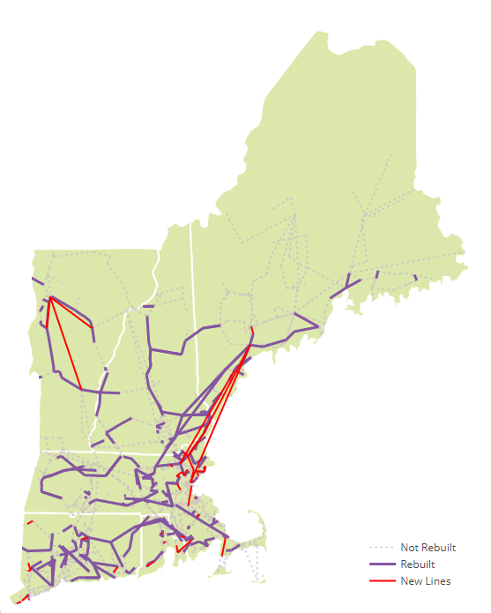
Figure 4-10: All Transmission Upgrades and Additions

: Cost of Transmission System Upgrades
One of the major goals of the 2050 Transmission Study was to provide a rough estimate of the costs required to develop the transmission system of 2050. The projects proposed as conceptual roadmaps in this study are not intended to constitute a transmission plan, and the region’s transmission system will likely develop differently from the system envisioned in this study. However, the identified upgrades are still useful for providing an order-of-magnitude estimate of future transmission system costs. These estimated costs are intended to inform consumers, industry stakeholders, and policy makers of the costs inherent in maintaining reliable transmission service through the clean energy transition.
The ISO’s estimates of costs for these representative transmission projects were developed from two sources. The first, used for more complex projects, was Electrical Consultants, Inc. (ECI), a consultant with extensive experience in project management and transmission system construction. ECI’s cost estimates were primarily made up of materials, labor, and right-of-way costs. These cost estimates did not include some aspects of transmission costs, such as financing costs (allowance for funds used during construction, or AFUDC), contingency costs for unexpected difficulties during construction, and engineering, permitting, and indirect costs. ECI did include permitting fees and filing costs, but these costs did not reflect the extensive labor typical of permitting large projects in New England. To account for these and to ensure ECI’s calculated costs were easily comparable to actual project costs in New England, a 95% adder was applied. This adder was calculated as follows:
- 10% adder for financing costs: Recent transmission projects in New England have incurred financing costs in the range of 5-14% of the total labor, materials, and right-of-way costs. A 10% adder approximates the midpoint of this range.
- 20% adder for engineering, permitting, and indirect costs: These costs have varied widely on recent transmission projects, from 2% to 32% of the total labor, materials, and right-of-way costs. Larger projects, especially those involving underground transmission, tend to be near the higher end of this range. A 20% adder is slightly higher than the midpoint of this range.
- 50% adder for contingency: ISO-NE Planning Procedure 4 (PP4), Attachment D specifies a contingency adder of 30-50% for projects with cost estimates in the “Proposed” stage of project development. ECI’s estimates were “desktop” estimates made without field visits or detailed analysis of local site conditions. Consequently, the high end of this 30-50% range is appropriate to reflect the possibility of significant extra costs as projects proceed.
- The 50% contingency is applied to the material/labor/right-of-way cost, financing, and engineering/permitting/indirect costs; this leads to a final cost of 130% (the financing and engineering/permitting/indirect adder) times 150% (the contingency adder), or a total of 195% (95% above the original materials/labor/right-of-way cost).
The second source of cost data was a set of assumptions based on recently-observed project costs in New England. The ISO analyzed cost data from reliability projects in both the Regional System Plan (RSP) Project List and asset condition projects from the Asset Condition List (ACL). These projects were used to develop per-mile assumptions for new or substantially rebuilt transmission lines, and for additions to existing substations such as new transformers and circuit breakers. These cost assumptions were used for rebuilds of existing lines and other less complex projects. Because of the sheer number of transmission projects included in this study, this approach provided a more cost-effective method for estimating costs. Conducting detailed cost analysis for these transmission line rebuilds and other simpler projects would be expensive, time-consuming, and unlikely to add significant precision. Some projects will likely exceed the costs calculated using these assumptions, and other projects will be less expensive than the assumptions, but the ISO’s expectation is that the aggregated cost of the full list of these projects will be within an order-of-magnitude range of accuracy. The cost assumptions developed are shown in Table 5-1.
Table 5-1: Cost Assumptions for 2050 Transmission Study Upgrades
Project Type | Assumed Cost
69/115 kV – rebuild of existing overhead lines | $5M per mile
69/115 kV – new overhead line construction | $7M per mile
230/345 kV – rebuild of existing overhead lines | $6M per mile
230/345 kV – new overhead line construction | $8M per mile
New 115/69 kV transformer | $10M per transformer
New 345/115 kV transformer | $10M per transformer
New 69/115 kV circuit breaker | $2M per breaker
New 230/345 kV circuit breaker | $2M per breaker
New/replaced underground line construction (any voltage level) | $35M per mile

In addition to the costs listed above, this study uses representative cost assumptions for components of offshore grids. These costs were developed as part of the National Renewable Energy Laboratory (NREL)’s Atlantic Offshore Wind Transmission Study, and presented as part of a progress update on that study on July 27, 2023. These costs are illustrated in Table 5-2.
Table 5-2: Cost Assumptions for Offshore Grid Components
Component | Assumed Cost
HVDC Circuit Breaker | $37.5M per breaker
“End” platform (wind farm connection to one other wind farm) | $112.5M per platform
“Middle” platform (wind farm connection to two other wind farms) | $142.5M per platform
HVDC Cable | $10.5M per mile

The costs provided by the NREL team include engineering, permitting, indirect, and financing costs; however, they do not include any allowance for contingency. As a result, a 50% adder above the materials and labor costs were applied to these estimates. This 50% adder is included in the costs.
A number of caveats must be applied to the cost estimates included in this report. First, they include only a subset of the total costs of transitioning the electric delivery system to a low-emissions future. The costs of upgrades related to voltage performance, transient stability performance, short-circuit performance, and other aspects of transmission planning that are beyond the scope of this study are not included here. Other transmission upgrades, such as new load-serving substations and required generator interconnection upgrades, are also not included. Second, significant upgrades to distribution systems will be needed in order to accommodate a 2050 peak load that is roughly double what New England has historically experienced. These distribution system upgrades will form a substantial portion of the cost of the clean energy transition. However, this is beyond the scope of the 2050 Transmission Study, and beyond the ISO’s jurisdiction and expertise.
It should also be noted that all costs quoted in this report are expressed in present-day (2023) dollars. No adjustments to account for inflation, increases in equipment prices, or other long-term trends were applied. As New England and other regions of the United States and the world are undergoing energy transitions simultaneously, it is difficult to predict long-term trends in electrical equipment costs, and these long-term trends could significantly affect the costs quoted in this report.

Estimated Costs by Roadmap and Year
The following section lays out the total costs estimated by the 2050 Transmission Study, and categorizes those costs by type of rebuild. All costs are subject to the caveats noted previously. Costs are provided for each roadmap and are broken down by the year studied (2035, 2040, and 2050) to illustrate the degree to which costs might possibly be deferred to later dates in the energy transition. Two sets of costs are included for 2050: one to accommodate a winter peak of 51 GW (a reduced peak load, as described in Section 2.1), and one to accommodate the 57 GW peak load assumed in the Energy Pathways to Deep Decarbonization report.
Costs illustrated in Table 5-3 and Figure 5-1 are associated with the North-South/Boston Import roadmaps. These costs will be affected by the choice of four roadmaps detailed in Section 4.1. Figure 5-2 and Figure 5-3 categorize the costs by rebuild type for both the 51 GW and 57 GW winter peak load snapshots.
Table 5-3: Estimated Cumulative Costs for North-South/Boston Import Roadmaps
Year/Load Level | AC Roadmap | Minimization of New Lines Roadmap | Point-to-Point HVDC Roadmap | Offshore Grid Roadmap
2035 | $4.4 Billion | $2.8 Billion | $5.0 Billion | $4.0 Billion
2040 | $6.2 Billion | $5.0 Billion | $6.5 Billion | $5.8 Billion
2050 (51 GW winter peak) | $7.6 Billion | $7.5 Billion | $7.9 Billion | $7.9 Billion
2050 (57 GW winter peak) | $10.2 Billion | Not Achievable* | $12.8 Billion | $10.7 Billion
*As described previously, the Minimization of New Lines roadmap is not capable of reliably serving a 57 GW peak load.
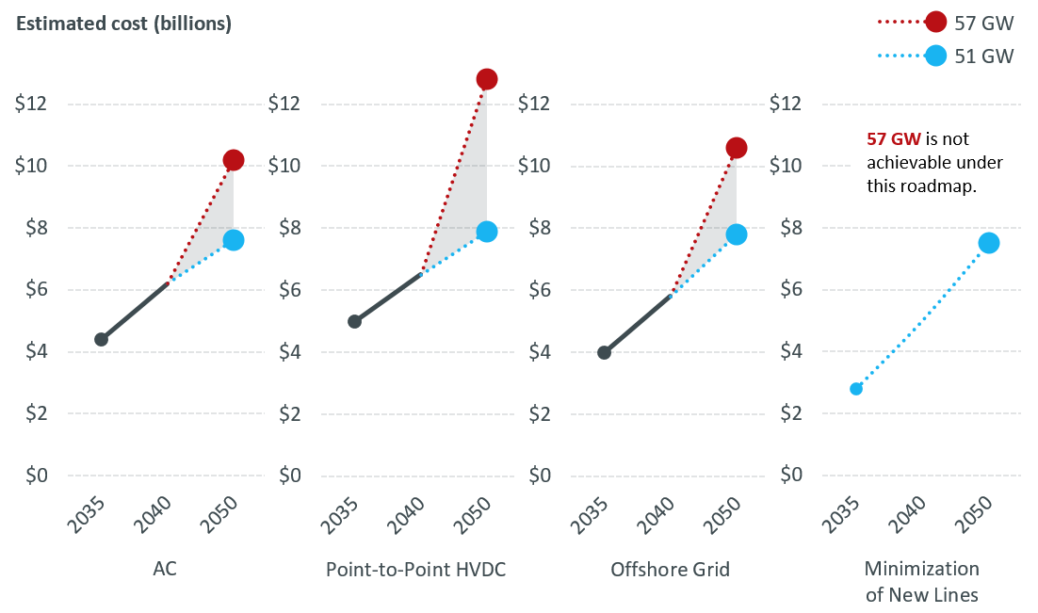
Figure 5-1: Estimated Cumulative Costs for North-South/Boston Import Roadmaps

Figure 5-2: Cost Categories for North-South/Boston Import Roadmaps: 51 GW Winter Peak

Figure 5-3: Cost Categories for North-South/Boston Import Roadmaps: 57 GW Winter Peak

Costs illustrated in Table 5-4 and Figure 5-4 are associated with the Northwest Vermont roadmaps. As with North-South/Boston Import costs above, multiple roadmaps were developed for this high-likelihood concern and detailed in Section 4.2. Figure 5-5 and Figure 5-6 categorize the costs by rebuild type for both the 51 GW and 57 GW winter peak load snapshots.
Table 5-4: Estimated Cumulative Costs for Northwestern Vermont Import Roadmaps
Year/Load Level | PV-20 Upgrade and Doubling of K-43 Roadmap | Coolidge – Essex Roadmap | New Haven – Essex and Granite – Essex Roadmap | Minimization of New Lines Roadmap
2035 | $0.7 Billion | $1.1 Billion | $1.1 Billion | $0.6 Billion
2040 | $0.8 Billion | $1.3 Billion | $1.1 Billion | $0.8 Billion
2050 (51 GW winter peak) | $0.9 Billion | $1.5 Billion | $1.2 Billion | $0.9 Billion
2050 (57 GW winter peak) | $1.2 Billion | $2.0 Billion | $1.4 Billion | $1.2 Billion

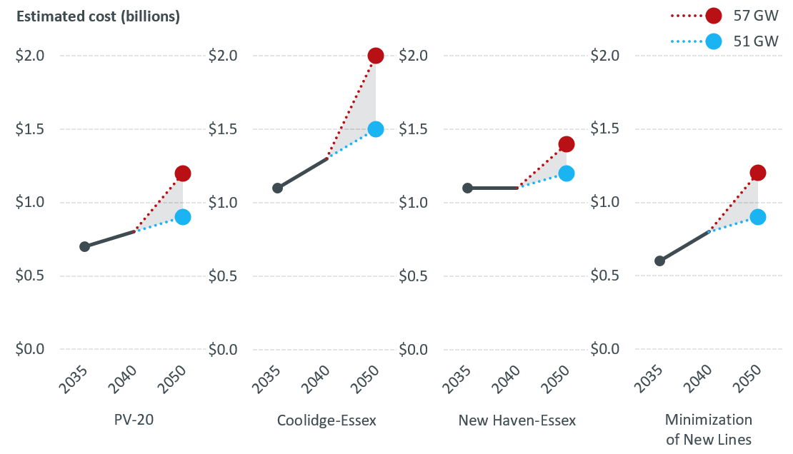
Figure 5-4: Estimated Cumulative Costs for Northwestern Vermont Import Roadmaps

Figure 5-5: Cost Categories for NWVT Import Roadmaps: 51 GW Winter Peak

Figure 5-6: Cost Categories for NWVT Import Roadmaps: 57 GW Winter Peak

Costs illustrated in Table 5-5 are associated with the Southwest Connecticut Import high-likelihood concern.
Table 5-5: Estimated Cumulative Costs for Southwest Connecticut Import
Year/Load Level | Southwest Connecticut Import
2035 | $0.5 Billion
2040 | $0.7 Billion
2050 (51 GW winter peak) | $0.8 Billion
2050 (57 GW winter peak) | $1.6 Billion

Costs illustrated in Table 5-6 are associated with miscellaneous high-likelihood concerns.
Table 5-6: Estimated Cumulative Costs for Southwest Connecticut Import
Year/Load Level | Miscellaneous High-Likelihood Concerns
2035 | $1.7 Billion
2040 | $2.8 Billion
2050 (51 GW winter peak) | $3.1 Billion
2050 (57 GW winter peak) | $3.1 Billion

Table 5-7 shows the costs associated with addressing non-high-likelihood concerns:
Table 5-7: Estimated Cumulative Costs for Non-High-Likelihood Concerns
Year/Load Level | Non-High-Likelihood Concerns
2035 | $0.4 Billion
2040 | $1.4 Billion
2050 (51 GW winter peak) | $3.3 Billion
2050 (57 GW winter peak) | $6.6 Billion

Table 5-8 totals the costs associated with each year in the tables above and provides a range of costs for each year studied, while Figure 5-7 illustrates how those costs change by year studied and maximum load served.
Table 5-8: Estimated Cumulative Costs by Year Studied
Year/Load Level | Maximum Load Served (MW) | Total Cost Range | Cost Breakdown
2035 | 35,000 | $6-9 Billion | $2.8-5.0 Billion | N-S/Boston
 |  |  | $0.6-1.1 Billion | NWVT
 |  |  | $0.5 Billion | SWCT
 |  |  | $1.7 Billion | Misc. HLC
 |  |  | $0.4 Billion | Non-HLC
2040 | 43,000 | $11-13 Billion | $5.0-6.5 Billion | N-S/Boston
 |  |  | $0.8-1.3 Billion | NWVT
 |  |  | $0.7 Billion | SWCT
 |  |  | $2.8 Billion | Misc. HLC
 |  |  | $1.4 Billion | Non-HLC
2050 (51 GW winter peak) | 51,000 | $16-17 Billion | $7.5-7.9 Billion | N-S/Boston
 |  |  | $0.9-1.5 Billion | NWVT
 |  |  | $0.8 Billion | SWCT
 |  |  | $3.1 Billion | Misc. HLC
 |  |  | $3.3 Billion | Non-HLC
2050 (57 GW winter peak) | 57,000 | $23-26 Billion | $10.2-12.8 Billion | N-S/Boston
 |  |  | $1.2-2.0 Billion | NWVT
 |  |  | $1.6 Billion | SWCT
 |  |  | $3.1 Billion | Misc. HLC
 |  |  | $6.6 Billion | Non-HLC

Figure 5-7: Total Costs by Year Studied
Note that these costs are only part of the required total investment in the transmission system. Other costs include asset condition projects unrelated to this study, and costs required to meet voltage, stability, and short-circuit needs. While these costs appear to be quite large, they should be viewed in the context of typical transmission system expenditures in New England on a yearly basis. The spending on these projects will be spread out over a 26-year period between now and 2050, so the total cost of $16-$17 billion to serve a 51 GW winter peak load is approximately $0.62-$0.65 billion per year. Similarly, the total cost of $23-$26 billion to serve a 57 GW winter peak load results in average spending of approximately $0.88-$1.00 billion per year. By way of comparison, total transmission project spending between 2002 and 2023 on both reliability-based projects and asset condition projects totaled $15.3 billion, or an average of approximately $0.73 billion per year. Similarly, the forecasted combined spending on reliability and asset condition projects in the upcoming five-year period, from December 2023 through December 2028, is a total of approximately $3.85 billion, or an average of $0.77 billion per year. Many of the line rebuilds proposed in this study will also overlap with asset condition needs, and any one project could address both system expansion and aging equipment.

: Future Work
The 2050 Transmission Study is the first longer-term transmission study conducted for New England. Results revealed many important lessons about the future development of New England’s transmission system, and many opportunities for similar studies in the future. As time passes, the assumptions regarding generator types, sizes, and locations used in this study will be replaced with real-life data, providing more precision around the transmission system upgrades that will be required in the future.
One potential area of focus for future longer-term transmission studies is the addition of analysis beyond steady-state thermal analysis. As mentioned in Section 1.1.4, the scope of this study was limited to steady-state thermal analysis, due in part to uncertainties about the detailed characteristics of future generators. More detailed models of future generation projects will allow future studies to include analysis of transmission system voltage, which will shed light on certain substation upgrades that may be required to maintain acceptable voltage and avoid equipment damage. In addition, these models may permit the ISO to analyze transient stability and electromagnetic transient (EMT) performance. These types of analyses examine the performance of the system in the milliseconds to seconds following an unexpected event like a lightning strike or tree contact on a transmission line, ensuring that generators can continue supplying power through the event and that the system can recover to a new operating condition. Finally, future longer-term transmission studies may leverage the findings of the ISO’s economic studies to examine conditions other than summer and winter peak loads. Analysis from economic studies will predict likely system conditions for off-peak periods (including load levels, renewable energy output, and the types of generators likely to be operating in a given hour), and can highlight periods of particular stress on the transmission system. This data can then be used in a future longer-term transmission study to examine the transmission system’s performance during these periods of interest.
At the time of this report’s publication, the longer-term transmission study process is purely informational. However, the ISO began stakeholder discussions on Phase II of the longer-term transmission study process in October 2023. This second phase is designed to create a process in the ISO New England Open Access Transmission Tariff by which NESCOE can choose transmission system concerns to address, conduct a Request for Proposals to solicit transmission project proposals, and then advance those proposals towards construction and operation. Depending on the timing of these changes to the Tariff, the results of this study or other future longer-term transmission studies may inform this solution development process.
Another key topic related to the future of the New England power system is the expansion of the distribution system. Plans for the distribution system are outside the ISO’s jurisdiction and area of expertise but could be a key input for further transmission studies. With more granular data on plans to meet customer load, future longer-term transmission studies can include better data on the location and sizes of substations that transfer electricity from the transmission system to local distribution systems, and eventually to individual customers. This will allow for more precise modeling of the future transmission system and a more accurate view of the region’s future power system.

: Conclusion
As the clean energy transition accelerates, power flows across New England’s transmission system will eclipse all previous highs. The “best case” 51 GW winter peak load snapshot analyzed in this study is more than double the highest winter peak ever recorded in New England, January 2004’s 23GW level, and the “worst case” 57 GW winter peak load snapshot is almost 150% higher. Assuming increased build-outs of renewables continue, and electrification of heating and transportation proceeds as expected, the region’s aging transmission system has the potential to become a significant bottleneck to progress if it does not keep pace with changes to other elements of the power system.
In 2021, NESCOE and the ISO recognized that the traditional 10-year planning horizon was no longer sufficient to adequately analyze a transmission system undergoing such immense change. The 2050 Transmission Study is an unprecedented look at the future of New England’s transmission system, and the results produced by this study will assist stakeholders and the ISO in making important decisions about improvements and pathways forward. Processes developed and lessons learned in this study also pave the way for future studies, as the ISO continues to meet its commitment to overseeing a reliable and cost-effective regional transmission system. With the addition of the Longer-Term Transmission Planning process to the ISO New England Open Access Transmission Tariff, studies like this one will be conducted periodically to re-assess the long-term evolution of the transmission system and associated costs.
Although the roadmaps provided in this study are not intended as comprehensive plans, and overloads and issues associated with the high-likelihood concerns may not occur in exactly the way this study has outlined, these big-picture observations represent a large step towards meeting the challenges that lie ahead for New England’s transmission system. Ensuring the reliable, economic delivery of electricity that customers have come to expect will require innovative solutions, and most importantly, collaboration and communication between stakeholders, the states, transmission owners, and the ISO.
Targeted approaches to problem-solving, like optimizing generator locations or right-sizing asset condition projects, could become particularly crucial as the region moves towards upgrading an aging system in the most cost-effective manner. Such targeted problem-solving requires cooperation and collaboration. The ISO will continue to provide the forward-looking analysis presented in this study in future studies, and will continue to focus on longer-term transmission planning studies in collaboration with stakeholders to help identify the best paths forward.

The six New England states are Connecticut, Maine, Massachusetts, New Hampshire, Rhode Island, and Vermont. The five states with the emissions reduction goals described here are Connecticut, Maine, Massachusetts, Rhode Island, and Vermont.
Load is defined as the demand for electricity measured in megawatts; electricity consumption; the amount of electric power delivered to any specified point on a system, accounting for the requirements of the customer’s electrical equipment.
For further details on the data set created by DNV, please see the “Variable Energy Resource (VER) Data” page on the ISO-NE website.
The No Thermal Pathway assumed all thermal capacity retired by 2050; the 100% Renewable Pathway assumed no fossil fuels allowed, with zero-carbon combustion fuels allowed for electricity generation by thermal power plants.
For further details on the reasons for this recasting and the process used, please see slide 11 of the following presentation: https://www.iso-ne.com/static-assets/documents/2021/04/a8_2021_economic_study_request_assumptions_part_1_rev2_clean.pdf
For further details, please see the November 2021 presentation on the 2050 Transmission Study scope of work.
An exact definition of the New England PTF may be found in section II.49 of the ISO New England Open Access Transmission Tariff.
The distribution of loads between the New England states can vary from month to month, day to day, and hour to hour. Values cited are seasonal approximations.
Detailed maps and diagrams of the New England transmission system may be found on ISO-NE’s website, at https://www.iso-ne.com/about/key-stats/maps-and-diagrams.
One exception is that Aroostook County and part of Washington County in Maine receive electricity from New Brunswick, and are administered by the Northern Maine Independent System Administrator (NMISA) rather than ISO New England.
This subsection concentrates on winter peak loads, which are the highest loads in the 2050 Transmission Study. These winter peak loads occur after sunset, so there is no difference between “gross load,” or the actual amount of power consumed by end users before reductions due to rooftop solar, and “net load,” or the load served by the transmission system after these reductions.
An interface is a boundary on the power system across which power flow is measured. For example, the Maine-New Hampshire interface is the sum of the flows on all six transmission lines connecting Maine to New Hampshire.
Numbers in this table are based on N-1-1 results when accounting for single-element second contingencies (loss of line, transformer, etc.) but not multiple-element second contingencies (breaker failures, double-circuit tower contingencies, etc.). Mileage includes both lines fully within the Boston subregion and lines crossing the Boston Import interface, which connect the Boston subregion to the remainder of New England.
Capitalized wind project names in this section and in Figure 4-4 are purely hypothetical, and are merely provided as placeholders in order to reduce confusion. These names refer to the onshore substations to which each wind farm connects.
Replacement of existing pipe-type underground cables in the Boston area for asset condition reasons, as mentioned on slide 13 of a July 2023 presentation regarding upcoming asset condition projects, is not included in this analysis, and the cost is not included in the total costs discussed in Section 5 of this report. When analysis for the 2050 Transmission Study was conducted, sufficient information to model these projects was not available.
It may be prudent to build this line to 345 kV standards in advance, to allow for an eventual conversion of the Vermont and New Hampshire 230 kV systems to 345 kV if necessary.
Temporary over-voltage is a phenomenon caused by short-circuit conditions and by switching of transmission elements. This phenomena is particularly severe in areas with significant development of underground transmission, including Southwest Connecticut.
Numbers in this table are based on N-1-1 results when accounting for single-element second contingencies (loss of line, transformer, etc.) but not multiple-element second contingencies (breaker failures, double-circuit tower contingencies, etc.).
Double-circuit towers are structures supporting two overhead transmission lines on the same structure. NERC, NPCC, and ISO-NE reliability criteria require the consideration of the loss of both lines on double-circuit towers simultaneously, which is often caused by lightning strikes. Separation of circuits on double-circuit towers involves building new structures for at least one of the two circuits, and depending on the right-of-way layout, may or may not require additional right-of-way width.
PP4 Attachment D is available on ISO-NE’s website at https://www.iso-ne.com/static-assets/documents/rules_proceds/isone_plan/pp04_0/pp4_0_attachment_d.pdf.
Source: RSP Project List and Asset Condition List June 2023 Update, https://www.iso-ne.com/static-assets/documents/2023/06/final_project_list_presentation_june_2023.pdf

