

**Economic Planning for the Clean Energy Transition:**

**Illuminating the Economic Challenges of Tomorrow’s Grid**

**DRAFT**

**© ISO New England Inc.**

**August 16, 2024**

**ISO-NE Public**

# Preface

The Economic Planning for the Clean Energy Transition (EPCET) study is the culmination of ISO New England’s lessons learned in the economic study process over the last several years. This wide-ranging, rigorous analysis highlights many of the potential economic challenges of the clean energy transition, and is supported by 33 [published](https://www.iso-ne.com/committees/planning/planning-advisory/?open_projects_value=Economic%20Planning%20for%20the%20Clean%20Energy%20Transition%20(EPCET)) scenarios and more than 2,800 simulations, presenting a comprehensive vision of what tomorrow’s grid might look like.

The New England states have set ambitious goals for reducing carbon emissions by 2050, and ISO New England studies such as EPCET help the region evaluate how the grid might evolve over this transition.[1] The expected shift toward mostly renewable, carbon-free power generation, coupled with electrification of heating and transportation, will radically transform the grid’s supply and demand. EPCET is the ISO’s first study to use new models, tools, and processes that allow for a more realistic picture of this expected shift. In its forward-looking scenarios, the study identifies trends and challenges likely to materialize as the region moves to cleaner energy. The study’s near-term modeling explores issues related to energy adequacy and the challenges of minimum load conditions that will begin to appear in the early 2030s. Longer-range analyses, looking as far out as 2050, focus on trends relating to public policy, including the cost of deep decarbonization and how dispatchable generation can complement intermittent resources. EPCET also includes a stakeholder-requested analysis to explore future market structures and revenue adequacy.

This study identifies trends that, if left unaddressed, could result in threats to power system reliability, a prolonged over-reliance on fossil fuels, failure to meet state decarbonization goals, inefficient spending and investment, or other negative outcomes. EPCET’s analysis is supported by other ISO studies like the [Pathways Study](https://www.iso-ne.com/static-assets/documents/2022/04/schatzki-et-al-pathways-final.pdf), [Future Grid Reliability Study](https://www.iso-ne.com/static-assets/documents/2022/07/2021_economic_study_future_grid_reliability_study_phase_1_report.pdf) (FGRS), [Operational Impacts of Extreme Weather Events](https://www.iso-ne.com/static-assets/documents/100006/operational_impact_of_exteme_weather_events_final_report.pdf) (also known as the Probabilistic Energy Adequacy Tool), and the [2050 Transmission Study](https://www.iso-ne.com/static-assets/documents/100008/2024_02_14_pac_2050_transmission_study_final.pdf). Although these studies cover different timeframes and topics, together with EPCET they form a wide-ranging vision of the future grid, and include insights related to the four pillars ISO New England has identified as key to a reliable clean energy future:

1) significant amounts of **clean energy** resources

2) sufficient **balancing resources** to ensure reliability

3) **energy adequacy** via a reliable fuel supply chain or energy reserve and

4) a **robust transmission** system.

The following table outlines EPCET’s three main study scenarios and one main sensitivity. Modeling also includes sensitivities not shown in this table.

|  |  |  |  |  |
| --- | --- | --- | --- | --- |
|  | Benchmark Scenario | Market Efficiency  Needs Scenario | Policy Scenario | Stakeholder-Requested Sensitivity |
| Timeframe Studied | 2021 | 2032 | Up to 2050 | Up to 2045 |
| Purpose | Compared the model’s results to actual historical system performance. | Identify gaps in ISO-administered markets within the traditional 10-year system planning range, using production cost modeling. | Explore the system performance of a hypothetical buildout of new resources that could help meet New England’s current carbon emission policy goals, using capacity expansion modeling. | Evaluate the reliability, market performance and revenue sufficiency of potential future resource mixes.[2] |
| Key Findings | This scenario tested the model’s validity, and adjustments were made as necessary. | System becomes more susceptible to challenging minimum load conditions, and energy adequacy concerns increase.  Congestion occurs mostly in the same areas that experience congestion today. | System achieves moderate decarbonization, but deeper decarbonization drives escalating costs.  Variability of peak loads between years increases dramatically.  Continued need for fuel-secure dispatchable resources.  Long-duration storage eventually becomes the most economically viable resource for achieving carbon reduction goals. | Some revenue streams in today’s grid, including power purchase agreements (PPAs), become far less economically viable over time.  Energy market becomes much smaller, and is eventually overtaken in size by PPAs and the capacity markets combined.  Discretionary load opportunities arise.  Targeted amounts of dispatchable resources and market elements that incentivize reliability help system economics. |

# Key Findings

Over the next decades, the New England states’ goals to reduce carbon emissions will transform the regional power grid. Fossil fuel-burning dispatchable resources that ensure reliable service in today’s system may be largely retired, and intermittent, low-to-zero-carbon renewable resources like wind, solar, and battery storage could provide most of the grid’s energy. Adoption of electric vehicles will accelerate, and electric heating systems in homes and businesses will displace oil and natural gas. Planning for and managing this transformed grid will require innovative and flexible solutions.

EPCET’s key findings converge on a common theme: **designing the power system of the future requires balancing reliability, economic efficiency, and carbon-neutrality**. Given current technology and market structures, no single existing scalable resource type is highly reliable, inexpensive *and* carbon-neutral. Future planning will require tradeoffs among these three factors.

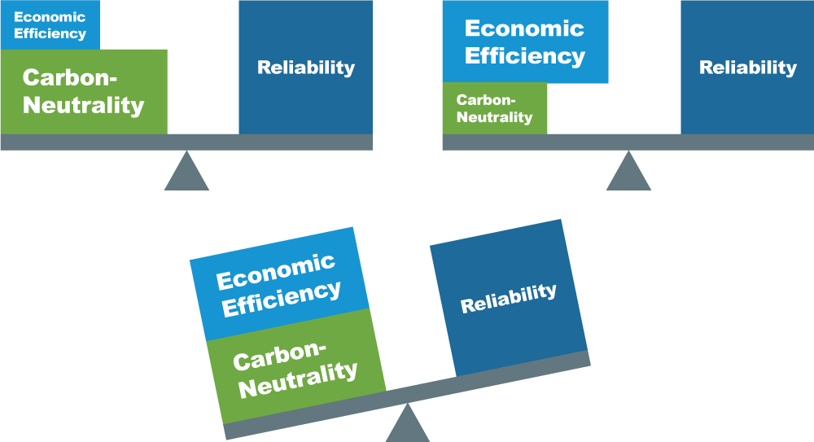

The region can make choices that could lessen the degree of required tradeoffs. Changes to current market rules and compensation strategies, for example, may ensure continued power system reliability and reduce carbon emissions while remaining economical. Future market mechanisms, designed to compensate resources capable of providing dispatchable, zero-carbon energy, could support generators that provide critical reliability services but run less frequently than other types of resources.

Though ISO New England has limited jurisdiction over the choices connected to these tradeoffs, EPCET’s key findings illustrate high-level observations about the future grid under many possible weather conditions, supported by multiple scenarios, sensitivities and simulations. Some findings explore potential solutions to challenges. Granular data about each finding is provided in ISO presentations on the [Final Benchmark and Market Efficiency Needs Scenario Results](https://www.iso-ne.com/static-assets/documents/100014/epcet_benchmark_mens_final_results.pdf) and [Final Policy Scenario and Stakeholder-Requested Sensitivity Results](https://www.iso-ne.com/static-assets/documents/100014/epcet_policy_final_results.pdf).

## Most paths to a low-carbon grid involve high variability in demand and supply.

One of EPCET’s broader themes is an expected increase in the variability of both supply and demand between future years. This variability appears first in the Market Efficiency Needs Scenario modeling of the 2030s, and accelerates dramatically in the longer-term Policy Scenario modeling of the 2040s and beyond.

Simulations of future years are modeled under a wide variety of weather conditions based on annual historical observations, called “weather years.” Modeling simulates the grid’s expected supply and demand under conditions from the 20 different weather years between 2000 and 2019. As the model’s heating electrification increases, weather has a greater effect on demand, and variability of peak demand for electricity between weather years increases.

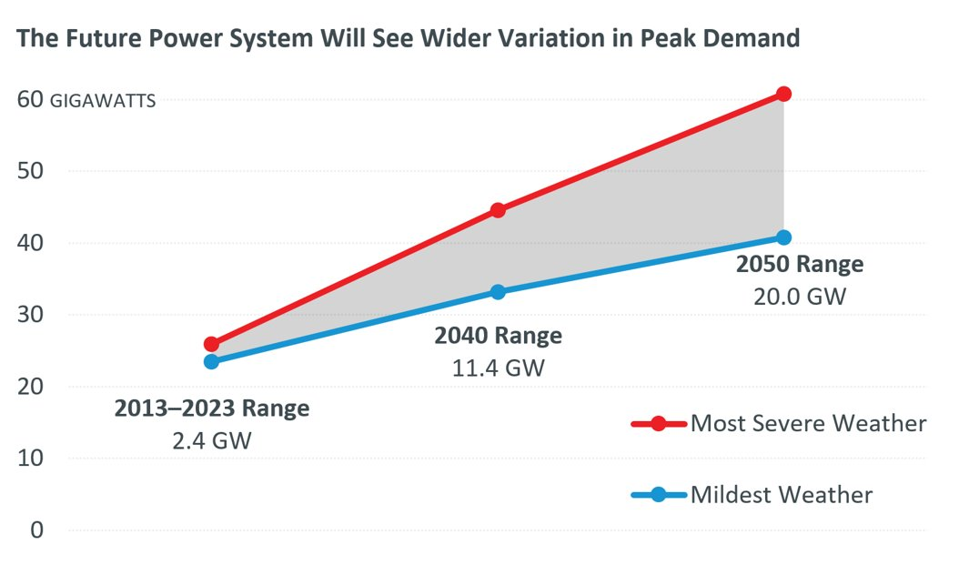Today’s electrical grid experiences only modest variations in peak annual demand from year to year, allowing for efficient planning for a limited range of possible outcomes. In the future, however, electric heating will shift annual system peak demand from summer to winter. The magnitude of the annual peak will vary dramatically from one year to the next, depending on how cold or how mild a winter the region sees. The figure above shows the variation in peak demand observed over the last decade, and the variation in peak demand between the mildest and most severe weather years modeled in EPCET’s 2040 and 2050 systems.[3]

As penetration of wind and solar resources increases, supply will also become much more weather-dependent, and thus much more variable. At times of low wind and solar generation, a renewable-heavy system may not produce enough energy to satisfy demand. Most weather years in the Policy Scenario analysis experience such stretches—and in these stretches, stored fuels meet demand.

## The large variation in peak demand will require vastly different supply from year to year. Some years will require all resources to operate. In other years, certain resources will run for just for a few hours, or not at all.

As variability in peak demand increases, the system will rely on certain dispatchable resources to maintain reliability, but these resources will run less and less frequently over time. The New England power grid will need to reliably serve peak demand for the most severe winter conditions the region might see. But despite the possibility of severe cold, most winters are likely to be milder, with significantly lower peaks. As a result, certain resources needed to maintain reliability during the harshest conditions may only run once every few years.

The Policy Scenario analysis uses capacity expansion modeling, which “builds” resources as needed to simulate a reliable system given particular weather conditions and demand for electricity. Build-outs for the Policy Scenario are optimized according to a single weather year, 2019, which featured typical weather conditions for the region. In order to evaluate how these hypothetical systems would perform under a wide variety of conditions besides a typical year, the study also analyzes their performance over 20 alternate weather years.

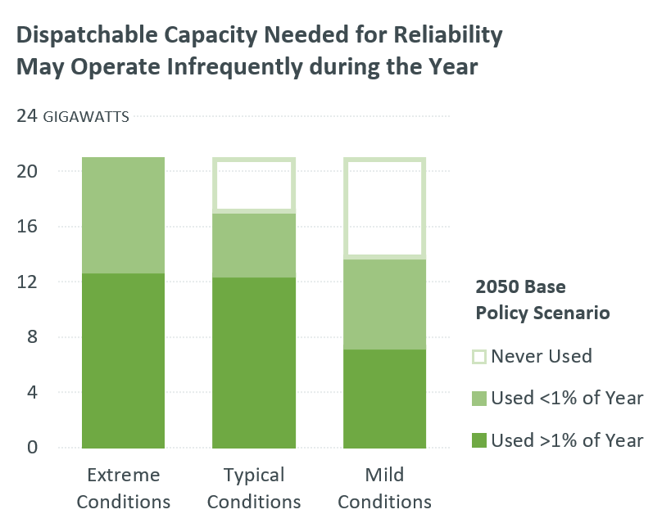Results from the 2050 build-out, shown in the image to the left, illustrate how rarely some resources will run in the future. In the most extreme winter conditions, 2050’s build-out would rely on 20.8 GW of dispatchable resources, while under the mildest weather conditions, it would need just 13.8 GW. But significant quantities of these resources would be used for less than 1% of the year. And since the grid must be ready to serve load under the most extreme conditions, significant quantities of dispatchable resources will sit idle during milder winters.

If these dispatchable resources run rarely, they will earn less revenue through the energy and ancillary services markets, which may mean they receive greater revenues through other means, like the capacity market, or new market mechanisms (see section 1.6).[4],[5]

EPCET’s forecasted peak demand inputs are taken from ISO New England’s [2022 Forecast Report of Capacity, Energy, Loads, and Transmission](https://www.iso-ne.com/system-planning/system-plans-studies/celt) (the CELT Report). For years beyond the 10-year horizon of the CELT Report, EPCET includes profiles generated from the ISO Load Forecasting team. If actual peak demand levels in future years are lower than these forecasts, overall variability among years will decrease, and fewer resources will be required to ensure reliability, reducing overall system costs.

This would not, however, address the variability of supply. All 20 weather years in the modeled 2050 system require dispatchable generation to serve load for between 8 and 13% of that year, underscoring the need for dispatchable resources in the policy horizon years despite a significant build-out of wind, solar, and battery resources. These modeled periods when dispatchable resources fill in energy gaps are not necessarily characterized by significantly high demand. Rather, they coincide with hours when wind and solar resources produce less due to weather, and energy storage is depleted.

## Emissions reductions will be seasonal. Some months will decarbonize years before others.

Decarbonization in the later years of capacity expansion modeling is highly correlated with the season, and certain times of the year are expected to decarbonize much faster than others. Modeled seasons decarbonize in the following order: spring, fall, summer, and, finally, winter. Notably, spring and fall will decarbonize long before winter. The table and illustration below show the progressive decarbonization of seasons over the Policy Scenario years, and highlight May and December as the first and last months to decarbonize.

Seasonal Reductions in Emissions (from 2022 levels) by Policy Scenario Year

|  |  |  |  |
| --- | --- | --- | --- |
|  | 2040 | 2045 | 2050 |
| **May** | 95% | ~100% | 100% |
| **All spring and fall months** | 88% | 97% | 100% |
| **Summer** | 75% | 94% | ~100% |
| **All winter months** | 52% | 72% | 95% |
| **December[6]** | 36% | 59% | 90% |

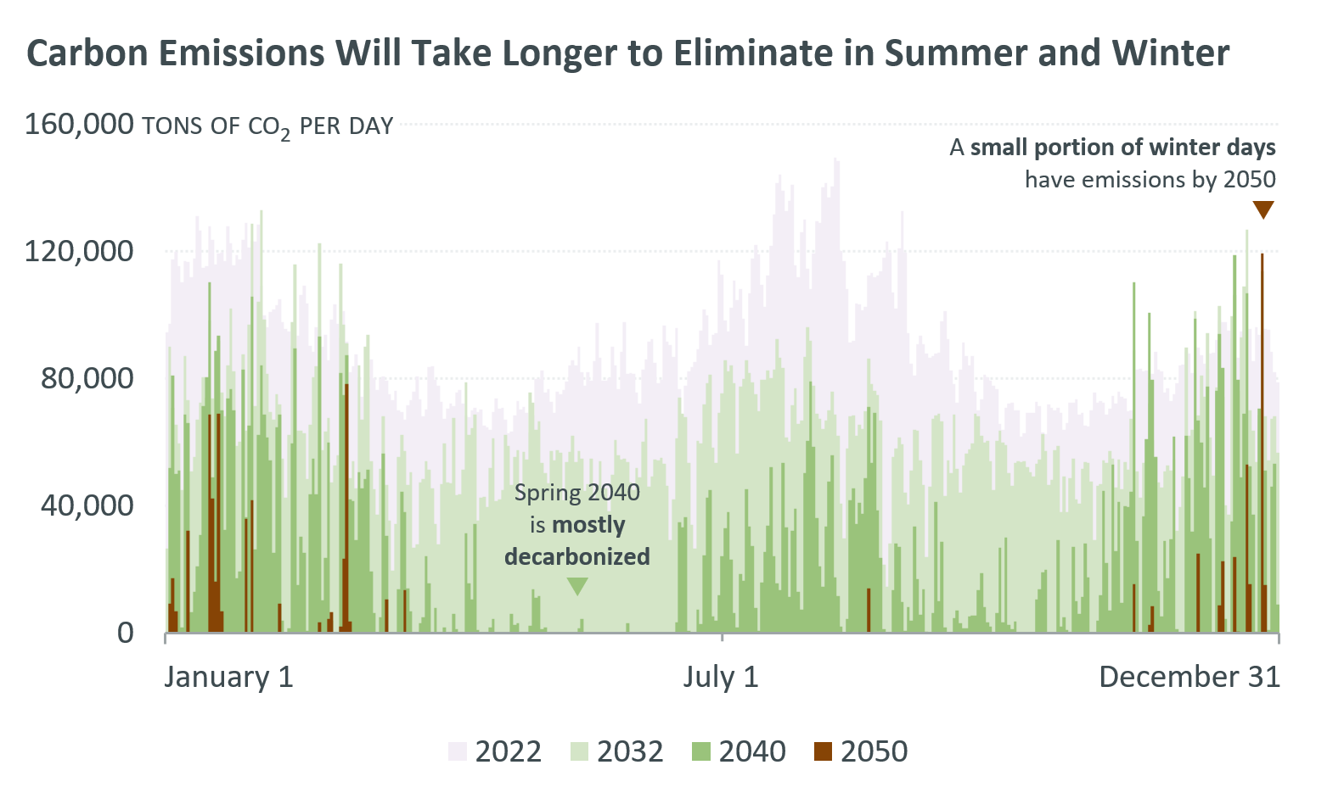

This trend is driven by two factors: seasonal demand and seasonal intermittent renewable generation. Demand is lower in spring and fall due to milder temperatures, and higher in summer and winter, when energy is used to cool or heat buildings. Electric vehicle charging also requires more energy in colder months. Similarly, wind and solar have different output levels in different seasons. Winters tend to be windy, but less sunny, while summers tend to be sunnier, but less windy. Spring and fall tend to be moderately sunny and windy. Together, these trends mean intermittent resources can more easily meet demand in the shoulder seasons, which will significantly decrease or eliminate emissions during these months.

While it would be useful to take excess energy from the spring and fall and shift it to the summer and winter, this would require vast quantities of energy storage. Given current technology, achieving this quantity of storage is unlikely to be economical.

## Renewable-only build-outs may be vast, and later additions of renewable resources could have diminishing environmental and economic returns.

As variability increases, larger and larger build-outs of wind, solar and batteries will be required to ensure reliability throughout the year. These build-outs will increase costs and could require significant amounts of land-based or offshore areas for siting. As more hours of each year decarbonize, new renewable additions will have less impact on reducing carbon emissions, particularly in the spring and fall months that are expected to decarbonize first.

### Scale of Renewable Build-Outs

EPCET’s Policy Scenario models the annual additions of zero-carbon resources necessary to achieve New England state policy goals by 2050.[7] Results show that the New England system will need 97 GW of total new renewable capacity by 2050 to achieve state goals. The figure below illustrates the average, simultaneous build-out that would be required ***each year***, for four types of renewable technologies.

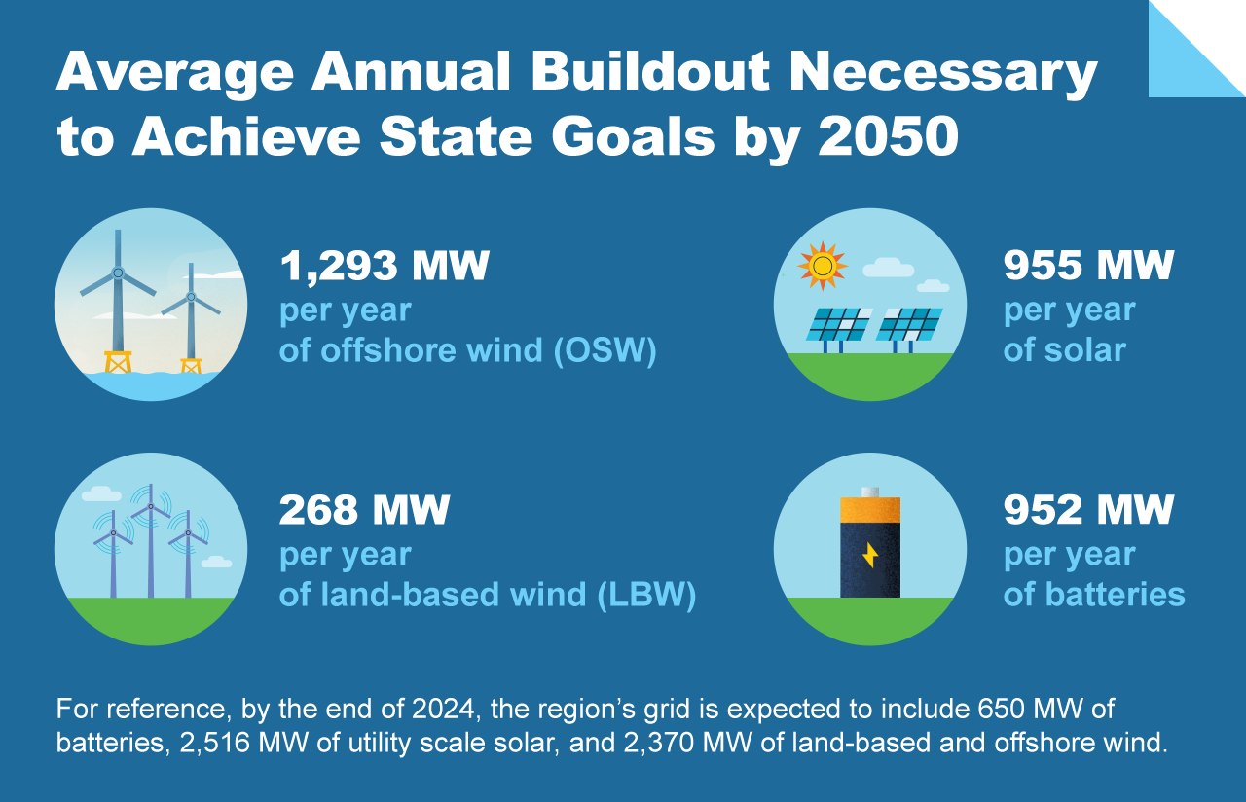

**While rates of renewable additions are accelerating, the region will need to add roughly 18 times its current combined capacity of wind, solar, and batteries within the next 25 years to achieve state emissions goals.** The region’s current renewable capacity was built almost entirely over the last two decades, and the necessary additions require significantly more capacity in only two and a half decades. The image below illustrates the square acreage of offshore wind that EPCET’s modeled 2050 requires to meet emissions goals. Three possible acreages are illustrated, based on different density scenarios.[8]

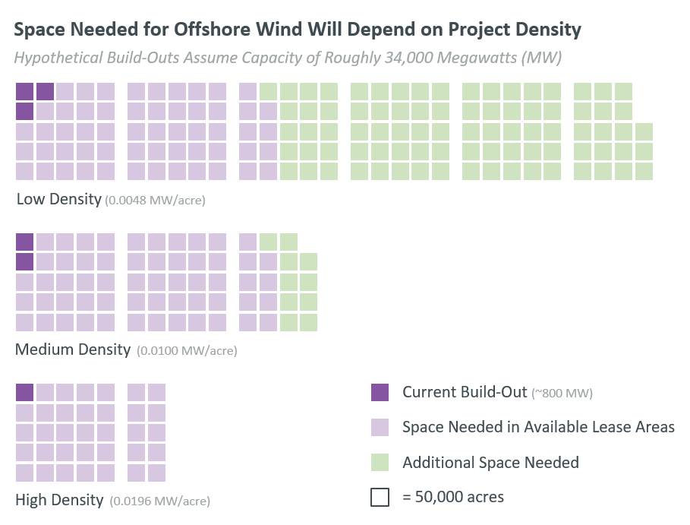

Significant quantities of renewable resources will be required specifically to decarbonize the few remaining hours of the year when fossil fuel-burning dispatchable resources are running, i.e., a few key days in winter. However, the expected seasonality of decarbonization means that by 2045, a newly-added renewable may run for just 10% of that year. As a consequence, the majority of resource additions in later years will be curtailed (their production will be limited by system operators) for most of the year. The image below supposes three new renewable resource units, each with a nameplate capacity of 1 gigawatt (GW), and illustrates how much energy they actually provide to the grid over time. The offshore wind example has the potential to provide almost 4,000 GWh of energy per year. However, the actual energy used reaches a high of 3,200 GWh in EPCET’s modeled 2035 and declines to 425 GWh in 2050.

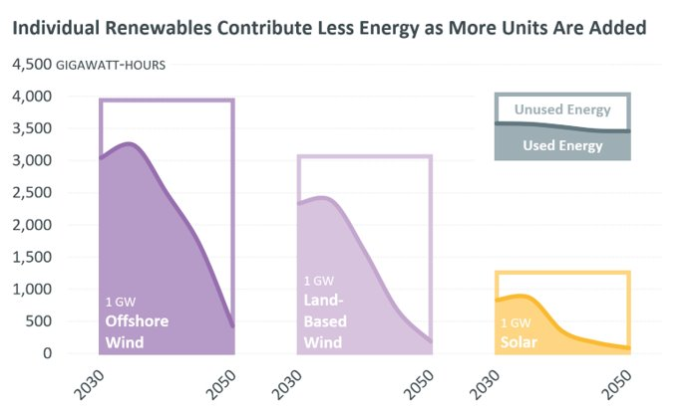

Similarly, the figure below supposes 1 GW each of 4-hour and 8-hour battery storage units. In the 4-hour example, the unit has the potential to operate for about 1,000 cycles per year. But in EPCET’s simulations, it completes a maximum of 384 cycles in 2035, declining to 41 cycles by 2050.

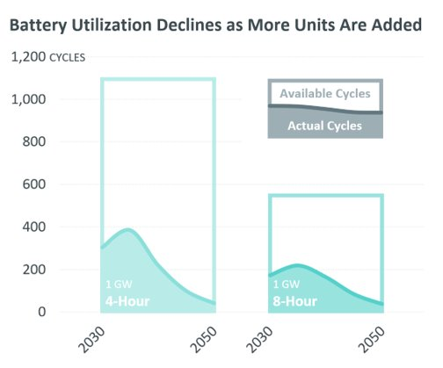

The marginal cost of carbon abatement and zero-carbon energy become very large in the later years of the study’s scope.

Altogether, EPCET analysis suggests it will require significant capacity to fully decarbonize an entire year:

* 36 GW of new capacity will significantly decarbonize the spring and fall months and provide increased decarbonization in other months.
* 73 GW of new capacity will almost fully decarbonize spring, fall, and summer.
* 97 GW of new capacity will decarbonize every month outside of winter and significantly reduce winter emissions.

## Higher variability will increase the value of current and future dispatchable resources, including long-duration storage.

Since increasing variability will require a critical fleet of dispatchable resources that can quickly meet demand whenever it is needed, planned retirements of fossil fuel generators in the coming decades may affect system reliability. Longer-duration storage that provides dispatchability will help support reliability, but will not solve all challenges. Seasonal storage that could charge in spring and fall for deployment in winter would be particularly valuable.

### Assessing the Need for Dispatchable Resources

Despite vast additions of wind, solar, and energy storage resources, EPCET’s modeled 2045 and 2050 show some hours requiring significant dispatchable generation. In today’s system, dispatchable generation is typically powered by fossil fuels. Though EPCET’s Policy Scenario does not include in-depth resource adequacy analysis, [FGRS resource adequacy analysis](https://www.iso-ne.com/static-assets/documents/2022/07/2021_economic_study_future_grid_reliability_study_phase_1_report.pdf#page=46) of a potential 2040 system showed that removing a small quantity of dispatchable resources with firm fuel supplies would require significantly more wind, solar, and energy storage to meet reliability criteria.

EPCET’s Stakeholder-Requested Sensitivity evaluates what quantity of dispatchable resources the system will need over the study’s timeframe through a “resource adequacy check” step. At five-year intervals, this step identifies whether additional storage would be required to meet energy shortfalls, or whether older generators could retire if no longer needed for reliability.

Before the 2030s, the modeled system is resource adequate—implying firm, dispatchable capacity will be sufficient to meet demand. By the mid-2030s, however, as peak loads grow, the model begins to add significant quantities of energy storage, implying a need for significantly more dispatchable resource production. This trend continues through the end of the modeling horizon. The figure below illustrates the GW of dispatchable capacity needed per year on average to meet expected demand from EPCET’s modeled 2025 to 2050.

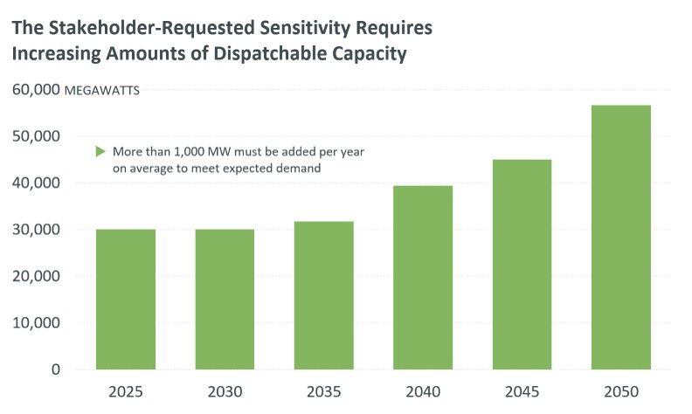

Though the model adds significant quantities of wind and solar resources in this timeframe, periods of high load and low solar and wind generation remain. During these periods, the system requires firm dispatchable resources. By 2045, wind and solar resources meet just 10 GW of the 51 GW peak gross load during peak winter demand. The modeled resource adequacy constraint requires that 110% of the remaining load must be met by dispatchable generation, which is 90% of peak gross load. A more comprehensive resource adequacy screen would likely require even more dispatchable resources.

Hourly production cost models for 2045 support the resource adequacy observations. Though zero-carbon resources serve most demand in the modeled 2045, a subset of hours require significant quantities of dispatchable generation. These hours are characterized by moderate-to-high load, and low solar and wind generation. When low solar and wind generation persist for multiple days, modeled energy storage struggles to recharge from renewable generation, and significant portions of load must be served by dispatchable generation. The model’s energy storage often charges from dispatchable generation in order to achieve adequate capacity and energy. Similar trends were observed in FGRS resource adequacy analysis, which suggests that energy storage contributes significantly more to reliability when it has fuel-secure dispatchable generation to charge from.

### Benefits and Challenges Associated with Long-Duration Storage

EPCET’s Policy Scenario analysis shows significant stretches of time in later state policy horizon years when moderate-to-high demand may coincide with low solar and wind generation, particularly beyond 2045. The 4- and 8-hour lithium ion (L-I) batteries assumed as expansion candidates in this scenario fill in some gaps during short periods of low renewable generation, but are rapidly depleted. Dispatchable generation with a firm energy supply could help maintain reliability during multi-day renewable droughts. Long-duration storage may help meet at least some of those needs.

A levelized cost analysis of later Policy Scenario years shows that over time, the decarbonization value of long-duration energy storage increases significantly, while the decarbonization value of wind, solar, and shorter-duration batteries drops. One EPCET sensitivity includes 100-hour iron air batteries in addition to 4- and 8-hour L-I batteries. As illustrated in the figure below, 100-hour batteries become the most cost-effective modeled storage type for reducing carbon emissions by 2050.

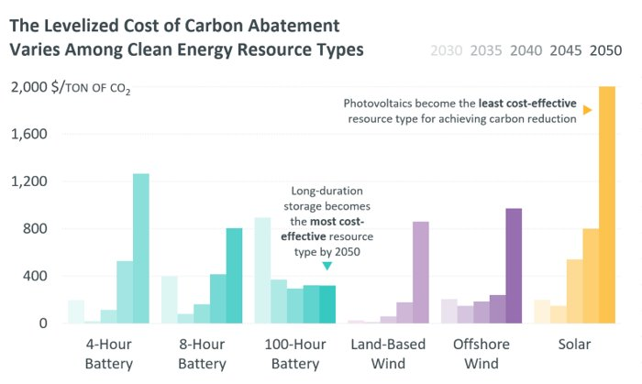

The inclusion of these 100-hour batteries reduces the total new capacity additions in this sensitivity by 16% from the base Policy Scenario by 2050, and lowers annualized costs significantly. However, even with a significant penetration of 100-hour batteries, the later years of this sensitivity still experience stretches of time when 100-hour batteries become depleted and significant fuel-secure dispatchable generation is needed to satisfy demand.

Future systems may be more energy-limited than capacity-limited. In other words, a grid with a diverse mix of renewable resources, energy storage, and dispatchable resources may have enough capacity to meet demand over a particular year or season, but the fuel in question (sun, wind, battery storage, pipeline fuel, etc.) may not be available exactly when needed. Long-duration energy storage like 100-hour batteries may be useful for shifting energy over several hours, or from one day to the next, but less useful during a multi-day wind and solar drought.

The economics and operational realities of long-duration storage are also uncertain. Despite its assumed ability to shift energy two, three or more days ahead, it is difficult in most situations to forecast arbitrage opportunities over those timeframes. The value of long-duration storage lies primarily in its ability to stay fully charged until a long cold snap when other resource types may be constrained. While the current pay-for-performance (PFP) market mechanism would compensate long-duration storage for producing energy during such an event, there is no certainty that long cold snaps will occur every winter.[9] In the event these periods do not materialize, storage resources that stay fully charged will forgo smaller but more frequent revenue opportunities during milder conditions. In a real system, long-duration storage may choose to operate conservatively, and earn less revenue while waiting for a long cold snap, or may operate more liberally during milder periods, and then lack sufficient energy during harsher conditions.

### Seasonal Storage Possibilities

Seasonal storage that can store vast quantities of energy during off-peak months to deploy during the winter would help alleviate challenges of an energy-limited system. A zero-carbon fuel that can be synthesized using excess renewable energy in the spring and fall and stored in large quantities for dispatchable generation in the winter fits these parameters, but supply chain and technology-related roadblocks may persist. Section 1.7 includes EPCET’s modeling of such a fuel.

## Current revenue structures may not adequately compensate resources for their value to the future grid.

The expected increase in variability and the critical but sporadic need for dispatchable resources to ensure reliability will change the grid dramatically, which will affect the performance of some elements of the current grid economy. EPCET’s Stakeholder-Requested Sensitivity explores how both current markets and alternative market structures and compensation strategies perform under highly variable conditions.[10] Results show that as deep decarbonization accelerates, the functionality of power purchase agreements (PPAs) changes, as does the size of the energy market. One key result illustrates that, assuming today’s PPA strategies hold, by the mid-2030s a new renewable resource becomes unprofitable within five years. Adjustments to PPA structures (section 1.6.1), the addition of market elements like reliability adders (section 1.6.3), and increased use of discretionary load (section 1.6.4) affect overall modeled market function.

### Feasibility of Power Purchase Agreements (PPAs)

PPAs are paid agreements between a customer, usually a large entity like a utility or a state, and a developer, usually of a larger-scale wind or solar resource. These agreements function outside the wholesale electricity markets that ISO New England administers. As part of the agreement, a PPA price per MWh is assigned to the proposed resource, and the customer agrees to pay the resource this price during the term of the agreement. Such agreements may help developers obtain financing. Once the generating resource is built, it bids into the energy markets at a low price (or even negative price, depending on the terms of the PPA), and the market then typically selects this resource for dispatch. Usually, the resource is paid for each MWh of energy provided at its PPA plus the energy price during periods when locational marginal prices (LMPs) are negative.[11] This outside revenue stream means that a resource that signed a $20/MWh PPA could offer as low as -$19.99/MWh into the energy market and still receive a positive payment for its energy.

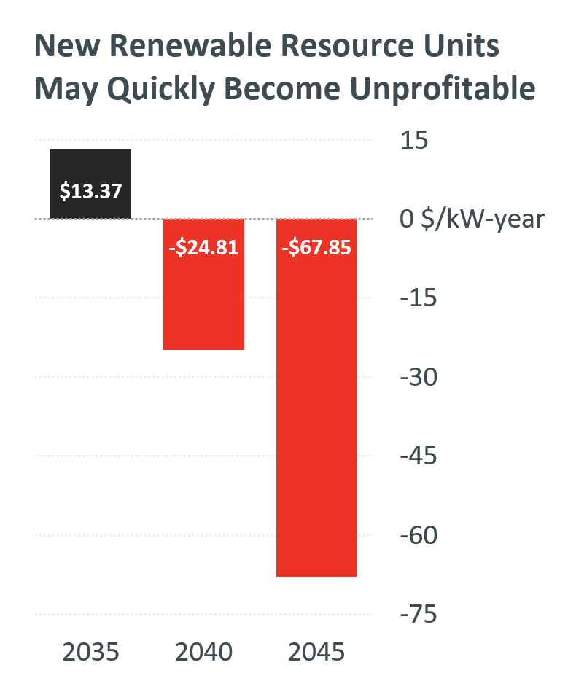Results from EPCET’s Stakeholder-Requested Sensitivity show that New England’s expected shift from a summer to winter demand peak in the mid-2030s will present feasibility challenges for current PPA structures. As noted in section 1.3, the decarbonization of spring and fall significantly outpace the decarbonization of winter. Current PPA strategies, however, are designed for a grid with carbon emissions throughout the year. EPCET’s modeling shows that PPA contracts become part of a “race to the bottom,” with the final new resources needed to complete winter decarbonization struggling to compete with resources that secured agreements years or decades earlier.

Consider, for example, a hypothetical 2040 scenario. By this time, fall and spring are essentially decarbonized. An existing wind resource with a PPA price of $50/MWh provides energy to the grid. A new wind farm seeks to enter the market, and due to supply chain and technology advancements, its build costs are less than those of the existing resource—so, it qualifies for a PPA price of $45/MWh. However, since its “break-even" LMP is -$45/MWh, which is higher than the existing resource’s break-even price of -$50/MWh, this new resource will be underbid in the energy markets, and will not run in fall and spring, when zero-carbon energy is abundant. The image to the right shows the progressive net profit of a hypothetical land-based wind resource built in 2035, with a PPA of $87/MWh. The resource is profitable the year it is built, but by 2040, its net profits have become negative. [12]

How then will states or utilities encourage the construction of new resources in order to fully decarbonize the winter months? The absolute PPA price of newer resources could be set *higher* than those of existing resources. However, under this strategy, older wind resources would be underbid in the energy markets during periods of negative LMPs, which could undermine their revenue sufficiency. Higher PPAs for newer resources may also result in higher costs to ratepayers as the marginal cost of new zero-carbon energy rises. Fundamentally, as decarbonization accelerates, but remains highly correlated with the seasons, zero-carbon resource additions will produce surplus energy for increasing periods of time, and their cost per MWh will rise. The image below shows how much unused energy a hypothetical land-based wind resource built in 2035 produces in the modeled 2040 and 2045.[13]

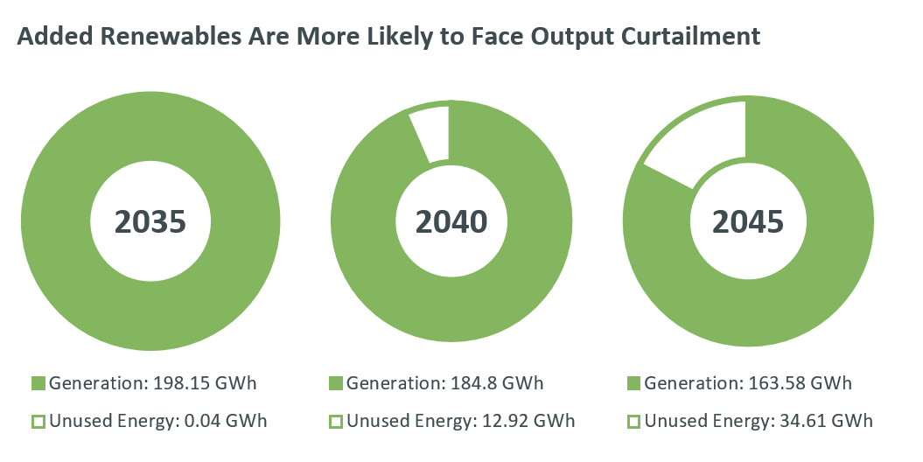

### Effect of Deep Decarbonization on Energy Markets

Results from the Stakeholder-Requested Sensitivity also illustrate how the size of capacity and the energy markets change during deep decarbonization. As EPCET’s modeled years pass, and more of the year is decarbonized, wind and solar resources with PPAs serve more and more demand. Since these resources receive out-of-market revenue streams, they receive little-to-no revenue from the energy market. Dispatchable resources *without* PPAs run less and less frequently over the model’s final years, and increasingly rely on capacity market payments to cover fixed costs. By 2045, the model’s dispatchable resources cover fixed costs through the capacity market over a variety of possible weather conditions.

During the final years of analysis, the majority of revenue for all generators is earned through either the capacity market or out-of-market PPAs. Although the energy market is currently the largest electricity market in the New England wholesale construct by a large margin, EPCET’s modeled future energy market decreases significantly in volume over time. By 2035, the combined values of the modeled capacity market and out-of-market PPAs overtake the modeled energy market.

#### Nuclear Baseload Resources

When renewable generation exceeds demand for longer stretches of time, driving extended periods of negative LMPs, any baseload resources that lack an outside revenue stream like a PPA are subject to substantial negative revenues. EPCET’s Stakeholder-Requested Sensitivity shows that baseload nuclear resources are at particular risk of exposure to periods of negative LMPs, since they cannot increase or decrease their output quickly. As a result, they continue generating energy through long periods of negative LMPs, reducing their energy market revenues.[14]

### Reliability Adder

One sensitivity of the Policy Scenario illustrates the possible effects of a reliability adder on revenue adequacy. This adder would effectively increase the bids of dispatchable resources in the energy market to help ensure that the region’s largest zero-carbon baseload resource (a nuclear generator) remains revenue adequate. In the model, the value of the adder is adjusted such that the time-weighted average LMP supports the nuclear resource’s revenue adequacy. This adder has no direct impact on resources that only earn revenue through PPAs, since their profitability is largely independent of energy market prices.

Non-PPA dispatchable resources tend to earn more revenue in the reliability adder sensitivity’s energy market than they do in the sensitivity without reliability adders. These increased energy market revenues consequently lower expected capacity revenues for dispatchable resources. However, as the modeled years progress and decarbonization accelerates, dispatchable generation runs less frequently. As a result, the adder portion of the time-weighted average LMP must rise significantly toward the end of the study horizon, since dispatchable resources increasingly rely on the adder for revenue adequacy. This leads to increasingly volatile LMPs.

The value of the adder itself also varies significantly from modeled year to modeled year, since the amount of dispatchable generation will vary significantly depending on the severity of winters, and predicting an adequate adder value in advance of the relevant period is difficult.

### Discretionary Load

Another sensitivity of the Policy Scenario explores how discretionary load might help reduce peak demand, curtailments, periods of negative LMPs, and PPA prices. Discretionary load is an operational strategy that shifts certain components of load from peak times to off-peak times. In doing so, discretionary load can reduce peak demand, and also “absorb” supply during times of high renewable production and negative LMPs. EPCET modeling deploys discretionary load using hydrogen electrolyzers, since these would have the added benefit of producing zero-carbon fuel.[15] In reality, discretionary load could take various other forms, including the strategic use of EV charging, smart appliances, and industrial processes and data centers.

Analysis shows that discretionary load does not significantly alleviate the challenging winter peak demand and low supply periods discussed in section 1.1. These peaks will be driven by heating demand, which may be difficult or impossible to shift. While EV charging or heating could be delayed by a few hours, heating in particular cannot be delayed for longer time periods.[16]

Discretionary load does, however, alleviate some of the economic concerns raised earlier. Sustained periods of negative LMPs in the later years of analysis, when renewable production far exceeds demand, are particularly ripe for activating discretionary loads. Since the later years of the Policy Scenario require vast build-outs of renewables to serve peak demand, particularly beyond 2040, and much of this modeled build-out sits idle for most hours of the year, discretionary loads could be incentivized financially to absorb available but otherwise unused renewable energy.

Since the large renewable build-out provides significant surplus energy in off-peak periods, expanding discretionary load also results in fewer curtailments, less frequent periods of negative LMPs, and lower expected PPA prices. The addition of discretionary load to absorb excess supply results in notable improvements in economic efficiency.

### Opportunities for Exports

As New England’s zero-carbon resource portfolio continues to expand, periods of renewable energy surplus will present opportunities for exports to neighboring regions. In one modeled weather year of the Policy Scenario’s 2050 build-out, renewables produce 18% more zero-cost energy than needed to meet the region’s total annual demand, resulting in a corresponding level of curtailment. Such conditions present significant opportunities to export excess generation to other regions at times when New England supply exceeds demand. One Policy Scenario sensitivity, described in more detail in section 1.7.1, explores carbon-neutral synthetic natural gas (SNG) production, which would balance the grid by decreasing curtailments and requiring fewer renewable resources. However, despite a reduction in curtailments, this sensitivity’s modeled system still produces surplus zero-cost renewable energy, suggesting export opportunities will exist under a variety of possible future conditions.

Opportunities for exports become especially relevant during hours of peak renewable production, which may not always align with local demand peaks. Exporting surplus renewable electricity could help mitigate the economic downsides of curtailment, optimize the grid’s use of assets, and support neighboring regions in their decarbonization efforts. This strategy could also enhance the economic viability of renewable investments in New England by opening up new revenue streams through energy sales, which could foster a more resilient and balanced regional energy market. This would, however, depend on the policies of neighboring regions, which fall outside the scope of this study.

## Firm, dispatchable, zero-carbon generation could help address challenges.

Previous sections have emphasized the importance of dispatchable generation in a highly variable system. To avoid fossil-fuel burning generation entirely, the future system will require vast quantities of seasonal storage, or a firm supply of zero-carbon fuel. Although the technology for zero-carbon dispatchable generation exists, the expense of necessary retrofits to existing generators, fuel delivery upgrades, and an uncertain storage and supply chain may be significant barriers to deployment at scale. A technology or fuel that requires minimal generator modification and little to no pipeline/storage upgrades could be most cost-effective under current market rules, and would help meet the winter peak demands noted in section 1.1. This section explores synthetic natural gas (SNG) and small modular nuclear reactors (SMRs) as possibilities in a future grid. The goal of analysis is not to show preference for any one resource type over another, but rather to simulate how a generic zero-carbon fuel might support reliability in the future grid.

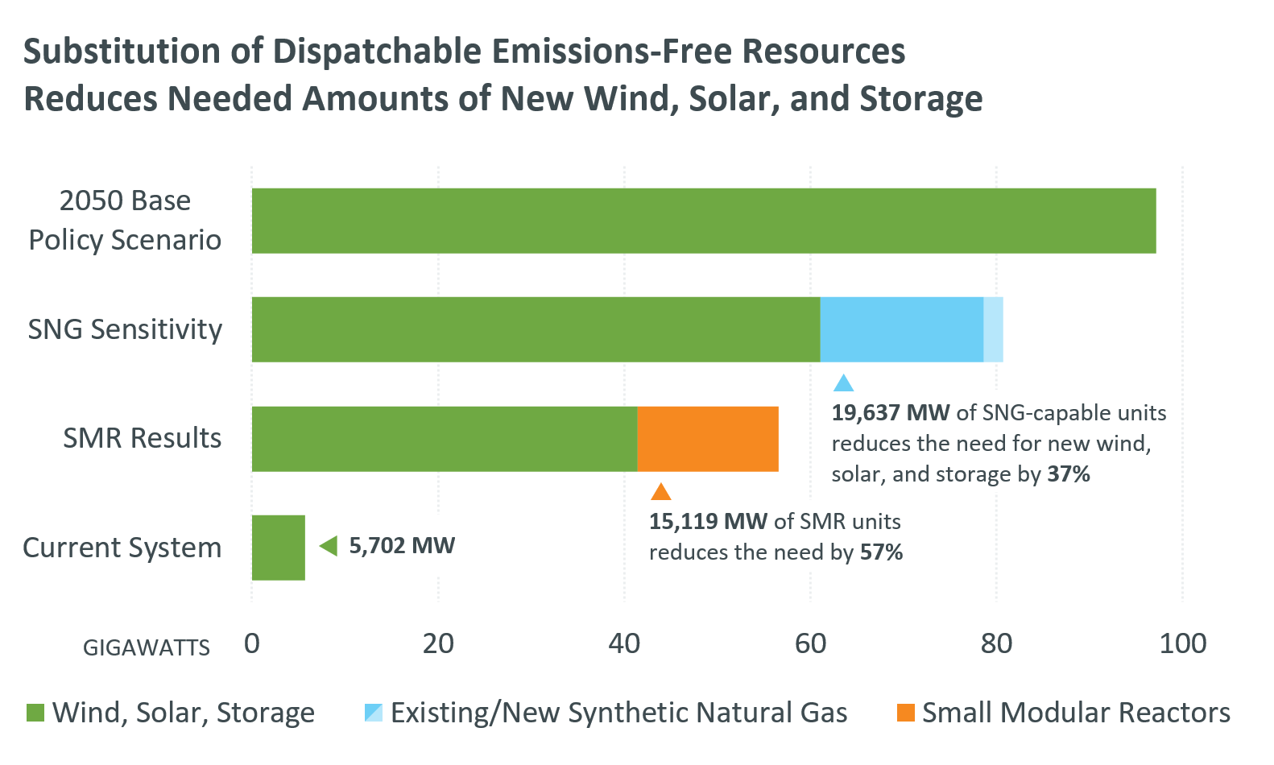

### Synthetic Natural Gas

One sensitivity of the Policy Scenario models the introduction of SNG between now and 2050, since SNG is carbon-neutral and can largely be delivered and stored using existing gas pipeline infrastructure.[17] Hydrogen presents a possible alternative to SNG, but was not selected for analysis in EPCET due to the lack of geographically feasible storage locations in New England, and need for new pipeline infrastructure.[18]

SNG capacity expansion sensitivity results show that a renewable-dominant build-out that also includes 2.1 GW of combined cycle resources achieves the states’ 2050 decarbonization targets while requiring 37% less new renewable capacity than the base Policy Scenario. This SNG build-out also reduces curtailment, resulting in a more efficient system. Carbon-free pipeline fuel would lessen future transmission upgrades if such capacity was located closer to load, and enable the region to reuse existing energy infrastructure.

Due to high fuel costs, *production costs* would be higher in an SNG build-out than a non-SNG system—but *total costs* would be lower, since the system would require a smaller renewable build-out. Such a system would also experience fewer periods of negative LMPs, which would allow generators to earn more revenue in the energy market. It is important to note, however, that the winter gas and pipeline constraints affecting LNG and natural gas in today’s system could remain in the future. If this trend persists, an SNG-centric dispatchable fleet that relies on the same underlying infrastructure used for natural gas today would likely continue to experience tight winter conditions.

Fossil fuel-burning resources may also be more competitive than zero-carbon fuels like SNG under current market structures. The EPCET model’s assumed SNG price is $40/MMBtu, and cost assumptions for hydrogen in similar studies are around $30-35/MMBtu. Current prices for natural gas are around $2-6/MMBtu, and oil prices typically range between $10 and $20/MMBtu. Absent a carbon price or a Renewable Energy Credit (REC) for the zero-carbon fuel, the zero-carbon fuel may be less economical than carbon-emitting fuels.[19]

### Small Modular Reactors

EPCET also explores the use of small modular nuclear reactors as a fuel-secure, dispatchable, zero-carbon alternative to SNG. Legacy nuclear generators usually provide between 200 and 1000+ MW of capacity. SMRs are smaller, theoretical reactors with more flexibility and fewer safety concerns than previous designs.

SMR results show that a renewable-dominant build-out that also includes 15.1 GW of SMRs achieves the states’ 2050 decarbonization targets while requiring 57% less new renewable capacity than the base Policy Scenario. As with SNG, curtailment also decreases. Overall capital costs of a build-out that includes SMRs are 33% lower than the base case.

Since SMRs are a new technology, lacking any significant existing supply chain, cost assumptions are highly uncertain. To incorporate some of this uncertainty in its forecasts, EPCET also simulates SMR-inclusive build-outs with double the original cost assumptions. Despite increased build costs, results show it is still more economical to include 10 GW of SMRs versus the base case, with the remainder of needed capacity made up by additional wind, solar and energy storage. Curtailment is more frequent, but overall utilization of renewable resources improves over the base case. Overall capital costs are 7% lower than the base case, despite the doubled SMR cost assumption.

## Difficult minimum load conditions, energy adequacy challenges, and potential system congestion may appear by the 2030s.

Much of this report has focused on build-out challenges related to the later years of the state policy horizon, but operational challenges begin to appear sooner in the study’s timeline. Production cost analysis of 2032 (EPCET’s Market Efficiency Needs Scenario) illustrates challenges related to duck curve days and energy adequacy, and potential congestion on transmission lines.

### Challenging Minimum Load Conditions

Grid reliability must be maintained during [*duck curve* days](https://isonewswire.com/2024/02/28/duck-curve-days-becoming-more-frequent-as-solar-power-spreads/), when behind-the-meter photovoltaics (BTM-PV) cause demand for grid electricity to drop significantly during daylight hours.These days are occurring with greater frequencyin spring and fall*.* With its large quantities of BTM-PV and electrified heating and transportation, EPCET’s modeled 2032 system experiences some duck curve days with unprecedented minimum net loads. Minimum load conditions are particularly relevant to the operational realities of less flexible baseload resources like the region’s existing nuclear plants, which must maintain a minimum economic operating level, and consequently are not able to turn on and off quickly. Any minimum net load that falls below the fleet’s aggregate economic minimum could create operational challenges.

All weather years in the modeled 2032 system experience days in which the net load falls below this threshold. The figure below shows the most pronounced duck curve in the modeled 2032 and one of the most pronounced observed duck curves to-date in relation to the existing New England nuclear fleet’s economic minimum level.[20] The depth of the duck curve and related ramping requirements are expected to grow over time as more BTM-PV comes online.

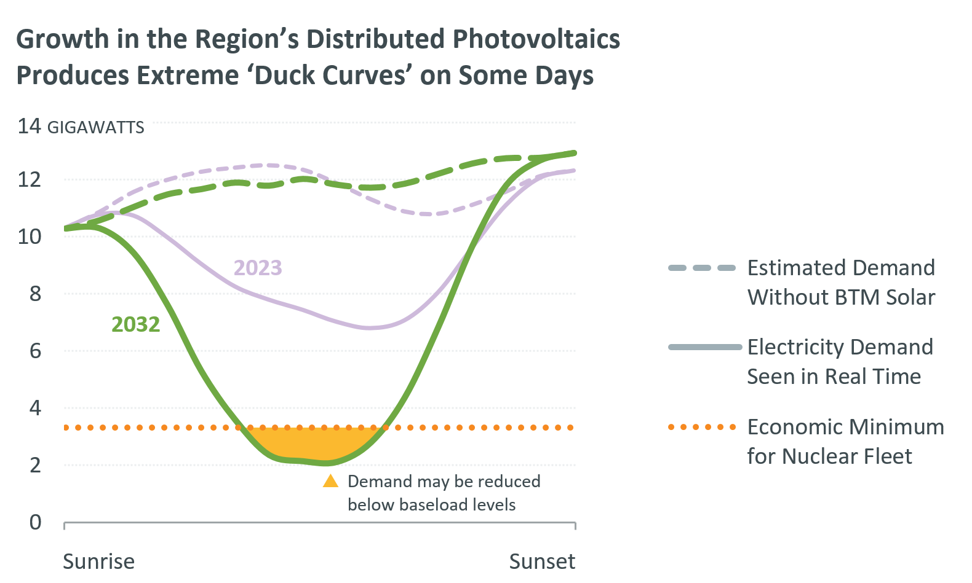

#### Possible Solutions to Challenging Minimum Loads

EPCET’s model navigates challenging minimum load conditions in several ways, and these strategies would likely form part of a real-life operational response. While the model navigates duck curves successfully with the optimized use of storage, exports, and peakers, the real system is less optimized, and would likely not perform as well.[21]

Alternate solutions may address the operational challenges of these extreme duck curve days. During the low net load hours of the analysis, locational marginal prices (LMPs) become very negative due to surplus energy from wind and solar resources. The discretionary load or long-duration storage mentioned in previous sections could be directed to take advantage of such conditions. If other regions are not experiencing minimum load conditions, New England could export excess energy economically. And within New England, managed electric vehicle charging programs could schedule or encourage EV charging during the duck curve valleys. EV owners would benefit from low or negatively priced energy, and may be attracted to the idea of using guaranteed low-to-zero carbon energy to charge their vehicles.

### Energy Adequacy Concerns

EPCET’s 2032 analysis also forecasts challenges related to energy adequacy. In today’s grid, heating drives demand for natural gas, which results in stretches of time when some electric generators cannot obtain gas, and the region relies on stored fuels to meet electricity demand. Though winter gas constraints are expected to recede as more natural gas heating is displaced by electric heat, the timing and pace of this regional conversion remains uncertain. If the conversion of fuel oil and wood heating to electric heat pumps significantly outpaces the conversion of natural gas heating to electric heat pumps, New England could see additional electricity demand from heating without additional natural gas availability.

Under certain winter weather conditions, EPCET’s modeled 2032 system requires levels of stored fuels comparable to present-day consumption. The most severe weather year (2015), for example, requires more stored fuels over a multi-day period than any historical observation between 2019 and 2023, illustrated below. Though wind, solar and battery additions will help the region fill in these gaps in supply, the grid of 2032 and beyond may sometimes require more dispatchable generation (either from stored fuels or an unconstrained fuel supply) than it has in recent winter conditions. Although pipeline availability in 2032 is uncertain, this level of demand is not sustainable under current pipeline conditions, given the retirement of stored fuel resources.

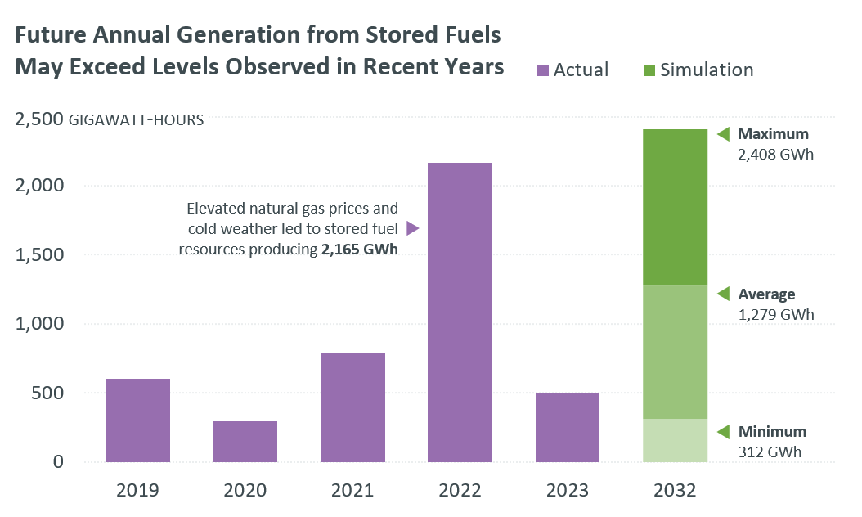

### Congestion Points

The model’s base 2032 Market Efficiency Needs Scenario does not produce significant congestion on the New England System. Most potential congestion is centered in historically constrained areas in northern New England, but the overall frequency and magnitude is relatively small. Some new congestion points appear due to the expected development of offshore wind and distributed PV in southern New England, but the frequency and magnitude is again relatively small. The [2050 Transmission Study](http://chrome-extension/efaidnbmnnnibpcajpcglclefindmkaj/https:/www.iso-ne.com/static-assets/documents/100008/2024_02_14_pac_2050_transmission_study_final.pdf) explores transmission concerns over the policy years in greater detail, and provides more granular data on congestion points and possible roadmaps for upgrades.

# Conclusion

In recent years, ISO New England has produced a suite of innovative studies to help explore reality-based paths to a clean future grid. These studies include forward-thinking frameworks to improve regional system planning, and actionable, creative ideas to assist policymakers and stakeholders in enacting change. This same creativity and flexibility will be necessary to move from the theoretical to the real as the clean energy transition accelerates.

EPCET results illustrate the highly variable nature of future supply and demand, which result in vast, costly build-outs of renewables that often sit idle. Current market rules and other revenue structures may not scale well in a renewable-heavy grid, and the ISO is exploring alternate market structures within its jurisdiction. Other issues remain outside the ISO’s jurisdiction, but help alleviate challenges—for example, reducing overall demand and demand peaks, implementing a price on carbon to integrate climate goals into the energy market, and retaining and/or adding dispatchable resources to help maintain an efficient and reliable grid.

Eliminating carbon emissions through complete electrification of the heating and transportation sectors and a near-exclusive reliance on wind, solar, and storage to generate electric power is possible, but involves significant cost and unresolved reliability concerns. This scenario places a high value on the decarbonization of the grid, but is very expensive to operate reliably. As noted earlier, planning the future grid involves balancing reliability, economic efficiency, and carbon-neutrality. A variety of other paths are possible, each with different tradeoffs.

Reducing carbon emissions requires significant financial investment. Given current technology, the last few percentage points of reductions designed to decarbonize a handful of winter days will be the most costly of all. Achieving these last few percentage points outside the power grid may lessen costs.

As part of its responsibility to plan for a reliable future grid, ISO New England assesses the need for future market rule enhancements to support the ongoing reliability and economy of the region’s grid. While the precise nature of these enhancements requires further exploration, they could include new ancillary services intended to incentivize the resource attributes that will become more important as the clean energy transition continues. EPCET, Pathways, FGRS, the 2050 Transmission Study and future economic studies will help inform this regional market development, and ensure that New England transitions to a cleaner grid in the most economical, reliable way possible.

ISO New England is committed to working within its jurisdiction to support the four pillars of the clean energy transition: **clean energy** resources, sufficient **balancing resources**, **energy adequacy** and a **robust transmission** system. EPCET explores the first three pillars in depth, and studies such as the 2050 Transmission Study support the fourth. Future work will continue to explore pathways to uphold these four pillars and provide stakeholders with actionable, rigorous studies to support decision-making at a crucial period in the history of the power grid.

Preface 3

Key Findings 5

1.1 Most paths to a low-carbon grid involve high variability in demand and supply. 6

1.2 The large variation in peak demand will require vastly different supply from year to year. Some years will require all resources to operate. In other years, certain resources will run for just for a few hours, or not at all. 7

1.3 Emissions reductions will be seasonal. Some months will decarbonize years before others. 8

1.4 Renewable-only build-outs may be vast, and later additions of renewable resources could have diminishing environmental and economic returns. 9

1.4.1 Scale of Renewable Build-Outs 10

1.5 Higher variability will increase the value of current and future dispatchable resources, including long-duration storage. 13

1.5.1 Assessing the Need for Dispatchable Resources 13

1.5.2 Benefits and Challenges Associated with Long-Duration Storage 14

1.5.3 Seasonal Storage Possibilities 16

1.6 Current revenue structures may not adequately compensate resources for their value to the future grid. 16

1.6.1 Feasibility of Power Purchase Agreements (PPAs) 16

1.6.2 Effect of Deep Decarbonization on Energy Markets 18

1.6.3 Reliability Adder 18

1.6.4 Discretionary Load 19

1.6.5 Opportunities for Exports 20

1.7 Firm, dispatchable, zero-carbon generation could help address challenges. 20

1.7.1 Synthetic Natural Gas 21

1.7.2 Small Modular Reactors 22

1.8 Difficult minimum load conditions, energy adequacy challenges, and potential system congestion may appear by the 2030s. 22

1.8.1 Challenging Minimum Load Conditions 22

1.8.2 Energy Adequacy Concerns 24

1.8.3 Congestion Points 24

Conclusion 26

1. ISO New England does not conduct resource planning, and does not predict whether new resources will be built, or what type of resources they might be.
2. This scenario incorporates analysis of what was initially conceived as FGRS Phase 2.
3. It is important to note that EPCET’s 60.8 GW peak demand projected for 2050 is based on data from the ISO’s load forecasting team. The 57GW peak demand cited in the 2050 Transmission Study is an input taken from the MA 2050 Decarbonization Study, and not a value forecasted by ISO New England.
4. Energy markets support the buying and selling of wholesale electric power from day-to-day. The capacity market helps ensure longer-term system reliability by securing obligations from resources to be available to deliver electricity during stressed system conditions in the future.
5. It is important to note that EPCET modeling does not include resource outages, since production cost models are not directly focused on resource adequacy. A real system with unplanned outages would likely require additional dispatchable resources to maintain reliability.
6. December’s emissions are higher than February’s due to December’s three additional days, though stretches of low solar and wind production coupled with depleted energy storage (conditions that drive more carbon emissions) generally occur more frequently in modeling for February.
7. State goals do not count emissions from wood, biomass, municipal solid waste (MSW), or landfill gas (LFG), so this modeled constraint only affects gas, coal, and oil resources.
8. The low density MW per acre value is based on the MW per acre of the region’s current least-dense approved offshore wind project. The high density MW per acre value is based on the MW per acre of the region’s current most-dense approved offshore wind project.
9. Pay-for-Performance rules penalize resources that fail to meet their capacity supply obligations in real time, while rewarding resources that exceed their obligations.
10. This sensitivity was requested by the New England States Committee on Electricity (NESCOE).
11. LMPs can be negative at times of high wind and/or solar output, when near-zero-cost energy is abundant.
12. EPCET’s modeling of net profit includes assumptions related to a hypothetical unit’s PPA revenue, annualized build costs, and total costs, among other metrics.
13. Similar cost escalation trends were observed in the ISO’s [Pathways Study](https://www.iso-ne.com/static-assets/documents/2022/04/schatzki-et-al-pathways-final.pdf).
14. Though they provide significant zero-carbon energy, nuclear resources do not typically receive PPAs.
15. Hydrogen electrolyzers split water into hydrogen and oxygen, and hydrogen is a potentially scalable zero-carbon dispatchable fuel.
16. The 2050 Transmission Study showed that discretionary load helped alleviate challenges for the future transmission system related to peak demand.
17. SNG production generates negligible amounts of carbon, as long as the methane is produced from direct air carbon capture and electrolysis using renewable energy.
18. While the zero-carbon production of SNG would require a supply of hydrogen for electrolysis, the amount of hydrogen needed to produce SNG is much lower than that of a hydrogen-centric system.
19. Carbon-capture technology was considered for analysis, but is currently less feasible in New England due to geographical constraints.
20. The 2023 representative example is occurred on April 9, 2023.
21. EPCET’s benchmark case tests the model’s fidelity versus the historical system of the year before. The model performs well against the historical system and provides valuable insights into the future grid. However, the ISO notes where models cannot fully simulate reality, and are likely more optimistic. As the grid operator, ISO New England must ensure that the system is reliable under any conditions, and notes potential discrepancies in that vein.