ISO New England Manual for
Market Operations
Manual M-11

Revision: 47
Effective Date: October 6, 2013

Prepared by
ISO New England Inc.

ISO New England Manual for
Market Operations
Table of Contents
Introduction
About This Manual INT-1
Section 1: Overview of Market Operations
1.1 Scope & Purpose of Scheduling and Dispatching 1-1
1.2 ISO Responsibilities 1-3
1.2.1 Day-Ahead Energy Market 1-3
1.2.2 Real-Time Energy Market 1-3
1.2.3 Summary of ISO Responsibilities. 1-3
1.3 Market Participant Responsibilities 1-6
1.3.1 Market Participants Buying from Energy Market 1-6
1.3.2 Market Participants Selling into Energy Market 1-6
1.3.3 Market Participants wheeling Energy through the Real-Time Energy Market 1-7
1.3.4 Market Participants Participating with Real-Time Demand Response and Real-Time Emergency Generation Resources 1-8
1.3.4.1 Data Requirements for Real-Time Demand Response and Real-Time Emergency Generation Resources 1-8
1.3.4.2 Real-Time Demand Response in the RAA Process 1-8
1.4 Non-Market Participant Transmission Customer Responsibilities 1-9
1.4.1 Non-Market Participant Transmission Customers wheeling Energy through the Real-Time Energy Market 1-9
Section 2: Energy Market
2.1 Overview of Energy Market 2-1
2.2 Day-Ahead Energy Market 2-2
2.3 Real-Time Energy Market 2-4
2.4 Pricing Locations 2-6
2.5 Energy Market Business Rules 2-10
2.5.1 Bidding & Operations Time Line 2-10
2.5.2 Market Participants Buying from Energy Market 2-11
2.5.3 Market Participants Selling into Energy Market 2-14
2.5.4 Transmission Customers 2-18
2.5.5 ISO Activities 2-19
2.5.6 Technical Rules 2-21
2.5.7 Major Modeling Assumptions 2-23
2.5.8 Using & Calculating Locational Marginal Prices and Real-Time Reserve Clearing Prices 2-24
2.5.9 Calculation of Locational Marginal Price 2-26
2.5.9.1 Day-Ahead Energy Market 2-28
2.5.9.2 Real-Time Energy Market 2-29
2.5.9.3 Example – Re-dispatch to Meet Local Requirements 2-33
2.5.9.4 Example – Re-dispatch to Meet System Requirements 2-38
2.5.10 ISO Real-Time Price Verification Procedure 2-40
2.5.11 Day-Ahead and Real-Time Energy Market Settlement 2-41
2.5.12 Emergency Conditions in the Day-Ahead Energy Market 2-41
2.5.12.1 Energy Deficient Conditions 2-41
2.5.12.2 Minimum Generation Conditions 2-41
2.5.13 Emergency Conditions in the Real-Time Energy Market 2-42
2.5.13.1 Capacity Deficient Conditions 2-42
2.5.13.2 Minimum Generation Conditions 2-43
Section 3: Reserved
Section 4: Reserved
Section 5: Scheduling and Dispatch Philosophy & Tools
5.1 ISO Philosophy 5-1
5.2 Scheduling and Dispatching Tools 5-3
5.2.1 Enhanced Energy Scheduler (EES) 5-3
5.2.2 Load Forecasting 5-4
5.2.3 Market Database System 5-5
5.2.4 Technical Software 5-5
5.2.5 Forecast Capacity Analysis 5-8
5.2.6 Regulation Assignment and Clearing Software 5-8
5.2.7 Generation Control System 5-9
5.2.8 Network Analysis and SCADA Programs 5-9
5.3 Dispatch Zones 5-10
Section 6: Scheduling Strategy & Method
6.1 Forecasting New England Resource Requirement 6-1
6.2 [Reserved] 6-4
6.3 Processing Market Information 6-5
6.3.1 Operating Reserve and Replacement Reserve Service 6-5
6.3.2 Local Second Contingency Protection Resources 6-5
6.3.3 Special Constraint Resources 6-5
6.3.4 Self-Scheduled Generator Resources 6-6
6.3.5 Self-Scheduled Dispatchable Asset Related Demand Resources 6-8
6.3.6 Deviations from Day-Ahead Energy Market for Generator Resources Scheduled Day-Ahead 6-8
6.3.7 Credits for Cancellation of Pool-Scheduled Resource Generators 6-9
6.3.8 [Reserved] 6-9
6.3.9 Dispatchable Asset Related Demand Resource Specific Data Requirements 6-9
6.4 Real-Time Operating Reserve Requirement Determination 6-10
6.4.1 New England Control Area Operating Reserve Requirement 6-10
6.4.2 Locational Operating Reserve Requirements 6-10
6.4.3 Calculation of Locational Operating Reserve Requirements 6-10
6.5 External Transactions 6-12
6.5.1 External Transaction Submission Deadlines 6-12
6.5.2 General Information 6-13
6.5.3 Ramps 6-13
6.5.4 EES Data Requirements 6-14
6.5.4.1 Day-Ahead Energy Market 6-14
6.5.4.2 Real-Time Energy Market 6-14
6.5.5 ISO Review of External Transaction Requests 6-16
6.5.6 Real-Time External Transactions 6-17
6.5.7 Check-out Procedure 6-17
6.5.8 ISO Emergency Energy Purchases during Emergency Conditon 6-18
6.5.9 [Reserved] 6-19
6.5.10 ISO Purchases of New Brunswick Security Energy 6-19
Section 7: Posting OASIS Information
7.1 OASIS 7-1
7.1.1 ISO Actions 7-1
7.1.2 Market Participant Actions 7-1
Section 8: Hourly Scheduling
8.1 Hourly Scheduling Adjustments 8-1
Revision History
Approval REV-1
Revision History REV-1

ISO New England Manual for
Market Operations
List of Figures and Tables
Table 2.1: Hub Definition 2-7
Exhibit 2.1: Single P-Node Mapped to Multiple “Close” E-Nodes 2-9
Table 2.3: External Transaction Modeling Treatment 2-25
Exhibit 2.2: Dual Degeneracy Diagram 2-29
Exhibit 5.1: Load Forecasting Process 5-4
Exhibit 5.2: Technical Software and subsystems 5-7
Exhibit 5.3: Technical Software Data Flow 5-8
Exhibit 6.1: Requirement Versus Generation Supply 6-2
Exhibit 6.3: Generating Resource Scheduling 6-7
Table 6.1: Available Exceptions Associated with External Transactions 6-16

Introduction

About This Manual
Welcome to the ISO New England Manual for Market Operations. This is one of a series of manuals concerning the wholesale electricity markets administered by ISO New England Inc. (“the ISO”). This manual provides guidance on Day-Ahead scheduling, including Day-Ahead Energy Market clearing and Reserve Adequacy Analysis scheduling, hour-ahead Real-Time Energy Market scheduling, in-hour Real-Time Dispatch and Real-Time Energy Market clearing activities.
It is assumed that the reader has reviewed Market Rule 1 before or in conjunction with using the manual. Terms that are capitalized in this manual generally are defined in Section I of the ISO Tariff.
The reader is referred first to Market Rule 1 for an explanation and information regarding the operation of the markets. This manual provides additional implementation or other detail for those provisions of Market Rule 1 that require the Market Participant to take an action.

Section 1: Overview of Market Operations

1.1 Scope & Purpose of Scheduling and Dispatching
Operation of the New England Control Area involves many activities that are performed by different operating and technical personnel. These activities occur in parallel on a continuous basis, 24 hours a day and can be grouped into three overlapping time frames:
- pre-scheduling operations
- scheduling operations and the Day-Ahead Energy Market
- scheduling and dispatching operations and the Real-Time Energy Market
In this manual, we focus on the scheduling activities associated with the Day-Ahead Energy Market, scheduling activities that take place in the Real-Time Energy Market throughout the Operating Day and Real-Time Energy Market dispatching activities that take place within the operating hour.
Resources fall into one of two categories, Resources (or portion of a Resource) with a Capacity Supply Obligation or Resources (or portion of a Resource) without a Capacity Supply Obligation. For the remainder of this document Resources (or portion of a Resource) with a Capacity Supply Obligation shall be referred to as CSO Resources, and Resources without any Capacity Supply Obligation shall be referred to as Non-CSO Resources. If available to operate, CSO Resources, other than Intermittent Power Resources, Non-Dispatchable Qualifying Facilities, Demand Resources or Settlement Only Resources must submit, to the extent of their Capacity Supply Obligation, Supply Offers in the case of a Generator, or Demand Bids in the case of a Dispatchable Asset Related Demand, into the Day-Ahead Energy Market and may elect either to Self-Schedule or offer the Resource to the ISO for scheduling as a Pool-Scheduled Resource. Resources that are not capable of receiving Dispatch Instructions electronically in Real-Time (i.e. do not have Electronic Dispatch Capability as required under ISO New England Operating Procedure #14) shall not submit Supply Offers (other than Self-Schedules) and are not considered Pool-Scheduled Resources in the Day-Ahead Energy Market. Resources that are capable of receiving dispatch instructions and are Self-Scheduled with increments available above their Self-Scheduled amounts will be issued Dispatch Instructions in Real-Time for the increments above the Self-Schedule based on the Supply Offers submitted. The offer submitted on behalf of the CSO Resource may include any additional portion of the Resource that is without a Capacity Supply Obligation and will be dispatchable in the Day-Ahead Energy Market and Real-Time Energy Market up to the offered Economic Maximum Limit.
Market Participants may submit Supply Offers for Non-CSO Resources for use in the Day-Ahead Energy Market. Non-CSO Resources that do not clear energy in the Day-Ahead Energy Market, and have not been assigned a Forward Reserve Obligation in at least one hour of the next Operating Day, and have not been designated as a Supplemental Capacity Resource for the next Operating Day, or are not otherwise required to submit a Supply Offer under the ISO Tariff, shall be deemed unavailable for commitment by ISO-NE for the next Operating Day, except as provided for in ISO New England Operating Procedure No. 4 where a request can be made for Non-CSO Resources. Market Participants may request to Self-Schedule these Non-CSO Resources in order to participate in the Real-Time Energy Market and may offer an Economic Maximum Limit that is above the Self-Schedule request, in which case the Resource would be dispatchable up to the offered Economic Maximum Limit. Scheduling and dispatching by the ISO involves the Day-Ahead Energy Market process, the Control Area reliability-based scheduling process (Reserve Adequacy Analyses or RAA), the hourly scheduling process and the Real-Time Dispatch process, including Operating Reserve designation. The RAA process begins at the close of the Re-Offer Period and continues, as needed, throughout the Operating Day. Hourly scheduling during Real-Time occurs within 60 minutes prior to the hour being scheduled during the Operating Day. Unless operating protocols exist between the ISO and the applicable neighboring Control Area to permit scheduling on shorter intervals and use of such shorter intervals is noted in the associated ISO System Operating Procedures, scheduling intervals for External Transactions in Real-Time are hourly.
The Dispatch process includes system control, Ancillary Service monitoring including Regulation assignment and Operating Reserve designation to specific Resources, and transmission system monitoring and control. During the dispatching process, the ISO implements and adjusts the Current Operating Plan, which is developed during the scheduling processes, as needed throughout the Operating Day, maintains reliability and minimizes the cost of supplying the Energy, Operating Reserve, and other services that are required by the Market Participants and Transmission Customers and the operation of the New England Control Area.
During the scheduling and Dispatch process, the ISO will:
(1) Clear the Day-Ahead Energy Market using least-cost security-constrained unit commitment and dispatch software,
(2) Determine a Current Operating Plan for the Real-Time Energy Market to reliably serve the hourly Energy, Regulation and Operating Reserve Requirements of the New England Control Area by minimizing the cost to provide sufficient operable capacity to meet the hourly Energy, Regulation and Operating Reserve Requirements,
(3) Perform hourly scheduling of internal Generators, External Transactions and Dispatchable Asset Related Demands in the Real-Time Energy Market to cover the entirety of each hour throughout the Operating Day and update the Current Operating Plan as required, and
(4) Schedule the dispatch of Real-Time Demand Response resources if the depletion of Thirty-Minute Operating Reserves is forecast.
(5) Perform in-hour Dispatch of Generators and Dispatchable Asset Related Demands and designation of Operating Reserve, on a continuous basis for the Dispatch of Regulating Generators and normally on a five-minute basis for Energy Dispatch and Operating Reserve designation, using the updated Current Operating Plan as a starting point.

1.2 ISO Responsibilities

1.2.1 Day-Ahead Energy Market
In the Day-Ahead Energy Market, the ISO determines the least-cost means (see Section 5 of this manual for additional details) of satisfying the cleared Demand Bids, cleared Decrement Bids, Operating Reserve, Replacement Reserve, Local Second Contingency Protection Resource requirements and other applicable Ancillary Services requirements of Market Participants, including the reliability requirements of the New England Control Area.
Following the Day-Ahead Energy Market scheduling process, the ISO will also commit and/or de-commit Resources as needed, based upon the ISO’s forecast of actual loads for the next Operating Day, to:
(1) satisfy Operating Reserve and Replacement Reserve requirements of the New England Control Area by minimizing the cost (see Section 5 of this manual for additional details) to provide additional Operating Reserve, Replacement Reserve and/or additional Local Second Contingency Protection Resources above what was scheduled in the Day-Ahead Energy Market, if required, as part of the ISO’s Real-Time Energy Market scheduling process;
(2) provide other Ancillary Services requirements, as required; and
(3) satisfy all other reliability requirements of the New England Control Area.

1.2.2 Real-Time Energy Market
In Real-Time, the ISO monitors and controls the New England Control Area such that the least-cost means (see Section 5 of this manual for additional details) of satisfying the projected hourly Energy, Regulation, Operating Reserve, Replacement Reserve and other Ancillary Services requirements (as required), including the reliability requirements of the New England Control Area, are met.

1.2.3 Summary of ISO Responsibilities
Specifically, the ISO’s responsibilities to support scheduling and dispatching activities for all Market Participants and Transmission Customers with firm transmission service inside the New England Control Area include:
(1) Develop the financially binding Day-Ahead Energy Market schedules based upon Market Participant-supplied Demand Bids, Decrement Bids, Supply Offers, Increment Offers, and priced and Self-Scheduled External Transactions utilizing least-cost security-constrained unit commitment and Dispatch analysis tools;
(2) Post the Day-Ahead Energy Market results;
(a) Schedules for the next Operating Day by Market Participant (generation & demand),
(b) External Transaction schedules (which may be in partial MW quantities),
(c) Day-Ahead LMPs,
(d) Day-Ahead binding transmission constraints including reactive constraints,
(e) Day-Ahead net tie schedules,
(f) ISO load forecast for the next Operating Day,
(g) Aggregate demand bids,
(h) ISO Real-Time Operating Reserve objective,
(i) ISO Real-Time Replacement Reserve objective.
(3) Perform Reserve Adequacy Analysis (RAA) for the Real-Time Energy Market based upon the ISO forecast load and Real-Time Operating Reserve and Replacement Reserve requirements. Real-Time load requirements, Operating Reserve, Replacement Reserve and Local Second Contingency Protection Resource requirements not covered through scheduling in the Day-Ahead Energy Market are accounted for by the ISO in the Real-Time Energy Market by adding to or modifying the Resource schedule created in the Day-Ahead Energy Market based upon Day-Ahead bids and offers supplemented by bids (for Dispatchable Asset Related Demands only) and offers made during the Re-Offer Period. Scheduling activities by the ISO for the Real-Time Energy Market start prior to and continue throughout the Operating Day;
(4) Post a pre-dispatch schedule report containing the forecast output/consumption of Resources (subject to appropriate confidentiality restrictions) under the Current Operating Plan with each change to the Current Operating Plan;
(5) Post preliminary values of Regulation Clearing Price;
(6) Maintain data and information which is related to generation facilities in the New England Control Area, as may be necessary to conduct the scheduling and Dispatch of the New England Markets and New England Control Area;
(7) Post its updated forecast of New England load on the ISO web site;
(8) Revise Current Operating Plan to reflect updated projections of load, changing electric system conditions and changing availability of Resources;
(9) Direct Market Participants to adjust the output of any Resource including canceling the selection of Resources and the Dispatch of Resource increments above amounts that were Self-Scheduled;
(10) Provide Emergency External Transaction sales to other Control Areas in accordance with the terms and conditions of the applicable interconnection agreements;
(11) Enter into Emergency External Transaction purchases in accordance with the procedures set forth in Section 6 of this manual and the terms and conditions of the applicable interconnection agreements;
(12) Operate the New England Control Area in accordance with NERC, NPCC and New England reliability criteria;
(13) Obtain the most cost efficient and reliable Regulation service available;
(14) Designate Resources for provision of Operating Reserve as part of the Real-Time linear optimization of Resource Dispatch to minimize the energy, congestion, and transmission loss costs, given system conditions and constraints;
(15) Post preliminary values of Real-Time LMPs, Real-Time Reserve Clearing Prices and Regulation Clearing Prices during each hour of the Operating Day; and
(16) Post final values of Real-Time LMP, Real-Time Reserve Clearing Prices and Regulation Clearing Prices no later than five Business Days following the Operating Day (normally two Business Days following the Operating Day).

1.3 Market Participant Responsibilities
Only Market Participants with settlement accounts for the Energy Market are eligible to submit Supply Offers, Increment Offers, Demand Reduction Offers, Demand Bids, External Transactions (other than Through Service External Transactions) and Decrement Bids and purchase Energy or related services in the Day-Ahead Energy Market and in the Real-Time Energy Market. All Market Participants and Non-Market Participant Transmission Customers may submit Through Service External Transactions in the Real-Time Energy Market. The major responsibilities of Market Participants are as follows:

1.3.1 Market Participants Buying from Energy Market
The key scheduling responsibilities of a Market Participant purchasing Energy from the Energy Market for consumption by end-users that are located inside the New England Control Area or that is selling to buyers external to the New England Control Area include but are not limited to (see Section 2 of this manual for additional details):
- submit hourly schedules for Self-Scheduled Resources;
- submit price sensitive Demand Bids;
- submit schedules for External Transaction sales to entities outside the New England Control Area from generation within the New England Control Area (External sales are treated as Day-Ahead or Real-Time Load Obligations at the applicable External Node.).

1.3.2 Market Participants Selling into Energy Market
The key scheduling responsibilities of a Market Participant that is selling Energy and Forward Reserve into the Energy Market for consumption and use by end users that are located inside the New England Control Area include but are not limited to (see Section 2 of this manual for additional details):
(1) submit hourly schedules for Self-Scheduled Resources;
(2) submit External Transactions for delivery within the New England Control Area (External purchases are treated as Day-Ahead or Real-Time Generation Obligations at the applicable External Node.);
(3) submit Supply Offers for CSO Resources for supply of Energy to the Day-Ahead Energy Market and Real-Time Energy Market to the extent of the resource’s Capacity Supply Obligation, for the next Operating Day whether for a Self-Scheduled Resource or a Pool-Scheduled Resource. The offer submitted by the Market Participant for the CSO Resource may include any additional portion of the Resource that is without a Capacity Supply Obligation. If the offer does not clear in the Day-Ahead Energy Market, the Market Participant may still request to Self-Schedule the Resource in Real-Time, and may include any additional portion of the Resource that is without a Capacity Supply Obligation. The Resource would be dispatchable in the Day-Ahead Energy Market and Real-Time Energy Market up to the offered Economic Maximum Limit.
(4) submit a forecast of the availability of the Capacity Supply Obligation portion of each Capacity Supply Obligation Resource, for the next seven days;
(5) submit optional Supply Offers for the supply of Energy and other services from Non-CSO Resources into the Day-Ahead Energy Market for the next Operating Day.
(a) Non-CSO Resources that do not clear energy in the Day-Ahead Energy Market, and have not been assigned a Forward Reserve Obligation in at least one hour of the next Operating Day, and have not been designated as a Supplemental Capacity Resource for the next Operating Day, or are not otherwise required to submit a Supply Offer under the ISO Tariff, shall be deemed unavailable for commitment by the ISO for the next Operating Day except as provided for in ISO New England Operating Procedure No. 4 where a request can be made for Non-CSO Resources.
(b) Market Participants may request to Self-Schedule these Non-CSO Resources in order to participate in the Real-Time Energy Market and may offer an Economic Maximum Limit that is above its Self-Schedule request, in which case the Resource would be dispatchable up to the offered Economic Maximum Limit.
(6) submit assignments of Forward Reserve to eligible Forward Reserve Resources on a daily basis that, in total, are greater than or equal to the Market Participant’s Forward Reserve Obligation (see the ISO New England Manual for Forward Reserve, M-36 for additional information). Assignments must be made prior to the close of the Re-offer Period (See Market Rule 1 Section III.9.6.1).
(7) submit Supplemental Availability designations of eligible Generating Capacity Resources up to the difference between the resource’s Capacity Supply Obligation and its CNR Capability, as further explained in Market Rule 1 Section III.13.5.3.1. Designations must be made by the deadline specified in Market Rule 1 Section III.13.5.3.1.2.

1.3.3 Market Participants wheeling Energy through the Real-Time Energy Market
The scheduling responsibilities of a Market Participant purchasing Energy from outside the Energy Market and wheeling the Energy through the New England Control Area for use outside the New England Control Area are to:
- submit External Transactions for the wheeling of energy through the New England Control Area.

1.3.4 Market Participants Participating with Real-Time Demand Response and Real-Time Emergency Generation Resources

1.3.4.1 Data Requirements for Real-Time Demand Response and Real-Time Emergency Generation Resources
(1) Market Participants must submit the quantity of demand reduction MWs available for each hour of the next two Operating Days for Real-Time Demand Response Resources and Real-Time Emergency Generation Resources. The data must be submitted by the offer submission deadline for the Day-Ahead Energy Market. The hourly data is not subject to re-declaration during the Operating Day.
(2) Market Participants must submit monthly maximum Forecast Hourly Demand Reduction MW for each of the next 12 months for Real-Time Demand Response and Real-Time Emergency Generation Resources. The Forecast Hourly Demand Reduction data must be submitted before the close of business on the last day of the previous month.

1.3.4.2 Real-Time Demand Response in the RAA Process
The ISO shall include Real-Time Demand Response Resources and the Day-Ahead Demand Reduction Offers of Real-Time Demand Response Assets in the Current Operating Plan for the Operating Day.
When all available generation and import resources have been scheduled and a capacity deficiency is declared, the ISO will dispatch Real-Time Demand Response Resources in amounts and at locations to reduce the demand, and to the extent possible, eliminate the deficiency.
Real-Time Demand Response Resources and Real-Time Emergency Generation Resources will be dispatched as provided in Section III.13 of Market Rule 1. Real-Time Demand Response Assets will be scheduled as provided in Appendix III.E of Market Rule 1.

1.4 Non-Market Participant Transmission Customer Responsibilities
Non-Market Participant Transmission Customers are eligible to submit wheel-through transactions into the Real-Time Energy Market. The major responsibilities of Non-Market Participant Transmission Customers are as follows:

1.4.1 Non-Market Participant Transmission Customers wheeling Energy through the Real-Time Energy Market
The scheduling responsibilities of a Non-Market Participant Transmission Customer purchasing Energy from outside the Energy Market and wheeling the Energy through the New England Control Area for use outside the New England Control Area are to:
- submit External Transactions for the wheeling of energy through New England Control Area.

Section 2: Energy Market

2.1 Overview of Energy Market
The Energy Market consists of two markets, a Day-Ahead Energy Market and a Real-Time Energy Market. The Day-Ahead Energy Market is a forward market in which hourly LMPs at pre-determined Locations are calculated for each hour of the next Operating Day based on Supply Offers, Demand Bids, Increment Offers, Decrement Bids and External Transaction schedules submitted into the Day-Ahead Energy Market all of which may clear in partial MW quantities. The Real-Time Energy Market is a balancing market for energy in which the LMPs at pre-determined Locations are calculated every five minutes based on the actual system operations security-constrained economic dispatch.
Additionally, in Real-Time, Operating Reserve Requirements are met as part of the Real-Time Dispatch process. As part of this process, specific Resources are designated as supplying Operating Reserve, also on a five-minute basis. The Real-Time Dispatch process satisfies the system-wide Energy requirement and Operating Reserve Requirements using a linear optimization algorithm to minimize the energy, congestion, and transmission loss costs, given system conditions and constraints (see Section 5 of this manual for a description of the methodology). Real-Time Reserve Clearing Prices are calculated simultaneously with Real-Time LMPs.
Separate accounting settlements are performed for each market. The Day-Ahead Energy Market settlement is based on Day-Ahead scheduled hourly quantities and on Day-Ahead LMPs and the Real-Time Energy Market settlement is based on actual hourly (integrated) quantity deviations from Day-Ahead scheduled quantities and on Real-Time LMPs integrated over the hour. The Day-Ahead price calculations and the Real-Time price calculations are based on the concept of Locational Marginal Pricing.
2.2 Day-Ahead Energy Market
The Day-Ahead Energy Market enables Market Participants to purchase and sell Energy at binding Day-Ahead Prices, buy from and sell to entities outside of the New England Control Area, including scheduling External Transactions at binding Day-Ahead Congestion Costs based on the differences in LMPs between the transaction source and sink. Market Participants may submit hourly demand schedules, including any price sensitive demand, for the amount of demand that they wish to lock-in at Day-Ahead Prices. Any Market Participant that owns a Generator that is a CSO Resource, other than Intermittent Power Resources, must submit a Supply Offer for that Generator to the extent of its Capacity Supply Obligation into the Day-Ahead Energy Market even if it is Self-Scheduled. Similarly, any Market Participant that owns a Dispatchable Asset Related Demand must submit a Demand Bid for the Resource with a Minimum Consumption Limit that is less than or equal to the Resource’s Nominated Consumption Limit into the Day-Ahead Energy Market.
A Market Participant that has Forward Reserve Obligations resulting from the Forward Reserve Auction must either convert these obligations into Resource specific obligations by assigning, on an hourly basis, its Forward Reserve Obligations to that Participant’s eligible Forward Reserve Resources at any time prior to the close of the Re-Offer Period or enter into an Internal Bilateral Transaction, on an hourly basis, that transfers that Market Participant’s Forward Reserve Obligation resulting from the Forward Reserve Auction to another Market Participant. Internal Bilateral Transactions and Resource specific Forward Reserve Obligation assignments may be changed on a daily basis.
Where a Market Participant has designated the portion of a Resource not subject to a Capacity Supply Obligation (whether from a CSO Resource or non-CSO Resource) to support a Supplemental Availability Bilateral, the Market Participants must submit Supply Offers for the amount of the designation.
Supply Offers for Self-Scheduled CSO Resources and non-CSO Resources will be used by the ISO for dispatch in the Day-Ahead Energy Market for those available Resource increments above Self-Scheduled amounts. Resources without Electronic Dispatch Capability that submit Supply Offers in the Day-Ahead Energy Market are required to submit a Self-Schedule. Market Participants may submit Supply Offers associated with Generators that are Non-CSO Resources for use in the Day-Ahead Energy Market. Non-CSO Resources that do not clear in the Day-Ahead Energy Market, have not been assigned a Forward Reserve Obligation in at least one hour of the next Operating Day, and have not been designated as a Supplemental Capacity Resource for the next Operating Day, or are not otherwise required to submit a Supply Offer under the ISO Tariff, shall be deemed unavailable for commitment by the ISO for the next Operating Day, except as provided for in ISO New England Operating Procedure No. 4 with respect to requests for energy from Non-CSO Resources pursuant to Market Rule 1 Section III.13.6.4. Market Participants may request to Self-Schedule these Non-CSO Resources in order to participate in the Real-Time Energy Market.
Market Participants may submit Self-Scheduled, priced or Up-to Congestion External Transaction bids and offers into the Day-Ahead Energy Market (no wheel-through External Transactions). Market Participants with External Transactions associated with Capacity Supply Obligations (Import Capacity Resources) must offer into the Day-Ahead Energy Market and Real-Time Energy Market.
All Energy transacted in the Day-Ahead Energy Market is settled at the Day-Ahead Prices.
After the Day-Ahead offer and bid period closes, the ISO develops the Day-Ahead schedule based on the bids, offers and schedules submitted, utilizing the scheduling and dispatch programs described in Section 5 of this manual, based on least-cost, security-constrained unit commitment and Dispatch for each hour of the next Operating Day. The Day-Ahead scheduling process incorporates ISO reliability requirements, Operating Reserve and Replacement Reserve targets into the analysis. The resulting Day-Ahead hourly schedules and Day-Ahead LMPs represent binding financial commitments to the Market Participants. Financial Transmission Rights (FTRs) are accounted for at the Day-Ahead LMP values (see the ISO New England Manual for Financial Transmission Rights, M-06 for additional information).
2.3 Real-Time Energy Market
Subsequent to the Re-Offer Period, the ISO performs a Reserve Adequacy Analysis to determine any change in unit commitment status based on minimizing the additional Start-Up Fees, No-Load Fees and out of rate Energy costs to operate units at their Economic Minimum Limits in order to provide sufficient capacity to satisfy the ISO load forecast (if greater than cleared total Demand Bids, Decrement Bids and scheduled External Transaction sales in the Day-Ahead Energy Market or if forecast load distribution is significantly different from the cleared Day-Ahead load distribution) and Operating Reserve or Replacement Reserve required in the Real-Time Energy Market. The purpose of this Reserve Adequacy Analysis is to ensure that the ISO has scheduled the proper amount of Resources in advance to meet the ISO load forecast, Operating Reserve and Replacement Reserve requirements for the next Operating Day and for the subsequent six days. Fast Start Generators are included in the scheduling process and are scheduled in the Day-Ahead Energy Market. However, the decisions concerning actual operation of pool-scheduled Fast Start Generators during the Operating Day are not made until the current operating hour in the Real-Time Energy Market. When insufficient capacity is available to meet the New England-wide or zonal capacity requirements, the RAA identifies the ISO New England Operating Procedure No. 4 Actions needed to resolve the deficiency. These actions include Real-Time Demand Response Resource activation, Thirty Minute Operating Reserve depletion, voltage reductions, Real-Time Emergency Generation Resource activation, requesting emergency energy transactions (EET), and requesting/scheduling Non-CSO Resources to meet reliability needs pursuant to Market Rule 1 Section III.13.6.4. For a full list of actions see ISO New England Operating Procedure No. 4.
The Real-Time Energy Market is based on actual Real-Time operations. Market Participants with Resources that are available may alter their Supply Offers, Demand Bids associated with Dispatchable Asset Related Demands, and priced External Transactions for use in the Real-Time Energy Market during the Re-Offer Period (otherwise the original Supply Offers or Demand Bids remain in effect for use in the Real-Time Energy Market). Market Participants may submit for ISO approval Self-Schedules, including quantity changes from previously submitted Self-Schedules, up to one hour prior to the operating hour. The ISO will use its best efforts to accommodate changes submitted after that time.
Market Participants may also re-declare priced External Transactions to a lower MW amount, including zero up to 60 minutes prior to the top of the hour. However, Market Participants with External Transactions supporting a Capacity Supply Obligation remain subject to their obligations under Market Rule 1. Market Participants may submit or modify Self-Scheduled External Transactions up to 60 minutes prior to the top of the hour in which the modification is to be effective, which will be subject to maintaining the reliability of the New England Balancing Area. When the necessary scheduling, Dispatch and settlement software and business practices are in place, shorter External Transaction modification and re-declaration times will be allowed. External Transactions are scheduled in the Real-Time Energy Market in whole MW quantities. Priced External Transactions that clear in the Day-Ahead Energy Market and have a corresponding Real-Time Energy Market submission will be treated as a Self-Scheduled External Transaction for purposes of economic dispatch in the Real-Time Energy Market, unless the Market Participant modifies the Real-Time price component of the offer during the Re-Offer Period. Market Participants with External Transactions that modify the Real-Time price or do not clear in the Day-Ahead Energy Market participate in the Real-Time Energy Market based on prices submitted in the Real-Time Energy Market and for purposes of Real-Time scheduling priority will be treated as if they did not clear in the Day-Ahead Energy Market.
Real-Time LMPs and Real-Time Reserve Clearing Prices used for settlement are calculated ex-post based on actual system operating conditions as developed by the ISO State Estimator and the ex-ante Real-Time Reserve designations. Market Participants with Real-Time Adjusted Load Obligations pay based on Real-Time LMPs for any demand that exceeds their Day-Ahead scheduled quantities and get paid based on Real-Time LMPs for any demand that is less than their Day-Ahead scheduled quantities. Market Participants with Real-Time Generation Obligations are paid based on Real-Time LMPs for any generation that exceeds their Day-Ahead scheduled quantities and pay based on Real-Time LMPs for actual generation that is less than their Day-Ahead scheduled quantities. Market Participants with Real-Time Reserve Designations receive compensation based upon the MW amounts designated and the Real-Time Reserve Clearing Price.
Non-Market Participant Transmission Customers may submit Through External Transactions into the Real-Time Energy Market, including quantity changes from previously submitted External Transaction schedules, up to one hour prior to the operating hour. Entities with Through External Transactions pay or get paid Congestion Costs and loss costs based on Real-Time LMPs and Real-Time External Transaction schedules. All Energy in the Real-Time Energy Market is settled at the Real-Time LMPs.
In addition, Real-Time Demand Response and Real-Time Emergency Generation Resources will receive electronic dispatch instructions as described in ISO New England Operating Procedure Nos. 14 and 18. Each dispatch instruction received over the ISO Communications Front End infrastructure (as described in ISO New England Operating Procedure #18 Appendix F) is effective immediately and overrides any previously received electronic dispatch instruction. In order to dispatch a Real-Time Demand Response Resource or Real-Time Emergency Generation Resource, the ISO must declare ISO New England Operating Procedure No. 4 for a Dispatch Zone in which the resource resides (See Market Rule 1, Section III.13.1.4.4).
Real-Time Emergency Generation Resources are dispatchable by the ISO under the circumstances described in Market Rule 1, Section III.13.1.4.4.
Real-Time Demand Response Assets are scheduled based on their Demand Reduction Offers in the Day-Ahead Energy Market and may provide additional reductions in Real-Time. Such additional reductions will be compensated only if the applicable Real-Time LMP exceeds the Real-Time Demand Response Asset’s Demand Reduction Offer. Such compensation will be at the Real-Time LMP for the Load Zone within which the Real-Time Demand Response Asset is located.
2.4 Pricing Locations
There is a set of Locations within the New England Control Area at which the ISO calculates LMPs, and a set of Reserve Zones at which the ISO calculates Real-Time Reserve Clearing Prices. Both are for use in settlement. LMPs are calculated at identified Nodes on the New England Transmission System, which may include both PTF and Non-PTF, to which Generators are physically connected and at all Nodes on the New England Transmission System at which Asset Related Demands are physically connected. Real-Time Reserve Clearing Prices are calculated on a jointly optimized basis with the energy LMPs for each Reserve Zone based upon system energy requirements and the Operating Reserve Requirements using a linear optimization method to minimize energy, congestion, and transmission loss costs, given system conditions and constraints (see Section 5 of this manual for description of the optimization methodology). Please see the ISO New England Manual for Forward Reserve, M-36, for details regarding the creation and use of the ROS Reserve Zone.
In addition to Nodes related to Asset Related Demands, the ISO has identified numerous other load related Nodes at which LMPs are calculated. Load modeling at these Nodes is based on a rolling seven-day average of historical State Estimator distributions of the estimated load, with regard to the Day-Ahead Energy Market, or State Estimator load for the Operating Day, with regard to the Real-Time Energy Market, within a particular Load Zone as actual metered values for these loads are not available at the Node level. For loads that are metered on a regional basis, the ISO calculates a Load Zone LMP at which all load within the particular Load Zone will settle (except for Asset Related Demand). The ISO has also identified a Hub at which LMPs are calculated for use by Market Participants. The Nodes that make up the Hub have been chosen such that the difference in the Congestion Component of the LMPs at these Nodes is minimal which will generally result in stable, more predictable pricing at the Hub. A more detailed description of Load Zones, Reserve Zones and Hubs is provided below.
(1) Hubs – The Hub can be used as a settlement Location in the Day-Ahead Energy Market for Increment Offers and Decrement Bids and a settlement Location in the Day-Ahead Energy Market and the Real-Time Energy Market for Internal Bilateral Transactions. Utilizing multiple points of delivery involves risk, as the prices at different buses can be more unpredictable under a congested system. Aggregating a representative selection of Nodes within the New England Control Area reduces risk of uncorrelated prices and provides a price signal at the Hub that is more predictable in its relationship to prices at other Locations. An equally important reason for creating a Hub is to provide a common point for commercial Energy trading by Market Participants. A single Hub has been created within the New England Control Area. The Nodes within the Hub are defined in Table 2.1 below:
Table 2.1 - Hub Definition
345 kV | 230 kV | 115 kV | 115 kV | 115 kV | 115 kV
Northfield | Pratts Jct. | Ludlow | Bloomingdale | Wendell Depot | Ayer
Ludlow |  | Palmer | Nashua | Wyman-Gordon | Sandy Pond
Carpenter Hill |  | W. Charleton | Greendale | Vernon Hill | Millbury #2
Sandy Pond |  | Carpenter Hill | Rolfe Ave./  Shrewsbury | E. Main St. | Thorndike
Millbury #3 |  | N. Oxford | W. Boylston/  Boylston | Northborough Rd. | Little Rest
 |  | Webster St. | Wachusetts | Paxton
 |  | Barre | Pratts Jct. | Sterling
Hub prices are the simple average LMPs of the specified Nodes constituting the Hub and these LMPs are calculated for both the Day-Ahead Energy Market and the Real-Time Energy Market. The ISO has selected the buses to be included within the Hub in accordance with the criteria as specified under Section III.2.8 of Market Rule 1 that states:
(a) Each Hub shall contain a sufficient number of Nodes to try to ensure that a Hub Price can be calculated for that Hub at all times;
(b) Each Hub shall contain a sufficient number of Nodes to ensure that the unavailability of, or an adjacent line outage to, any one Node or set of Nodes would have only a minor impact on the Hub Price;
(c) Each Hub shall consist of Nodes with a relatively high rate of service availability;
(d) Each Hub shall consist of Nodes among which transmission service is relatively unconstrained; and
(e) No Hub shall consist of a set of Nodes for which directly connected load and/or generation at that set of Nodes is dominated by any one entity or its affiliates.
(2) Load Zones – These settlement Locations are currently defined as approximately coterminous with Reliability Regions. Real-Time Zonal Prices for each applicable Load Zone are equal to the load weighted average of the Nodal Prices within a Load Zone. The real-time dispatch software calculates the Nodal Prices, while the State Estimator determines the load weights, excluding Asset Related Demand. Day-Ahead Zonal Prices are calculated in a similar fashion using a set of historical State Estimator load weights that are associated with the Nodes within the Load Zone. These historical load weights are unaffected by Demand Bids or Decrement Bids that settle at the Node level Day-Ahead.
In the event the ISO makes changes to a Reliability Region or Load Zone or adds or subtracts Reliability Regions and Load Zones, for settlement purposes and to the extent practicable, Load Assets that are physically located in one Reliability Region and electrically located within another Reliability Region shall be located within the Reliability Region to which they are electrically located.
(3) Reserve Zones – Please see the ISO New England Manual for Forward Reserve, M-36, for information on Reserve Zones.
(4) External Nodes - External Nodes are the Nodes at which External Transactions settle and are listed in Section III.F.3.2.16 of Market Rule 1. As appropriate and after consulting with Governance Participants, the ISO will establish and re-configure External Nodes taking into consideration appropriate factors, which may include: tie line operational matters, FTR modeling and auction assumptions, market power issues associated with external contractual arrangements, impacts on Locational Marginal Prices and inter-regional trading impacts.
(5) P-Nodes and AP-Nodes – Nodes of several different types are used within the New England electricity markets. At the most fundamental level, an electrical node, or E-Node, is a point where two or more devices (such as a line, transformer, breaker, etc.) connect. E-Nodes represent the physical connection points of the components of the power system that are modeled in the ISO’s network model. Generation is injected and load is withdrawn from the electrical system at E-Nodes. The ISO’s dispatch and pricing software calculates prices at E-Nodes. Prices for E-Nodes are not publicly reported.

P-Nodes are “Pricing Nodes”. Each P-Node is mapped to a single E-Node. P-Nodes are used to translate the physical “private” power system model (“private” in that the Market does not “see” this model) into a commercial or financial “public” model for market purposes. When multiple E-Nodes are electrically “close” together such that there would never be congestion between the E-Nodes (for example, multiple E-Nodes at the same voltage level within a substation), a single P-Node is sufficient to represent the price of the “close” E-Nodes. As a result, many E-Nodes do not have a P-Node mapped to them, as shown in Figure 2.1. The set of all P-Nodes is therefore smaller than the set of all E-Nodes. This is advantageous because the “public” financial model of the power system is able to remain relatively stable, even though the physical power system model may undergo frequent small changes.

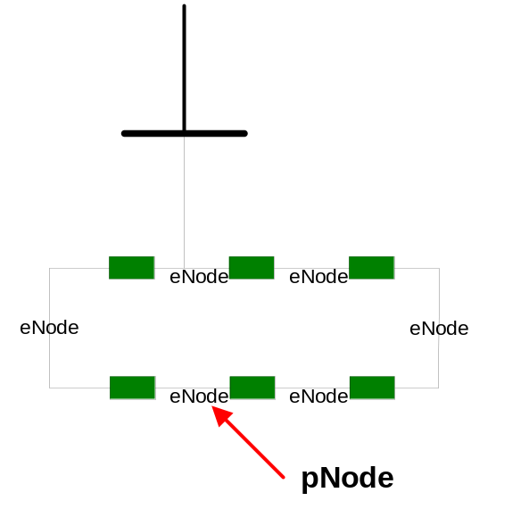
Exhibit 2.1: Single P-Node Mapped to Multiple “Close” E-Nodes

Certain P-Nodes are used only for modeling purposes as part of AP-Nodes (“Aggregated Pricing Nodes”). Prices for these P-Nodes are not published and are not “public” P-Nodes. For other P-Nodes that are “public” P-Nodes, prices are published for the Day Ahead, Real Time, and FTR markets. These “public” P-Nodes represent locations that may be used for the submission of Offers/Bids/FTR transactions.

AP-Nodes are all “public” locations, and prices are published for all AP-Nodes. The price at an AP-Node is a weighted average price of the P-Nodes included in the AP-Node. The New England Hub is an example of an AP-Node. For the New England Hub, the Hub price is the arithmetic average of the prices of the P-Nodes that comprise the Hub. Load Zones are also examples of AP-Nodes. For each Load Zone, the Load Zone AP-Node Price is the load-weighted average of P-Node prices within the Load Zone. Certain generators (typically combined cycle units) and Dispatchable Asset Related Demands may have the Resource modeled as an AP-Node comprised of several P-Nodes. For these Resource AP-Nodes, the AP-Node Price is a MW-weighted average of the P-Node prices. Only the Resource’s AP-Node price is published, and all bidding for the Resource takes place at the AP-Node.

Settlement of the Markets is based on generation injections, load withdrawals, and prices at the “public” AP-Nodes and “public” P-Nodes for which prices are publicly published.

2.5 Energy Market Business Rules

2.5.1 Bidding & Operations Time Line
The normal day-ahead scheduling, offer and bidding timeline for the Energy Market consists of the following time frames. Times may be adjusted as required to account for software failures or other events and the ISO will post any such change on its website as soon as practicable:
10:00 a.m. — Day-Ahead Energy Market offer and bid period closes. All Day-Ahead Energy Market offers and bids, including all Day-Ahead Energy Market External Transactions, and Real-Time Energy Market priced External Transactions and any changes to the Start-Up and No-Load Fees must be submitted to the ISO. Generator designation as a Supplemental Capacity Resource must also be submitted to the ISO no later than the close of the Day-Ahead Energy Market on the day before the Operating Day. Subsequent to the offer submission deadline for the Day-Ahead Energy Market, the ISO begins to run the security-constrained unit commitment and dispatch software tools utilized in the determination of the hourly commitment schedules and the LMPs for the Day-Ahead Energy Market. This first unit commitment run determines the unit commitment profile that satisfies the Self-Scheduled Demand Bids, including Day-Ahead Energy Market Self-Scheduled External Transaction sales, cleared price-sensitive Demand Bids, including Day-Ahead Energy Market priced External Transaction sales, Dispatchable Asset Related Demands and Demand Resources, and Decrement Bids, and the ISO Operating Reserve and Replacement Reserve objectives at least cost (see Section 5 of this manual for a description of least cost methodology).
Upon Completion of the Day-Ahead Energy Market — The ISO posts the Day-Ahead Energy Market hourly schedules and Day-Ahead Energy Market LMPs and the Re-Offer Period begins. The Day-Ahead Energy Market schedules and LMPs are also available in downloadable files.
During the Re-Offer Period, Market Participants can submit certain revisions to Supply Offers, revised prices on priced External Transactions, revised Demand Bids for Dispatchable Asset Related Demands and Regulation offers. All assignments of Forward Reserve Obligations to eligible Resources and all Internal Bilateral Transactions for Forward Reserve for the next Operating Day must be submitted to the ISO prior to the close of the Re-Offer Period. Priced External Transactions that do not clear in the Day-Ahead Energy Market participate in the Real-Time Energy Market based on prices submitted in the Real-Time Energy Market. Market Participants with priced External Transactions that cleared in the Day-Ahead Energy Market must modify the price component of the corresponding Real-Time Energy Market offer during this period in order to opt out of the Real-Time scheduling priority treatment as a Self-Scheduled transaction for the Day-Ahead Energy Market cleared MW.
2:00 p.m. — The Real-Time Energy Market Re-Offer Period closes. The ISO performs a Reserve Adequacy Analysis. It includes the updated Supply Offers, updated External Transactions, updated Demand Bids for Dispatchable Asset Related Demands, updated unit availability information, and updated ISO load forecast information including deviation between the ISO load forecast and the sum of cleared Demand Bids and Decrement Bids utilized in the first commitment. The focus of this Reserve Adequacy Analysis is reliability and the objective is to minimize the capacity costs associated with any additional capacity that may be required (see Section 5 of the manual for additional information). When insufficient supply side capacity is available to meet the New England-wide or zonal capacity requirements, the RAA identifies the ISO New England Operating Procedure No. 4 Actions needed to resolve the deficiency. These actions include Real-Time Demand Response activation, Thirty Minute Operating Reserve depletion, voltage reductions, Real-Time Emergency Generation Resource activation, requesting emergency energy transactions (EET), and requesting/scheduling Non-CSO Resources to provide Reliability Energy. For a full list of actions see ISO New England Operating Procedure No. 4. This analysis could result in the release of Generators that were committed in the Day-Ahead Energy Market in order to avoid a projected Minimum Generation Emergency. Day-Ahead Energy Market schedules remain financially binding even if released in this step.
5:00 p.m. — The RAA results are published. The ISO populates individual Resource schedules developed during the initial Reserve Adequacy Analysis for non-Fast Start Resources, priced External Transactions and Real-Time Demand Response Resources to affected Market Participants only.
Throughout the Operating Day — The ISO may also perform additional Reserve Adequacy Analyses, as necessary, based on updated ISO load forecasts and updated Resource availability information. The ISO sends out individual Resource schedule updates developed during the additional Reserve Adequacy Analysis for non-Fast Start Resources, priced External Transactions and Real-Time Demand Response Resources to affected Market Participants only. The ISO may, under the circumstances described in ISO New England Operating Procedure No. 4 Action 7, request that Resources, or portions thereof, without a Capacity Supply Obligation voluntarily provide energy to meet reliability needs pursuant to Market Rule 1 Section III.13.6.4.

2.5.2 Market Participants Buying from Energy Market
The following business rules apply to Market Participants purchasing from the Energy Market:
- Submittal of Demand Bids must be associated with a physical load that has been registered as a Load Asset. ISO implementation of this requirement is set forth in Section 2.5.6. (Please see Section 1.2 of the ISO New England Manual for Registration and Performance Auditing, M-RPA for details on requesting the demand response enrollment information specified in Market Rule 1, Section III.13.1.4.10.)
(2) Market Participants may submit only one hourly fixed Demand Bid quantity for which it commits to purchase Energy at Day-Ahead LMPs for consumption in the next Operating Day. The quantity bid must specify MW quantity and Location. For all fixed Demand Bids, other than Demand Bids associated with Asset Related Demands, the valid settlement Location is the applicable Load Zone.
(3) Market Participants may submit hourly Self-Scheduled External Transaction quantities for which it commits to purchase Energy (i.e., export) at Day-Ahead LMPs for consumption in the next Operating Day. The Self-Scheduled External Transaction submittal must specify MW quantity and External Node.
(4) Market Participants may submit hourly Self-Scheduled External Transaction quantities for which it commits to purchase Energy (i.e., export) at Real-Time LMPs for consumption in the next Operating Day. The External Transaction submittal must specify MW quantity and External Node (s).
(5) Market Participants should not include the impact of PTF losses as part of their Demand Bids or External Transaction sales submitted for use in the Day-Ahead Energy Market as PTF losses are accounted for on a financial basis through the Loss Component of the LMP.
(6) Price sensitive Demand Bids for use in the Day-Ahead Energy Market shall specify MW quantity, Location, and the price above which the demand should not be scheduled. For all price-sensitive Demand Bids, other than Demand Bids associated with Dispatchable Asset Related Demands, the valid settlement Location is the applicable Load Zone.
(7) Priced External Transactions submitted for use in the Day-Ahead Energy Market shall specify MW quantity, External Node, and the price above which the demand should not be scheduled.
(8) Priced External Transactions submitted for use in the Real-Time Energy Market shall specify MW quantity, External Node, and the price above which the demand should not be scheduled.
(9) Price sensitive Demand Bids for use in the Day-Ahead Energy Market are accepted in single bid blocks only. Up to ten bid blocks applicable to each hour of the day may be submitted per Market Participant at a specific Location.
(10) If a Market Participant submits no Day-Ahead Demand Bid information for load other than Asset Related Demand, then a zero MW quantity is assumed in the Day-Ahead Energy Market. (i.e., Demand Bids do not carry forward on a day-to-day basis).
(11) If a Market Participant submits no Day-Ahead Demand Bid information for an Asset Related Demand, then the most recent previously submitted Day-Ahead value is assumed in the Day-Ahead Energy Market. (i.e., Demand Bids associated with Asset Related Demands carry forward on a day-to-day basis). The default Demand Bid MW quantity for an Asset Related Demand is zero.
(12) For modeling purposes, the load distribution to Nodes within a Load Zone for the Day-Ahead Energy Market is the historical State Estimator distribution for that Load Zone.
(13) For modeling purposes, the load distribution to Nodes within a Load Zone for the Real-Time Energy Market is the actual State Estimator distribution of loads.
(14) Up-to Congestion External Transactions and Decrement Bids are supported in the Day-Ahead Energy Market only.
(15) The list of Load Zones, and Nodes at which Demand Bids are accepted is defined by the ISO and posted on the ISO’s web site.
(16) Market Participants may submit up to fifty Decrement Bid blocks per hour for use in the Day-Ahead Energy Market at any Hub, Load Zone or Node for which an LMP is calculated. It is not required that physical load exists at the Location that is specified in the Decrement Bid. Decrement Bids are only applicable in the Day-Ahead Energy Market.
(17) Price-sensitive Demand Bids, Decrement Bids and External Transaction sales must be in compliance with the price cap level of $1,000 per MWh for Energy offer prices (such price cap level is as stated under Market Rule 1) and must be equal to or greater than zero.
(18) Market Participants with Dispatchable Asset Related Demands must submit Demand Bids into the Day-Ahead Energy Market for such Resources with a Minimum Consumption Limit that is less than or equal to the Nominated Consumption Level specified during the Asset Registration Process and shall specify changes to the Maximum Consumption Limit and Minimum Consumption Limit from those submitted as part of the Resource’s Bid Data to reflect the physical operating characteristics and/or availability of the Resource, except that, for a Self-Scheduled Resource, the Minimum Consumption Limit may be revised to reflect the Self-Scheduled consumption level of the Resource. Market Participants may submit up to ten Demand Bid blocks per day for each Dispatchable Asset Related Demand Bids the Day-Ahead Energy Market.
(19) Market Participants with Dispatchable Asset Related Demands that are Self-Scheduled Resources must submit Demand Bids for the entire operating range of the Resource (Demand Bids between the Nominated Consumption Level and Maximum Consumption Limit).
(20) A Market Participant may revise its Demand Bid associated with a Dispatchable Asset Related Demand and submit it for use in the Real-Time Energy Market or it may Self-Schedule the Dispatchable Asset Related Demand with ISO approval during the Re-Offer Period. The Market Participant must contact the ISO forecast office via telephone, or other means specified by the ISO, with any Self-Schedule requests and the forecast office must approve the request prior to the Market Participant entering the change via the eMKT User Interface. Self-Schedule requests made pursuant to the applicable procedures after the Re-Offer Period has ended will be entered by the ISO as a Redeclaration if the request is approved by the ISO.
- External Transaction sales that comply with the conditions described in Market Rule 1, Section III.1.10.7(f) may qualify for treatment that improves the transactions’ likelihood of flowing in Real-Time through the ISO’s commitment of Local Second Contingency Protection Resources and improved scheduling and curtailment priorities, as delineated in Section III.1.10.7(g) of Market Rule 1 and Section II.44 of the ISO New England Open Access Transmission Tariff. Export Transaction sales receiving this treatment will be assessed a share of certain NCPC charges and Reserve charges as explained in Sections III.1.10.7(h), III.9.9, III.10.3, III.F.3.2.5 and III.F.3.2.16.

2.5.3 Market Participants Selling into Energy Market
The following business rules apply to Market Participants selling into the Energy Market:
(1) Submittal of Supply Offers must be associated with a physical Generator that has been registered as a Generator Asset. ISO implementation of this requirement is set forth in Section 2.5.6.
(2) Market Participants with Generators that are CSO Resources, other than Intermittent Power Resources, must submit Supply Offers (such Supply Offers must be Self-Schedules for Resources without Electronic Dispatch Capability) into the Day-Ahead Energy Market. Such Supply Offers shall be for at least the entire Capacity Supply Obligation (as adjusted to account for ambient air temperature and other physical adjustments, as needed) of such Generators unless they are unavailable due to a Generator Forced Outage, Generator Planned Outage, or Generator Maintenance Outage, and may be for the entire operating range of the resource. Please see the ISO New England Manual for the Forward Capacity Market, M-20 and the ISO New England Manual for Registration and Performance Audits, M-RPA, for additional information regarding the rules and requirements for Intermittent Power Resources.
(3) Market Participants with Generators that are Non-CSO Resources may submit Supply Offers for use in the Day-Ahead Energy Market. Non-CSO Resources that do not clear energy in the Day-Ahead Energy Market, and have not been assigned a Forward Reserve Obligation in at least one hour of the next Operating Day, and have not been designated as a Supplemental Capacity Resource for the next Operating Day, or are not otherwise required to submit a Supply Offer under the ISO Tariff, shall be deemed unavailable for commitment by the ISO for the next Operating Day, except as provided for in Operating Procedure No. 4 where a request can be made for Non-CSO Resources to voluntarily provide energy pursuant to Market Rule 1 Section III.13.6.4. Market Participants may request to Self-Schedule these Non-CSO Resources in order to participate in the Real-Time Energy Market, where the Resources would be dispatchable in Real-Time up to the offered Economic Maximum Limit.
(4) Market Participants with Generators that are Self-Scheduled CSO Resources must submit Supply Offers for the entire Capacity Supply Obligation of the Resource, to the extent it is available, and may optionally submit Supply Offers for MW between the Capacity Supply Obligation and the maximum operating range of the Resource. The Resource will be dispatched in Real-Time up to the offered Economic Maximum Limit.
(5) Market Participants with Generators that are CSO Resources must submit a schedule of availability for the next seven days for such Generators and may submit non-binding Supply Offer prices for some or all of the seven days for which it submits an availability schedule beyond the next Operating Day.
(6) The set of Supply Offers (including Self-Schedules if submitted through the Market User Interface as changes to the daily default interface but not if submitted on the unit hourly update display) last submitted for each Generator shall remain in effect for each day until specifically superseded by subsequent Supply Offers except as specified below:
(a) For Market Participants with Generators that are CSO Resources with a notification time greater than 24 hours, if the ISO commits these Resources for Emergency reasons, the Supply Offer submitted for this Resource will become binding beginning with the day the ISO commits the Resource through the end of the ISO’s commitment period for the Resource.
(b) For a Pool-Scheduled Resource continuing to run into the second Operating Day to satisfy its minimum run time, the Supply Offer prices originally utilized by the ISO to commit the Resource in the first Operating Day will continue to remain binding into the second Operating Day until such time as the Resource’s minimum run time has been satisfied for purposes of calculating NCPC Credits.
(c) For Market Participants with Generators that are CSO Resources where the sum of the Generating Capacity Resource’s notification time plus start time plus minimum run time plus minimum down time is less than or equal to 72 hours, the Resource shall be offered, to the extent available, into the Day-Ahead Energy Market at a MW amount at least equal to its Economic Minimum Limit at a price of zero, or shall be Self-Scheduled at a MW amount equal to or greater than its Economic Minimum Limit.
(7) During the Re-Offer Period, a Market Participant may revise the Supply Offer of a Generator that was not committed in the Day-Ahead Energy Market, or modify only the incremental Energy offers of a Generator that was committed in the Day-Ahead Energy Market. Alternatively, a Market Participant may request to Self-Schedule a Generator, subject to ISO approval. The Market Participant must contact the ISO forecast office via telephone, or other means specified by the ISO, with any Self-Schedule requests and the forecast office must approve the request prior to the Market Participant entering the change via the eMKT User Interface. Self-Schedule requests made pursuant to the applicable procedures after the Re-Offer Period will be entered by the ISO as a Redeclaration if the request is approved by the ISO. Similarly, if a Generator was committed in the Day-Ahead Market and would like to request de-commitment, that Resource must notify the ISO and receive approval from the ISO prior to de-commitment.
(8) Shall specify a minimum run time to be used for scheduling purposes that does not exceed 24 hours. Generators with minimum run time limitations that require that they run for more than 24 hours may Self-Schedule to remain on-line. Such Generators are eligible to receive NCPC Credits only during the initial 24 hours of pool-scheduled operation but may account for expected levels of lost NCPC Credits during the remainder of their required minimum run time through submission of Supply Offer prices for these initial 24 hours.
(9) For Limited Energy Resources, a Market Participant shall submit into the Day-Ahead Energy Market, as part of the normal Supply Offer for the Generator, an estimate of the total Energy that unit is capable of producing for the Operating Day. In Real-Time, the Market Participant can manage the use of energy from any portion of a Limited Energy Resource through the use of limited energy hourly maximum levels for the associated Limited Energy Resource.
(10) A Supply Offer for a Generator may consist of a Start-Up Fee, No-Load Fee, and up to ten incremental Energy offer blocks. Market Participants must indicate whether or not Start-Up Fees and No-Load Fees are to be considered as part of the Supply Offer price or if only the incremental Energy price is to be used.
(11) Market Participant can change the Supply Offer of a Generator on a daily basis prior to the close of the Day-Ahead Energy Market or as allowed during the Re-Offer Period.
(12) Market Participants must submit, for any Resource for which a Supply Offer is submitted, the maximum amount of 10-minute off-line reserve (CLAIM10) and the maximum amount of 30-minute off-line reserve (CLAIM30) for the purposes of maintaining system reliability.
(13) Only one Supply Offer for each Generator may be offered into the Day-Ahead Energy Market.
(14) A Supply Offer for a Generator that is accepted but not cleared for the Day-Ahead Energy Market automatically carries over for use in the Real-Time Energy Market unless modified in the Re-Offer Period, except as noted below:
(a) Non-CSO Resources that do not clear in the Day-Ahead Energy Market, and have not been assigned a Forward Reserve Obligation in at least one hour of the next Operating Day, and have not been designated as a Supplemental Capacity Resource for the next Operating Day, or are not otherwise required to submit a Supply Offer under the ISO Tariff, shall be deemed unavailable for commitment by the ISO for the next Operating Day except as provided for in Operating Procedure No. 4 where a request can be made for Non-CSO Resources to voluntarily supply energy pursuant to Market Rule 1 Section III.13.6.4. Market Participants may request to Self-Schedule these Non-CSO Resources in order to participate in the Real-Time Energy Market. The Resource will be dispatchable in Real-Time up to the offered Economic Maximum Limit.
(15) Only one Supply Offer for each Generator may be submitted into the Real-Time Energy Market.
(16) Valid Supply Offer operating limits, which must be based on the following:
(a) Emergency Minimum Limit shall be based on the physical capability and design of the generator and should not change on a day to day basis, except as required by the impact of environmental factors, including ambient temperature, emission limits and other operating permit requirements.
(b) Economic Minimum Limit shall be based on the physical capability and design of the generator, except in the case of a Self Schedule which may change this limit on an hourly basis.
(c) Economic Maximum Limit shall be no less than the greater of the Capacity Supply Obligation of the Resource or its Economic Minimum Limit to the extent the generator is available.
(d) Real-Time High Operating Limit must reflect the maximum output, in MW, of a resource that could be achieved, consistent with Accepted Electric Industry Practice, in response to an ISO request for Energy under Section III.13.6.4 of Market Rule 1, for each hour of the Operating Day, and must be based on real-time operating conditions and the physical operating characteristics and operating permits of the unit.
(e) [Reserved]
(f) Generator operating limits submitted as part of the Offer Data may be revised during the Re-Offer Period. Subsequent to the Re-Offer Period, revised operating limits are entered by the ISO via a Redeclaration after being notified by the Market Participant of the change.
(17) A Market Participant may submit up to fifty Increment Offer blocks per hour for use in the Day-Ahead Energy Market at any Hub, Load Zone or Node for which an LMP is calculated. It is not required that physical generation or load exists at the Location that is specified in the Increment Offer. Increment Offers are only applicable in the Day-Ahead Energy Market.
(18) A Supply Offer for a Generator includes an Economic Maximum Limit, which is the highest unrestricted output level on its Supply Offer curve that the Market Participant owner of the Generator is offering for economic dispatch. The Economic Max point should not be greater than the actual capability of the Generator to operate on its Supply Offer curve.
(19) A Market Participant with an Import Capacity Resource must submit priced or self-scheduled External Transactions that meet the requirements of Section III.13.6.1.2 of Market Rule 1 into both the Day-Ahead Energy Market and the Real-Time Energy Market.
(20) Market Participants may submit hourly Self-Scheduled External Transaction quantities for which they commit to sell Energy (i.e., import) at Day-Ahead LMPs for delivery in the next Operating Day. The External Transaction submittal must specify MW quantity and External Node.
(21) Market Participants may submit hourly Self-Scheduled External Transaction quantities for which it commits to sell Energy (i.e., import) at Real-Time LMPs for delivery within the Operating Day. The External Transaction submittal must specify MW quantity and External Node.
(22) Priced External Transaction purchases submitted for use in the Day-Ahead Energy Market shall specify MW quantity, External Node, and the price below which the transaction should not be scheduled.
(23) Priced External Transaction purchases submitted for use in the Real-Time Energy Market shall specify MW quantity, External Node, and the price below which the transaction should not be scheduled.
(24) Up-to Congestion External Transactions and Increment Offers are supported in the Day-Ahead Energy Market only.
(25) A Market Participant may revise the price component of its priced External Transaction for the Real-Time Energy Market during the Re-Offer Period.
(26) Supply Offers, Increment Offers and External Transactions must be in compliance with the $1,000/MWh Energy offer price cap levels as stated under Market Rule 1.
(27) For Market Participants submitting an Economic Maximum Limit value for a Resource as part of a Day-Ahead Energy Market offer, the Real-Time High Operating Limit is provided to ISO through each Resource’s Day-Ahead Supply Offer data and must be re-declared to reflect changes in physical operating characteristics and operating permit limitations.
(a) [Reserved]
(b) If Real-Time High Operating Limit changes at any time after the initial data values were communicated to the ISO, the Designated Entity must Re-Declare the data values as follows:
(i) Re-Declarations made on the day prior to the Operating Day must be called into the Forecaster Desk.
(ii) Re-Declarations made during the Operating Day must be called into the Control Room Generation Desk.

2.5.4 Transmission Customers
The following business rules apply to Transmission Customers:
- Market Participants may submit External Transaction schedules and may indicate willingness to pay Congestion Charges for the Day-Ahead Energy Market through submittal of an Up-to Congestion External Transaction. In the Real-Time Energy Market, External Transactions scheduled are always considered as willing to pay Congestion Charges.
- Market Participants may submit hourly Self-Scheduled External Transaction quantities for which it commits to wheel Energy (i.e., Through External Transaction) in the Real-Time Energy Market during the Operating Day. The External Transaction submittal must specify MW quantity and External Nodes.
- Non-Market Participant Transmission Customers cannot submit External Transactions into the Day-Ahead Energy Market. Non-Market Participant Transmission Customers may only submit Through External Transactions into the Real-Time Energy Market.
- A Transmission Customer should not include the impact of transmission losses as part of its External Transaction submitted for use in the Day-Ahead Energy Market or Real-Time Energy Market as transmission losses are accounted for on a financial basis through the Loss Component of the LMP.
- Up-to Congestion External Transaction offers and bids shall be no larger than $25/MWh.
- External Transaction submittals must be in compliance with the $1,000/MWh Energy offer price cap levels as stated under Market Rule 1.

2.5.5 ISO Activities
The following business rules apply to ISO activities:
(1) The ISO shall post on the ISO’s web site the ISO load forecast, total bid demand, Operating Reserve objective and Replacement Reserve objective for each hour of the next Operating Day at the completion of the Day-Ahead Energy Market scheduling process.
(2) The ISO shall post hourly LMP values for the next Operating Day at the completion of the Day-Ahead Energy Market scheduling process.
(3) The ISO shall post the schedule of demand, supply, and External Transactions for private viewing by the applicable Market Participants.
(4) The ISO will perform Reserve Adequacy Analyses after the close of the Re-Offer Period in order to maintain reliable operation. Such Reserve Adequacy Analyses are performed with the objective of minimizing Start-Up Fees and the cost to operate at minimum load.
(5) During the various Reserve Adequacy Analyses, the ISO may limit its dependence on off-line Fast Start Generators to provide Operating Reserve in order to maintain reliable operational standards. Such limits shall be based on past performance of these units.
(6) The ISO will designate available Operating Reserve in Real-Time to Resources that meet the following criteria:
- the Resource must be following ISO Dispatch Instructions;
- the Resource must be on-line or be an off-line Resource with CLAIM10 and/or CLAIM30 values greater than zero;
- the Resource must have excess capacity not being utilized to meet the energy needs of the system (i.e., be operating below its Economic Maximum Limit or consuming above its Minimum Consumption Limit);
- the applicable portion of the Resource is subject to a Capacity Supply Obligation or has otherwise voluntarily offered the megawatts for Real-Time dispatch;
- and the generating Resource must not have been designated as constrained down in order to manage transmission congestion.
(7) For Limited Energy Generators that submit a “maximum Energy available for the Operating Day”, the ISO will ensure that that this maximum Energy value will not be exceeded within the Operating Day in the Day-Ahead Energy Market unless additional Energy is required to satisfy a Self-Schedule or minimum run time. Additionally, in Real-Time, the ISO will allow the declaration of an hourly profile of economic Dispatch maximums that can be below the Economic Maximum Limit specified in the Offer Data. These hourly limits can be set to a Day-Ahead hourly schedule or Redeclared subject to ISO business procedures restrictions. The offering Market Participant can request that the Real-Time Dispatch limit hourly scheduling to the lower limit for the purpose of preserving a limited supply of Energy for future hours of the Operating Day. However, the ISO will continue to designate the Operating Reserve available above the lower limit up to the Economic Maximum Limit requested by the Market Participant and activate that Operating Reserve as it deems appropriate to maintain reliability.
(8) Within two Business Days following the Operating Day, the ISO will post the final Real-Time Prices, final Real-Time Reserve Clearing Prices and final Regulation Clearing Prices that will be used to settle the Real-Time Energy Market and the Regulation Market and to calculate credits associated with provision of Operating Reserve in Real-Time. However, in accordance with Section III.2.9 of Market Rule 1, under exceptional circumstances the ISO may post the final Real-Time Prices, final Real-Time Reserve Clearing Prices and final Regulation Clearing Prices up to five Business Days following the Operating Day.
(9) The ISO’s market power mitigation procedures apply under both the Day-Ahead Energy Market and Real-Time Energy Market.

2.5.6 Technical Rules
- A valid Supply Offer consists of the following elements:
For Generator Resources, a valid Supply Offer consists of a price-based schedule consisting of the following inputs. The default values are:
- Day-Ahead Energy Market switch is “check” or yes (“1”).
- Real-Time Energy Market switch is “check” or yes (“1”).
- Use Start-Up Fee & No-Load Fee switch is “check” or yes (“1”).
- Use offer slope switch is “square box” or no (“0”).
- Condense available switch is blank or no (“0”).
- Start-Up Fee and No-Load Fee is zero.
- Must contain an Emergency Minimum Limit and an Economic Maximum Limit of at least one MW.
- Hourly economic max/min and emergency min are the unit level economic and emergency MW limits. Emergency max limit is automatically set equal to economic max limit.
- Minimum down time, minimum run time, start times, and notification times are zero.
- Maximum run time and maximum number of starts per week are infinity.
- The default for incremental offer curve data is $0. The curve is extended up using zero slope from the last incremental point on the curve if the offer curve is of inadequate length to Dispatch and/or price operating capability.
- CLAIM10 MW Amount (Maximum 10-minute off-line reserve MWs). Default value is zero MWs.
- CLAIM30 MW Amount (Maximum amount of 30-minute off-line reserve MWs). Default value is equal to zero.
- Manual Response Rates (MRR) for associated MW ranges.
- Valid Demand Bids, price sensitive and fixed, consist of the following items:
- MW, with a default value of zero MW.
- Location (Load Zone).
- Price above which demand should not be scheduled (for price-sensitive Demand Bids).
(3) Valid Demand Bids for Asset Related Demand consist of the following items:
- Hourly Maximum Consumption Limit and hourly Minimum Consumption Limit (for non-dispatchable Asset Related Demand, Minimum Consumption Limit is equal to Maximum Consumption Limit).
- Monotonically decreasing bid curve for segments offered between Minimum Consumption Limit and Maximum Consumption Limit for Dispatchable Asset Related Demand (non-dispatchable Asset Related Demand is considered fixed demand at the Node).
- Ramp rate for associated MW ranges for Dispatchable Asset Related Demand.
- CLAIM10 MW Amount for Dispatchable Asset Related Demand (Maximum amount of TMNSR MW that can be provided by a Dispatchable Asset Related Demand). Default value is zero MW.
- CLAIM30 MW Amount for Dispatchable Asset Related Demand (Maximum amount of TMOR MW that can be provided by a Dispatchable Asset Related Demand). Default value is equal to zero MW.
(4) Data validation:
- The ISO will not allow a Supply Offer MW amount to be submitted that is greater than the largest generating unit in the system;
- The ISO will not allow an External Transaction entry greater than 999 MW;
- On a locational basis, the ISO will monitor Demand Bids for consistency with the submitting Market Participants’ expected Real-Time Load Obligations, using the moving average of the Real-Time Load Obligation over a number of Operating Days adjusted for forecast load, and may contact Market Participants to verify their Demand Bids. If the Market Participant contacted by the ISO agrees that such a Demand Bid was submitted in error, a replacement bid may be submitted by that Market Participant to adjust the MW amount submitted to a level consistent with the ISO’s expectation of the Market Participant’s Real-Time Load Obligation or a level acceptable to the ISO based on demonstrated historical bid patterns. If, after discussion, a Market Participant refuses to correct a Demand Bid at a Location to a level that the ISO reasonably believes will not exceed the submitting Market Participant’s expected Real-Time Load Obligation, the ISO may reduce the MW quantity of any such Demand Bid to a level consistent with the ISO’s expectation of the Market Participant’s Real-Time Load Obligation. It is intended that this process normally be completed within one hour after the close of the Day-Ahead Energy Market offer and bid period.
- The ISO will monitor Supply Offers (MW quantities and Economic Maximum and Minimum Limits) for consistency with the physical characteristics of the associated Resource using a percentage of Seasonal Clamed Capability and the Capacity Supply Obligation as a basis for comparison. If Supply Offer MW quantities or Economic Maximum or Minimum Limits appear inconsistent with the Resource’s Capacity Supply Obligation value, the ISO may contact the Market Participant to verify the Supply Offer MW quantities and/or Economic Maximum and Economic Minimum Limits. If the Market Participant contacted by the ISO agrees that such a Supply Offer was submitted in error, a replacement offer may be submitted by that Market Participant to adjust the MW amount submitted to a level consistent with the expected capability of the Resource. If, after discussion, a Market Participant refuses to correct a Supply Offer that the ISO reasonably believes does not reflect the Capacity Supply Obligation and the physical characteristics of the Resource, the ISO may adjust the Supply Offer to a level that reflects those characteristics. It is intended that this process normally be completed within one hour after the close of the Day-Ahead Energy Market offer and bid period.
- The ISO may monitor Increment Offers and Decrement Bids and may, but is not obligated to, contact Market Participants when such Increment Offers or Decrement Bids appear to have been submitted in error. If the Market Participant agrees that its Increment Offer or Decrement Bid was in error, a replacement offer or bid may be submitted by that Market Participant to adjust the MW amount submitted. It is intended that this process normally be completed within one hour after the close of the Day-Ahead Energy Market offer and bid period.

2.5.7 Major Modeling Assumptions
- Self-Scheduled External Transactions, priced External Transactions, Generator Supply Offers, Increment Offers, Decrement Bids and Demand Bids are modeled in the Day-Ahead Energy Market Technical Software. Up-to Congestion External Transactions are not modeled in the Day-Ahead Energy Market commitment, but are handled in the Day-Ahead Energy Market Dispatch. The ISO does not commit additional generation in the Day-Ahead Energy Market to support Up-to Congestion External Transaction sales and does not reduce generation commitment in the Day-Ahead Energy Market to account for Up-to Congestion External Transaction purchases.
- The ISO allows the commitment during the Reserve Adequacy Analysis to be affected by the expected net interchange of Self-Scheduled and priced Real-Time External Transactions.
- For the Day-Ahead Energy Market, the Resource ramp rate that is utilized within the SPD software is calculated based on the MW weighted average of all ramp rates that are submitted as part of the Resource’s Supply Offer. For the Real-Time Energy Market dispatch, the Resource ramp rate that is utilized within the UDS software is the ramp rate for the MW segment being dispatched (see the User Guide for Submitting Bids and Offers via eMKT for details on submitting multiple ramp rates).
- The Day-Ahead security analysis treats Increment Offers as the equivalent of a Supply Offer at the Location specified and Decrement Bids as the equivalent of a Demand Bid at the Location specified. For Increment Offers and Decrement Bids submitted at a Hub or Load Zone, the Increment Offer or Decrement Bid amounts are distributed down to Nodes within the Hub or Load Zone using the same weightings that are applicable to calculation of the Hub Price or Load Zone Price for that Hub or Load Zone. Increment Offers and Decrement Bids create an imbalance where physical generation and load do not exist.
- The ISO shall develop schedules (used for financial settlement and preliminary Real-Time scheduling priority only) for External Transactions that have been submitted to the Day-Ahead Energy Market for each hour of each Operating Day on each external interface. Imports submitted as External Transactions or Increment Offers, exports submitted as External Transactions or Decrement Bids will be cleared based on the applicable LMPs. Schedules will be developed for each balancing area interface, on a net basis for each scheduling interval, up to the transfer limit, as forecasted by the ISO. Additional system reliability considerations shall also apply. Table 2.3 summarizes the modeling treatment of External Transactions. Please see Table 3.1 of the ISO New England Manual for Market Rule 1 Accounting, M-28 for a summary of the settlement treatment of External Transactions.
Table 2.3: External Transaction Modeling Treatment
Source/Sink Location | Self-Scheduled/priced  Day-Ahead | Up-To-Congestion  Day-Ahead | Self-Scheduled/priced  Real-Time
Single External Node | Injection/withdraw at External Node.  Cleared based on External Node LMP if priced | Not Applicable. Source/Sink Location cannot be the same. | Injection/withdraw at External Node.  Dispatched based on External Node LMP if priced
External Node and Internal Location | Not Applicable.  Source/Sink Location must be the same. | Purchase: Injection at External Node (Source or POR), withdraw at Internal Location (Sink or POD). Cleared based on  (LMP@ Internal Location – LMP@ External Node).  Sale: Withdraw at External Node (Sink or POD), injection at Internal Location (Source or POR). Cleared based on  (LMP@ External Node – LMP@ Internal Location). | Not Applicable.
External Node 1,  External Node 2 (i.e., a Through transaction) | Not Applicable. Software cannot accommodate Day-Ahead Through Transactions at this time. | Not Applicable. Software cannot accommodate Day-Ahead Through Transactions at this time. | Injection at External Node 1  Withdraw at External Node 2  (or vise versa)  Through transaction cannot be priced.

2.5.8 Using & Calculating Locational Marginal Prices and Real-Time Reserve Clearing Prices
LMPs and Real-Time Reserve Clearing Prices are used in the Market accounting to calculate Charges or Credits for many of the market services, including:
- Energy Market Energy — The Energy Component of the LMP is used to calculate the Charges for Energy purchases and the Credits for Energy deliveries. (See the “Energy Market Accounting” Section of the ISO New England Manual for Market Rule 1 Accounting, M-28 for a detailed description of these calculations).
- Net Commitment Period Compensation (NCPC) — LMPs, along with other components, are used to determine whether eligible Market Participant Resources are properly compensated for their costs. (See Appendix F to Market Rule 1 for a detailed description of this calculation).
(3) Operating Reserve — Real-Time Reserve Clearing Prices are used to calculate the compensation paid to Market Participants with Resources that have been designated in Real-Time as providing TMSR, TMNSR and/or TMOR. (See the “Forward Reserve Market and Real-Time Reserve Accounting” Section of the ISO New England Manual for Market Rule 1 Accounting, M-28 for a detailed description of this calculation).
(4) Forward Reserves — Real-Time Reserve Clearing Prices are used to calculate Forward Reserve Obligation Charges and Real-Time LMPs are utilized in the calculation of penalties associated with non-activation of Forward Reserve (See the “Forward Reserve Market and Real-Time Reserve Accounting” Section of the ISO New England Manual for Market Rule 1 Accounting, M-28 for a detailed description of this calculation).
(5) Transmission Congestion — The Congestion Component of the LMP is used in the calculation of Congestion Costs and to determine the value of FTRs in the calculation of corresponding Transmission Congestion Credits. (See the “Transmission Congestion Accounting” Section of the ISO New England Manual for Market Rule 1 Accounting, M-28 for a detailed description of this calculation).
(6) Transmission Losses — Transmission losses are accounted for through the Loss Component of the LMP. (See the “Transmission Losses Accounting” Section of the ISO New England Manual for Market Rule 1 Accounting, M-28 for a detailed description of this calculation).
(7) Emergency Energy — LMPs are used to calculate the Charges and Credits for Emergency purchases and sales between the New England Control Area and other Control Areas. (See the “Emergency Energy Accounting” Section of the ISO New England Manual for Market Rule 1 Accounting, M-28 for a detailed description of this calculation).
(8) Data Reconciliation — The LMPs used in the original monthly Settlements are applied on an hourly basis to the re-settlement of the Real-Time markets which may be required due to the submission of revised meter data or other revised data. (See the “Data Reconciliation Accounting” Section of the ISO New England Manual for Market Rule 1 Accounting, M-28 for a detailed description of this calculation).
(9) Inadvertent Energy Accounting — The LMPs calculated at External Nodes are used in determining the value of Inadvertent Energy (See the “Inadvertent Energy Accounting” Section of the ISO New England Manual for Market Rule 1 Accounting, M-28 for a detailed description of this calculation).
For the Real-Time Energy Market, Market Participants with Generators are paid based on the Generator Node LMP, Market Participants with Asset Related Demands are charged based on the load Node LMP and Market Participants with load other than Asset Related Demand are charged based on the Zonal Price of the Load Zone in which the applicable loads reside.
In general, for the Day-Ahead Energy Market, Market Participants with Generators are paid based on the Generator Node LMP and Market Participants with cleared Increment Offers are paid based on the LMP at the Location at which the Increment Offer cleared. Market Participants with load are charged based on the LMP of the Location at which the Demand Bids or Decrement Bids cleared.
LMPs are calculated hourly for use in the Day-Ahead Energy Market and LMPs and Real-Time Reserve Clearing Prices are calculated on a periodic basis throughout the Operating Day, nominally every five minutes, for use in the Real-Time Energy Market. At the end of each Real-Time hour, a time-weighted average of the five-minute LMP values and the five-minute Real-Time Reserve Clearing Price values are computed for the Real-Time Energy Market. The resulting hourly Day-Ahead Energy Market LMPs, Real-Time Energy Market LMPs at Nodes, Load Zones and the Hub and hourly Real-Time Reserve Clearing Prices at Reserve Zones are then used for settlement purposes as described in the ISO New England Manual for Market Rule 1 Accounting, M-28.

2.5.9 Calculation of Locational Marginal Price
Locational Marginal Price (LMP) is defined as the marginal price for Energy at the Location where the Energy is delivered or received and is made up of three components: the Energy Component, the Congestion Component and the Loss Component. For accounting purposes, LMP is expressed in dollars per megawatt-hour ($/MWh).
LMPs result from the application of a linear optimization method to minimize energy, congestion, and transmission loss costs, given system conditions and constraints, while satisfying energy and operating reserve needs for the entire New England Control Area. The process yields the three components of LMPs:

LMP ($/MW) = Energy Component + Loss Component + Congestion Component
The Energy Component is the same for all locations. The Loss Component reflects the marginal cost of system losses specific to each Location, while the Congestion Component represents the individual location’s marginal transmission congestion cost as impacted by all binding constraints including local Operating Reserve Requirements in Real-Time.

Energy Component
The Energy Component of an LMP is the marginal cost of to the system to provide an increment of energy (either through an increase in generation or a reduction in Dispatchable Asset Related Demand) to the distributed market reference bus, while respecting all transmission and operating reserve constraints. In the Day-Ahead Energy Market, this assumes optimal dispatch beyond self-scheduled generation to satisfy energy and operating reserve needs consistent with the level of cleared Supply Offers, Increment Offers, Decrement Bids and Demand Bids across all 24 hours. In the Real-Time Energy Market, this assumes optimal dispatch to satisfy Energy and Operating Reserve needs for the next five minutes, based upon the actual load and generation levels on the system.

Loss Component
All electrical networks experience losses. The level and location of demand, transmission system component capabilities, and the level and location of generation can impact the incremental loss effect of a change in generation injections at any point on the system and thereby impact unit commitment, dispatch, and pricing decisions. The Loss Component of the LMP is calculated on an incremental basis.

Congestion Component
In the Day-Ahead Energy Market, the Congestion Component of an LMP is the difference between the Energy Component and the cost of providing additional energy at that location, net of the Loss Component. Binding transmission constraints create non-zero Congestion Components in LMPs, which signal congestion in the network.

In the Real-Time Energy Market, the Congestion Component of an LMP is the difference between the Energy Component and the cost of providing additional Energy at that location, net of the Loss Component. Binding transmission constraints, including local reserve constraints that provide second contingency protection for a local Reserve Zone, create non-zero Congestion Components in LMPs. Deficiencies in meeting the second contingency protection criteria for a local Reserve Zone will contribute to the Congestion Component of LMPs in an amount that is equal to the local Reserve Constraint Penalty Factor.

When the system is constrained, the next increment of energy cannot flow from the least expensive generating unit to serve load in all locations. Increasing more expensive local generation or reducing Dispatchable Asset Related Demand with a high Demand Bid price then may be required to avoid overloading the network or violating operating criteria (e.g. voltage levels, reserve constraints in Real-Time).

In utilizing linear programming techniques to calculate LMPs, a mathematical condition known as “dual degeneracy” can occur under extremely rare conditions. Dual degeneracy occurs when the amount of demand cleared exactly coincides with the price discontinuity of two Supply Offers (see illustration below). When this condition occurs, there is a range of valid LMPs that can be reported by the software and the price reported will reflect the marginal cost of an infinitely small increment or decrement. In the vast majority of dual degeneracy cases, the software produces the lower price.

Illustration: Where the supply and demand curves intersect there will be multiple price points. As noted above, a dual degeneracy condition will occur when the amount of demand cleared exactly coincides with the price discontinuity of two Supply Offers as in the illustration below.

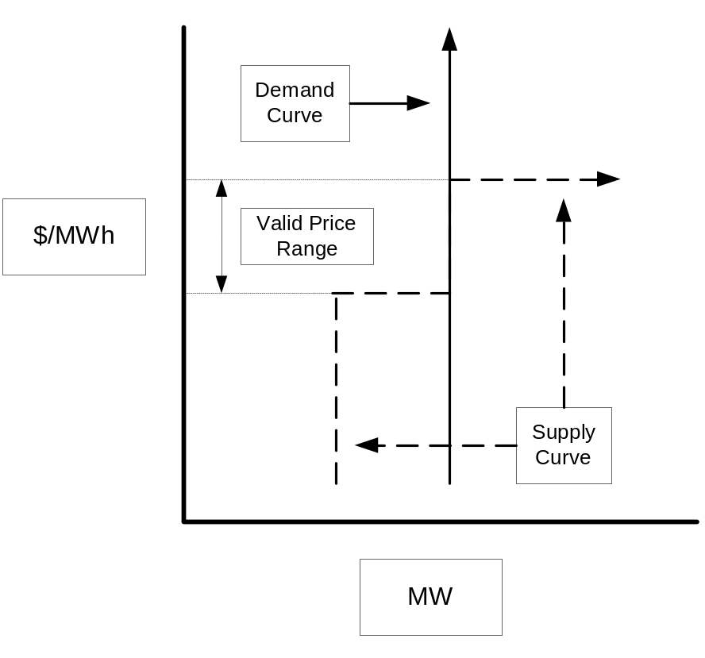
Exhibit 2.2: Dual Degeneracy Diagram

Additional information explaining the derivation of Locational Marginal Prices and the Components thereof can be found in a paper entitled “Locational Marginal Pricing Under Standard Market Design” which is posted on the ISO’s website (www.iso-ne.com).

2.5.9.1 Day-Ahead Energy Market
(1) If, in the Day-Ahead Energy Market, there are no constraints on the New England Transmission System, the LMP is equal to the offer or bid price of the highest increment of Energy that is requested to operate by the ISO to serve the next increment of load during the hour plus a Loss Component to account for losses.
(2) When there is transmission Congestion on the New England Transmission System in the Day-Ahead Energy Market, the ISO will modify the forecasted unit commitment and dispatch for the Day-Ahead Energy Market. Through the use of the ISO’s security constrained unit commitment and dispatch software, the ISO will commit and dispatch one or more generating units, taking all price sensitive Demand Bids and Decrement Bids into account, on a least cost (see Section 5 of this manual for a description of least cost methodology) basis in order to keep the forecast flows on the New England Transmission System within limits. There may be multiple large areas, each including many generating units that are dispatched to relieve the congestion. If constraints occur during an hour, the Congestion Cost between two Locations is the difference in the Congestion Component of the LMP between the source and sink (injection point and withdraw point). Likewise, the cost for losses between two Locations is the difference in the Loss Component of the LMP between the source and sink.
The Day-Ahead LMP calculation is based on the unit commitment and hourly dispatch analysis, which has the objective to satisfy security constraints, the cleared Day-Ahead Demand Bids, Decrement Bids and External Transaction sales, plus the ISO Operating Reserve and Replacement Reserve requirement. There is no joint optimization of energy and reserve clearing Day-Ahead (i.e. Day-Ahead Operating Reserve Requirement constraints are not included as part of the LMP formulation). The following Resources are eligible to set LMP in the Day-Ahead Energy Market:
(a) Resources operating above Economic Minimum Limit that are in merit;
(b) Non-Self-Scheduled Fast Start Generators operating at or above their Economic Minimum Limit;
(c) Price sensitive Demand Bids (including Dispatchable Asset Related Demand), Decrement Bids and Increment Offers; and
(d) Price sensitive External Transactions.

2.5.9.2 Real-Time Energy Market
If, in the Real-Time Energy Market, there are no constraints on the New England Control Area, the LMP is equal to the offer or bid price of the highest increment of Energy that is requested to operate by the ISO to serve the next increment of load during the hour adjusted by a marginal Loss Component. When there is transmission congestion and/or Operating Reserve Requirements that cannot be met in the Real-Time Energy Market, the ISO re-dispatches, through the use of the ISO’s security constrained dispatch software, one or more of the generating units or Dispatchable Asset Related Demands to keep transmission flows within limits and/or to meet Operating Reserve Requirements.
The process for determining Dispatch Rates and LMPs in the Real-Time Energy Market is as follows. Dispatch Rates and Real-Time Reserve Designations are calculated ex-ante for use in Real-Time Dispatch. LMPs, adjusted Real-Time Reserve Designations based on actual conditions and Real-Time Reserve Clearing Prices are calculated on an ex-post basis for the purposes of settlements:
- Determine Forecast and Actual Operating Conditions – The ISO obtains a complete description of conditions on the electric network in the New England Control Area by using the most recent power flow solution produced by the State Estimator. The current version of the State Estimator includes busses in the New England Control Area, as well as busses in systems adjacent to the New England Control Area. The ISO obtains a State Estimator solution approximately every five minutes, which provides the estimated megawatt output of Generators, based on telemetered values, and the loads at busses in the New England Control Area, transmission line losses, and loading on transmission facilities. External Transactions between the New England Control Area and other Control Areas are included based on Real-Time transaction schedules that are implemented by the ISO dispatcher which are fixed for each interval within the hour unless the transactions are curtailed within the hour, however priced External Transactions are allowed to set the LMP. This information is used as input into the ISO’s security constrained dispatch software and subsequently adjusted to produce a forecast of system conditions for the next five-minute interval. The ISO’s Unit Dispatch Software (UDS) calculates Dispatch Rates (Both Desired Dispatch Points, in MW and a rate in $/MW), ex-ante Real-Time Reserve Designations, and ex-ante Real-Time Reserve Clearing Prices for Generators and Dispatchable Asset Related Demands. The ISO forecasts Dispatch Rates on an hour-ahead basis for use by the ISO in the dispatching of External Transactions. As capability and operating protocols of the ISO and other Control Areas allow, the ISO may forecast Dispatch Rates for shorter intervals for purposes of dispatching of External Transactions within the hour. Ex-ante Dispatch Rates and Real-Time Reserve Designation are calculated and communicated every five minutes for Generators and Dispatchable Asset Related Demands. The five-minute Dispatch Rates as well as Ex-ante Real-Time Reserve Designations and Real-Time Reserve Clearing Prices are saved and compared to actual Generator output and offer prices, and actual Dispatchable Asset Related Demand consumption and bid prices for the purpose of determining Generator and Dispatchable Asset Related Demand eligibility to set Real-Time LMPs. The ex-post five-minute Resource specific Real-Time Reserve Designations are integrated for the hour and are saved for future use in settlements.
- Determine Generators following Dispatch Instructions – The ISO applies two tests for determining whether or not a Generator is following Dispatch Instructions: one test to determine eligibility to set Real-Time LMP and one test to determine eligibility for Real-Time NCPC Credits and allocation of Real-Time NCPC Charges. Each test is described below.
(a) Real-Time LMP for Generators: Because of practical Generator response limitations, a Generator is considered to be following a Dispatch Instruction if the actual output of the Generator is not greater than 10% above its expected MW output (its Desired Dispatch Point). This 10% criterion applies separately to each five-minute interval.
(b) Real-Time NCPC Credits and Charges: Because of practical Generator response limitations, a Generator is considered to be following a Dispatch Instruction if the actual output of the Generator is not greater than 10% above its Desired Dispatch Point and is not less than 10% below its Desired Dispatch Point for each interval in the hour. Generators with an Economic Max less than or equal to 50 MW are considered to be following a Dispatch Instruction if the actual output of the Generator is not more than five MW above its Desired Dispatch Point and is not more than five MW below its Desired Dispatch Point for each interval in the hour. If the Generator violates this criterion in any interval during the hour, the Generator is considered to be not following Dispatch Instructions for the entire hour. This criterion will not be applied to Generators during the time periods in which the Generator is providing Regulation service. Generators providing Regulation service will be monitored and audited in accordance with the provisions in Sections 2.2 and 2.3 of ISO New England Manual for the Regulation Market.
(3) Determine Dispatchable Asset Related Demand following Dispatch Instructions: Because of practical Dispatchable Asset Related Demand response limitations, a Dispatchable Asset Related Demand is considered to be following a Dispatch Instruction if the actual consumption of the Dispatchable Asset Related Demand is greater than or equal to 90% of its expected MW consumption (its Desired Dispatch Point). This criterion applies separately to each five-minute interval.
(4) Determine Eligibility to set Dispatch Rate and Real-Time LMP – Resources that are following their Desired Dispatch Points are eligible to set the Dispatch Rate for the current interval.
A Resource, other than a Resource or Resource increment that has been Postured by the ISO unless said Postured Resource or Resource increment is dispatched to produce Energy, in accordance with Appendix F to Market Rule 1, which may include:
- a Pool-Scheduled Resource that is a Fast Start Generator that has a State Estimator MW output that is greater than zero and is operating at or above its Economic Minimum Limit; or
- a Pool-Scheduled Resource that is a Dispatchable Asset Related Demand that has an EMS SCADA consumption level that is greater than or equal to its Minimum Consumption Limit; or
- a Generator that is operating above its Economic Minimum Limit (this includes both Pool-Scheduled Resources and Self-Scheduled Resources with dispatchable increments above the Self-Scheduled MW amount); or
- A Fast Start Generator that is not Self-Scheduled and is operating at more than zero MW; or
- a Generator or Dispatchable Asset Related Demand that is specifically requested to operate by the ISO’s dispatcher and the associated Energy offers or bids submitted are otherwise eligible to be included in the calculation of Real-Time Locational Marginal Prices.
A Resource that is following a Dispatch Instruction as described above is eligible to set the Real-Time LMP on a five minute basis. If the Resource is eligible to set LMP, the ISO determines that Resource’s Supply Offer price or Demand Bid price to be used in calculating Real-Time LMPs by comparing that Resource’s actual output/consumption to the Resource’s Supply Offer price curve or Demand Bid price curve. If the Resource’s Supply Offer price at the actual MW output point is greater than the Dispatch Rate or the Resource’s Demand Bid price at the actual MW consumption level is less than the Dispatch Rate, the Resource’s Supply Offer price or Demand Bid price is set equal to the Dispatch Rate. Resources or Resource increments that have been Postured by the ISO are not eligible to set the Real-Time LMP unless such Postured Resource or Resource increment is dispatched in merit to produce energy or reduce energy consumption.
Additionally, Real-Time priced External Transaction purchases, other than Emergency External Transaction purchases as described under Section III.4 of Market Rule 1 and Section 6 of this manual, that have been scheduled by the ISO are eligible to set the Dispatch Rate and the Real-Time LMP on a five minute basis.
(5) Calculating LMPs - The ISO calculates the Real-Time LMPs on an ex-post basis using actual system conditions and the Resource eligibility determined above to set LMP. The ISO determines the security-constrained jointly optimized dispatch of Energy and designation of Operating Reserve, using a linear optimization methodology that minimizes the energy, congestion, and transmission loss costs, given system conditions and constraints of serving load and meeting Operating Reserve Requirement in Real-Time at all Locations in the New England Control Area, based on the actual operating conditions that existed on the power system and on the prices of Resources eligible to set LMP. LMPs for generation and load Nodes in the New England Control Area and External Nodes are calculated based on the actual economic Dispatch and the eligible Resource Supply Offer prices. In performing the LMP calculation, the ISO calculates, using the ISO’s security-constrained Unit Dispatch Software (UDS), the cost of serving an increment of load at each bus from eligible Resources as the sum of the following elements:
- the price at which a Market Participant offers to supply an additional increment of Energy from an eligible Resource or reduce an additional increment of Energy from an eligible Resource, and
- the effect on transmission congestion costs and transmission losses (positive or negative) associated with increasing or decreasing the output of the eligible Resource, based on the effect of increased generation or reduced load from that eligible Resource on transmission line loadings and/or Operating Reserve Requirement in Real-Time.
The eligible Resource(s) that can service an increment of load at a bus at the lowest cost determines the LMP at that bus. The calculation is performed every five minutes, using the ISO’s security constrained dispatch program, which produces a set of LMPs based on system conditions at a specific instant in time. The prices produced at five–minute intervals during an hour are integrated on a time-weighted basis to determine the LMP for that hour.
(6) Calculating Real-Time Reserve Clearing Prices - The ISO calculates Real-Time Reserve Clearing Prices on a jointly optimized basis with the calculation of Energy LMPs on an ex-post basis using actual system conditions, the Resource eligibility determined above to set LMP and the ex-ante unit-specific Operating Reserve designations (both price and MW). There are two ways in which positive Real-Time Reserve Clearing Prices can occur:
(a) if a re-dispatch occurs in order to meet local Operating Reserve requirements (second contingency protection criteria of a local area) or a re-dispatch occurs to meet system Operating Reserve requirements that create a Real-Time Reserve Opportunity Cost, under which case, the Real-Time Reserve Clearing Prices are set based upon the highest Real-Time Reserve Opportunity Cost incurred (see the following Sections 2.5.9.3 and 2.5.9.4 for examples) or;
(b) if there is insufficient Operating Reserve available to meet the Operating Reserve Requirement causing a violation of a reserve constraint. This will result in a Reserve Constraint Penalty Factor (RCPF) setting the Real-Time Reserve Clearing Price. Reserve Constraint Penalty Factors are as defined in Market Rule 1.
Real-Time Reserve Opportunity Cost of a dispatchable Resource is equal to the difference between (i) the Real-Time LMP at the Location of the Resource and (ii) the offer or bid price associated with the dispatchable Resource’s output. Only Resources that can provide additional Operating Reserve by changing their generation output or consumption level such that their profit from Real-Time Energy Market is reduced, can have non-zero Real-Time Opportunity Cost.

2.5.9.3 Example – Re-dispatch to Meet Local Requirements
The following example illustrates the interaction between system and local LMPs and local Real-Time Reserve Clearing Prices for a number of assumed system conditions, including conditions that cause a deficiency in Real-Time Operating Reserve.

Consider the follow initial conditions assumptions that are applicable to a system with a single local Reserve Zone:

Units | Actual Output | Economic Minimum | Economic Maximum | Offer Price | Manual Response Rate | Reserve Available
Gen A | 25 | 25 | 100 | 70 | 1 | 30
Gen B | 80 | 50 | 100 | 50 | 5 | 20
Gen C | 0 | 5 | 25 | 150 | CLAIM10 = 25 | 25
Gen D | 0 | 5 | 25 | 200 | CLAIM30 = 25 | 25

- Local Reserve Requirement = 100 MW
- Interface Limit = 200 MW
- Local load = 255 MW at t=0

As can be calculated from the t=0 input assumptions, the total amount of local reserve available is sum of generation reserve (30+20+25+25) plus available reserve from system (200 MW Limit – 150 MW actual flow) = 150 MW. Since Generator B is the marginal unit and the interface flow is less than the limit, Local LMP = System LMP = $50/MWh. Also, since the local reserve requirement has been met without any need for re-dispatch (local reserve requirement = 100 MW and available reserve = 150 MW), the Real-Time Reserve Clearing Price is equal to zero.
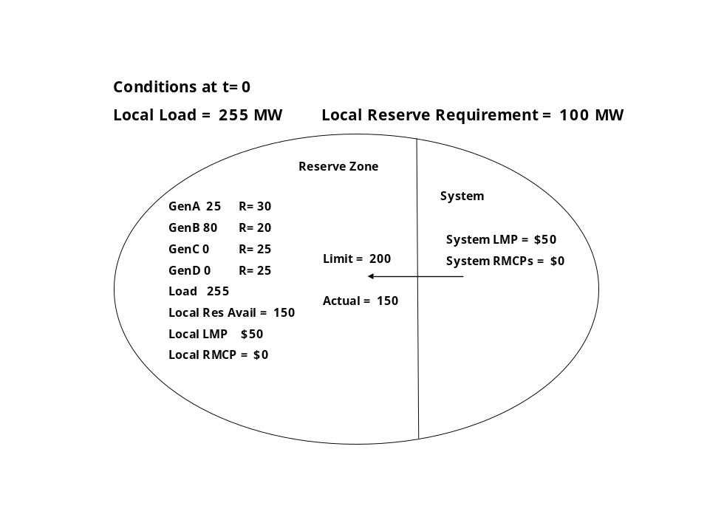
If we increase the Local load to 300 MW, we get the following results:

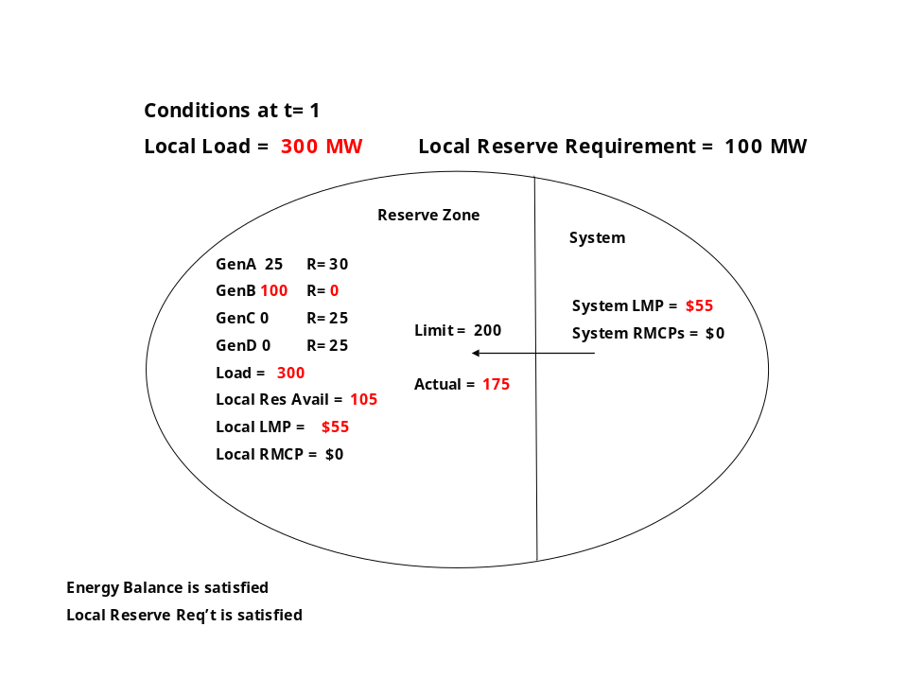

Generator B is now dispatched to full load, leaving zero reserve available on Generator B. In order to serve the remaining 25 MW of load, imports into the local Reserve Zone have been increased by 25 MW, causing the System LMP to increase to $55/MWh. Once again, since the reserve requirement continues to be met in the Reserve Zone (Generating Units = 30 MW + 25 MW + 25 MW = 80 MW) + 25 MW import capability remaining = 105 MW) and there is no import limit constraint, the Local LMP = System LMP = $55/MWh and the Real-Time Reserve Clearing Price is equal to zero.

If we once again increase the Local load, this time to 310 MW, a re-dispatch is required in order to meet the local reserve requirement as illustrated below:
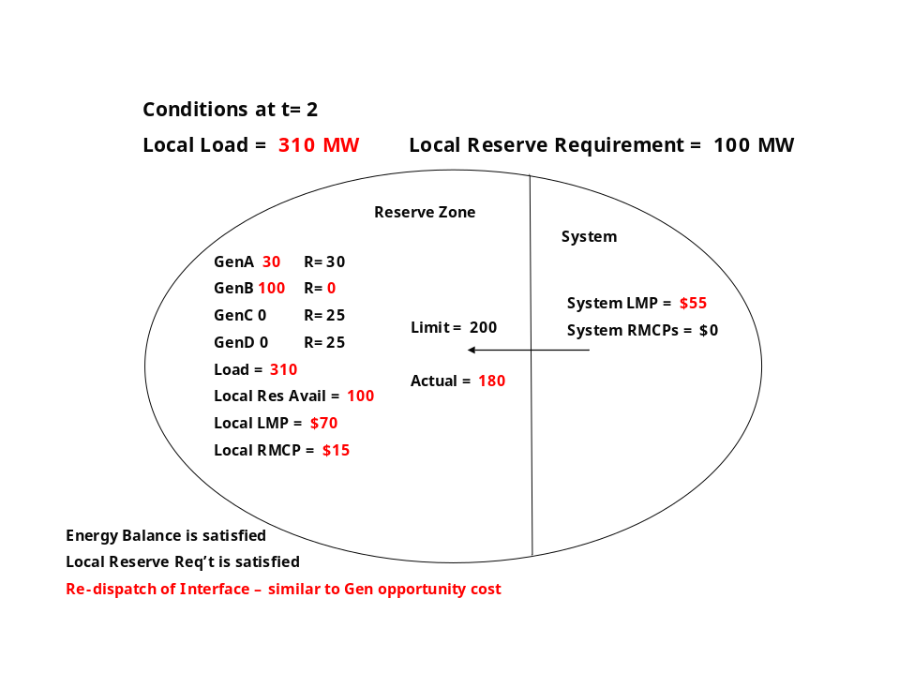
The actual flow on the interface would have been 185 MW if we did not need to maintain the local reserve requirement of 100 MW. With an actual flow of 185 MW, the actual amount of local reserve would have been 95 MW (Gen A(30) + Gen C(25) + Gen D(25) + interface(15)). Therefore, a re-dispatch action is needed in order to maintain the required 100 MW reserve. Generator A is dispatched up by five MW @ $70/MWh, thus reducing the actual tie flow down to 180 MW, which creates the extra five MW of reserve needed to meet the 100 MW reserve requirement. In this case, the increase in LMP from $55/MWh (unconstrained price) to $70/MWh was a direct result of meeting the local reserve requirement and, therefore, sets the Real-Time Reserve Clearing Price at $15/MWh.

Increasing the Local load to 351 MW creates a situation where the local reserve requirement can not be met, thus causing the use of the local RCPF as illustrated below:

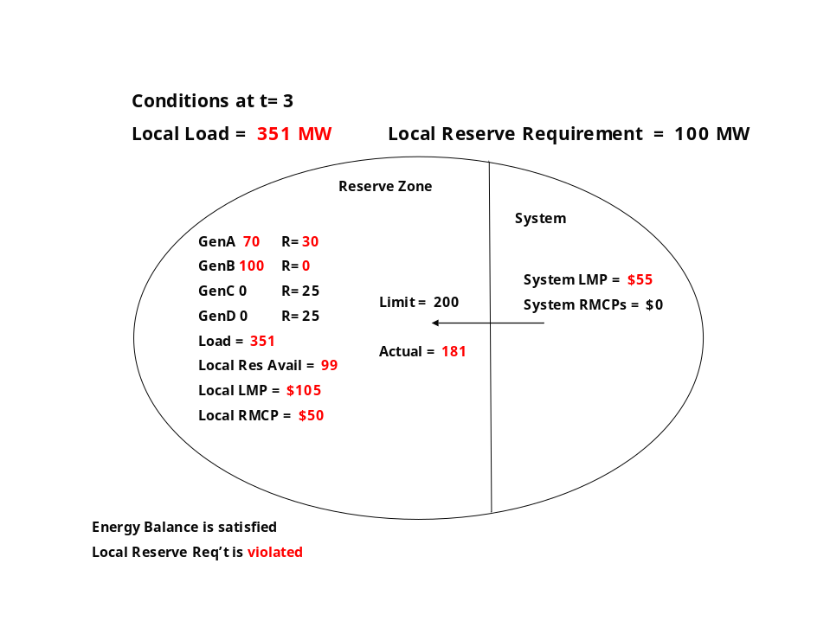
In this case, the Real-Time Reserve Clearing Price is set equal to the $50/MWh local RCPF. The local LMP is the sum of $55/MWh and the $50/MWh RCPF ($105/MWh). The energy price of the local area is equal to $105/MWh in this case since the next MW needed to maintain energy balance while at the same time minimizing the amount of reserve deficiency was supplied via the import tie with a reserve penalty of $50/MWh (System LMP = $55/MWh).

Finally, increasing the Local load to 371 MW creates a situation where again, the local reserve requirement can not be met, thus causing the use of the local RCPF and also cause the entire import capability to be utilized, as illustrated below:
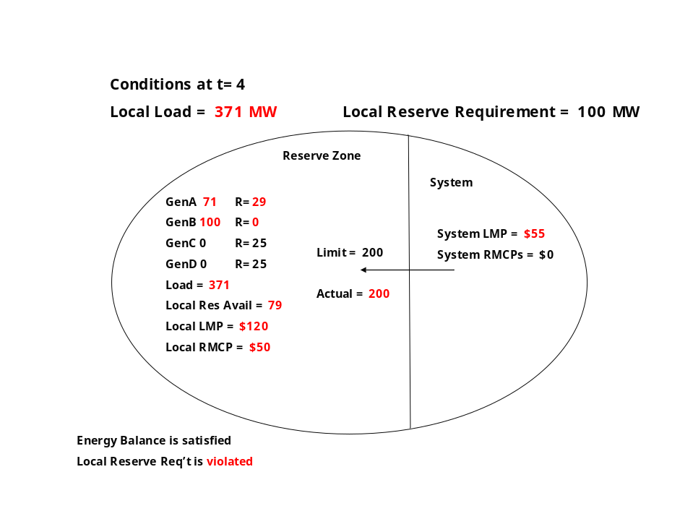
In the case, the Real-Time Reserve Clearing Price is set equal to the $50/MWh local RCPF. The local LMP is the sum of $70/MWh and the $50/MWh RCPF ($120/MWh). The energy price at the local area is equal to $120/MWh in this case since the next MW needed to maintain energy balance while at the same time minimizing the amount of reserve deficiency was supplied via Generator A with a reserve penalty of $50/MWh since the import tie was completely utilized.

2.5.9.4 Example – Re-dispatch to Meet System Requirements
The following example illustrates the calculation of Real-Time Reserve Clearing Prices when a re-dispatch is required in order to meet system TMSR requirements:

Consider the following initial conditions assumptions:

 | Unit A | Unit B | Unit C
Economic Maximum | 175 | 185 | 150
Economic Minimum | 100 | 150 (SS) | 75
Manual Response Rate | 2 | 1 | 3
Initial Dispatch | 155 | 150 | 75
Initial TMSR Available | 20 | 10 | 30
Energy Offers
Block 4 | 175 MW @$35 | 185 MW @$50 | 150 MW @$48
Block 3 | 150 MW @$30 | 165 MW @$40 | 140 MW @$42
Block 2 | 125 MW @$25 | 125 MW @$25 | 125 MW @$38
Block 1 | 100 MW @$20 | 100 MW @$25 | 75 MW @$20

- TMSR Requirement = 60 MW
- Local load = 380 MW at t=0

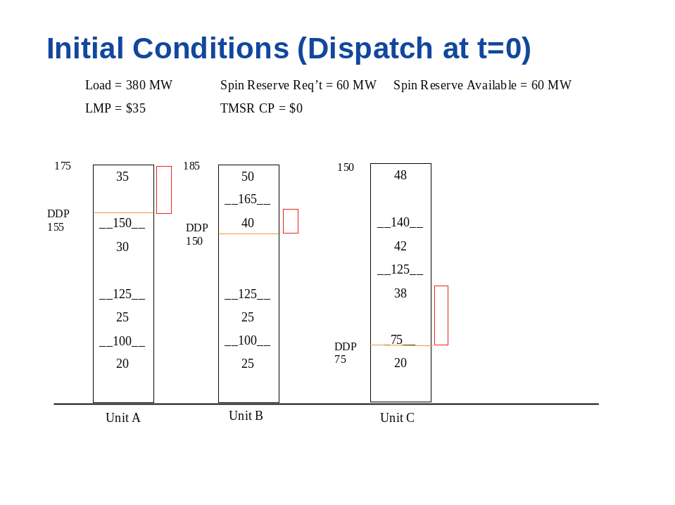
In this initial condition case, Unit A is setting the LMP at $35/MWh.

Increasing the load to 390 MW creates a situation where the system must be re-dispatched to maintain the 60 MW TMSR requirements as illustrated below:

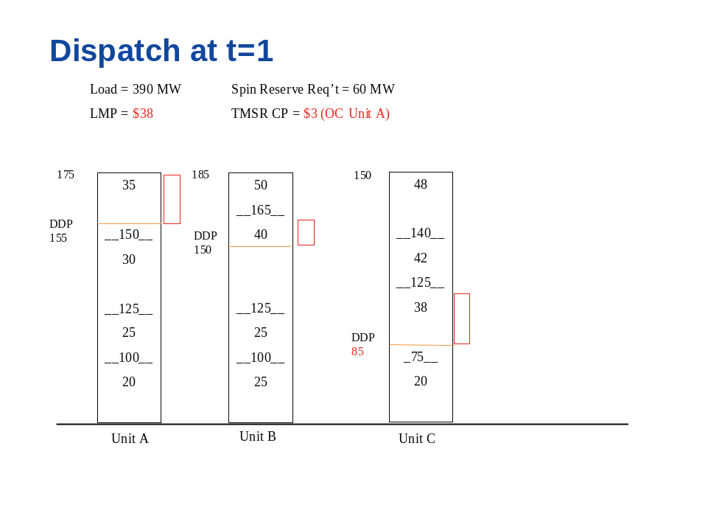
Absent the requirement to maintain 60 MW of TMSR, Unit A would have dispatched up to 165 MW and the LMP would have remained at $35/MWh. However, if Unit A was dispatched up to 165 MW, only 10 MW of TMSR would remain on Unit A. Unit B still has 10 MW of TMSR available and Unit C still has 30 MW of TMSR available. Thus, the total available TMSR = 50 MW prior to the re-dispatch. In order to provide the required amount of TMSR, a system re-dispatch is required causing Unit A to be held down at 155 MW and Unit C to increase output by 10 MW. Unit C now sets the LMP at $38/MWh and Unit A incurs a Real-Time Opportunity Cost of $3/MWh (Nodal LMP of $38 – Offer Price of $35). This Real-Time Reserve Opportunity Cost sets the Real-Time Reserve Clearing Price for TMSR at $3/MWh.

2.5.10 ISO Real-Time Price Verification Procedure
The ISO continually monitors the processes that are associated with the calculation of LMPs, Real-Time Reserve Clearing Prices and Regulation Clearing Prices (RCP). In the event of a data input failure, program failure or binding constraint errors, corrective actions may be taken to ensure that the resulting LMPs are as accurate as is reasonably obtainable. The ISO will continue to review the specific corrective actions outlined below and make changes as needed to reflect actual experience.
(1) Data Input Failures (stale price data, stale Dispatch Rates, stale EMS data) or Program Failures (State Estimator failure) - Data input failures can occur when telecommunication problems exist either on the ISO computer network or on the data lines between the ISO and Market Participants. If failures occur within the ISO’s network, all possible steps will be taken to recover the original data for use in LMP, RCP or Real-Time Reserve Clearing Price calculation reruns. In the event of a program failure, an attempt will first be made to correct the reason for the failure and to recalculate LMP, RCP or Real-Time Reserve Clearing Price values for the affected intervals. If the failure cannot be corrected (due to a data input failure), and the original data cannot be recovered, the ISO may utilize data from the best available alternate data sources including, but not limited to, backup systems, dispatcher logs, raw telemetry data, and Market Participant data sources. In the event of a data input or program failure and LMPs, RCPs or Real-Time Reserve Clearing Prices cannot be recalculated as described above, replacements will be performed as outlined below:
(a) If the stale data or program failure exists for 11 intervals or less within the same hour then the affected intervals will be replaced with data from the last successful interval or the next successful interval, as appropriate.
(b) If the stale data or program failure exists for all intervals within the same hour then the replacement values will be recalculated using data from the best available sources.
(2) Binding Constraint Errors - In the event of a binding constraint error between UDS and the LMP calculator, LMP and Real-Time Reserve Clearing Price replacements will be performed as outlined below:
- Binding transmission constraints entered (or removed) with a delay of less than four intervals – No recalculation is required.
- Binding transmission constraint entered (or removed) with a delay of four intervals or more) – The Binding Transmission constraint data will be corrected and values will be recalculated using data from the best available sources.
- Binding Transmission constraint entered incorrectly - The binding transmission constraint data will be corrected and values will be recalculated using data from the best available sources.

2.5.11 Day-Ahead and Real-Time Energy Market Settlement
Please see the ISO New England Manual for Market Rule 1 Accounting, M-28 for market settlement details.

2.5.12 Emergency Conditions in the Day-Ahead Energy Market

2.5.12.1 Energy Deficient Conditions
If the sum of Day-Ahead fixed Demand Bids and Self-Scheduled External Transaction sales cannot be satisfied with the sum of all scheduled External Transaction purchases, cleared Increment Offers, and available generation at its Economic Maximum Limit, the Technical Software issues an Emergency Condition warning message due to a shortage of economic supply in the Day-Ahead Energy Market. The following steps shall then be performed to achieve power balance:
- All Self-Scheduled External Transaction sales are considered to be priced at $1,000/MWh;
- Reduce any remaining price-sensitive Demand Bids (including External Transaction sales) and Decrement Bids from lowest price to highest price to zero MW until power balance is achieved (there may be some price sensitive bids that are higher priced than the highest Supply Offer or Increment Offer price cleared). Set LMP values equal to the highest price-sensitive Demand Bid or Decrement Bid that was cut in this step. If no price-sensitive Demand Bid or Decrement Bid was reduced in this step, the LMP values are set equal to highest offer price of all on-line generation, Increment Offers or External Transaction purchases;
- If power balance is not achieved after Step 2, reduce all remaining fixed Demand Bids proportionately (by ratio of load MW) until balance is achieved. Set LMP values equal to the highest offer price of all on-line generation, Increment Offers or External Transaction purchases or the price from Step 2, whichever is higher.

2.5.12.2 Minimum Generation Conditions
If the sum of Day-Ahead cleared Demand Bids, Decrement Bids and External Transaction sales is less than the total system wide generation MW (including Self-Scheduled External Transaction purchases) with all possible generation off and with all remaining generation at their Economic Minimum Limit, the Technical Software issues a Minimum Generation Emergency warning message due to an excess of economic generation in the Day-Ahead Energy Market. The following steps shall then be performed to achieve power balance:
(1) All Self-Scheduled External Transaction purchases are considered to be dispatchable at $0/MWh and reduced pro-rata, as applicable, until power balance is reached;
(2) If power balance is not reached in Step 1, reduce all committed generation down proportionately by ratio of Economic Minimum Limits but not below Emergency Minimum Limits. If power balance is achieved prior to reaching Emergency Minimum Limits, set LMP values equal to the lowest offer price of all on-line generation.
(3) If power balance is not achieved in Step 2, set LMP values to zero and reduce all committed generation below Emergency Minimum Limits proportionately (by ratio of Emergency Minimum Limits) to achieve power balance.
If the sum of Day-Ahead cleared Demand Bids, Decrement Bids and External Transaction sales is less than the total generation MW in a local transmission restricted export area with all possible generation in the local area off and with all remaining generation at their Economic Minimum Limit, scheduling will proceed under the assumption that there is a local Demand bid in excess of the excess supply with a zero Demand bid.

2.5.13 Emergency Conditions in the Real-Time Energy Market

2.5.13.1 Capacity Deficient Conditions
The ISO will post as soon as practicable, an Emergency Condition warning (in this case Master Local Control Center Procedure #2 and/or OP-4 forecast or actual implementation) on the ISO’s web site, as soon as Emergency Conditions or anticipated Emergency Conditions are identified by the ISO. Please see ISO New England Operating Procedure No. 4 for a description of ISO actions during capacity deficient conditions.
When scheduling External Transactions for the next scheduling interval of an Operating Hour, if the expected net schedule of all External Transactions, coupled with the expected load consumption and output of available generating units, will result in a capacity deficiency condition, the ISO shall determine the export amount of External Transactions that can be reliably scheduled without entering a capacity deficient condition and, as a result, will restrict the upcoming scheduling of Real-Time Energy Market External Transaction exports that have not cleared the Day-Ahead Energy Market, to the extent required. An External Transaction referencing a Generator whose associated Generating Resource has capacity not subject to a Capacity Supply Obligation shall be treated in accordance with Market Rule 1, Section III.1.10.7(i).
If Real-Time Energy Market External Transaction exports need to be restricted as described above to prevent the capacity deficiency, then the ISO will issue a notice on the ISO New England web site.
If the restriction of Real-Time Energy Market External Transaction exports that have not cleared the Day-Ahead Energy Market does not prevent the capacity deficiency condition, ISO New England Operating Procedure No. 4 will be implemented. When ISO New England Operating Procedure No. 4 has been implemented, Real-Time Energy Market External Transaction exports that have cleared the Day-Ahead Energy Market will continue to be scheduled until such time as Market Participant Emergency Energy Transactions are not available to resolve the capacity deficient condition. An External Transaction referencing a Generator whose associated Generating Resource has capacity not subject to a Capacity Supply Obligation shall be treated in accordance with Market Rule 1, Section III.1.10.7(i).
To the extent restrictions in scheduling External Transactions are required as set forth above, the process for reducing all Real-Time Energy Market External Transaction exports is described in ISO New England Operating Procedure No. 9 Appendix B.
The dispatch of Real-Time Demand Response Resources may be increased, decreased or cancelled in Real-Time from the amount forecast in the initial Current Operating Plan, and Real-Time Emergency Generation Resources may be dispatched in Real-Time when ISO New England Operating Procedure No. 4 has been declared.

2.5.13.2 Minimum Generation Conditions
During the Operating Day, the ISO will issue Minimum Generation Emergency warnings, as needed, if the ISO projects the difference between: the sum of projected load consumption; and the sum of the expected net schedule of all External Transactions and all on-line generating unit Economic Minimum Limits; to be equal to or less than the threshold MW amount set forth in ISO New England’s System Operating Procedures (SOP RTMKTS.0120.0015, “Implement Minimum Generation Emergency Remedial Action”), either with regard to a sub-region or the New England Control Area, as applicable.
When scheduling External Transactions for the next scheduling interval within an Operating Hour where a Minimum Generation Emergency Warning has been issued, the ISO will determine if scheduling External Transaction imports that have not cleared in the Day-Ahead Energy Market will cause the threshold Minimum Generation Emergency margin to be reached (using the equation from the System Operating Procedure referenced above). If so, then the ISO will restrict the upcoming scheduling of Real-Time Energy Market External Transaction imports that have not cleared the Day-Ahead Energy Market. This process is also applicable if the Minimum Generation Emergency Warning occurs within a scheduling interval. The process for reducing these External Transaction purchases is described in ISO New England Operating Procedure No. 9.
During the Operating Day, the ISO will declare a Minimum Generation Emergency if the difference between: load consumption; and the sum of External Transaction purchases (imports) cleared in the Day-Ahead Energy Market and all on-line generating unit Economic Minimum Limits; is equal to or less than the threshold MW amount referenced above and the following steps shall then be performed to maintain system reliability:
(1) The ISO will set all LMPs to zero within the sub-region or the New England Control Area, as applicable.
(2) Based on price, generating Resources will be subject to Dispatch Instructions from the ISO to reduce generation down to Emergency Minimum Limits and all External Transaction purchases that cleared in the Day-Ahead Energy Market will be subject to reduction. Such reductions of generation and External Transactions will be applied on a 50/50 basis until supply and demand are matched or the capability of either generation or External Transactions to reduce is exhausted; required reductions will then be taken on the remaining Resource type as needed. The reduction of External Transaction purchases that cleared in the Day-Ahead Energy Market will occur as described in ISO New England Operating Procedure No. 9.
(3) If the actions in Step 2 are not sufficient to match supply to demand, the ISO will utilize all available information available to it, including but not limited to minimum run times or minimum down times and expected capacity conditions for the next Operating Day, recognizing the Pool-Scheduled Resource vs Self-Scheduled Resource priority, in issuing de-commitment orders.
(4) LMPs will remain at zero until the ISO cancels the Minimum Generation Emergency. The ISO shall cancel the Minimum Generation Emergency when the ISO projects the difference between: projected load consumption and; the sum of External Transaction purchases (imports) cleared in the Day-Ahead Energy Market and all on-line generating unit Economic Minimum Limits; equals or exceeds the threshold MW amount.
When the ISO cancels a Minimum Generation Emergency and restores the affected Generators’ Economic Minimum Limit, the Unit Dispatch Software (UDS) will not issue the Generator that is operating below its Economic Minimum Limit a DDP to move to the Economic Minimum Limit unless it is economic to do so. In the case where UDS does not issue a DDP for a Generator to move from below its Economic Minimum Limit to its Economic Minimum Limit, the Generator is required to move to its Economic Minimum Limit on its own initiative. Generators moving up to their Economic Minimum Limit will not be determined to be failing to follow Desired Dispatch Point. Failure to move to Economic Minimum Limit after a Market Participant is notified of the situation by the ISO for any units operating below Economic Minimum Limit as a result of a Minimum Generation Emergency may result in the ISO entering a Redeclaration of the generating unit’s Economic Maximum Limit to match its current output level so as to create a Generator Forced Outage.

Section 3: Reserved

Section 4: Reserved

Section 5: Scheduling and Dispatch Philosophy & Tools

5.1 ISO Philosophy
Scheduling and Dispatch of Resources by the ISO is performed for both the Day-Ahead Energy Market and the Real-Time Energy Market on the basis of the prices and operating characteristics of Resources offered by Market Participants, using least cost security-constrained unit commitment and dispatch software such that sufficient generation is scheduled in each hour of the Day-Ahead Energy Market and Real-Time Energy Market to serve all Energy consumption requirements, as well as meeting the New England Control Area requirements and transmission security requirements.
The ISO scheduling philosophy in the Day-Ahead Energy Market is to schedule and Dispatch generation, Increment Offers and External Transaction purchases on a least cost, security-constrained basis (minimize Start-Up Fees, No-Load Fees and incremental Energy costs) to meet the aggregate cleared Demand Bids, cleared Decrement Bids, cleared External Transactions sales and Operating Reserve and Replacement Reserve requirements, while maintaining the reliability of the New England Control Area.
The ISO scheduling philosophy during the Reserve Adequacy Analysis that begins after the close of the Re-Offer Period and continues as needed throughout the Operating Day is to commit additional Resources as needed (or de-commit Resources originally scheduled in the Day-Ahead Energy Market to maintain system reliability) to ensure sufficient capacity is available to satisfy the ISO load forecast, Operating Reserve, Replacement Reserve, and Regulation requirements for the Real-Time Energy Market on both a New England Control Area wide basis and on a sub-regional basis. The objective of the commitment performed during the Reserve Adequacy Analysis is to minimize the cost to procure such additional Resources by committing Resources that have the lowest Start-Up Fee plus cost to maintain minimum output over the scheduling period. The following steps are performed once the initial RAA commitment (the first commitment which uses offers submitted during the Re-Offer Period) is determined:
(1) Perform security constrained economic Dispatch to meet ISO load forecast (load forecast includes expected Dispatchable Asset Related Demand pumps and any Real-Time Energy Market External Transaction sales that were cleared through the Day-Ahead Energy Market) and operating reserve requirements based on RAA commitment.
(2) Review results to ensure that Regulation, Operating Reserve, Replacement Reserve and Local Second Contingency Protection Resource requirements are met.
(3) If required, review Limited Energy Generator schedules to ensure maximum Energy available for the day is not exceeded.
(4) Perform power flow contingency analysis to ensure feasibility of RAA commitment and Dispatch and modify RAA commitment, if necessary.
(5) When a capacity deficiency is declared, the ISO will dispatch Real-Time Demand Response Resources in amounts and at locations as necessary to reduce or eliminate the deficiency.
During the operating hour, the ISO communicates Desired Dispatch Points, Real-Time Reserve Designations and Dispatch Rates to Resources on a periodic basis to ensure that Energy, Operating Reserve and Replacement Reserve requirements are met on an optimized basis that minimizes energy, congestion and transmission loss cost, given system conditions and Resource and transmission constraints that may exist. In addition to the Posturing of Resources to maintain reserve, the ISO continues to utilize the Reserve Adequacy Analysis, as needed, to determine additional Generator commitment and or the dispatch of Real-Time Demand Response Resources that may be required to maintain adequate Operating Reserve and Replacement Reserve levels throughout the day.
The scheduling and Dispatch process in the Day-Ahead Energy Market and Real-Time Energy Market evaluates the price of each available supply Resource compared with every other available Resource. The philosophy for scheduling within the New England Control Area requires:
- scheduling sufficient Resources in the Day-Ahead Energy Market to cover cleared Demand Bids, Decrement Bids, External Transaction sales, Operating Reserve Requirements, Replacement Reserve requirements and transmission security requirements.
- scheduling sufficient Resources in the Real-Time Energy Market to cover the ISO load forecast, Dispatchable Asset Related Demand pumps, External Transaction sales, Operating Reserve Requirements, Replacement Reserve requirements and transmission security requirements.
- scheduling sufficient Resources to satisfy the Regulation Requirement and other ancillary service requirements of the New England Control Area.
- that Market Participants respond at the ISO’s direction to mitigate conditions that threaten the reliable operation of the New England Control Area.
5.2 Scheduling and Dispatching Tools
Analytical scheduling tools exist to assist the ISO with the scheduling process. These tools permit the ISO scheduling staff to analyze numerous scheduling scenarios. ISO personnel use several tools to assist in scheduling the Resources for short-term and hourly activities. The scheduling tools include but are not limited to:
- Enhanced Energy Scheduler (EES)
- Load Forecasting Algorithms
- Market Database System
- Technical Software (RSC, SPD, UDS and STNET)
- Forecast Capacity Analysis
- Regulation Scheduling Software
- Outage Scheduling Software
- Generation Control System
- Network Analysis and SCADA
Together these tools recognize the following conditions:
- reactive and/or thermal transmission limits
- unit constraints
- unscheduled power flows
- inter-area transfer limits
- unit distribution factors
- Self-Scheduled Resources
- limited fuel resources including hydro
- External Transaction schedules
- Dispatchable Asset Related Demand requirements
- Demand Resource requirements
- generation requirements
- Regulation Requirement and Operating Reserve Requirements
- Replacement Reserve requirements

5.2.1 Enhanced Energy Scheduler (EES)
The EES program records and allows for the management of the interchange of bulk power between the New England Control Area and other Control Areas. The ISO uses EES to process daily External Transaction schedules that are submitted by Transmission Customers. In general, EES is used to perform the following activities:
- processes External Transaction requests
- validates External Transaction requests
- determines External Transaction schedules in the Real-Time Market

5.2.2 Load Forecasting
The ISO scheduling staff develops load forecasts with the objective of creating forecasts of load that minimize the MW difference between actual and forecast load, whether positive or negative.
- The first step in developing a load forecast is to obtain the weather information for the time period. Weather information is provided to the ISO at regular intervals by several contracted-for weather services. Additional weather data sources include the National Weather Service, radio, television, internet based weather sources, and existing local New England Control Area conditions.
- The forecast period is reviewed to determine any conditions that could affect the New England Control Area’s load, including but not limited to:
- day of week
- NERC Holidays and non-NERC holidays for which the load forecast for the New England Control Area is likely to deviate from the load forecast that would otherwise be expected on a non-holiday
- special events
- daylight savings time changes
- historical operation of Demand Resources
- Peak loads and load shapes are determined using a similar day’s forecast. The ISO retrieves the load data from a historical file and adjusts the forecasts, as needed, to reflect growth or other discrepancies. This analysis is complemented by the results of a statistical modeling tool, the Artificial Neural Network (“ANN”). ANN uses artificial intelligence to provide an independent forecast for purposes of comparison to the similar day results. The forecaster uses the output of these models and experience to create a final load forecast.
Exhibit 5.1 presents the typical approach the ISO uses to forecast load.

Exhibit 5.1: Load Forecasting Process
Record Final Discretionary Adjustments
Obtain Weather Forecast

Develop Similar Days
Execute ANN Program
Finalize Load Forecast

Compare Model Outputs

The load forecasts for each 24-hour period are inputs to the security-constrained unit commitment and dispatch software that is utilized for the Reserve Adequacy Analysis.

5.2.3 Market Database System
The Market Database System is a two-part system:
(1) The Market Database stores the basic unit data supplied by the Market Participants, including operating limits and unit availability.
(2) The eMKT tool that provides the internet-based user interface that allows Market Participants to submit Supply Offers, Demand Bids, Increment Offers and Decrement Bids and Regulation offers into the Market Database (External Transactions are submitted via EES and Internal Bilateral Transactions are submitted using the Internal Bilateral Transaction user interface).
The Market Database is a very large database that contains information on each generating unit that operates as part of the Market, information on Demand Bids, Increment Offers, Decrement Bids and Regulation offer information, Day-Ahead Energy Market results and Regulation Clearing Prices.
Market Participants may access the Market Database by using the eMKT tool via the internet or may submit information via direct file upload capability.

5.2.4 Technical Software
The ISO Technical Software is a set of computer programs, which performs security-constrained unit commitment and economic Dispatch for the Day-Ahead Energy Market and Real-Time Energy Market. The individual programs include but are not limited to the following are:
Resource Scheduling & Commitment (RSC) - Performs security-constrained unit commitment based on Supply Offers, Demand Bids, Increment Offers, Decrement Bids and External Transaction schedules submitted by Market Participants and based on New England Control Area reliability requirements as developed by the ISO. RSC will enforce physical unit specific constraints that are specified in the Supply Offer data and generic transmission constraints that are entered by the ISO and will commit Resources to meet Energy, Operating Reserve and Replacement Reserve requirements as appropriate. RSC provides an optimized economic unit commitment schedule for up to seven days and it utilizes a linear programming solver to create an initial unit Dispatch for the next Operating Day. RSC minimizes the as-bid (including mitigated bids when applicable) production cost of serving load in one Operating Day (or in some cases over two Operating Days) subject to all applicable constraints.
Scheduling, Pricing, & Dispatch (SPD) - Performs security-constrained economic Dispatch using the commitment profile produced by RSC. SPD calculates hourly Resource MW levels and Day-Ahead LMPs for all load and generation buses for each hour of the next Operating Day. SPD utilizes a linear programming solver to develop the economic Dispatch solution to meet Energy requirements and Operating and Replacement Reserve targets as appropriate while respecting generic transmission constraints that affect Dispatch, such as reactive transmission interface limits, and thermal transmission limits. SPD minimizes the as-bid (including mitigated bids when applicable) production cost of serving forecasted load for the next five to 15 minutes subject to all applicable constraints.
Unit Dispatch System (UDS) - Performs jointly optimized security-constrained economic Dispatch periodically throughout the hour and produces Desired Dispatch Points (in MW), Dispatch Rates (in $/MW) and Real-Time Reserve Designations in Real-Time to be communicated to Generators in five-minute intervals. UDS utilizes a linear programming solver to develop the economic Dispatch solution to meet Energy requirements and Operating and Replacement Reserve requirements as appropriate while respecting generic transmission constraints that affect Dispatch, such as reactive transmission interface limits, and thermal transmission limits. The results from UDS are utilized by an ex-post LMP calculator that calculates five-minute LMPs that are used in settlements.
Study Network Analysis (STNET) - Creates a power flow model for each hour of the Operating Day based on the scheduled network topology, the generation and demand MW profile produced by RSC and SPD, and the scheduled New England Control Area net tie flow with adjacent control areas which is developed based on the amount of External Transactions scheduled. STNET performs AC contingency analysis using a contingency list from ISO EMS and creates generic constraints based on any violations that are detected. These generic constraints are then passed back to RSC and/or SPD for resolution. STNET ensures that the Day-Ahead Energy Market results are physically feasible considering New England Control Area security constraints and reliability requirements.
The following Exhibit 5.2 illustrates the interaction between the Technical Software and settlement systems:
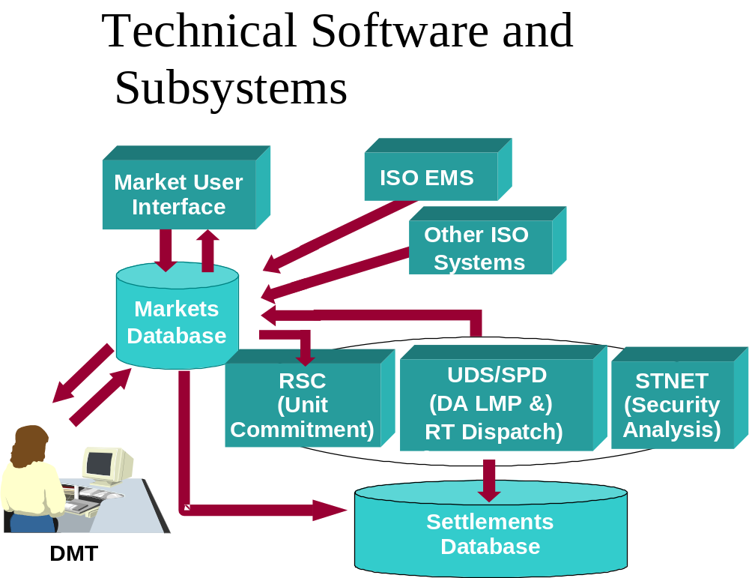
Exhibit 5.2: Technical Software and subsystems
The Technical Software develops the Day-Ahead Energy Market results based on minimizing costs to meet the Demand Bids, Decrement Bids and External Transaction sales that are submitted by Market Participants and cleared in the Day-Ahead Energy Market while respecting the New England Control Area security constraints and reliability requirements that are necessary for the reliable operation of the New England Control Area.
The following diagram summarizes the data flow between other ISO systems and the Technical Software:

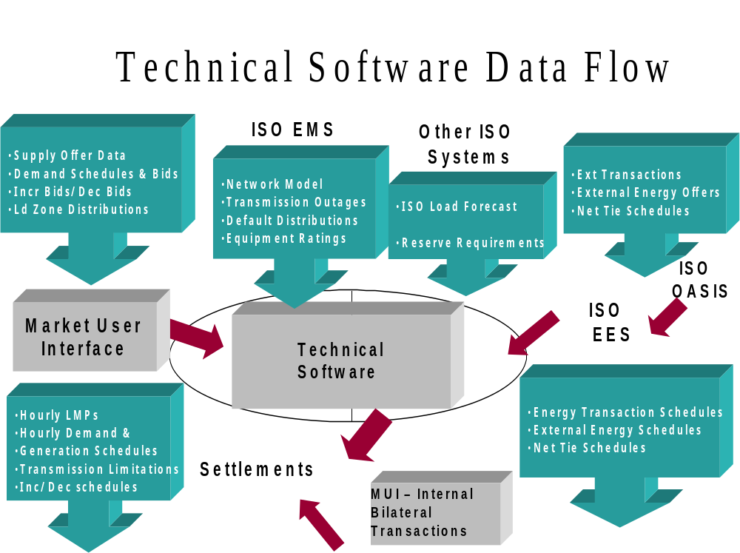
Exhibit 5.3:Technial Software Data Flow

5.2.5 Forecast Capacity Analysis

The ISO’s Forecast Capacity Analysis application calculates hourly capacity surplus/deficiency values based on the Current Operating Plan. The Current Operating Plan for the next Operating Day is initiated by the publication of the Day-Ahead Energy Market. The COP is updated with the initial RAA and all subsequent RAA updates during the Operating Day.

5.2.6 Regulation Assignment and Clearing Software
The ISO uses this software to assign Regulation to Generators, both prior to and during an operating hour, and to calculate Regulation Clearing Prices.

5.2.7 Generation Control System
This program runs on the ESCA EMS computer on a dynamic basis every few seconds, calculating Area Control Error (ACE), Regulation and economic Dispatch.

5.2.8 Network Analysis and SCADA Programs
These programs run on the ESCA EMS computer with periodicities up to five minutes and monitor the following parameters:
- frequency deviations
- frequency offset schedules
- net interchange tie flows
- voltage limits
- voltage changes
- generation losses
- transmission actual overloads

5.3 Dispatch Zones
Real-Time Demand Response Resources and Real-Time Emergency Generation Resources are located within specific Dispatch Zones. The ISO can selectively dispatch Demand Response Resources by Dispatch Zone as required to meet the reliability needs of the system.
Dispatch Zones are established by the ISO pursuant to Section III.13.1.4.6.1 of Market Rule 1.

Section 6: Scheduling Strategy & Method

6.1 Forecasting New England Resource Requirement
The first step in the scheduling process is to examine the relationship between Day-Ahead Demand Bids, Decrement Bids, External Transaction sales, Supply Offers, Increment Offers, External Transaction purchases, Operating Reserve Requirements, Replacement Reserve requirements, Local Second Contingency Protection Resource requirements and transmission security requirements and to clear the Day-Ahead Energy Market based on this information. In the Reserve Adequacy Analysis that follows the Day-Ahead Energy Market clearing, the relationship between the ISO load forecast, the Operating Reserve Requirements, Replacement Reserve requirements and Resource Energy supply for the Real-Time Energy Market is considered. Exhibit 6.1 illustrates the Real-Time Energy Market relationships in the form of a bar chart.
External
Bilateral Purchases
Self-Scheduled
Pool-Scheduled and Committed
ISO Committed as needed to meet Operating Reserve Requirement

Resource Supply
Requirements
Operating Reserve and Replacement Reserve Requirement
ISO Load Forecast
Dispatchable ARD Load
External
Bilateral Sales
Energy Requirement
Capacity Requirement
MW
MW

Exhibit 6.1: Requirement Versus Generation Supply
Exhibit 6.1 presents the following information:
(1) The ISO requirement is represented by the bar on the left. The height of this bar is the total ISO capacity requirement in MW. The capacity requirement consists of three components:
(a) Energy requirement, consisting of the ISO load forecast plus pumping load and External Transaction sales to other Control Areas that cleared the Day-Ahead Energy Market;
(b) Operating Reserve Requirement for the New England Control Area; and
(c) Replacement Reserve requirement.
(2) The ISO generation supply is represented by the bar on the right which consists of four supply components:
(a) External Transaction purchases from other Control Areas that cleared the Day-Ahead Energy Market and/or are qualified as New England capacity Resources;
(b) Generation that is Self-Scheduled by the Market Participants;
(c) Generation and capacity, that has been bid into the Day-Ahead Energy Market and the Real-Time Energy Market and is scheduled by the ISO to meet the Energy requirement and Operating Reserve Requirement; and
(d) Additional capacity to satisfy the Operating Reserve Requirement and Replacement Reserve requirement is committed by the ISO as required.
The ISO identifies the generation Resources that are Self-Scheduled or Pool Scheduled Resources, including separate identification of Pool-Scheduled Local Second Contingency Protection Resources, for settlements purposes.
The ISO’s load forecast is developed in accordance with Section 5 of this manual. The amount of External Transaction sales as scheduled by Market Participants is also considered when establishing the amount of generation that must be scheduled.
6.2 [Reserved]
6.3. Processing Market Information
Our attention now focuses on the elements that make up the requirement and supply picture in both the Day-Ahead Energy Market and in the Real-Time Energy Market. In the Day-Ahead Energy Market, Market Participants submit Demand Bids, Decrement Bids, Increment Offers, Supply Offers and External Transaction information into the Day-Ahead Energy Market and the ISO clears the Day-Ahead Energy Market based on this information using least-cost security-constrained unit commitment and dispatch software. For the Real-Time Energy Market, Market Participants may submit revised Generator related Supply Offer information, revised External Transactions, and revised Dispatchable Asset Related Demand Bid information during the Re-Offer Period. Resource Supply Offer and Demand Bid information with a Dispatchable Asset Related Demand automatically carries forward for use in the Real-Time Energy Market except for External Transaction information that must be submitted separately for use in the Day-Ahead Energy Market and Real-Time Energy Market, even if the External Transactions cleared in the Day-Ahead Energy Market.

6.3.1 Operating Reserve and Replacement Reserve Service
The Operating Reserve Requirement and the Replacement Reserve requirement in Real-Time are based on New England Control Area and Reserve Zone reliability requirements and is calculated based upon the criteria specified in ISO New England Operating Procedure No. 8 and ISO New England Operating Procedure No. 19. Compensation is paid to Market Participants with Resources designated as providing TMSR, TMNSR and/or TMOR in Real-Time based upon the MW amount of the designations and the Real-Time Reserve Clearing Prices.

6.3.2 Local Second Contingency Protection Resources
Local Second Contingency Protection Resources are those Resources identified by the ISO on a daily basis as necessary for the provision of Operating Reserve Requirements and adherence to NERC, NPCC and New England reliability criteria over and above those Resources required to meet first contingency reliability criteria within a Reliability Region
When establishing operating schedules, the ISO chooses (or “flags”) which units must be operated for local second contingency protection. The ISO will also indicate, in an auditable log, why the unit was so chosen. See the ISO New England Manual for Market Rule 1 Accounting, M-28 and Appendix F to Market Rule 1 for a description of the settlement treatment associated with Local Second Contingency Protection Resources.

6.3.3 Special Constraint Resources
In order to maintain area reliability, Transmission Owners or distribution companies may request the ISO to change the commitment of a Resource or the incremental loading on a previously committed Resource to provide relief for constraints not reflected in the ISO’s systems for operating the New England Transmission System or its operating procedures. Requests will normally be made to the ISO via the appropriate Local Control Center unless Emergency Conditions justify immediate communications with the Resources.
Such out of merit operation of units for any reliability purposes to provide relief for constraints (thermal, voltage or stability) not reflected in the System Operator’s systems or procedures will result in the Resource(s) being designated as a Special Constraint Resource (SCR). However, in the event a SCR is requested on by a Transmission Owner or distribution company and the ISO also requires that unit to be on-line in accordance with the ISO’s systems and procedures, the ISO will apply the appropriate flag to reflect the ISO’s need for the unit and will only flag the unit as SCR when the ISO does not require the Resource (or when changed Dispatch of the unit is requested by the Transmission Owner or distribution company). When a unit would not be operating above its Economic Minimum but for the request of the Transmission Owner or distribution company, it shall be flagged as SCR. In the event that the ISO requires that a unit, previously designated and flagged as SCR, become a unit required by the ISO to be on-line in accordance with the ISO’s systems and procedures (including economic Dispatch or for purposes of RMR, first contingency or capacity), the SCR designation and flag will be removed.
NCPC Credits associated with the scheduling of Special Constraint Resources compensate these Resources for helping to maintain New England Control Area reliability requirements and are collected as stated in Appendix F to Market Rule 1.

6.3.4 Self-Scheduled Generator Resources
Market Participants can choose to Self-Schedule their generation in the Day-Ahead Energy Market and/or can, if it has Electronic Dispatch Capability, choose to allow the ISO to schedule their generation in the Day-Ahead Energy Market based on the Supply Offer prices submitted. The Market Participant indicates the desired level of Self-Scheduled MW by submitting an Economic Minimum Limit equal to the amount of Self-Scheduled MW. Subsequent to the Day-Ahead Energy Market clearing a Generator may choose to Self-Schedule if it has Electronic Dispatch Capability, and may submit revised Supply Offer prices, as allowed, during the Re-Offer Period.
Exhibit 6.3 illustrates the relationship between Self-Scheduling and pool-scheduling for a particular generating Resource.
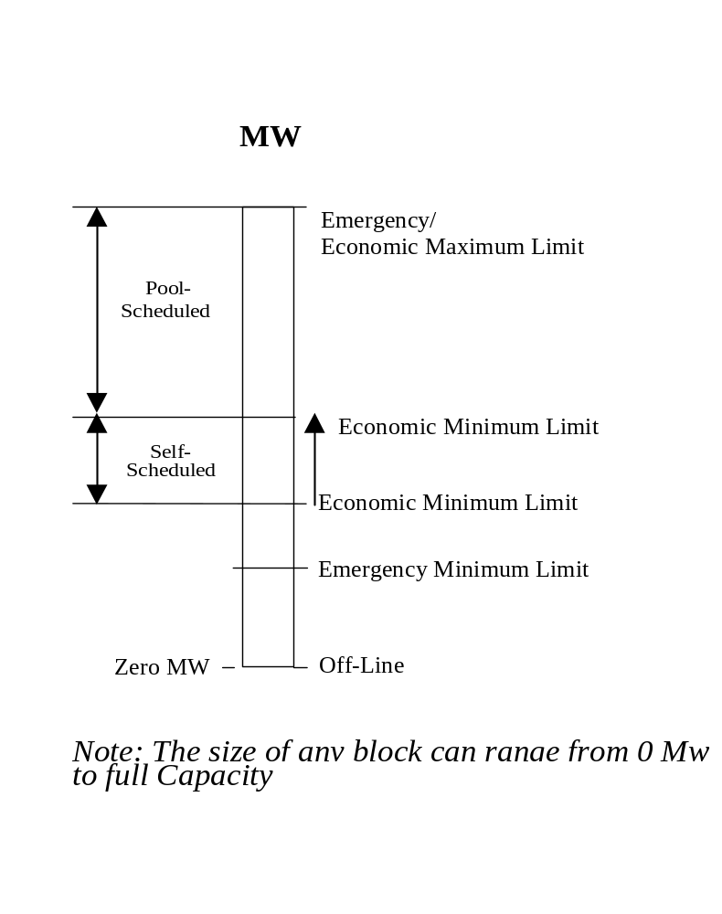
Exhibit 6.3: Generating Resource Scheduling

6.3.5 Self-Scheduled Dispatchable Asset Related Demand Resources
Market Participants can choose to Self-Schedule their Dispatchable Asset Related Demands in the Day-Ahead Energy Market or can choose to allow the ISO to schedule their demand in the Day-Ahead Energy Market based on the Demand Bids submitted. The Market Participant indicates the desired level of Self-Scheduled MW by submitting a Minimum Consumption Limit equal to the amount of Self-Scheduled MW. Subsequent to the Day-Ahead Energy Market clearing, any Dispatchable Asset Related Demand may choose to Self-Schedule or submit revised Demand Bids during the Re-Offer Period.

6.3.6 Deviations from Day-Ahead Energy Market for Generator Resources Scheduled Day-Ahead
If a generation Resource has been scheduled in the Day-Ahead Energy Market and the ISO determines that the unit should not be run in order to avoid a Minimum Generation Emergency, the generation owner will be responsible for all Real-Time Energy Market Deviation Energy Charges but will not incur generation related deviations for the purpose of allocating Real-Time NCPC Charges.
If a generation Resource has been scheduled in the Day-Ahead Energy Market and the owner wishes to deviate from that schedule (i.e., not run), the generation owner should contact the ISO to determine if this course of action is possible. The ISO will then:
(1) If the ISO determines that the generation Resource is not needed for reliability purposes for the Operating Day, the generation owner can decide not to run the unit and no Generator Forced Outage will be incurred. The generation owner will be responsible for all Real-Time Energy Market Deviation Energy Charges and will incur generation related deviations for the purpose of allocating Real-Time NCPC Charges.
(2) If the ISO determines that the unit is needed for reliability purposes, the ISO will inform the generation owner. The generation owner may still elect to not run the unit, but a Generator Forced Outage for the duration of the scheduled operation of the unit will be generated. The generation owner will be responsible for all Real-Time Energy Market Deviation Energy Charges and will incur generation related deviations for the purpose of allocating Real-Time NCPC Charges.
The timing guideline for notifying the ISO of expected deviations for Pool-Scheduled Resources and Self-Scheduled Resources will be the sum of the unit’s notification time plus the time to start. If this sum is less than 60 minutes, then the minimum notification time will be 60 minutes prior to the scheduled commitment time of the unit. This allows the ISO adequate time for determining if the unit is needed for reliability.

6.3.7 Credits for Cancellation of Pool-Scheduled Resource Generators
At the end of each month, the ISO calculates the Credits due to each affected Market Participant for Pool-Scheduled Resource Generators that were committed by the ISO after the Day-Ahead Energy Market has cleared and subsequently canceled by the ISO before coming on-line. See Appendix F to Market Rule 1 for the details regarding the calculation of this Credit.

6.3.8 [Reserved]

6.3.9 Dispatchable Asset Related Demand Resource Specific Data Requirements
Market Participants’ Offer Data for Dispatchable Asset Related Demands is submitted through the eMKT web site.
If Offer Data for a Dispatchable Asset Related Demand is not submitted by applicable deadline on the day before the Operating Day, the ISO uses the Offer Data and unit availability previously submitted and considers the data a binding offer. For a more detailed description of the Demand Bids and Offer Data, see the User Guide for Submitting Offers and Bids via eMKT.

6.4 Real-Time Operating Reserve Requirement Determination
In Real-Time, Operating Reserve Requirements for each Reserve Zone and Operating Reserve Requirements and Replacement Reserve requirements for the New England Control Area are calculated using Real-Time system data. The Operating Reserve Requirements (any New England Control Area Replacement Reserve requirement is accounted for by increasing the New England Control Area TMOR requirement by the applicable amount of required Replacement Reserve) are inputs to the dispatch algorithm (Unit Dispatch Software (UDS)) for use in dispatch and pricing. The following methodology is used to establish the Operating Reserve Requirements.

6.4.1 New England Control Area Operating Reserve Requirement
The Operating Reserve Requirements and Replacement Reserve requirements for the New England Control Area will be calculated based on the criteria specified in ISO New England Operating Procedure No. 8 (OP-8). These values are calculated by the ISO’s Energy Management System reserve requirements application every 20 seconds based on real time telemetry data and the status of supply resources (generating Resources and tie line schedules). These requirements are used by the dispatch and pricing algorithms and are posted to the ISO’s Website. Replacement Reserve requirements are accounted for by adding such requirement to the New England Control Area TMOR requirement.

6.4.2 Locational Operating Reserve Requirements
Operating Reserve Requirements for each Reserve Zone will be calculated based on the requirements of ISO New England Operating Procedure No. 19 (OP-19) and current ISO operating practice. These values will be calculated every five minutes and will be a function of Real-Time system conditions. Operating Reserve Requirements for a Reserve Zone may be zero in Real-Time.

6.4.3 Calculation of Locational Operating Reserve Requirements
Under current operating practice, the Real-Time local Operating Reserve Requirement (RTLRR) for each Reserve Zone is calculated according to the following formulae.

(a) The second contingency in each Reserve Zone shall be calculated as follows:
Second Gen = Limit_{N-1} - Limit_{N-2, Gen} + CONTG – 30 ACT
Second Line = Limit_{N-1} - Limit_{N-2, Line} – 30 ACT

(b) The External Reserve Support (ERS) will be calculated as follows:
ERS = Limit_{N-1} – Actual Interface Flow

(c) The RTLRR, which is the amount of 30-minute contingency response, given the available transfer capability on the interface, that must be physically located within the import-constrained area to ensure recovery from the loss of the second contingency, will be calculated for use in each five minute SPD execution as follows:
RTLRR = MAX( Limit_{N-2, Gen}, Limit_{N-2, Line} ) – ERS
Where:
CONTG = Output of the largest generator on-line in the import constrained area
Limit_{N-1} = First contingency interface limit (as calculated in RT)
Limit_{N-2, Gen} = Second generation contingency interface limit (as calculated in RT)
Limit_{N-2, Line} = Second line contingency interface limit (as calculated in RT)
30ACT = Available non-generation based actions available within 30-minute (the MW available is a function of system conditions)
6.5 External Transactions
External Transactions are requested through the Enhanced Energy Scheduler (EES) application. They may be submitted for either the Day-Ahead Energy Market, Real-Time Energy Market or both.
Requests for External Transactions must be submitted before specific deadlines and contain all required data in order to be considered a valid request as described below.
Other definitions and detail associated with External Transactions can be found within ISO New England Operating Procedure No. 9 - Scheduling and Dispatch of External Transactions (OP9) and Open Access Transmission Tariff Section II.44.

6.5.1 External Transaction Submission Deadlines
(1) External Transaction requests may be submitted as early as 10 days prior to the first Operating Day of the requested schedule. External Transactions shall have a minimum duration of one hour and a maximum duration of one month. (For example, a month-long transaction might run from February 21 to March 20, from March 21 to April 20 or from March 1 to March 31.)
(2) To be considered in the Day-Ahead Energy Market, External Transactions must be submitted or modified via EES to the ISO by the offer submission deadline for the Day-Ahead Energy Market and designated as being applicable in the Day-Ahead Energy Market. External Transactions must be designated as Self-Scheduled, priced or Up-To Congestion.
(3) Priced Real-Time External Transactions must be submitted or modified by the offer submission deadline for the Day-Ahead Energy Market on the day before the Operating Day in order to be considered in the Real-Time Energy Market. Priced Real-Time External Transactions that have met the preceding submittal deadline may have the requested megawatt value modified between the current MW amount on the External Transaction and zero with at least 60 minutes notice prior to the applicable scheduling interval.
(4) Any Real-Time priced External Transaction may have its price revised during the Re-Offer Period.
(5) Self-Scheduled Real-Time External Transactions may be submitted or modified with at least 60 minutes notice in order to be considered in the applicable scheduling interval.
A change to one day of a multi-day request nullifies the timestamp for the rest of the request. The change request is given a new timestamp and scheduled as though the rest of the transaction was submitted at the time of the change.

6.5.2 General Information
(1) Transmission reservations, where applicable, will be subject to transmission charges, as appropriate, whether or not they are used to support Real-Time External Transactions.
(2) External Transactions are subject to the ISO’s ramping rules. For a detailed description of the ramp rules, see the Section below titled “Ramps”.
(3) The ISO does not accept Supply Offers associated with Resources committed to supply Operating Reserve to another Control Area. In other words, the ISO considers all External Transaction Supply Offers that clear in the Day-Ahead Energy Market or have a Capacity Supply Obligation as firm offers and, as such, accounts for such transactions in RSC by allowing Supply Offers at External Nodes to reduce the amount of internal Resources committed. Conversely, the ISO treats External Transaction sales that clear the Day-Ahead Energy Market or are associated with Resources with capability above their Capacity Supply Obligation as firm sales and accounts for such transactions in RSC by allowing such Demand Bids to increase the level of internal Resources committed.
(4) External Transactions not properly submitted via EES are rejected. The Market Participant is notified of the reason for rejection and the Market Participant may then take action to submit a new External Transaction.
(5) External Transaction data applicable to the Day-Ahead Energy Market does not carry forward for use in the Real-Time Energy Market. A Real-Time Energy Market External Transaction must be submitted for all External Transactions that were designated as applicable in the Day-Ahead Energy Market if the Market Participant wants the Energy to be considered in the Real-Time Energy Market. However, a single External Transaction can contain information for both the Day-Ahead Energy Market and Real-Time Energy Market.
(6) Priced External Transactions cleared in the Day-Ahead Energy Market will be treated as Self-Scheduled External Transactions for purposes of price in Real-Time scheduling, unless the Market Participant modifies the Real-Time price component of the offer during the Re-Offer Period.
(7) The ISO will not schedule net interchange on a given external interface to levels that exceed the forecasted transfer limit at the External Node.

6.5.3 Ramps
The ISO will consider its ability to schedule Real-Time External Transactions on a system wide basis for each scheduling interval. The External Transactions scheduled in the current interval will be evaluated against the expected External Transactions in future scheduling intervals. If the system wide net interchange differs between the two Real-Time scheduling intervals by more than 500 MW, the ISO will review and resolve any ramp issues.

6.5.4 EES Data Requirements

6.5.4.1 Day-Ahead Energy Market
The following information is submitted to the ISO via the EES for Day-ahead External Transactions:
(1) valid transaction path
(2) External Node(s), and internal Node, if required
(3) start date and end date
(4) start time and end time
(5) requested MW value, expressed in whole megawatts (MW) and must be stated in terms of the MW quantity to be received at or delivered to the balancing area boundary
(6) price associated with the transaction, if the transaction is a priced External Transaction
(7) congestion price associated with the transaction, if the transaction is an Up-to Congestion External Transaction
(8) Market Participants submitting External Transactions into the Day-Ahead Energy Market are not required to include transmission service information or NERC E-Tag information.

6.5.4.2 Real-Time Energy Market
Transmission Customers must keep the ISO informed of all External Transactions into, out of and through the New England Control Area. The following information is submitted to the ISO via the EES for Real-Time External Transactions:
(1) valid transaction path
(2) identity of associated external interface(s) associated with the External Transaction.
(3) start date and end date
(4) start time and end time
(5) requested MW value, expressed in whole megawatts (MW) and must be stated in terms of the MW quantity to be received at or delivered to the balancing area boundary
(6) price associated with the transaction, if the transaction is a priced External Transaction
(7) special exceptions associated with the transaction, as appropriate (available exceptions are listed in Table 6.1)
Exception | Description | Comment
Import Resource | Participants with an Import Capacity Resource with a Capacity Supply Obligation must use this exception to notify ISO that transaction is backing an Import Capacity Resource. | Must reference the Import Capacity Resource ID
Flex Reservation | Applicable only to Participants submitting priced transaction backing Import Capacity Resources over interfaces where advance reservations are required. Checking this flag allows the user to link an OASIS reservation, and NERC eTag, up to one hour before the start of the transaction. User must also reference the Import Resource exception. | Must reference the Import Capacity Resource ID
Non-Capacity Supply Obligation Export | Participants must reference this exception for transactions to be considered under Section III.1.10.7(i) during system-wide capacity deficient conditions. | Must reference the numerical Asset ID
LSCC Export  (Capacity Export Through Import Constrained Zone or FCA Cleared Export Transaction) | When this is selected by Participants that have bid and cleared appropriately in the FCA and submitted the transaction in accordance with Section III.1.10.7(f) i or ii, Participant is requesting that the transaction be considered in local second contingency commitment and will be allocated a share of certain costs as defined in III.1.10.7(h). Transactions with this exception are considered supported in real-time scheduling as defined in Section II.44.  Note: Participant must also reference Non-Capacity Supply Obligation Export to be considered under Section III.1.10.7(i) | Must reference the numerical Asset ID backing the FCA de-list bid
Unconstrained Export  (Same Reserve Zone or Unconstrained Export Transaction) | When this option is selected and the referenced generator meets criteria in Section III.1.10.7(f) iii or iv, transaction is considered supported in real-time scheduling as defined in Section II.44.  Note: Participant must also reference Non-Capacity Supply Obligation Export to be considered under Section III.1.10.7(i). | Must reference the numerical Asset ID
Excepted Transaction | When this is selected by Participants with active items in Tariff Section II Attachment G-3 and submitted in accordance with Tariff Section II.44(a), special priority is assigned in real-time scheduling. | There are currently no active items in Attachment G-3
Generation Information System | Used to indicate transaction is associated with Generation Information System | Must contain a comment
EET Emergency | When emergency transactions are requested by ISO-NE, allows user to submit priced transactions within the operating day. | Does not require a comment
Security Energy Transactions | When security transactions are requested by ISO-NE, allows user to submit priced transactions within the operating day. | Must contain a comment – “NB” is the suggested value
Grandfathered | When this is selected by Participants with active items in Tariff Section II Attachment H and submitted in accordance with Tariff Section II.44(a), special priority assigned in real-time scheduling. | Must reference MEPCO Grandfathered Transmission Service Agreements (MGTSA); user must also link a valid associated OASIS reservation
Table 6.1: Available Exceptions Associated with External Transactions
(8) Advance purchase of transmission service on the ISO New England OASIS is not required for purchase, sale or Through External Transactions.
(9) For a Real-Time priced External Transaction supporting an Import Capacity Resource on an interface where an advance transmission reservation is required that has a special exception of “Flex Reservation”, the Market Participant must submit a valid NERC E-Tag and the associated non-PTF transmission service reservation(s) by one hour before the Operating Hour in order to be considered for Real-Time dispatch.
(10) For all other External Transactions, the associated non-PTF transmission service reservation, if applicable, and a valid NERC E-Tag must be identified and must be provided at the time of the Real-Time Energy Market submission.

6.5.5 ISO Review of External Transaction Requests
Upon submittal of an External Transaction to the Real-Time Energy Market, the ISO logs the request and performs the following tasks:
- Assigns a unique transaction identifier
- Assigns a time stamp when the request is received to be used for scheduling purposes
- Applies automated validity of NERC E-Tag and verification of the existence of required transmission service
External Transactions that do not pass the automated verification process are assigned a status of Pending Action. The Transmission Customer is notified of the validation failure and the Transmission Customer may then take action to resubmit the transaction within the appropriate submission deadlines. The ISO does not take administrative action to review transactions in a status of Pending Action, except for actions taken on specific priced Real-Time External Transactions that have been submitted in support of an Import Capacity Resource, as described further in Section 6.5.7 below.
Once External Transactions pass the automated verification, they are assigned a status of Pre-Approved. The ISO shall perform the following manual administrative tests on Pre-Approved Real-Time External Transaction requests to establish the final status of the transaction.
(1) Confirm that the request is using pre-arranged transmission service reservations (valid dates, type, services), as appropriate.
(2) Ensure a valid NERC Tag has been associated. A valid NERC Tag is one in which:
- The profile is entirely covered by the tag.
- The tag duration is not longer than the schedule.
- The tag does not overlap profiles within a schedule.
- The tag is not used for multiple schedules.
If the requested Real-Time External Transaction passes all of the preceding tests, the status will be set to Approved and will proceed to the Check Out process described in Section 6.5.7 below. If the requested Real-Time External Transaction fails any of the preceding tests, the status will be set to Denied. The ISO will inform the Market Participant or Transmission Customer that the External Transaction request has been denied and the reason for the denial.

6.5.6 Real-Time External Transactions
Priced Real-Time External Transactions will be scheduled in accordance with Sections III.1.10.1A and III.1.10.7 of Market Rule 1 and Section II.44(b) of the Tariff.
External Transactions associated with Import Capacity Resources are subject to adjustments and penalties under Sections III.13.7.1.2 and III.13.7.2.7.2 of Market Rule 1.

6.5.7 Check-out Procedure
Day-Ahead Energy Market: There is no check-out procedure for External Transactions submitted for use in the Day-Ahead Energy Market. For the Day-Ahead Energy Market, all External Transaction requests accepted by software are valid requests.
Real-Time Energy Market Day Before Checkout: Real-Time Energy Market External Transaction requests with a status of Approved are validated with the appropriate neighboring Control Areas. The following Real-Time Energy Market External Transaction information is confirmed with the neighboring Control Area:
(1) NERC E-Tag identifier
(2) dates
(3) times
(4) path
(5) energy profile
Regardless of the results of this confirmation, all reviewed transactions will remain with the status of Approved.
Real-Time Energy Market Check-Out for Next Scheduling Interval: The ISO applies the scheduling rules defined in ISO New England Operating Procedure No. 9 to all External Transactions with a status of Approved for each scheduling period, then confirms the transactions that will be scheduled with the appropriate neighboring Control Areas. If a transaction does not pass this check out for the next scheduling interval with the neighboring Control Area, no MW will be scheduled for that transaction in the coming interval. However, the status of that transaction will remain Approved and will continue to be reviewed for all future requested hours. This scheduling process will also include all Pending Action Real-Time priced External Transactions that have been submitted in support of an Import Capacity Resource and contain the special exception of “Flex Reservation”. If those transactions would have been scheduled, but the Market Participant submitting the transaction had not provided the NERC E-tag identifier and transmission reservation, this information will be recorded for appropriate penalty review during the settlement of the Import Capacity Resource, as defined in Market Rule 1, Section III.13.7.1.2.

6.5.8 ISO Emergency Energy Purchases during Emergency Condition
Consistent with Section 4 of Market Rule 1 and upon implementation of ISO New England Operating Procedure No. 4 allowing the dispatch of Emergency Energy Purchases, the ISO may purchase available Energy from any Market Participant (as emergency) that is available up to the amount required or until there is no more available in accordance with the following:
(1) The Market Participant is responsible for delivery (i.e., securing all necessary transmission service) of the Emergency Energy to the New England Control Area. This includes applicable and appropriate transmission service reservations over the non-PTF New England external interfaces.
(2) The ISO will provide at least 60-minutes notice before the Emergency Energy is anticipated to be required by posting on the ISO’s website an emergency procedures message stating that the ISO anticipates requiring Emergency Energy purchases.
(3) Once the ISO posts the request for Emergency Energy purchases, the ISO will allow submission of Emergency Energy offers from Market Participants via the EES software and such offers may not exceed $1,000/MWh. The ISO accepts the offers and schedules the Energy using the following guideline:
(a) Energy (including Emergency Energy purchases) is scheduled as required based on economics from the available offers (i.e., if the ISO requires 500 MW immediately it takes the cheapest 500 MW bid at the time). The ISO adjusts current schedules to correct economics if time permits (i.e., if a cheaper offer is received after a more expensive schedule is loaded, the ISO only cancels the first if reasonable time exists to both cancel one and load the other).
(4) Emergency Energy offers scheduled by the ISO are Emergency External Transaction purchases by the ISO and are not eligible to set the Real-Time LMP. Market Participant’s are paid the higher of their offer price or applicable External Node LMP for Emergency Energy purchases accepted by the ISO, with amounts paid in excess of the applicable External Node LMP accounted for according to the Emergency Energy accounting procedures contained in the ISO New England Manual for Market Rule 1 Accounting, M-28.
(5) The ISO implements and curtails Emergency Energy purchase transactions from Market Participants with as much notice as practical to allow for a reliable transition into and out of Emergency Conditions.
(6) The ISO requests Emergency Energy from neighboring Control Areas (under current Control Area agreements) after all Energy offered by Market Participants is accepted, unless there is an immediate need for the energy.
(7) The ISO can deviate from or change the order of the above actions as necessary to maintain system reliability.

6.5.9 [Reserved]

6.5.10 ISO Purchases of New Brunswick Security Energy
Consistent with Section III.3.2.6A of Market Rule 1 and ISO New England Operating Procedure No. 9 allowing the dispatch of Security Energy Purchases, the ISO will purchase available Energy from any Market Participant up to the amount required or until there is no more available in accordance with the following:
(1) The Market Participant is responsible for delivery (i.e., securing all necessary transmission service) of the Security Energy Transaction to the New England Control Area. This includes applicable and appropriate transmission service reservations over the non-PTF New England external interfaces.
(2) When possible, the ISO will provide notice before New Brunswick Security Energy is anticipated to be required by posting on the ISO’s web site a message stating that the ISO anticipates requiring New Brunswick Security Energy purchases.
(3) Once the ISO posts the request for New Brunswick Security Energy purchases, the ISO will allow submission of External Transactions flagged as Security Energy Transaction offers from Market Participants via the EES software and such offers may not exceed $1,000/MWh. The ISO accepts the offers and schedules the Energy using the following guideline:
(a) Energy (including Security Energy Transactions submitted by Market Participants) is scheduled as required based on economics from the available offers (i.e., if the ISO requires 200 MW to be scheduled in the next hour, it takes the least expensive 200 MW available at the time).
(4) Security Energy Transactions from Market Participants scheduled by the ISO are not eligible to set the Real-Time LMP. Market Participants are paid the higher of their offer prices or the applicable External Node LMP for Security Energy Transaction purchases accepted by the ISO, with amounts paid accounted for as provided in the ISO New England Manual for Market Rule 1 Accounting, M-28.
(5) The ISO implements and curtails Security Energy Transaction purchases from Market Participants with as much notice as practical.
(6) The ISO requests Security Energy from the New Brunswick Control Area (under the current Control Area agreement) after all Security Energy Transactions offered by Market Participants are accepted, unless there is an immediate need for the energy.
(7) Under exigent circumstances the ISO may deviate from or change the order of the above actions as necessary to maintain system reliability.

Section 7: Posting OASIS Information

7.1 OASIS
The ISO is responsible for providing the OASIS node for the New England Control Area. OASIS serves as an information network for use by Transmission Customers. Please refer to the ISO’s web site (www.iso-ne.com) for additional information. OASIS is used for the dissemination of transmission, generation, and Ancillary Services information. In addition to the dissemination of information on OASIS, the following scheduling-related information is posted on the ISO website or on the OASIS:
(1) total load forecasts (hourly for next two days) are posted on ISO web site.
(2) peak load forecasts (for next seven days) are posted on ISO web site.
(3) generation Resources are posted on ISO web site.
(4) transmission service reservations are posted on OASIS web site.
(5) transmission congestion is posted on ISO web site.
(6) Ancillary Services are posted on the OASIS and ISO web sites.

7.1.1 ISO Actions
- Not later than 1600 hours on the day before each Operating Day, the ISO posts the following information on the ISO web site:
(a) forecast of the location and duration of any expected transmission congestion
- At ISO-designated times during the day, the ISO posts the following information on the ISO web site:
(a) a revised forecast of the location and duration of any expected transmission congestion
- As required by the FERC, the following information is posted on the OASIS web site:
(a) curtailment or interruption of External Transactions
(b) availability of Transmission Services to Transmission Customers

7.1.2 Market Participant Actions
None for scheduling purposes.

Section 8: Hourly Scheduling

8.1 Hourly Scheduling Adjustments
During the course of power system operations, planned and unplanned events are continually occurring. This Section discusses the process by which pre-planned operating schedules may be changed by the ISO or Market Participants to reflect changing conditions.
A Market Participant may adjust the schedule of a Self-Scheduled Resource on an hour-to-hour basis under the following conditions:
- subject to the right of the ISO to schedule and Dispatch Self-Scheduled Resources in an Emergency; and
- provided that the ISO is notified not later than 30 minutes prior to the hour in which the adjustment is to take effect for internal Resources; or not later than 60 minutes prior to the hour in which the adjustment is to take place (or such shorter period, up to 20 minutes before the hour, when the ISO has notified the Market Participants that it has the necessary hardware, software, and procedures in place to implement the shorter notice period) for Resources or Transactions requiring scheduling with another Control Area; and
- in either case, the ISO approves the request.
The Market Participant must contact the ISO forecast office via telephone, or other means specified by the ISO, with any Self-Schedule requests and the forecast office must approve the request. The ISO will generally approve all requests unless the requested change would cause a system reliability problem. If the request is approved, the ISO will enter the request as a Redeclaration.
The following adjustments may be made:
- A Market Participant may request to Self-Schedule any of its Resources or Resource increments not previously designated as Self-Scheduled Resources including those Resources that were scheduled as a Pool-Scheduled Resource.
- A Market Participant may request the Self-Scheduling of a new External Transaction.
- A Market Participant may remove from service a Resource or Resource increment that it had previously designated as a Self-Scheduled Resource, provided that the ISO has the option to schedule Energy from such Resource or Resource increment at the price offered in the scheduling process, with no obligation to pay any Start-Up Fee.
With regard to Self-Schedule changes, when the ISO approves an increase in a Self-Schedule, thus causing an increase in the generating unit’s Economic Minimum Limit, the UDS software will not issue the Generator that is operating below its Economic Minimum Limit a DDP to move to the Economic Minimum Limit unless it is economic to do so. In the case where UDS does not issue a DDP for a Generator to move from below its Economic Minimum Limit to its Economic Minimum Limit, the Generator is required to move to its Economic Minimum Limit on its own initiative. Failure to move to Economic Minimum Limit for any units operating below Economic Minimum Limit as a result of an increase in a Self-Schedule may result in the ISO entering a Redeclaration of the generating unit’s Economic Maximum Limit to match its current output level so as to create a Generator Forced Outage.

Market Participants may request a change in the hourly generation schedule of a Limited Energy Generator by calling the ISO system operators at least 30 minutes prior to the time of the desired change. If the ISO can accommodate the LEG schedule change in less than the 30-minute LEG notification period, the change may be granted earlier.

Revision History

Approval
Approval Date: November 1, 2002
Effective Date: March 1, 2003

Revision History
Revision: 1 - Approval Date: February 5, 2003
Section No. Revision Summary
1.2.2 (4)……..Deletes the forecast of Day-Ahead LMPs from the posted pre-dispatch schedule report.
2.5.2 (1),
2.5.3 (1) &
2.5.6 (3)……..Corrects problems discovered during Market Trials by adding language to the data verification section to have the ISO review Demand Bids, Supply Offers, Increment Offers and Decrement Bids in the Day-Ahead Energy Market for errors and to provide for ISO revision of certain Demand Bids and Supply Offers after discussion with the submitting Participant.
2.5.2 (14)……Clarifies that the Hub is not a valid Location for Demand Bids.
2.5.9…………Adds a better explanation of the calculation of the three components of the LMPs.
3.2.1 (10) &
3.2.7 (4)……..Clarifies the calculation of Opportunity Costs in the Regulation Market.

Revision: 2 - Approval Date: April 4, 2003
Section No. Revision Summary
1.1…….……..Adds language stating that Resources without Electronic Dispatch Capability (EDC) must Self-Schedule in the Day-Ahead Energy Market.
2.2…………...Clarifies that ICAP Resources without EDC must meet the requirement to offer in the Day-Ahead Energy Market through a Self -Schedule.
2.5.3 (3)……..Adds language stating that ICAP Resources without EDC must Self-Schedule in the Day-Ahead Energy Market.
2.5.3 (9)……..Replaces the word “in” with the word “for” in the description of Supply Offers for Generators with minimum run times in excess of 24 hours.
2.5.9.2 (2)(b)..Clarifies that Generators on Regulation are excluded from the calculation for flagging units for failure to follow Dispatch Instructions.
6.3.4…………Clarifies that only Resources with EDC may submit Supply Offers in the Day-Ahead Energy Market.
Revision: 3 - Approval Date: May 2, 2003
Section No. Revision Summary
2.5.10(1)(a)….Revise treatment of stale data or program failure to apply to cases where 11 intervals or less are affected and to explain when the next successful interval will be used in lieu of the last successful interval.

Revision: 4 - Approval Date: June 26, 2003
Section No. Revision Summary
2.5.9……...….Adds a description of a mathematical condition encountered by the software in the calculation of Real-Time Nodal Prices in rare instances known as “dual degeneracy” to the description of the calculation of Real-Time Nodal Price.

The addition of Section 2.5.16.3 is contingent upon FERC acceptance of corresponding revisions to Market Rule 1 filed by the ISO on May 15, 2003.

2.5.16.3……...Adds a new subsection that adds Reserve Shortage Condition provisions to the Manual, including: when a Reserve Shortage Condition will be declared, notification to the market by the ISO, pricing implications, and the calculation of Reserve Shortage Opportunity Costs to be recovered pursuant to ISO New England Manual for Market Rule 1 Accounting, M-28.

Revision: 5 - Approval Date: October 3, 2003
Section No. Revision Summary
8.1…………...Language is added to conform Manual 11 to the recent change in notice requirements announced pursuant to Market Rule 1 for changes to Self-Schedules for certain internal generating Resources to 30 minutes.

Revision: 6 - Approval Date: February 20, 2004
Section No. Revision Summary
3.2.1(3)……...Adds language clarifying that the information must be supplied prior to the close of the Regulation Market.
3.2.1(4)……...Revises the section to state that unit regulating status for units available for Energy in the Day-Ahead Energy Market may be changed from available to unavailable after the Regulation Market closes.
3.2.1(7)……...Revises the treatment of units that were unavailable in the Day-Ahead Energy Market and become available later so that they may Self-Schedule for Regulation only if they are available and submit the Self-Schedule prior to the close of the Regulation Market.
3.2.1(10)…….Limits requests by Limited Energy Generators to Self-Schedule for Regulation (and the associated Redeclaration of Regulation Limits and Regulation Capacity to be consistent with the LEG MWh limit) to those submitted prior to the close of the Regulation Market.

Revision: 7 - Approval Date: March 12, 2004
Section No. Revision Summary
1.2.2(2)(b)
& 2.1…..…….Adds language indicating that all offers and bids and External Transactions may clear in the Day-Ahead Market in partial MW quantities.
2.3…………...Adds language indicating that External Transactions are scheduled and settled in whole MW quantities in the Real-Time Energy Market.

Revision: 8 - Approval Date: May 7, 2004
Section No. Revision Summary
3.2.1(3)(b)…..Clarifies that Regulation Capability represents the amount of movement that can be achieved within 5 minutes while providing Regulation.
3.2.1(9)……...This subsection is deleted.

Revision: 9 - Approval Date: November 5, 2004
Section No. Revision Summary
These revisions shall cease to be in effect after April 15, 2006 (Sunset Provision).

1.1…………...Clarifies that the timeline for scheduling activities in Exhibit 1.1 applies under normal conditions and adds Exhibit 1.1.A to describe the scheduling timeline when a Cold Weather Event is declared pursuant to OP-20.
1.2.2(5)……...Replaces “12:00” with “the close of the Day-Ahead Energy Market bid/offer period”.
2.3…………...Replaces “noon” with “the close of the Day-Ahead Energy Market bid/offer period”.
2.5.1…………Divides the last sentence of the paragraph into two sentences for clarity.
2.5.7(2)……...Replaces “12:00 deadline” with “the close of the Day-Ahead Energy Market bid/offer period”.
3.1…………...Adds “under normal conditions” to the description of the Regulation Market Timeline. Adds a new Exhibit 3.1.A to illustrate the Regulation Market Timeline when a Cold Weather Event is declared pursuant to OP-20.
3.2.4…………Replaces “12:00” with “the close of the Day-Ahead Energy Market bid/offer period”.
6.4.1(2)&(3)...Replaces “12:00” with “the close of the Day-Ahead Energy Market bid/offer period”.
6.4.7…………Replaces “12:00” with “the close of the Day-Ahead Energy Market bid/offer period”.

Revision: 10 - Approval Date: June 28, 2004
Section No. Revision Summary
Entire Manual revised to reflect RTO terminology and to reflect the Market Rule 1 and Transmission Markets and Service Tariff provisions filed with the FERC (e.g., the elimination of Internal Point-to-Point Transmission Service).

Revision: 11 - Approval Date: May 6, 2005
Section No. Revision Summary
2.5.16.3……...Renumbers the subsections.
2.5.16.3(3)(vi)
………………Replaces the terms “Market Monitoring Unit” and “Independent Market Advisor” with “Internal Market Monitoring Unit” and “Independent Market Monitoring Unit”.

Revision: 12 - Approval Date: May 27, 2005
Section No. Revision Summary
The following revision is contingent upon FERC acceptance of corresponding revisions to Market Rule 1 to be filed by the ISO. The ISO will request a waiver of the 60-day notice requirement so that the Market Rule 1 revisions may become effective on June 7, 2005.

6.4.10………..Adds new subsection titled “ISO Purchases of New Brunswick Security Energy”.

Revision: 13 - Approval Date: September 9, 2005
Section No. Revision Summary
1.1, 2.5.2 &
3.1…………...Replace references to OP-20 with references to Appendix H to Market Rule 1.
2.5.8(2),
2.5.9.3(b),
2.5.16.3(4),
5.1, 6.3.2, 6.3.3
& 6.36……… Replace references to Section 5 of ISO New England Manual M-28 with references to Appendix F to Market Rule 1.

Revision: 14 - Approval Date: March 11, 2005
Section No. Revision Summary
1.2.2…………Adds a reference to Regulation.
1.2.3…………Adds a new subsection title.
1.2.3(5)……...Revises the subsection to provide for hourly posting of preliminary Real-Time Regulation Clearing Prices.
1.2.3(14)&(15)
………………Adds language providing for the posting of preliminary and Real-Time LMPs and RCPs.
2.3…………...Revises the subsection to allow Resources selected in the Day-Ahead Market to participate in the Re-Offer Period.
2.5.1…………Revises the subsection to allow Resources selected in the Day-Ahead Market to participate in the Re-Offer Period.
2.5.3(8)……...Revises the subsection to allow Resources selected in the Day-Ahead Market to participate in the Re-Offer Period.
2.5.5(7)……...Adds the final RCP to the data to be posted.
2.5.6…………Deletes “Mechanical” from the subsection title.
2.5.9.2(c)…… Revises the section to make Real-Time Dispatchable External Transactions eligible to set the Dispatch Rate.
2.5.10………..Adds RCP to verification procedure and to title of subsection.
3.1…………...Completely revises the subsection to describe the new Regulation Market.
3.2.1(2)……...Revises the criteria for units participating in the Regulation Market.
3.2.1(3)……...Revises the information requirements and redefines Regulation Capability. Also revises the description of the manner in which the software treats Regulation High and Low Limits when they are not the most restrictive limits submitted.
3.2.1(4)–(8)….These subsections are deleted and replaced with new subsections (4) through (10).
3.2.1(4)……...Adds a new subsection describing Minimum Regulation Range.
3.2.1(5)……...Adds a new subsection on changing the unit’s Regulation status from available to unavailable.
3.2.1(6)……...Adds a new subsection (revised former Section 3.2.1(9)) to describe the treatment of Limited Energy Generators.
3.2.1(7)……...Adds a new subsection describing Self-Scheduling for Regulation.
3.2.1(8)……...Adds a new subsection setting forth limitations on the submission of Self-Schedule requests.
3.2.1(9)……...Adds a new subsection describing the treatment of Opportunity Cost in Self-Scheduled hours.
3.2.1(10)…….Adds a new subsection describing unit eligibility for Regulation assignment.
3.2.2…………Revises the subsection to describe the method for setting Regulation Requirements.
3.2.4…………Deletes the words “necessary data”. Revises language describing the use of default offer values when no offer is submitted.
3.2.5…………Adds this new subsection to describe the process of assigning Regulation.
3.2.6…………Re-writes the subsection to describe the new Regulation Clearing Price calculation.
3.2.7…………Revises the subsection to describe the new Regulation assignment process.
3.2.8…………Adds language to provide for Regulation Service Credits and Time-On-Regulation Credits.
3.2.9…………Revises subsection to provide for monitoring of Automatic Response Rates.
3.2.10………..Revises the subsection to use new terminology, delete subsection (2) and re-define the qualifying measurement interval.
3.2.11………..Revises the performance calculation to reflect new Regulation Market.
3.2.12………..Revises list of existing performance records and adds several items for monitoring of ARR.
3.2.14………..Revises subsection to use Regulation Capability Compliance Rating, change rounding to nearest 0.1 MW and add a paragraph dealing with ARR.
5.2.3…………Eliminates the limitation on Resources that cleared Day-Ahead Market submitting offers in the Re-Offer Period.
5.2.5…………Revises and re-titles subsection to describe Regulation Assignment and Clearing software.
6.2…………...Replaces “ISO Regulation Requirement” with “Regulation Requirement” here and throughout the document.
6.2.1(3)……...Deletes subsection providing for the notification of Regulation Requirement by 16:00.
6.2.1(4)……...Replaces clearing price at 22:00 with hourly clearing of the Regulation Market.
6.2.3…………Deletes the reference to a 22:00 posting of the Regulation Clearing Price.
6.3…………...Eliminates the limitation on Resources that cleared in the Day-Ahead Market submitting offers in the Re-Offer Period.
6.3.1…………Adds references to OP-8 and OP-19.
6.3.4…………Eliminates the limitation on Resources that cleared in the Day-Ahead Market submitting offers in the Re-Offer Period.
6.3.6…………Replaces “pool-scheduled” with “Pool-Scheduled”.

Revision: 15 - Approval Date: December 2, 2005
Section No. Revision Summary
The following revisions are part of the Winter 2005/2006 Action Plan and will expire (along with their associated Market Rule 1 provisions) on March 31, 2006.

2.5.1…………Adds references to Start-Up and No-Load Fees in the timeline to reflect daily submission of these values.
2.5.3(12)……. Replaces the two eligibility periods twice a month to change Start-Up and No-Load Fees to once per day by noon of the day prior to the Operating Day for which the Start-Up and/or No-Load Fee is to be effective.
6.3…………...Inserts “(excluding Start-Up and No-Load Fees)”.
6.3.4…………Inserts “(excluding Start-Up and No-Load Fees)”.

The following revisions are conforming changes to reflect Appendix H to Market Rule 1 and will expire with that Market Rule 1 provision on April 15, 2006.

Table 1.1…….Replaces reference to OP20 with a reference to OP21.
1.1…………...Adds “Except as otherwise provided in Appendix H to Market Rule 1,” before the statement describing when the Re-Offer Period begins and ends.
1.1…………...Adds the revised times for close of the Day-Ahead Energy Market, posting of DAM schedules and the close of the Re-Offer Period.
Exhibit 1.1A... Revises the timeline to conform to Appendix H to Market Rule 1.
1.2.3(2)……... Deletes “at 16:00”.
2.3…………...Deletes “at 18:00” in the first paragraph and “from 16:00 to 18:00” in the second paragraph.
2.5.1…………Adds Cold Weather Events to the list of items that may result in changes to the Supply Offer timeline.
2.5.3(25)……. Revises section to reflect Appendix H to Market Rule 1 process related to Supply Offer caps for internal Resources.
Exhibit 3.1.A.. Revises Exhibit 3.1.A to reflect revised Supply Offer deadlines, Re-Offer Period, etc. as detailed in Appendix H to Market Rule 1.
3.2.1(3)……... Deletes reference to 18:00 Day-Ahead.
5.1(1)……….. Deletes “prior to 12:00”.
5.2.3…………Revises last paragraph to reflect potential for changed deadlines pursuant to Appendix H to Market Rule 1.
6.2…………...Adds language to the last sentence indicating the timeline could be adjusted pursuant to Appendix H to Market Rule 1 or for technical reasons.
6.2.1(3)……... Deletes a reference to 18:00.
6.3.7…………Replaces “12:00 noon of the day before” with “the applicable deadline on the day before”.
6.4.8…………Adds a reference to the Appendix H to Market Rule 1 process.
8.1…………...Adds “under normal conditions” to the last sentence.

Revision: 16 - Approval Date: October 14, 2005
Section No. Revision Summary
1.2.1, 1.2.1(1),
1.2.3.(3), 5.1(2),
6.1 & 6.3.2…. Replaces the terms “Daily RMR Resource” and “RMR Resource” with “Local Second Contingency Protection Resource”.
2.5.3(7)(b),
2.5.3(9),
2.5.9.2(2)(b),
2.5.11(3),
2.5.12(3),
2.5.13(2)(d), (e) & (f),
2.5.14(3),
3.2.7(5), 6.3.1,
6.3.3 & 6.3.5...Replaces the term “Operating Reserve” with “NCPC”.
6.3.2………... Replaces the term “RMR Agreement” with “Reliability Agreement”.

Revision: 17 - Approval Date: December 2, 2005
Section No. Revision Summary
The following Winter 2005/2006 Action Plan revisions (see Revision 15) have expired (along with their associated Market Rule 1 provisions) on March 31, 2006 and the previous Manual language has been reinstated.

2.5.1…………Adds references to Start-Up and No-Load Fees in the timeline to reflect daily submission of these values.
2.5.3(12)……. Replaces the two eligibility periods twice a month to change Start-Up and No-Load Fees to once per day by noon of the day prior to the Operating Day for which the Start-Up and/or No-Load Fee is to be effective.
6.3…………...Inserts “(excluding Start-Up and No-Load Fees)”.
6.3.4…………Inserts “(excluding Start-Up and No-Load Fees)”.

Revision: 18 - Approval Date: April 7, 2006
Section No. Revision Summary
5.2.2(2)……... Replace the term “holidays” with “NERC Holidays and non-NERC Holidays for which the load forecast for the New England Control Area is likely to deviate from the load forecast that would otherwise be expected on a non-holiday”.

Revision: 19 - Approval Date: December 2, 2005
Section No. Revision Summary
The following conforming changes to reflect Appendix H to Market Rule 1 have expired (along with Appendix H to Market Rule 1) on April 15, 2006 and the previous Manual language has been reinstated.

(see Revision 9)
1.1…………...Clarifies that the timeline for scheduling activities in Exhibit 1.1 applies under normal conditions and adds Exhibit 1.1.A to describe the scheduling timeline when a Cold Weather Event is declared pursuant to OP-20.
1.2.3(5)……...Replaces “12:00” with “the close of the Day-Ahead Energy Market bid/offer period”.
2.3…………...Replaces “noon” with “the close of the Day-Ahead Energy Market bid/offer period”.
2.5.1…………Divides the last sentence of the paragraph into two sentences for clarity.
2.5.7(2)……...Replaces “12:00 deadline” with “the close of the Day-Ahead Energy Market bid/offer period”.
3.1…………...Adds “under normal conditions” to the description of the Regulation Market Timeline. Adds a new Exhibit 3.1.A to illustrate the Regulation Market Timeline when a Cold Weather Event is declared pursuant to OP-20.
3.2.4…………Replaces “12:00” with “the close of the Day-Ahead Energy Market bid/offer period”.
6.4.1(2)&(3)...Replaces “12:00” with “the close of the Day-Ahead Energy Market bid/offer period”.
6.4.7…………Replaces “12:00” with “the close of the Day-Ahead Energy Market bid/offer period”.

(see Revision 15)
Table 1.1…….Replaces reference to OP20 with a reference to OP21.
1.1…………...Adds “Except as otherwise provided in Appendix H to Market Rule 1,” before the statement describing when the Re-Offer Period begins and ends.
1.1…………...Adds the revised times for close of the Day-Ahead Energy Market, posting of DAM schedules and the close of the Re-Offer Period.
Exhibit 1.1A... Revises the timeline to conform to Appendix H to Market Rule 1.
1.2.3(2)……... Deletes “at 16:00”.
2.3…………...Deletes “at 18:00” in the first paragraph and “from 16:00 to 18:00” in the second paragraph.
2.5.1…………Adds Cold Weather Events to the list of items that may result in changes to the Supply Offer timeline.
2.5.3(25)……. Revises section to reflect Appendix H to Market Rule 1 process related to Supply Offer caps for internal Resources.
Exhibit 3.1.A.. Revises Exhibit 3.1.A to reflect revised Supply Offer deadlines, Re-Offer Period, etc. as detailed in Appendix H to Market Rule 1.
3.2.1(3)……... Deletes reference to 18:00 Day-Ahead.
5.1(1)……….. Deletes “prior to 12:00”.
5.2.3…………Revises last paragraph to reflect potential for changed deadlines pursuant to Appendix H to Market Rule 1.
6.2…………...Adds language to the last sentence indicating the timeline could be adjusted pursuant to Appendix H to Market Rule 1 or for technical reasons.
6.2.1(3)……... Deletes a reference to 18:00.
6.3.7…………Replaces “12:00 noon of the day before” with “the applicable deadline on the day before”.
6.4.8…………Adds a reference to the Appendix H to Market Rule 1 process.
8.1…………...Adds “under normal conditions” to the last sentence.

Revision: 20 - Approval Date: August 11, 2006
Section No. Revision Summary
8.1…………...Adds language to the end of this section requiring LEG units to notify the ISO at least 30 minutes prior to a change in LEG status.

Revision: 21 - Approval Date: June 2, 2006
Section No. Revision Summary
Entire Manual revised to reflect ASM Phase II subjects which include the Locational Forward Reserve Market, Real-Time Reserve Clearing Prices, and Asset Related Demands.

Revision: 22 - Approval Date: November 3, 2006
Section No. Revision Summary
These FCM Transition Period revisions shall become effective December 1, 2006 and shall be replaced by provisions implementing the Forward Capacity Market on or about June 10, 2010 as provided in the FERC approved Settlement Agreement in Docket No. ER03-563.

1.1…………...Revises the third paragraph to add references to Non-Dispatchable QFs, Other Demand Resources and Settlement Only Generators. Revises section reference to Market Rule 1.
1.3.1(3)……... Adds “(External sales are treated as Day-Ahead or Real-Time Load Obligations at the applicable External Node.)”.
1.3.2(2)……... Adds “(External purchases are treated as Day-Ahead or Real-Time Generation Obligations at the applicable External Node.)”.
1.3.2(6)……... Deletes a Section reference to Market Rule 1.
2.2…………...Corrects a Section reference in the last line of the third paragraph.
2.5.3(3)&
2.5.5(8)……... Corrects Section references to Market Rule 1.

Revision: 23 - Approval Date: May 5, 2006 and August 11, 2006
Section No. Revision Summary
This set of revisions was approved on May 5, 2006:

2.5.1………... Adds references to Start-Up and No-Load Fees in the timeline to reflect daily submission of these values.
2.5.3(12)……. Replaces the two eligibility periods twice a month to change Start-Up and No-Load Fees to once per day by noon of the day prior to the Operating Day for which the Start-Up Fee and/or No-Load Fee is to be effective.
2.5.9.2(3)(b)... The word “postured” is replaced by “Postured” to reflect the newly defined term added to Market Rule 1 and ISO New England Manual M-35.
5.1…………...The word “postured” is replaced by “Postured” to reflect the newly defined term added to Market Rule 1 and ISO New England Manual M-35.
6.3 & 6.3.4…..Inserts “(excluding Start-Up and No-Load Fees)”.

This set of revisions was approved on August 11, 2006

1.1…………...Adds a reference to the new Exhibit 1.3 which describes the scheduling timeline when a Cold Weather Event is declared pursuant to Market Rule 1.
1.1.1………....Adds a new Exhibit 1.3 to describe the scheduling timeline when a Cold Weather Event is declared pursuant to Appendix H to Market Rule 1.
2.5.1…………Revises the second sentence to add Cold Weather Events as an event which could cause the listed times to be adjusted.
3.1…………...Adds a new Exhibit 3.1.A to illustrate the Regulation Market Timeline when a Cold Weather Event is declared pursuant to Appendix H to Market Rule 1.
5.2.3…………Adds “(see Appendix H to Market Rule 1 for deadlines during Cold Weather Events)” to the first sentence of the fourth paragraph.

Revision: 24 - Approval Date: November 3, 2006
Section No. Revision Summary
3.2.5(1)(d)….. Deletes the previous subsection (d) language.
3.2.5(1)(d)…...Adds to the new subsection (d) the phrase “0.17 multiplied by” to the third sentence to now read “It is calculated as 0.17 multiplied by the greater of:”.
3.2.5(2)……... Revises the section reference 3.2.5(1)(c,d,e,f) to now read “3.2.5(1)(c,d,e)”.

Revision: 25 - Approval Date: October 12, 2007
Section No. Revision Summary
List of Figures
and Tables….. Adds “ISO New England Business Procedures” to the Table 1.1 title.
Introduction… Adds “ISO New England Business Procedures” to this section.
Table 1.1…… Adds “ISO New England Business Procedures” to the title and adds “Ancillary Service Schedule No. 2 Business Procedure” to the Transmission column.
Table 2.2…… Revises the table by deleting the 1385 Line as part of the Roseton External Node definition and adding a new External Node (.I.NRTHPORT1385) for the 1385 Line (FERC acceptance of corresponding changes to Appendix F to Market Rule 1 was issued by FERC on June 19, 2007 in Docket No. ER07-767-000). Deletes the footnotes (a), (b), (c) and (d) in the table.

Revision: 26 - Approval Date: October 12, 2007
Section No. Revision Summary
Table 2.2…… Revises the table by replacing external node “.I.KESWICK 345 1” with “.I.SALBRYNB345 1” and adding “Lepreau – Orrington (390 Line)” as an associated transmission facility. Revises the table by deleting “HQ - Comerford 451+452 Lines (Phase 1)” as an associated facility for the .I.HQ_P1_P2345 5 external node.

Revision: 27 - Approval Date: December 7, 2007
Section No. Revision Summary
2.6…………...Replaces the terms “Claim 10” and “Claim 30” with “CLAIM10” and “CLAIM30”.
2.6.1………....Deletes the phrase “such authority as granted” in the second paragraph, deletes the third paragraph and deletes the third and fourth sentences in the fourth paragraph. Replaces the term “Dispatch” with “dispatch” in the last paragraph.
2.6.2………....Revises the title to state “2.6.2 Designated Entity/Lead Market Participant Responsibilities”.
2.6.2(3)……... Replaces “Designated Entity” with “Lead Market Participant” in the first sentence.
2.6.3………....Deletes the opening paragraph which duplicated the language contained in Section III.1.11.3(c) of Market Rule 1.
2.6.3(1)……... Revises this subsection to describe only the ISO’s performance audit and testing process of CLAIM10 and CLAIM30 capability.
2.6.3(2)……... Revises this subsection to describe the ISO’s performance audits of parameters other than CLAIM10 and CLAIM30 capability.
2.6.3(2)(g)….. Adds a new subsection detailing the ability of the Designated Entity to request an audit of a Resource to demonstrate that a deficiency identified in an audit has been corrected.
2.6.4, 2.6.5,
2.6.6 & 2.6.7...Deletes these sections in their entirety.

Revision: 28 - Approval Date: May 9, 2008
Section No. Revision Summary
2.5.2(3), (7) &
(14)…………. Revises the sections to remove the capability of Fixed and Dispatchable External Transactions to have different Source and Sink Locations in the Day-Ahead Energy Market.
2.5.3(19), (21)
& (23)………. Revises the sections to remove the capability of Fixed and Dispatchable External Transactions to have different Source and Sink Locations in the Day-Ahead Energy Market.
Table 2.3…… Revises the table to remove the capability of Fixed and Dispatchable External Transactions to have different Source and Sink Locations in the Day-Ahead Energy Market.
6.5.4.1(2)…… Deletes “(s), and internal Node, if required”.

Revision: 29 - Approval Date: June 6, 2008
Section No. Revision Summary
Entire Manual revised to reflect Market Rule 1 and Transmission, Markets and Services Tariff provisions filed with the FERC (i.e., provisions making External Transactions comparable to internal generation pursuant to FCM Settlement Agreement).

Revision: 30 - Approval Date: June 23, 2008
Section No. Revision Summary
2.3…………...Revises the third paragraph to clarify a scheduling and delivery practice for priced External Transactions as it may relate to Imports supporting a Capacity Supply Obligation.
2.5.13.1……...Deletes “Abnormal Conditions Alert” in the first and third paragraphs.

Revision: 31 - Approval Date: August 1, 2008
Section No. Revision Summary
1.1…………...Revises this subsection to reflect the prospect of the ISO being able to schedule External Transactions more than once an hour.
1.1(3)……….. Revises this subsection to reflect the ISO’s performance of hourly scheduling to cover the entirety of each hour throughout the Operating Day.
2.5.7(5)……... Deletes “hourly” in the phrase “hourly transfer limit” in the third sentence.
Table 2.3…… Revises the table by deleting “Internal Location not applicable in Real-Time” in the Self-Scheduled/priced Real-Time column.
2.5.9.2(1)…… Revises this subsection to reflect the prospect of the ISO being able to schedule External Transactions more than once an hour.
2.5.13.1…….. Revises the second paragraph by adding the phrase “scheduling interval of an” and replacing the term “next-hour” with “upcoming”.
2.5.13.2…….. Revises the second paragraph by replacing “upcoming” with “the next scheduling interval within an”, replacing “next-hour” with “upcoming”, and replacing “in-hour” with “within a scheduling interval”.
6.5.1(1)……... Revises the footnote to state that any scheduling interval based on a thirty minute period will be begin at the top of the hour or thirty minutes after the top of the hour.
6.5.3………... Revises the section by deleting “hourly” in the phrase “hourly ramp constraints” and replacing “hour” with “scheduling interval”.
6.5.4.1(2)…… Revises the phrase “External Node” to “External Node(s), and internal Node, if required”.
6.5.7………... Revises the section by replacing “Next Hour” with “for Next Scheduling Interval” in the title and within the paragraph. Replaces “hour” with “interval” in the second sentence.

Revision: 32 - Approval Date: June 6, 2008 and June 22, 2009
Section No. Revision Summary
This set of revisions was approved on June 6, 2008

6.5.4.2(7-10)... Revises the subsections to address the submittal timing of External Transaction information for the Real-Time Energy Market.
6.5.5………....Revises the ISO review process for specific priced Real-Time External Transactions that have been submitted in support of an ICAP Import Contract which have a Pending Action status.
6.5.7………....Revises the “Real-Time Energy Market Next Hour Check-Out” process for Real-Time priced External Transactions.

This set of revisions was approved on June 22, 2009

Sections 1, 2
and 6………... Revises these three sections to reflect competitive offer requirements for ICAP Import Contracts.

Revision: 33 - Approval Date: May 7, 2010
Section No. Revision Summary
Entire Manual revised to reflect the Forward Capacity Market as contained in Section III.13 of Market Rule 1.

Revision: 34 - Approval Date: November 18, 2010
Section No. Revision Summary
Throughout the
manual……... Replaces “business days” with the defined term “Business Days”, utilizes military time (without colons), utilizes “manual” rather than “Manual” when not naming the manual (e.g., Manual M-11), and, with several exceptions, expressing numbers 1-9 by utilizing the words one through nine and expressing all higher numbers as numerals.
Introduction… Incorporates standardized description of the content and purpose of ISO New England Manuals and deleted Section listing.
Opening
Introduction for
each Section... Deletes the opening introduction for each Section.
2.5.3(19)……. Revises the subsection to refer to the Market Rule 1 offer requirements for External Transactions associated with Import Capacity Resources.
6.5…………...Revises the section to reference the competitive offer requirement in Section III.13.6.1.2.1 of Market Rule 1 for priced External Transactions.
6.5.2………....Revises the section to delete obsolete reference to ISO New England Manual M-20, and revises a subsection that might imply rejection of External Transactions where the aggregate amount of such transactions is less than an associated Capacity Import Contract’s Capacity Supply Obligation.
6.5.3…………Revises the section to eliminate reference to warnings (ramp constraint status is routinely posted, there is no explicit warning) and to clarify the section.
6.5.6…………Revises the section to refer to Market Rule 1 and OATT provisions that provide detailed scheduling information for various types of External Transactions and to refer to the adjustments and penalties that may apply to Import Capacity Resources.

Revision: 35 - Approval Date: October 15, 2010
Section No. Revision Summary
Table 2.2…… Replaces “Keswick – Orrington (396 Line)” with “Keene Road – Keswick (3001)”.

Revision: 36 - Approval Date: January 7, 2011
Section No. Revision Summary
1.1………….. Adds the phrase “, or are not otherwise required to submit a Supply Offer under the ISO Tariff,” to the second sentence within the fourth paragraph.
1.3.2(5)(a)….. Adds the phrase “, or are not otherwise required to submit a Supply Offer under the ISO Tariff,” to the first sentence.
1.3.2(5)(b)….. Creates a new subsection (b) from the second sentence previously contained in Section 1.3.2(5)(a).
2.2…………...Adds the phrase “, or are not otherwise required to submit a Supply Offer under the ISO Tariff,” to the fourth sentence within the fourth paragraph.
2.5.3(3)……... Adds the phrase “, or are not otherwise required to submit a Supply Offer under the ISO Tariff,” to the second sentence.
2.5.3(14)(a)… Adds the phrase “, or are not otherwise required to submit a Supply Offer under the ISO Tariff,” to the first sentence.

Revision: 37 - Approval Date: December 10, 2010
Section No. Revision Summary
6.3.2………... Deletes the third and fourth sentences in the second paragraph which conforms this Manual to the Appendix A to Market Rule 1 sunset of provision Section III.A.6 Reliability Agreements.

Revision: 38 - Approval Date: April 1, 2011
Section No. Revision Summary
2.5.2………....Adds citation to access details on requesting the demand response enrollment information contained in ISO New England Manual M-RPA.

Revision: 39 - Approval Date: January 20, 2012
Section No. Revision Summary
2.5.6(3)……... Deletes the sentence “Hourly Maximum Consumption Limit must be greater than or equal to five MW.”

Revision: 40 - Approval Date: May 6, 2011
Section No. Revision Summary
2.5.1,
2.5.3(7)&(11),
6.3 & 6.3.4…. Removes language that prohibited updates to the Start-Up and No-Load parameters of the Supply Offer during the Re-Offer Period.
2.5.2(2)……... Clarifies that only one hourly fixed Demand Bid quantity can be submitted for the next Operating Day.
2.5.2(9)……... Clarifies that up to ten price sensitive Demand Bid blocks can be submitted.
2.5.2(16)……. Clarifies that up to fifty Decrement Bid blocks per hour can be submitted.
2.5.2(18)……. Adds the sentence “Market Participants may submit up to ten Demand Bid blocks per day for each Dispatchable Asset Related Demand Bids the Day-Ahead Energy Market.”
2.5.3(10)……. Clarifies that a Supply Offer for a Generator may consist of up to ten incremental Energy offer blocks.
2.5.3(17)……. Clarifies that up to fifty Increment Offer blocks per hour can be submitted.

Revision: 41 - Approval Date: June 1, 2012
Section No. Revision Summary
1.3…………...Revises the section to add Demand Reduction Offers.
1.3.4.2……….Adds Day-Ahead Demand Reduction Offer of Real-Time Demand Response Asset. Changes OP-4 dispatch trigger to declaration from forecast OP-4. Deletes third paragraph and adds a new paragraph to describe capacity and energy dispatch of Real-Time Demand Response Resources, Real-Time Emergency Generation Resources (OP-4 dispatch) and energy dispatch under Appendix III.E of Real-Time Demand Response Assets.
2.3………….. Revises dispatch language to eliminate advance notice and deletes the word “increase”.
5.1(5)……….. Adds language on OP-4 dispatch of Real-Time Demand Response Resources.

Revision: 42 - Approval Date: October 3, 2012
Section No. Revision Summary
6.5.7………....Deletes the phrase “that were submitted by 1200 on the day before the Operating Day” within the Real-Time Energy Market Day Before Checkout subsection.

Revision: 43 - Approval Date: January 4, 2013
Section No. Revision Summary
3.2.4(3)……... Deletes this subsection in its entirety.
5.2.3(2)……... Deletes the phrase “for Regulation” within this subsection.
6.2.2………... Deletes the third sentence “Market Participants use the MUI to submit Internal Bilateral Transactions for Regulation that must be submitted prior to the Real-Time Internal Bilateral Transaction Trading Deadline.” in this section.
Exhibit 6.3….. Deletes the “Internal Bilateral Trans.” phrase which was contained in the “Other ISO Systems” flow chart box.

Revision: 44 - Approval Date: May 3, 2013
Section No. Revision Summary
1.1, 1.2.1(2), 1.2.3, 1.2.3(2), (4), (5) and (7), 1.3.4.1(1), 1.3.4.2, 2.3, Table 2.2, 2.5.1, 2.5.3(7), (11), (14), (16)(e), (27), (27)(a) and (b), 2.5.5(4), 2.5.6(4) bullets 3 and 4, 2.5.10(1)(a), 2.5.13.1, 2.5.13.2, 3.1, 3.2.1(3), 3.2.2(2), 3.2.3(1)(b), 3.2.4(1), 5.1 bullet 4, 5.2 bullet 7, 5.2.2(1), 5.2.3,
5.2.5, 6.2, 6.2.1(3), 6.2.2, 6.2.3, 6.3.8, 6.5.1(2), (3) and (4), 6.5.9, 8.1…………………………….
………………These Sections were revised to reflect the earlier clearing of the Day-Ahead Energy Market and earlier completion of the initial Reserve Adequacy Analysis process.
Exhibits 1.1, 1.2, 1.3, 3.1, 3.1.A, 6.2, 6.3, 8.1……………………………………………………...
………………These Exhibits were deleted to reflect the earlier clearing of the Day-Ahead Energy Market and earlier completion of the initial Reserve Adequacy Analysis process.

Revision: 45 - Approval Date: June 7, 2013
Section No. Revision Summary
2.5.3(12),
2.5.5(6),
2.5.6(1)&(3),
& 2.5.9.3…… Replaces “Claim 10” and “Claim 30” terminology with the defined terms “CLAIM10” and “CLAIM30”.

Revision: 46 - Approval Date: June 27, 2013
Section No. Revision Summary
2.5.9.2(2)(b)... Updates cross reference to point to ISO New England Manual for the Regulation Market (M-REG).
3……………. Deletes this section and relocates the information to ISO New England Manual for the Regulation Market (M-REG).
5.2.6………... Updates cross reference to point to ISO New England Manual for the Regulation Market (M-REG).
6.2.1, 6.2.2,
6.2.3 and
Exhibit 6.2….. Deletes these subsections and exhibit, and relocates this information to ISO New England Manual for the Regulation Market (M-REG).

Revision: 47 - Approval Date: August 2, 2013
Section No. Revision Summary
2.4(4)……….. Replaces reference to Table 2.2 with a reference to Section III.F.3.2.16 of Market Rule 1.
Table 2.2…….Deletes Table 2.2.

For the period June 1, 2010 through May 31, 2011, dispatch of Demand Response Resources is by Load Zone.
ISO will implement schedules for less than full-hour intervals when all Control Areas and dispatching authorities on the scheduling path have agreed to such intervals, provided ISO’s staff has scheduling, dispatch and settlement software and/or business practices in place to allow shorter schedules to be developed, implemented and settled. Any such scheduling interval based on 15 minutes or multiples of 15 minutes will begin at the top of the hour, or at 15, or 30, or 45 minutes after the top of the hour. Any such scheduling interval based on 30 minutes will begin at the top of the hour or 30 minutes after the top of the hour.

