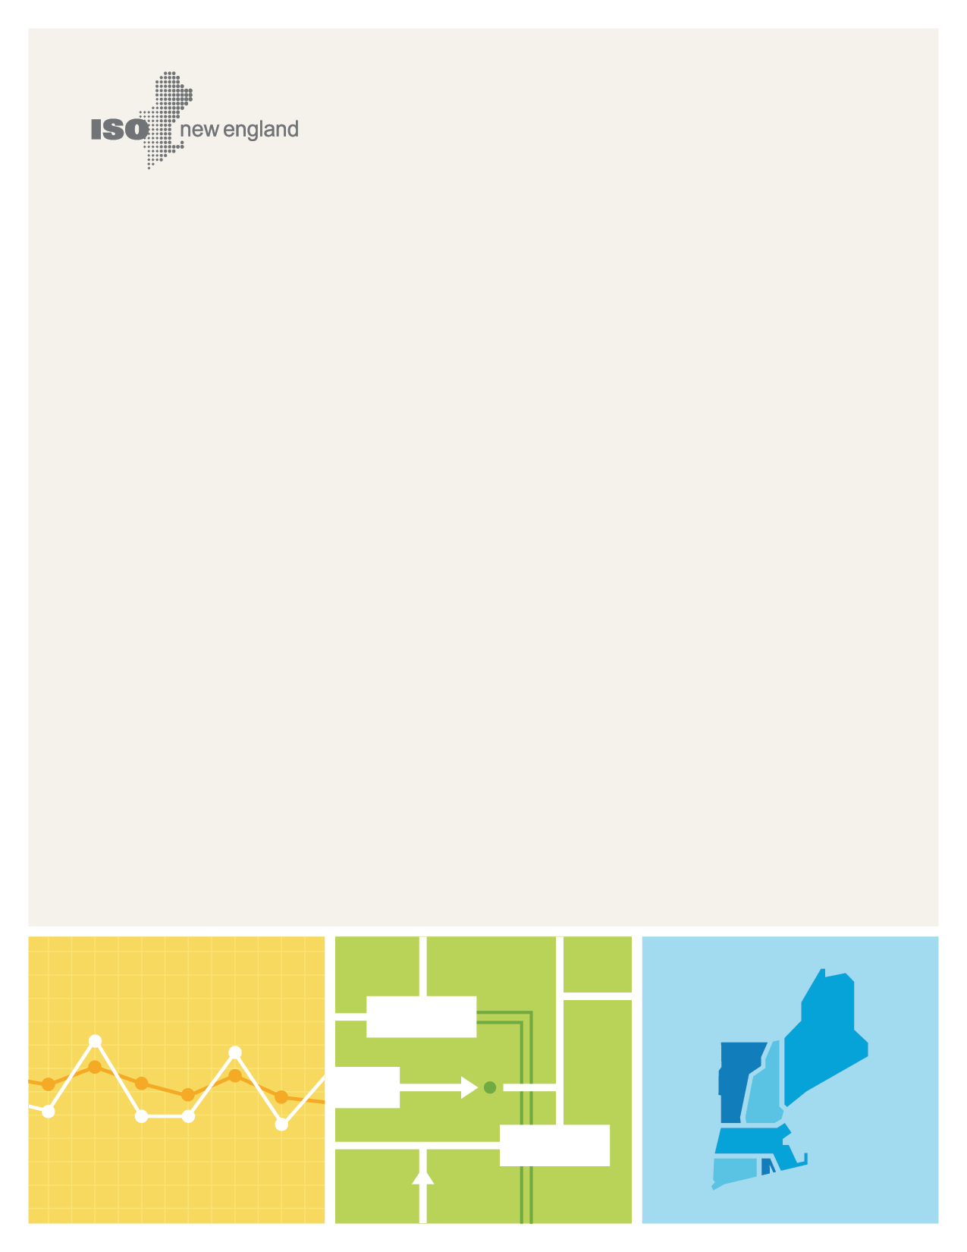
Wholesale Markets Project Plan
Closed Market Design Projects
© ISO New England Inc.
DEcember 2017
ISO-NE PUBLIC

Preface
ISO New England publishes the Wholesale Markets Project Plan (WMPP) on a biannual basis to communicate changes and advancements on the scope and status of key market initiatives and to identify new efforts to ensure an efficient and reliable electricity system in New England. The WMPP is available on ISO New England’s website (http://www.iso-ne.com). This document, the Wholesale Markets Project Plan: Closed Market Design Projects, includes information on closed WMPP projects.

Contents
Preface i
Closed Market Design Projects iii

Closed Market Design Projects
The ISO has closed the following projects, either by modifying the market design and tariff or by determining that no further action is required at this time. Market design projects are moved to this document when the effective date has passed and the projects have been implemented. Market design projects that did not result in near-term design changes are also shown in this section. The ISO maintains a historical repository of Federal Energy Regulatory Commission (FERC) by month and year located at http://www.iso-ne.com/participate/filings-orders.
Summary of Completed Market Design Projects
(Listed by Estimated Earliest Effective Date)
Project ID |  | Market Design Project | Estimated Earliest Effective Date | Docket No.  (Filing Date) | Design Status
― |  | Financial Transmission Right Auction Enhancements | January 2012 | ER11-3568-000  (May 13, 2011) | Complete
― |  | Reopen Regulation Market Pilot | February 2012 | ER12-505-000  (December 1, 2011) | Complete
― |  | Load Reconstitution | March 2012 | ER10-1653-000  (June 30, 2010) | Complete
― |  | FCM Design Reforms Extension | April 2012 | ER12-953-000  (January 31, 2012) | Complete
― |  | Start-Up and No-Load Reoffer Changes | April 2012 | N/A | Complete
― |  | Virtual Transaction Submission Limits | April 2012 | N/A | Complete
― |  | NCPC: Weekly Posturing Rules | May 2012 | ER12-1809-000  (May 17, 2012) | Complete
― |  | NCPC: Weekly Posturing Rules Compliance | May 2012 | ER12-1809-001  ER12-1809-002  (July 30, 2012) | Complete
― |  | End-Use Customer Aggregation (Order 745 Compliance) | June 2012 | ER11-4336-005  (March 26, 2012) | Complete
― |  | FCA Informational Publishing | June 2012 | ER12-1455-000  (April 6, 2012) | Complete
― |  | FCA Informational Publishing Compliance | June 2012 | ER12-1455-001  (July 2, 2012) | Complete
― |  | FCM Capacity Transfer Rights (CTRs) | June 2012 | ER12-1234-000  (March 9, 2012) | Complete
― |  | FCM Demand-Resource Capacity  Auditing | June 2012 | ER12-1389-000  (March 29, 2012) | Complete
― |  | FCM Demand-Resource Performance Incentives | June 2012 | ER12-1392-000  (March 29, 2012) | Complete
― |  | FCM Net Regional Clearing Price (NRCP) | June 2012 | ER12-1325-000  (March 23, 2012) | Complete
― |  | FCM Supplemental Availability Bilateral Transactions | June 2012 | ER12-1382-000  (March 29, 2012) | Complete
― |  | Price-Responsive Demand: Transition Period Changes | June 2012 | ER12-1550-000  (April 1, 2012) | Complete
― |  | System TMOR Reserve-Constraint Penalty Factor Prices | June 2012 | ER12-1314-000  (March 22, 2012) | Complete
― |  | Electronic Data Reporting (Order 760) | August 2012 | ER12-2228-000  (July 11, 2012) | Complete
― |  | FCM Rejected Delist Bid Follow-Up Actions | August 2012 | ER12-1914-000  (June 1, 2012) | Complete
― |  | FCM Rejected Delist Bid Follow-Up Actions Compliance | August 2012 | ER12-1914-001  (August 30, 2012) | Complete
― |  | FCM Partial Nonprice Retirement | October 2012 | ER12-2393-000  (August 3, 2012) | Complete
― |  | FCM Resource Termination | November 13, 2012 | ER12-2625-000  (September 14, 2012) | Complete
― |  | FCA #7 | November 2012 | ER12-2697-000  (September 27, 2012) | Complete
― |  | FRM Threshold Price Calculation Frequency | November 2012 | ER12-2485-000  (August 20, 2012) | Complete
― |  | Financial Assurance Bilateral Transaction Cure Period | January 2013 | ER12-2575-000  (September 4, 2012) | Complete
― |  | Central Counterparty (Order 741) | January 2013 | ER12-1651-000  (April 30, 2012) | Complete
1 |  | Gas Pipeline Information Sharing | January 2013 | N/A | Complete
13 |  | Financial Assurance and Bilateral Transactions | Phase 1: January 2013  Phase 2: N/A | ER13-270-000  (November 1, 2012) | Complete  No action taken
― |  | FCM Static Delist Bids | February 2013 | ER13-612-000  (December 21, 2012) | Complete
12 |  | FCM Redesign | February 2013 | ER12-953-001  (December 3, 2012) | Complete
2 |  | Forward Reserve Market TMNSR Procurement | March 2013 | ER13-465-000  (November 27, 2012) | Complete
 | 50 | Wind Forecasting and Dispatch | Q2 2013 | N/A | Merged with other project
 | 11 | FCM Reconfiguration Auction and Capacity Supply Obligation (CSO) Bilateral Transaction Enhancements | April 2013 | ER13-585-000  ER13-585-001  (December 19, 2012) | Complete
 | 4 | FCM Demand-Asset Auditing | May 1, 2013 | ER13-1010-000  (March 1, 2013) | Complete
 | ― | Off-line Reserve Capability  Determination | June 2013 | ER13-323-000  (November 6, 2012) | Complete
5 |  | Day-Ahead Energy Market Schedule | June 2013 | ER13-895-000  (February 7, 2013) | Complete
6 |  | Obsolete Language Review | June 15, 2013 | ER13-1149-000  (March 22, 2013) | Complete
47 |  | Reliability Commitment Cost Recovery | June 25, 2013 | EL13-72-000  (August 13, 2013)  Er13-2149-000  (August 20, 2013) | Complete
3 |  | Regulation Market Opportunity Cost | July 2013 | ER13-1259-000  (April 11. 2013) | Complete
22 |  | PRD and Net Supply | August 21, 2013 | ER13-1742-000  (June 21, 2013) | Complete
20 |  | Price-Responsive Demand: Full Integration Capacity Market Changes | August 21, 2013 | ER13-1742-000  (June 21, 2013) | Complete
7 |  | Generation Capacity Auditing | Phase 1:  December 2012  Phase 2: September 2013 | N/A  ER13-323-000  (November 6, 2012) | Complete
51 |  | Winter 2013/2014 Reliability Solutions  Winter 2013/2014 Reliability Solutions Compliance | August 27, 2013  September 6, 2013  September 6, 2013 | ER13-1851-000  (June 28, 2013)  ER13-1851-001  (August 9, 2013)  ER13-1851-000  (October 15, 2013) | Complete  Complete
14 |  | Forward Capacity Auction #8  Carry-Forward and Administrative Pricing  Objective Function | N/A  September 2, 2013 | N/A  ER13-1880-000  (July 1, 2013) | No action taken  Complete
17 |  | Import Capacity Resource Qualification Documentation | September 23, 2013 | N/A | Complete
16 |  | Forward Reserve Market (FRM) Incentives | October 1, 2013 | ER13-1733-000  (June 20, 2013) | Complete
25 |  | TMOR RCPF & Replacement Reserve | October 1, 2013 | ER13-1736-000  (June 20, 2013) | Complete
37 |  | FCM Shortage-Event Triggers | October 4, 2013 | ER13-2313-000  (September 4, 2013) | Complete
24 |  | Tie-Line Name Clean-Up | October 6, 2013 | ER13-2113-000  (August 6, 2013) | Complete
43 |  | Net Metered Generator Auditing | October 7, 2013 | ER13-2110-000  (August 5, 2013) | Complete
60 |  | Non-Commercial Resource Treatment | 2014 | ER14-2440-00  (July 16, 2014) | Complete
57 |  | Gas Pipeline Information Sharing | January 11, 2014 | ER14-970-000  (January 10, 2014) | Complete
40 |  | NCPC Local Second-Contingency Protection Resource (LSCPR) Cost Allocation | January 23, 2014 | ER14-584-000  (December 9, 2013) | Complete
10 |  | FCM Estimated Capacity Requirement | March 1, 2014 | N/A | Complete
38 |  | Fuel Switching: Use of Reference Level as the Supply Offer | March 1, 2014 | ER14-707-000  (December 20, 2013) | Complete
26 |  | Capacity Zone Modeling | April 28, 2014 | ER12-953-004  (January 31, 2014) | Complete
35 |  | FCM Performance Incentives | June 2014 | ER14-2419-000  ER14-2419-001  (January 17, 2014) | Complete
28 |  | Demand-Response: Asset Auditing and FCM Financial Assurance | June 1, 2014 | ER14-581-000  (December 9, 2013) | Complete
29 |  | Demand-Response Baseline and Outages | June 1, 2014 | ER14-727-000  (December 20, 2013)  ER14-1659-000  (April 4, 2014)  ER14-727-001  (May 1, 2014) | Complete
44 |  | Nonprice Retirement Request Timeline | June 9, 2014 | ER14-1693-000  (April 9, 2014) | Complete
66 |  | Dual-Fuel Resource Auditing | September 9, 2014 | ER14-2407-000  (July 11, 2014) | Complete
65 |  | Winter Reliability Program | September 9, 2014 |  | Complete
30 |  | Energy Market Offer Flexibility | December 3, 2014 | ER13-1877-000  (July 1, 2013) | Complete
31 |  | Energy Market Offer Flexibility: Conforming Rules | December 3, 2014 | ER14-2376-000  (July 8, 2014) | Complete
76 |  | Energy Market Offer Flexibility: IMM-Related Conforming II | December 3, 2014 | ER14-2686-000  (August 22, 2014) | Complete
77 |  | Energy Market Offer Flexibility NCPC Clarifications | December 3, 2014 | ER14-2929-000  (September 23, 2014) | Complete
32 |  | Energy Market Offer Flexibility: Self-Funding Tariff | December 3, 2014 | ER14-2929-000  (September 23, 2014) | Complete
70 |  | Ex-Post Mitigation of Dual-Fuel Resources | December 3, 2014 | ER14-2407-001  (July 11, 2014) | Complete
41 |  | NCPC Payments | December 3, 2014 | ER14-1147-000  (January 24, 2014) | Complete
42 |  | NCPC Payments: Appendix A | December 3, 2014 | ER14-1147-000  (January 24, 2014) | Complete
45 |  | Real-Time Reserve and Pumped Storage | December 3, 2014 |  | Complete
62 |  | Capacity Zone Modeling: Conforming Rules | Q4 2014 | ER15-195-000  (October 27, 2014) | Complete
73 |  | FCM Administrative Clarifications | January 30, 2015 | ER15-369-000  (November 10, 2014)  ER15-369-000  (December 31, 2014) | Complete
56 |  | FCM Sloped Demand Curve: System Curve | FCA #9  (February 2015) | ER14-1639-000  (April 1, 2014)  ER14-1639-002  (July 11, 2014) | Complete
34 |  | FCM Noncommercial Capacity Financial Assurance | February 2015 | ER14-525-000  (December 4, 2013)  ER15-369-001  (November 10, 2014) | Complete
67 |  | Elective Transmission Upgrade | February 16, 2015 | ER15-1050-000  (February 13, 2015) | Complete
88 |  | Offer Review Trigger Price (ORTP) Exemptions for Distributed Renewable Technology Resources | February 21, 2015 | ER15-716-000  (December 23, 2014) | Complete
74 |  | Regulation Enhancements for Storage Management | March 31, 2015 | ER14-2918-000  (September 22, 2014) | Complete
46 |  | Regulation Market (Order 755) Compliance | March 31, 2015 | ER12-1643-003  (August 5, 2013) | Complete
63 |  | FCM Sloped Demand Curve: Local Curves: FCA 10 (Market Monitoring-Related Capacity Market Changes) | June 1, 2015 | ER15-1650-000  (June 30, 2015) | Complete
80 |  | FCA Qualification Enhancements | Q2 2015 |  | Merged with other project
93 |  | Ownership Share Change Timing | August 7, 2015 | Manuals complete | Complete
81 |  | Winter Reliability Program: Winter Periods Prior to June 1, 2018 | September 14, 2015 | ER15-2208-002  (December 23, 2015) | Complete
64 |  | FCM Sloped Demand Curve: Reconfiguration Auctions | October 12, 2015 | ER15-2404-000  (October 7, 2015) | Complete
8 |  | Coordinated Transaction Scheduling | Q4 2015 | ER12-1155-000  (February 13, 2015) | Phase 1 complete
92 |  | Reactive Capability Auditing | December 1, 2015 | ER15-2628-000  (November 12, 2015) | Complete
27 |  | CTS: Self-Funding Tariff | December 15, 2015 | ER15-2641-000  (November 9, 2015) | Complete
83 |  | CTS: Conforming Changes | December 15, 2015 | ER15-2641-000  (November 9, 2015) | Complete
94 |  | Baseline Method Modifications | December 31, 2015 | ER16-167-000  (December 23, 2015) | Complete
96 |  | Price Responsive Demand: Implementation Delay | December 31, 2015 | ER16-167-000  ER16-167-001  (December 23, 2015) | Complete
68 |  | FCM Sloped Demand Curve: Conforming Changes | 2016 |  | Merged with other project
95 |  | NCPC Modifications | February 1, 2016 | ER16-250-000  (December 23, 2015) | Complete
97 |  | Resource Retirement Reforms | March 1, 2016 | ER16-551-000  ER16-551-001  ER16-551-002  (April 12, 2016) | Complete
50 |  | Do Not Exceed Real-Time Dispatch | May 25, 2016 | ER15-1509-000  ER16-870-000  (July 23, 2015) | Complete
86 |  | FRM Modifications: Offer Cap | June 1, 2016 | ER16-921-000  (March 25, 2016) | Complete
61 |  | Simultaneous RTDR and RTEG Audit | June 1, 2016 | ER16-167-001  (December 23, 2015) | Complete
86 |  | FRM Modifications: Heat Rate | June 15, 2016 | ER16-1296-000  (May 6, 2016) | Complete
98 |  | Zonal Demand Curves | June 15, 2016 | ER16-1434-000  (April 15,2016) | Complete
101 |  | Dual-Fuel Auditing NCPC Fixes | November 1, 2016 | ER16-2529-000  (September 1, 2016) | Complete
84 |  | Resource Dispatchability Requirements | December 12, 2016 | ER17-68-000  ER17-68-001  (December 9, 2016) | Complete
75 |  | FCA Qualification Provisions | December 27, 2016 | ER16-2126-001 (December 6, 2016) | Complete
105 |  | Natural Gas Index Changes | January 10, 2017 | ER17-337-000  (January 9, 2017) | Complete
110 |  | Deletion of Active Demand Resource Tariff Provisions | Part 1: February 24, 2017  Part 2: June 1, 2018 | ER17-925-001  (March 15, 2017) | Complete
67/75/97 |  | Manual M-20 Conforming Changes | March 1, 2017 | Manual Complete | Complete
48 |  | Subhourly Real-Time Settlement | March 1, 2017 | ER16-1838-000  (June 2, 2016) | Complete
106 |  | NCPC Modifications for Sub-Hourly Settlement | March 1, 2017 | ER17-680-000  ER17-680-001  (February 23, 2017) | Complete
100 |  | CONE Recalculation and ORTP Updates | March 15, 2017 | ER17-795-000  (January 13, 2017) | Complete
55 |  | DARD Pump Intertemporal Parameters | March 31, 2017 | ER16-954-000  ER16-954-001  (March 22, 2016) | Complete
85 |  | Fast-Start Resource Pricing | March 31, 2017 | ER15-2716-000  (October 19, 2015) | Complete
84 |  | Resource Dispatchability Requirements: Conforming Manual M-11 Changes | May 5, 2017 | Manual Complete | Complete
107 |  | Order 825 Compliance: Settlement Interval Requirements | December 1, 2017 | ER17-774-000  (February 24, 2017) | Complete
35 |  | FCM Performance Incentives | June 1, 2018 | ER14-1050-000  ER14-1050-001  EL14-52-000  (January 17, 2014) | Phase 1 Complete
21 |  | Price-Responsive Demand: Energy Market (Order 745) | June 1, 2018 | ER11-4336-000  ER11-4336-001  ER11-4336-002  (January 19, 2012) | Complete
59 |  | Regulation Market: Improved Resource Modeling and Automatic Generation Control (AGC) Dispatch Coordination | N/A | ER14-584-000  (March 20, 2014) | No action taken
71 |  | FCM Peak Energy Rent Modifications  (CCP 5-8) | N/A |  | No action taken
49 |  | Treatment of Resources Retained for Reliability | N/A |  | No action taken at this time
33 |  | FCM Cost Allocation and Load Reconstitution | N/A |  | No action taken
53 |  | Monthly Forward Reserve Market Auction | N/A | N/A | No action taken
9 |  | FCM Demand-Resource Asset-Transfer Rules | N/A | N/A | No action taken
52 |  | Winter 2014/2015 Solution | N/A | N/A | No action taken
63 |  | FCM Sloped Demand Curve: Local Curve | N/A | N/A | No action taken
39 |  | NCPC Cost Allocation | N/A | N/A | Phase 1  no action taken
15 |  | Financial Transmission Rights Auction Enhancement Language Restructuring | N/A | N/A | No Action Taken
54 |  | Submission of FTRs for Clearing | N/A | N/A | No Action Taken
99 |  | Uncleared ARA3 Demand Bids | N/A | N/A | No Action Taken
― |  | Regulation Market (Order 755) | N/A | ER12-1643-000  (April 30, 2012) | Merged with other project
― |  | Day-Ahead Reserve Markets Enhancements Assessment | N/A | N/A | No action taken at this time
― |  | FCA Format Assessment | N/A | N/A | No action taken
― |  | FCM Demand-Resource Reliability-Only Product | N/A | N/A | No action taken
― |  | FCM Peak Energy Rent (PER) Review | N/A | N/A | No action taken
― |  | Negative Incremental Energy Offers | N/A | N/A | Merged with other project
― |  | Resource Modifications and Interconnection Terms | N/A | N/A | No action taken
― |  | Review of Defined Terms for Offers and Parameters in Energy Markets | N/A | N/A | Merged with other project

