Control Room Operations Window
(CROW) User Guide

Document Version: 4.0
Posting Date: November 2022

Software Release Date: December 2022

This page is left intentionally blank unless UG is to be co-authored.
Contents

Part 1: General Information Sections 1 – 4
Part 2: Generation Outage Request Submittal Sections 5 – 6

1 CROW Application Access 1
1.1 General Information 1
1.1.1 Web Access 1
1.1.2 Web Services Access 2
1.1.3 Setting up CROW Users 2
1.1.4 User Access to CROW Equipment 2
2 Initial Login and Setting Options 3
2.1 Date/Time Options 3
2.2 Asset Naming Options 4
2.3 Outage Request Notification Options 4
2.4 Outage Request Form Options 4
3 Generation Outage Request Types 5
3.1 OP-5 Overview 5
3.2 OP-5 Outages 5
3.3 Other types of Outage Requests 6
4 Generation Outage Request Lifecycle 7
4.1 Outage States 8
5 Creating a GOR 11
5.1 Open a new request 11
5.2 Select Outage Priority 11
5.3 Add Equipment 12
5.4 Define Constraint/Commitment type 15
5.4.1 If all physical components are Out of Service (OOS): 16
5.4.2 If single physical component and not OOS: 16
5.4.3 If multiple physical components and not all OOS: 17
5.5 Other Fields in GOR 18
5.5.1 Fields Planned Outage 18
5.5.2 Fields for other OP-5 Outages 18
5.6 Selecting Dates 18
5.6.1 Summer/Winter Boundary 19
5.7 External Comments field 20
5.8 Attachments 20
5.9 Request Details/Approval tab 21
5.10 Submitting Outage Request 22
5.10.1 Conflicts 22
5.10.2 After Submittal 23
5.11 Returning to Web Index 24
5.12 Modifying Previously Submitted Outage Requests 24
5.13 Viewing GOR History 25
5.14 Duplicating Outage Requests 25
5.15 Printing Outage Requests 26
6 Using Web Index for GORs 27
6.1 Filtering 27
6.2 Export to Excel 27
6.3 Export to GANTT 28
6.4 Gen Outage Report 29

Figures
Figure 1. Lifecycle of Planned Outage 7
Figure 2. Lifecycle of GORs other than Planned Outage 8

Preface
Purpose
This user guide will serve as the reference document for the Control Room Operator Window (CROW) for the overall features of the application and for submittal and review of generation outages.
This user guide is broken into two parts
Part 1: General Information
Part 2: Generation Outage Request Submittal

Change Summary
Revision | Date | Comments
1.0 | 10/2010 | Original published for use in Sandbox
2.0 | 04/2011 | - Updated documentation for production release  - Removed placeholder transmission sections of user guide  - 5.3 Changed default tag during outage creation  - 5.4.1 All components of generator initially set to OOS once first component set to OOS  - 5.7 Added examples of when External Comments should be provided
3.0 | 08/2012 | - 2.3 and 5.9, Activation of Approval Notifications  - 3.2, Modified options for GOR Priority = MVAR Test and Informational  - 4.1 and 5.12, Clarify communications for any changes to existing GORs  - 6.3, Addition of weekly GANTT chart feature  - 6.4, Updated screenshot to show new default date range of ‘Yesterday’
3.1 | 04/2013 | - 3.1 Op-5 Overview section added
4.0 | 11/2022 | - 3.1 OP-5 overview section removed  - 5.5, 5.12 FCM Exempt flag removed

CROW Application Access

General Information
The CROW application is to be used for both generation and transmission outages. This application does not capture outages on demand resources, generators associated with import resources or settlement only resources.
CROW can be accessed through a Web browser and through Web Services. The appropriate application group will be applied in the Customer and Asset Management System (CAMS) by ISO New England (ISO) based on your company’s functions in the markets. There are separate application groups for the production and sandbox environments. The application group names in CAMS are:
CAMS Application Group Name | Company Type | user guide refers to users under these company types as shown below
CROW Gen User Role SBox  CROW Gen User Role | Generation Lead Participants | Gen User
CROW Participant Role SBox  CROW Participant Role | Transmission Owners (TO) | TO User
CROW LCC Role SBox  CROW LCC Role | Local Control Centers (LCC) | LCC User
Note: LCC and TO Users are not required to make any changes in CAMS.
Company Security Administrators (SA) need to apply the desired CROW roles to their persons in CAMS. Under each of the application groups there are three roles; one is for read only access, one is for read/write access and one is for web services access. The role for web services access should only be applying to an entity that will be performing computer-to-computer Web Services functions.
This user guide is generally applicable to those users with read/write access. If you have read only access you will not be able to perform any actions that create or modify data on the outage requests.

Web Access
Once a company’s SA has assigned a user the rights to CROW and that user has a valid digital certificate issued by the ISO, that user will be able to access the “CROW Outage Scheduler” button at URLs below. The digital certificate will provide direct access to the application, no username/password is required.
Sandbox = https://sandboxsmd.iso-ne.com/
Production = https://smd.iso-ne.com/

Web Services Access
This user guide focuses on the Web based user interface. If you require information on Web Services access to CROW please contact ISO Customer Service at custserv@iso-ne.com

Setting up CROW Users
When the SA is assigning access to persons in CAMS the SA must be aware that each user in the CROW application is uniquely identified by their email address in CAMS. Therefore, every person granted CROW access in CAMS must have a unique email address. Below are scenarios addressing the possible conflicts that can occur:
- If a person is being assigned a CROW role in CAMS and another CROW user already has the same email address, that new user will not be created in CROW.
- If a person that is a CROW user changes their email address in CAMS to an email address that exists for another CROW user that email address change will not be applied in CROW.

User Access to CROW Equipment
Generation
Access to a generator and its associated outage requests in CROW is based on the company in CAMS that is assigned as Lead Participant for that generator. All CAMS users under that Lead Participant company will have access to all generators for which that company is Lead Participant. A change in a Lead Participant of a generator in CAMS will result in all current and historic outage requests being visible only to the ‘new’ Lead Participant, and no longer visible to the ‘old’ Lead Participant, based on the effective date of the change as defined in CAMS.
While LCCs must review some generation outage requests and can see all generation outage requests they do not operate any generation and therefore cannot create a generation outage request nor can they modify data associated with any generation outage request. Transmission Owners will not have any access to any generation outage requests.
Transmission
Access to transmission equipment is based on the ISO Energy Management System (EMS) model and managed by the ISO and is unchanged from the current version of CROW.

Initial Login and Setting Options
Upon initial login the Outage Requests tab will appear. The screen, which will look different for different users and those differences are addressed in the generation and transmission sections. The Options tab is common to all users.

Date/Time Options
Users can select the desired Time Zone from the dropdown list. It is recommended that the ‘Use Daylight Savings Time’ option is selected which automatically adjusts the displays for Daylight Saving Time.
The user can select the desired Date Format from the options in the dropdown list.

Asset Naming Options
There are three options available from the dropdown. This allows the user to control which ‘version’ of the name of the equipment they want used in the CROW displays. For generation, all three options will all provide the same data. For transmission, these provide the user additional options, as shown below:
1-Line Designation | Name as defined in the EMS model
External Name | Name as defined by TO or LCC, where TO/LCC must request ISO to modify the data. If none provided, will be the same as the 1-Line Designation.
Asset Long Name | Name as presented in the posted transmission outage reports

Outage Request Notification Options
If the “Send Me Outage Request Approval/Denial Notifications” checkbox is checked the user that creates the outage request will receive an email notification when the status of that outage request reaches the Approved, Denied or Cancelled states.
As described in Section 5.9, notification of the outage status change can also be sent to additional users if they have this option checked.

Outage Request Form Options
This checkbox allows the user to select whether the active outage request form should remain open or be closed once the data is saved.

Generation Outage Request Types
Data required to be submitted for each outage request is dependent on the outage request type, identified by the Priority field in CROW.

OP-5 Overview
See “ISO New England Operating Procedure No. 5 Generator and Dispatchable Asset Related Demand Maintenance and Outage Scheduling” (OP-5) for outage type definitions and obligations.

OP-5 Outages
OP-5 outage types are reflected in CROW as shown below:
- Planned Outage (PO)
  - Must be submitted through CROW unless software is unavailable
  - Option is only available in dropdown if Start Date is greater than or equal to 15 calendar days in future
- Overrun Planned Outage (OPO)
  - May be submitted through CROW
  - May continue to be called in
- Maintenance Outage (Short Term, STO)
  - May be submitted through CROW
  - May continue to be called in
  - After 9:00 a.m. day-before, must be called-in
- Forced Outage (FO)
  - May be submitted through CROW
  - May continue to be called in
  - After 9:00 a.m. day-before, must be called-in

Other types of Outage Requests
There are other options in the Priority field that do not necessarily reflect a reduction in operating capability on a generator but are still referred to in the software and this user guide as a Generation Outage Request (GOR). Some of these options have sub-categories that will be identified by the Constraint/Commitment field.
- Owner Test
  - Used when generator needs to operate at a predefined schedule to perform testing
  - Sub-categories are: General, Black Start (to be used only as required by Black Start business process)
  - NOT to be used to request audits
- MVAR Test
  - Used, in conjunction with Schedule 2 Business Practices, to request an MVAR test
  - Sub-categories are Leading and Lagging
- Informational
  - Used to capture generator information that would be useful for the LCC and/or the ISO to be aware of
  - Sub-categories are AVR, Communications, Miscellaneous and PSS
    - AVR recommended to be used for problems with automatic voltage regulation and reactive control system equipment
    - Communications recommended to be used for problems with RIG or telemetry equipment
    - Miscellaneous recommended to be used for reliable grid requests by nuclear units.
    - PSS recommended to be used when a power system stabilizer that is supposed to be in-service in accordance with MLCC * is out-of-service
  - Does not replace required verbal communication
    - Verbal communication will result in the Implementation and Completion of the request

Generation Outage Request Lifecycle
The lifecycle of a generator outage is dependent on the outage type. The Status field on the outage request will indicate where GOR is in its lifecycle. The ability for different users to modify outage data is dependent on where GOR is in its lifecycle. For example, a Gen User can only modify a GOR while it is in the Preliminary state.
The following diagrams show the lifecycle of the various outage types

Figure 1. Lifecycle of Planned Outage

Figure 2. Lifecycle of GORs other than Planned Outage

Outage States
The table below lists the various states of an outage request. These states indicate where that outage request is with respect to the review, approval and implementation.
State | What state indicates for a GOR
Preliminary | Request entered by Gen User, still editable by Gen User
Submitted | LCC has accepted request
Study | ISO is reviewing request
Negotiate | ISO has found potential conflicts with the request and is actively communicating with affected parties
Interim Approved | ISO has completed capacity assessment for Planned Outage and is performing reliability review
Approved | ISO has accepted request
Implemented | ISO has received notice from Gen User that GOR has begun; Actual Start time will reflect this notice
Completed | ISO has received notice from Gen User that GOR is completed; Actual End time will reflect this notice
Withdrawn | Gen User removed GOR while in Preliminary state
Denied | ISO or LCC denied GOR during approval process  Note: If Gen User does not need the requested GOR and it is in the Submitted, Study, Negotiate or Interim Approved state, Gen User may request the ISO to set to a state of Denied on their behalf
Cancelled | ISO or LCC cancelled GOR after it was approved  Note: If Gen User does not need the requested GOR and it is in the Approved state, Gen User must request the ISO to set to a state of Cancelled on their behalf using the ISO contacts defined in OP-5.
Recalled | ISO has requested that the Gen User return the generator to service prior to Planned End of the outage due to system conditions

Creating a GOR
This section describes the process of creating a generation outage request.

Open a new request
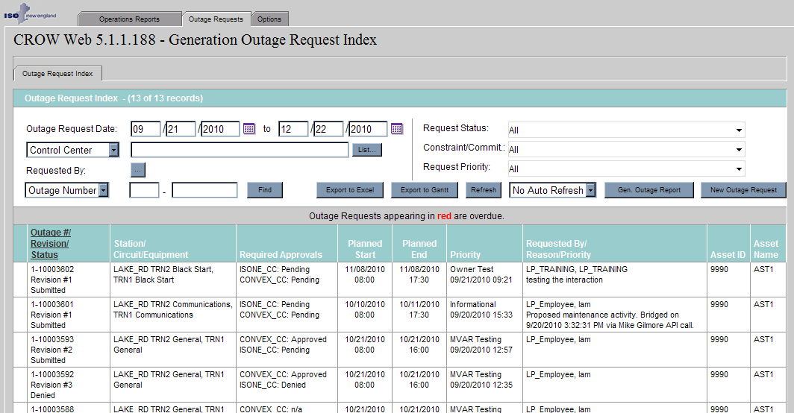
Begin by selecting New Outage Request button

Select Outage Priority
Select an Outage Priority from the dropdown list indicating the outage type. Click Add to open the window to select the generator:
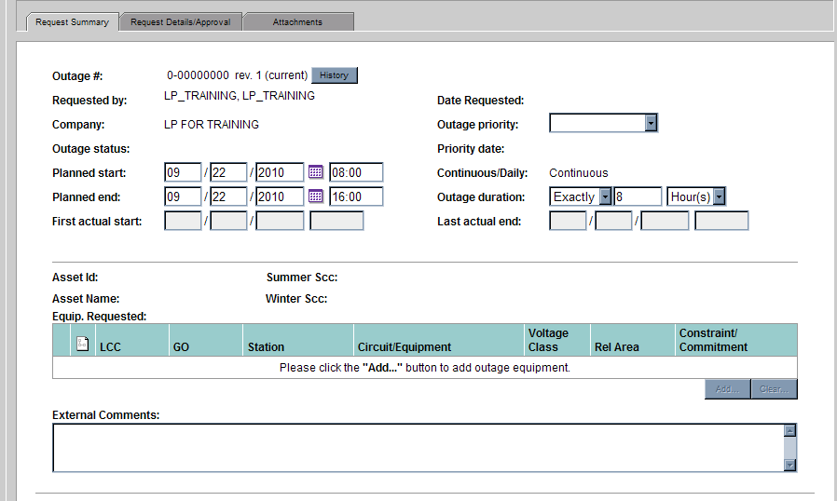
Outage Priority must be selected before Add button will be enabled

Add Equipment
Clicking the Add button opens the window shown blow, which defaults to tab labled Market Asset. This tab contains all generators registered to the Lead Participant company in CAMS. Select the desired generator and click OK.
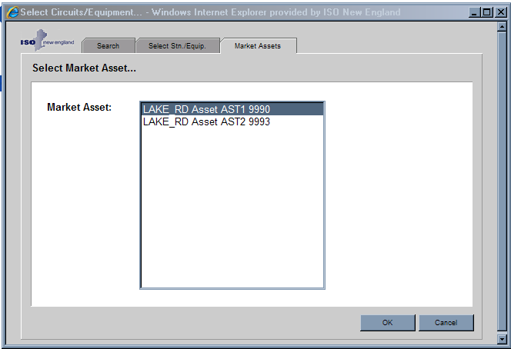

The Shift and CTRL key are not active on this display since each GOR is applicable to only one Market Asset.

Clicking Add will return the user to the GOR entry form, populating the Equip. Requested section with the physical components (Units) and other information associated with the selected generator. The information model behind CROW is populated from the ISO EMS model and therefore contains the physical components, Units, associated with the generator. The selected generator is reflected by the .Asset ID and Asset Name fields on the GOR form below.

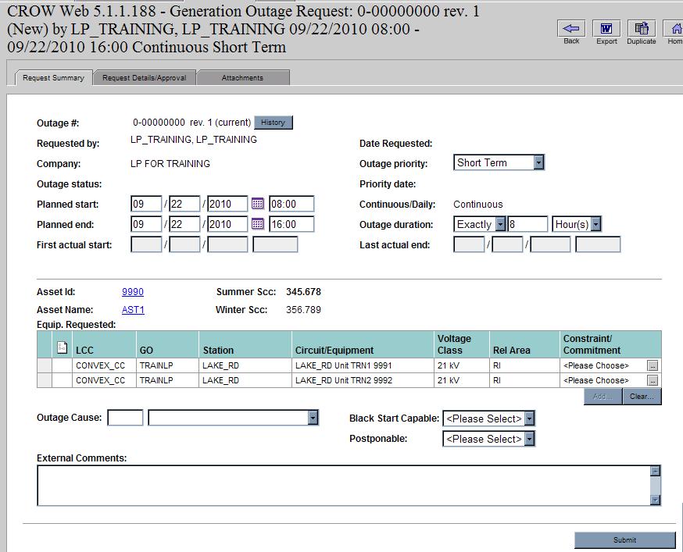
B
A
Equip. Requested contains physical components associated with Market Asset
Clear removes all equipment

Details about the Market Asset can be viewed by selecting the hyperlinks Asset ID or Asset Name and will show the data below.
A
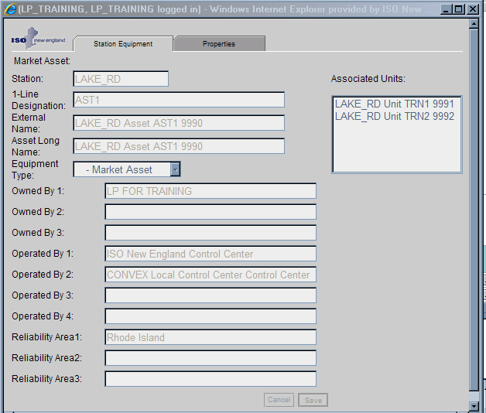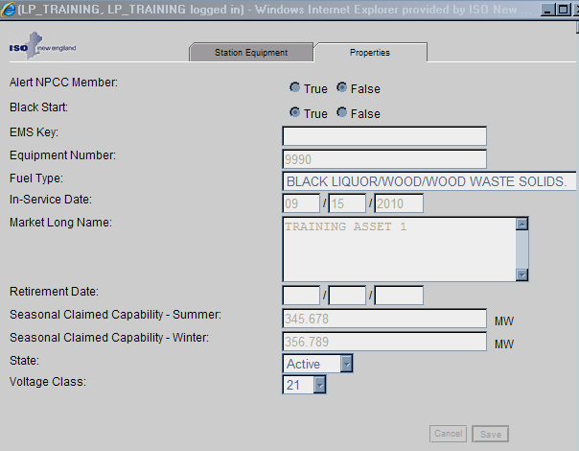

Details about the Units can be viewed by double clicking on the unit in the Equipment Requested section and will show the data below.
B
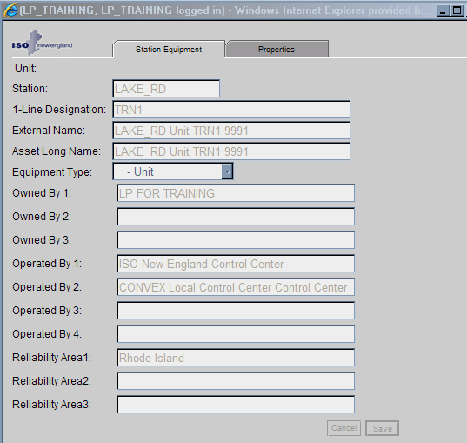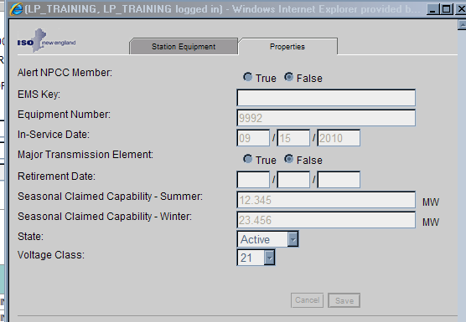

Define Constraint/Commitment type
Users must define the Constraint/Commitment for each Unit associated with the generator by selecting the […] under the Constraint/Commitment column. This provides additional required detail about the outage.

Tip: If you click on one row in the Equipment Requested section and then click on the […] too quickly it is taken as a double click and will open a new window with the Unit details.

Click […] below to select Constraint/ Commitment type

For an OP-5 outage type the user must define if each physical component is out of service or reduced. This information provides the ISO with the capability of the generator during the outage, which must be constant for the duration of the outage request. If the generator capability is known to vary substantially across the duration of the outage then multiple outage requests must be entered.

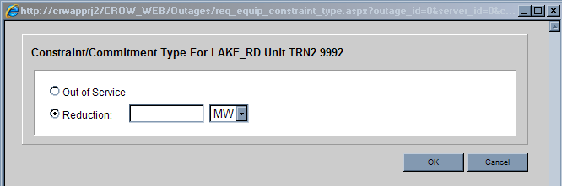

When selecting OOS a MW value is sometimes required. When selecting Reduction a MW value is always required. The next sub-sections provide examples of combinations of these selections.

If all physical components are Out of Service (OOS):
  - No MW entry required
  - All components will be set to OOS once OOS is set for one component
  - Physical Reduction defaults to the SCC that is active based on the Planned Start of the outage. This value will be updated if SCC changes while outage still active

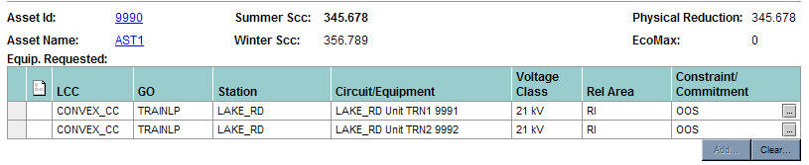

If single physical component and not OOS:
  - Must enter how many MW the unit is reduced
  - NOT what the unit is reduced to
  - EcoMax is calculated value, 222.222 - 100 = 122.222
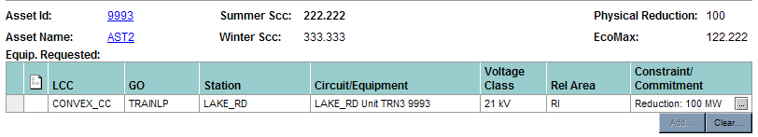

If multiple physical components and not all OOS:
  - Must enter how many megawatts (MW) each individual Unit is reduced
  - If Unit not impacted then Reduction = 0 MW
  - If Unit is OOS user must define how many MW that Unit is reduced
    - 0 MW is not a valid entry for OOS
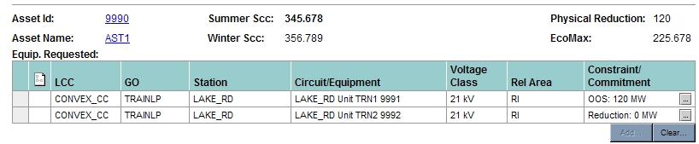

Another variation of the scenario where there are multiple physical components and not all OOS is shown below:
  - MW entry field not present if OOS is applied to first Unit selected
  - Calculated values will not appear until ALL Units have MW entry

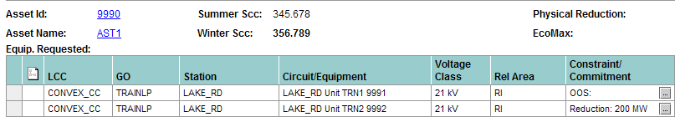

Tip: Always enter Constraint/Commitment on units with Reductions BEFORE units that are OOS

  - This example would produce an error message upon submit

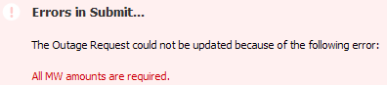

Other Fields in GOR

The other fields that will be presented in the GOR form are dependent on the type of outage that is selected.

Fields Planned Outage
The following are the fields presented for a Planned Outage, showing which are required and which are optional.

Outage Cause | Selection of value is optional
Forced Rescheduling | Set by the ISO if OP-5 rescheduling process applied
Black Start Capable | If generator flagged as such in CAMS, user must indicate whether generator will continue to be Black Start Capable during the requested outage

Fields for other OP-5 Outages
For other OP-5 outages the following table shows the additional fields that will be presented on the display and which fields must be filled in before the outage request can be submitted. Some Outage Cause selections have a related sub-cause list. Where a sub-cause list is presented an item must be chosen from the list.

 | Planned Overrun | Short Term | Forced
Outage Cause | Required | Required | Required
Black Start Capable | Required | Required | Required
Postponable | Not applicable | Required | Not applicable

Selecting Dates

The dates of the GOR can be entered manually or be using the calendar tool. If the Priority dropdown list does not contain the type Planned, then the selected date does not meet the required 15 calendar day notice; the start time will not influence the presence of the Planned type in the list.

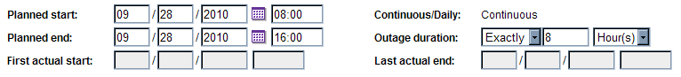

Summer/Winter Boundary

Due to the variation in SCC across the summer/winter boundary, no outage may not cross summer/winter boundary. Since EcoMax is a calculation based on SCC, submitter must notify the ISO of impact of the season change. This OP-5 business rule is a general rule for all outages, so users will find this restriction for all outage types, even if they are not dependent on SCC, i.e. Informational.

Example: Desired outage 9/20-10/15
Result: User must submit two outage requests 9/20 - 9/30 23:59 and 10/1 00:00 -10/15

It is recommended that the user enter text in External Comments to indicate the outage is one of two parts. The ISO will link the outages and study as one complete outage request

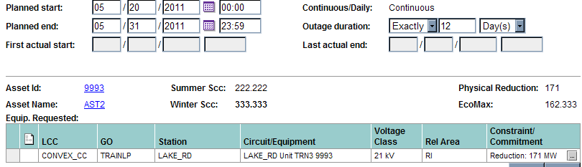
For example, Physical Reduction is noticeably different but EcoMax is relatively constant

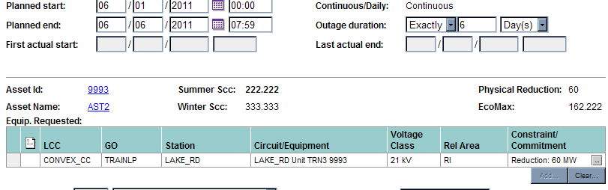

External Comments field

The External Comments field is a free form field where the user can provide additional information about the outage request.

Examples of information for external comments:
- If the generator will have temperature dependent variation in EcoMax during outage it is recommended that the Gen User indicate the range of EcoMax values that should be expected during the outage.
- If the current SCC for the generator is not representative of the actual generator capability it is recommended that the Gen User enter the Reduction MW to indicate the physical reduction that is expected and also provide comments indicating the appropriate current maximum generator capability.

Attachments

Attachments can be added/removed when outage is being created or anytime the outage is in the Preliminary state. Attachments that have been added can be viewed by the Gen User even when the outage cannot be modified.
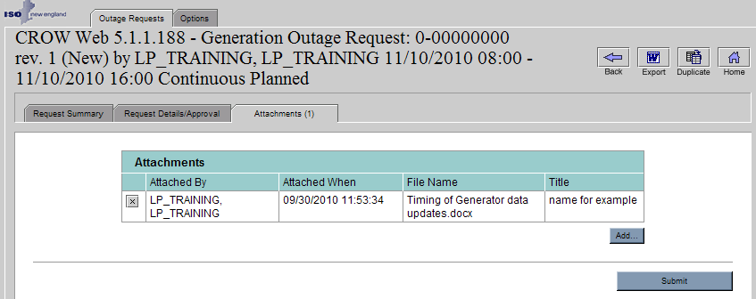

Request Details/Approval tab
If a user has the ““Send Me Outage Request Approval/Denial Notifications” option set, they will automatically receive emails when the state of any outage they have created transitions to Approved, Denied or Canceled. If notifications of these state changes are desired for others, the user creating the outage can add other CROW Users in the Notifications area of the Request Approvals/Details tab

Click Add to add the Approval Notification record. Click the ellipse to select the user. Once the CROW User is selected, their name and email address will appear in the record.

Note: While there are other options available in the Notification Type dropdown list, those are only for ISO use. The software will allow a user to select them but ISO will delete any records other than Approval Notification that created by an outside user.
.

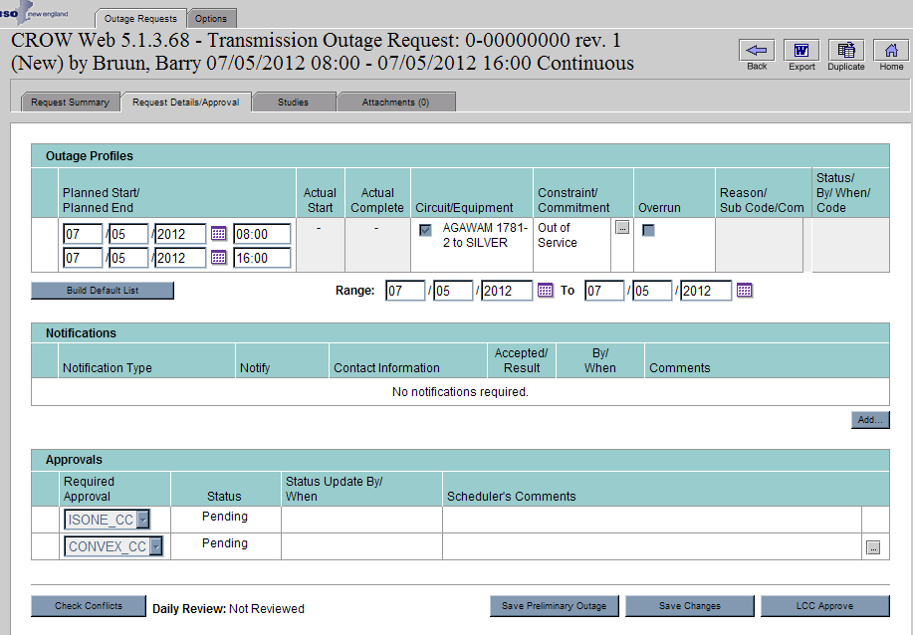
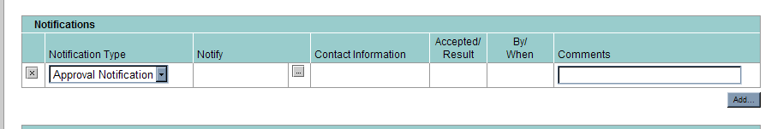
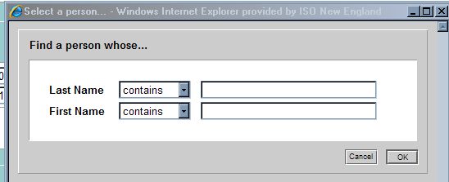

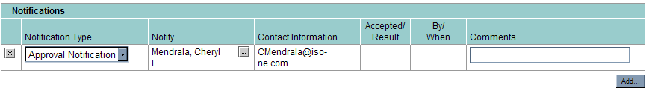

Submitting Outage Request
Once all required fields and desired optional fields have been entered, user will click ‘Submit’ to enter the outage request. If the outage is of type Planned or MVAR Test, the status will go to Preliminary. For other outage types the status will go Submitted and no additional changes will be able to be made by the Gen User.

Conflicts
After clicking “Submit” a warning box will appear if another outage exists in the same time period for the same generator. Outages in the Preliminary state will NOT be considered to produce a conflict. Therefore, a Planned Outage being submitted will never present this message since it will be in the Preliminary state.
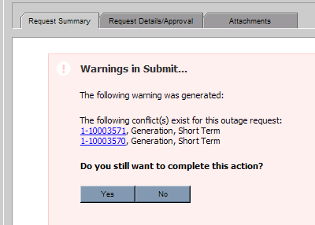
- Selecting “Yes” will complete the submittal.
- Selecting “No” will return you to the GOR form.
- Clicking on the hyperlink(s) provided in the warning will open a new window with the selected outage displayed

After Submittal
Upon submittal the Outage ID, Requested By, Priority Date and Outage Status will all be filled in.
Requested by and Company reflect ‘who’ created GOR.
If called in by Gen User, will reflect ISO person and company

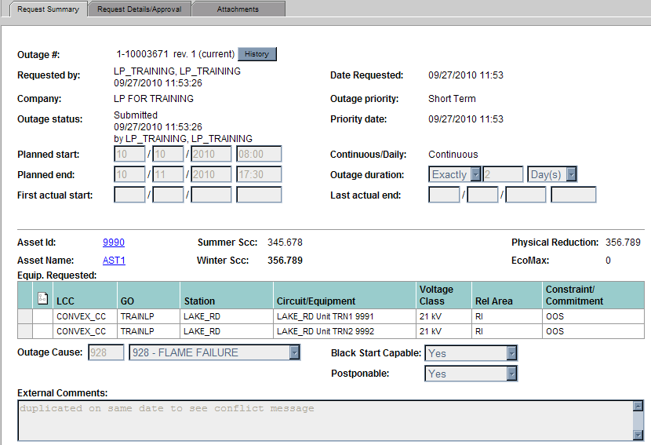
Priority Date reflects when outage was last submitted or saved by Gen User

Outage status will always reflect current status, when it reached that status and which user moved it to that status

Returning to Web Index
After outage submittal, or after viewing any outage request, use the Back or Home button to return to the Web Index.
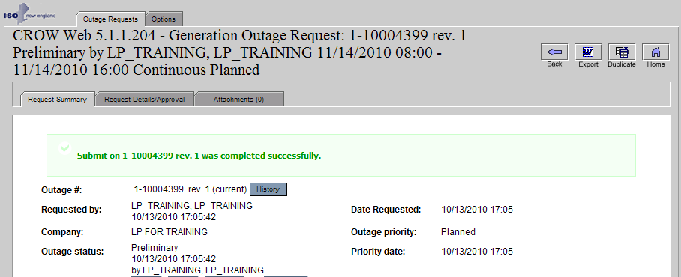

Modifying Previously Submitted Outage Requests

When the GOR is in Preliminary state the following data can be modified.
- Planed Start/End Date/Time
- Constraint/Commitment type and MW
- Outage Cause
- Black Start flag
- External Comments

When the GOR is in the Submitted state or beyond the Gen User cannot make any changes to GOR. Any changes to a previously submitted GOR must be requested through the ISO using the same communication protocols as before CROW was in place; as defined in OP-5. Changes that increase the scope or duration of the existing GOR may require a new GOR to be submitted.

Viewing GOR History
The revision history of an outage request can be downloaded to a spreadsheet using the History button. The previous versions of the GOR can be viewed by selecting the previous version from the dropdown list. In addition, the form will highlight with red text any field that has changed since the previous revision.
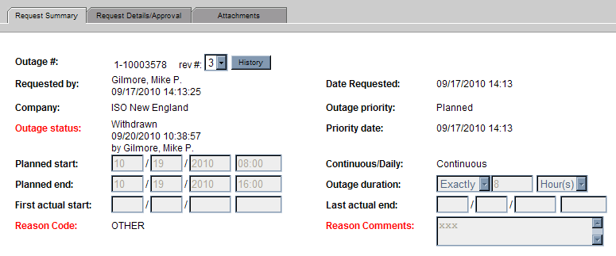
User can view previous versions using dropdown

User can export history using button

Changes from previous version highlighted in red

Duplicating Outage Requests
If there is a previously submitted outage request that you want to duplicate select the Duplicate button at the top right of the GOR form. Selecting this button copies: priority, market asset, dates, and constraint/commitment type. Any remaining information must be entered by the user before submitting.

Printing Outage Requests
Use may print from the File/Print menu on Web Browser but may alternatively select the Word icon on the top right of the GOR form that will produce a Word report than can be saved and/or printed.

Below shows the formatting of the Word export
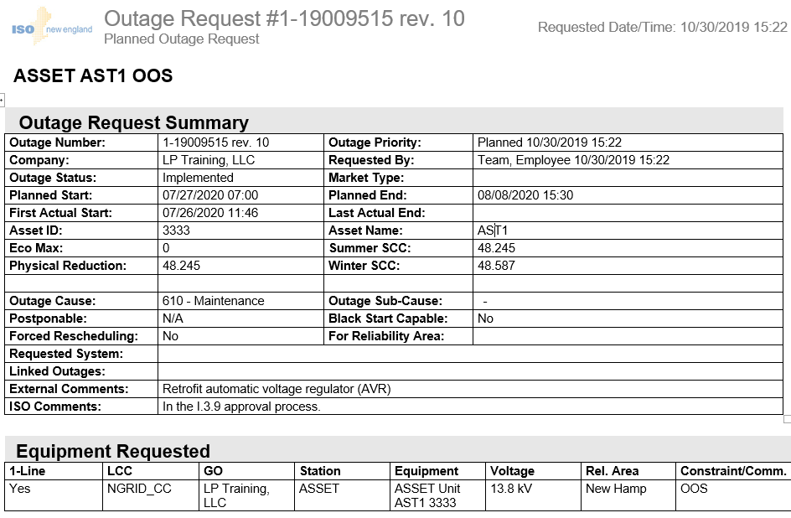

Using Web Index for GORs
This section describes the main CROW display, Web Index, where all generation outage requests are presented to the user.
Indicates total returned by query and total in current filtered view, 300 maximum in view

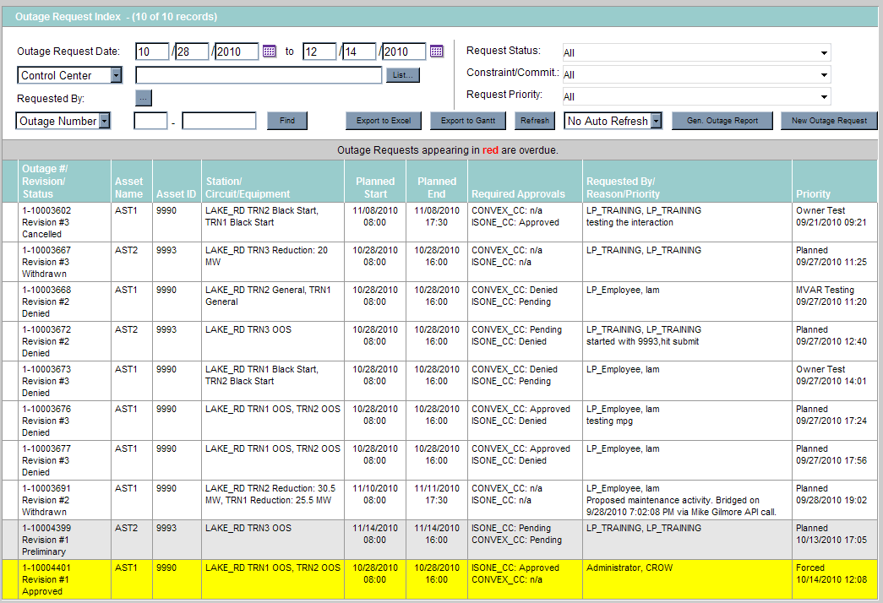
Yellow highlighting indicates a revision has been made by another user

Filtering
Each of the fields in the header area allows the user to filter the results presented on the Web Index. Once the data in the filter have been modified, click away from that filter to a blank space on the page to refresh the screen. Clicking on the column title will sort the screen by that column’s data

Export to Excel
The Export to Excel button exports all the records currently on the Index into a spreadsheet where each piece of data is in a separate column; whereas the Index has multiple pieces of data in each cell.

Export to GANTT
When you select the Export to GANTT button a popup window will appear with the message shown below. The answer to the first question will not impact the results for generation outage requests. The GANTT chart will be displayed containing basic data about the GORs and will utilize the sort order active on the Index.
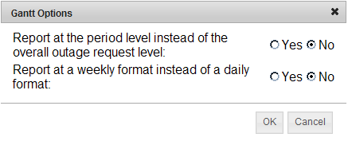
A sample of the GANTT chart is shown below. For a weekly GANTT chart the column will be filled in if the outage occurs in ANY day of that week.
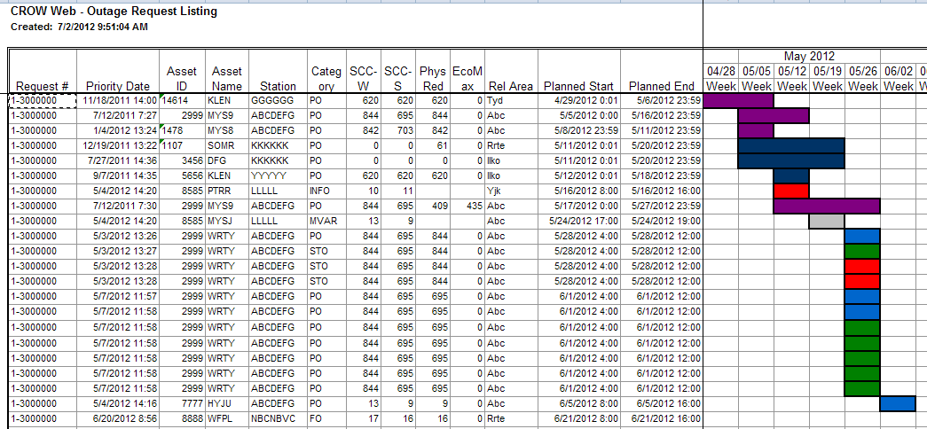
The colors displayed on the GANTT chart represent the status of the GOR
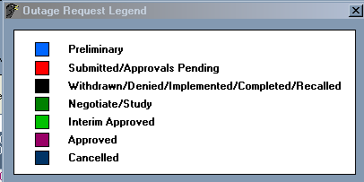

Gen Outage Report
The Gen Outage Report can be produced in Word or Excel formats. If the word version is chosen there is formatting applied. If the Excel version is chosen all data is shown in columns with no formatting.
For either the Excel or Word version of the report the user must select the desire date range using the radio buttons. For all but the Custom option the dates will be pre-selected. The typical Custom date setup utilizes the two date fields shown below. Having all four date fields allows the user to search on only START dates by using the top two fields or search on only END dates by using the bottom two fields.
Tip: If selecting ‘Actual Dates’ be sure outages exist with Actual Start/Actual Stop in the date range you have selected or you will get nothing in the returned results.
